Linked List, Node, & Vector Assignment

Output:

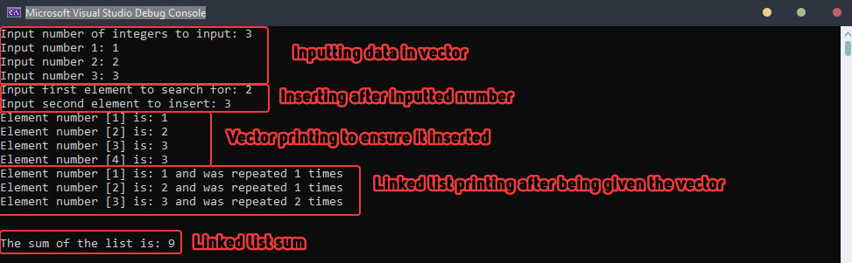

Notes:

* A parameterized constructor was used to take the vector directly as input for the linked list instead of making an external function to change the vector a linked list. This was taken permission to do first through email.
* Adding and removing nodes was treated similar to a stack, were push and pop were used.