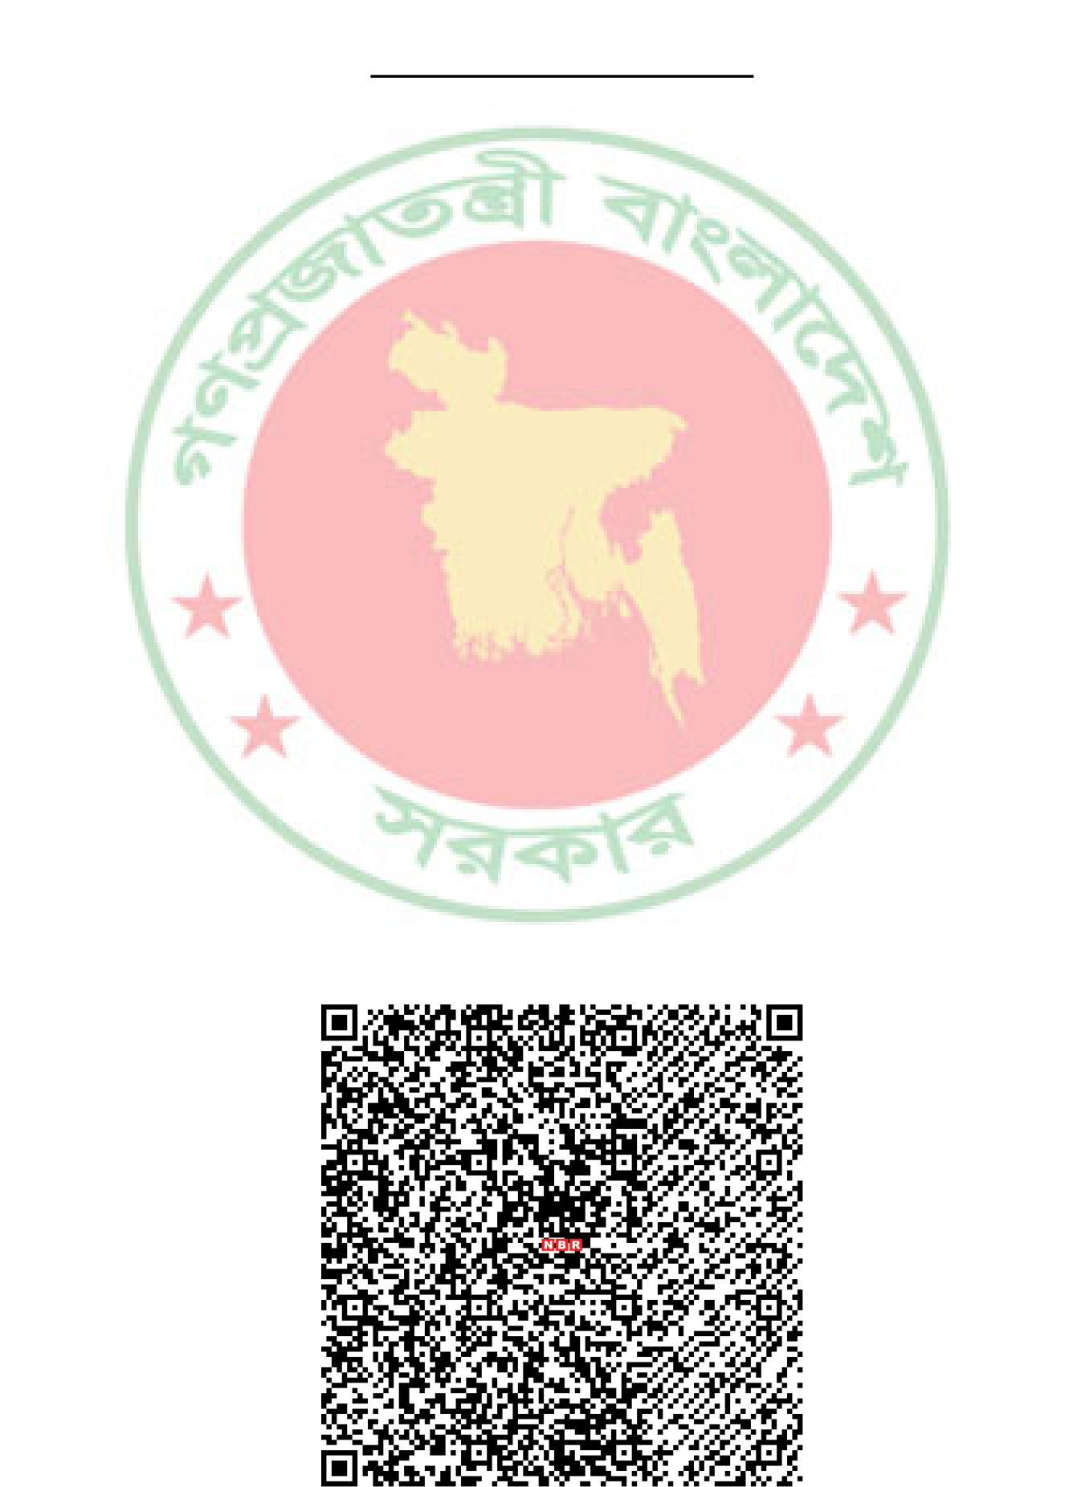


Government of the People's Republic of Bangladesh National Board of Revenue
Taxpayer's Identification Number (TIN) Certificate
TIN : 613776464280
This is to Certify that MOHAMMAD MAZHARUL HAQUE is a Registered Taxpayer of National Board of Revenue under the jurisdiction of Taxes Circle-252 , Taxes Zone 12, Dhaka.
Taxpayer's Particulars :
1) Name : MOHAMMAD MAZHARUL HAQUE
2) Father's Name : MD.ABDUL MALEK
3) Mother's Name : JAHANARA BEGUM
4.a) Current Address : house:247,payerkhandi, Muktagacha, Mymensingh, PO : 2210 4.b) Permanent Address : house:247,payerkhandi, Muktagacha, Mymensingh, PO : 2210 5) Previous TIN : Not Applicable
6) Status : Individual
Date : March 13, 2017
Please Note:  1. A Taxpayer is liable to file the Return of Income under section 75 of the Income Tax Ordinance, 1984.  2. Failure to file Return of Income under section 75 is liable to-  (a) Penalty under section 124; and  (b) Prosecution under section 164 of the Income Tax | Deputy Commissioner of Taxes  Taxes Circle-252  Taxes Zone 12, Dhaka  Address : Modina Tower, 3/4, Purana Paltan, Dhaka. Phone : 7115901
Ordinance, 1984.
N. B: This is a system generated certificate and requires no manual signature.

