Talent hunting program in Bangladesh: An analytical study on design and development of MIS for Notun Kuri.
Table of Contents
Introduction 3
Problem Statement 3
Research Objectives 4
Research Questions / Hypothesis 5
Literature Review 5
Methodology 7
Data Sources 7
Research Approach 8
Expected Outcome 8
Limitations of the Study 9
Conclusion 9
Workplan and Timeline (6 Months) 10
Reference list 11

Introduction
Talent hunting programs play a crucial role in searching and nurturing the capabilities of the youths with structured training, assessment and exposure to the society. These programs give the youths a chance to develop skills and engage in social and cultural activities. Aspen Institute reports that with youth development programs, young people develop confidence, creativity and social interactions (Aspen Institute, 2025). Cultural programs and other activities and initiatives targeted at youth promotion of participation in music, dance, acting, and other creative activities have a significant part in Bangladesh, where a significant majority of the population is young (BRAC, 2025; The Business Standard, 2024).
Notun Kuri is one of the best known talent discovery schemes in Bangladesh and it was first aired on Bangladesh Television in 1976. The program has given the children and adolescents a platform to demonstrate their talents in the various performing arts and has helped in creation of numerous successful cultural individuals ( Inside Bangladesh, 2025).
In the new digital age, organizations are becoming more and more reliant on Management Information Systems (MIS) as a means of managing information effectively and aiding decision making. Management Information Systems: Managing the Digital Firm indicates that MIS assists organizations in gathering, handling, and sharing information to aid planning and operational control (Laudon and Laudon, 2021). Hence, incorporating MIS with talent searching programs like Notun Kuri could enhance the efficiency of the operations, data management and general performance of the program.

Problem Statement
Even though the Notun Kuri talent hunting programs has a great cultural importance and popularity, a large number of its operational processes are still handled in manual and disjointed operations. The records of participants, the evaluation and performance information can be easily kept in different formats and this brings issues of establishing consistency and made accessibility of the data. Cosentino (2022) remarked that so-called data fragmentation poses a challenge to the efficient process of analysis and making a decision. On the same note, MedTech News argued that divided data systems decline efficiency and cause hindrances to integrate information flowing (MedTech News, 2025).
Lacking built-in systems to track participants and obtain real-time information also adds more burdens to the administrators and evaluators in traditional systems. Feldacker et al. (2024) further reasoned that with the manual systems a significant portion of time is wasted on data entry and data integration actions but not on the operations required. This makes talent identification, tracking, and development less efficient and opaque in the long term.
Moreover, the unavailability of centralized Management Information System restricts the capabilities of the managers to receive the right and timely information to plan strategic and make decisions. This minimizes the scalability and modernization of the program. The lack of structured MIS, therefore, has a serious impact on the efficiency and sustainability of the process of talent management of Notun Kuri.

Research Objectives
The main objective of this research paper is to compare the current talent hunting system of Notun Kuri and coming up with a well-organized Management Information system (MIS) architecture that can streamline its performance, transparency, and performance. Through the incorporation of contemporary information systems, the research aims to support the e-revolution of the old ways of talent management in Bangladesh.
General Objective:
To examine and suggest an MIS framework of Notun Kuri.
Specific Objectives:
- To explore the existing talent hunting activities in Bangladesh and learn how these work.
- To detect the gaps and restrictions in the current system of Notun Kuri.
- To determine the effectiveness of MIS in enhancing talent identification, evaluation and management process.
- To construct a relevant and effective MIS model, which would support the requirements of the Notun Kuri program.

Research Questions / Hypothesis
A set of research questions direct this study to investigate the current challenges and opportunities of improvement in talent hunting programs management such as Notun Kuri by trying to integrate Management Information Systems (MIS) into the program. These questions are used to determine the operational constraints and the technological improvement opportunities in the program.
Research Questions:
- What are the current problems with management of the talent programs like Notun Kuri?
- What are the ways to enhance efficiency, transparency and decision-making in talent management with the introduction of an MIS?
- Which MIS structure best fits the socio-economic, technological situation of Bangladesh?
Beside the research questions, the following hypotheses are also taken into account during the research:
- H1: MIS implementation has a great deal of influence on efficacy of talent management.
- H2: MIS leads to the accuracy and objectivity of the processes of participant evaluation and selection.

Literature Review
Talent hunting programs have a lot of publicity as a successful system of identifying and nurturing the talents of young people in various fields like sports, culture, music and performing arts. These programs offer chances to develop skills, to train and expose oneself to the public which brings about long-term personal and professional developments. Talent Management maintains that talent development is relevant as early identification and sustained support have a positive correlation with future performance and success. Collings, Mellahi, and Cascio (2019) maintained that the talent management practices assisted organizations and institutions to develop sustainable competitive advantages by enhancing human potential systematic development. On the same note, Baker, Cobley, and Fraser-Thomas (2009) elucidated that well organized developmental environments have a positive impact on the development of young talents by availing access to opportunities to learn and professional advice.
Social and cultural development is also achieved through youth-related programs. The United Nations Children's Fund highlighted that creativity, confidence, and social inclusion are boosted as youths engage in cultural and educational activities (UNICEF, 2023). The cultural projects of youth have become and are becoming more prominent in Bangladesh due to the high level of youth population in the country that is actively taking part in social and creative practices. UNESCO believes that cultural involvement by young people stimulates the self-identification process and the maintenance of the cultural heritage, as well as social integration (UNESCO, 2022). Thus, talent hunting programs not only help to discover individual talents but also lead to broader cultural and community growth.
However, Notun Kuri is one of the biggest instances in Bangladesh and through the years has been used as a nationwide venue to showcase talents in music, dancing, acting, and recitation by the children and adolescents. The show has helped to produce numerous musicians and performers within the cultural sector in Bangladesh. Nevertheless, even when such programs are important, several of the conventional talent hunting programs still use the manual system of operations that restrict operational efficiencies and transparency.
Management Information Systems (MIS) are believed to be important tools in the contemporary organizations since they help in the process of gathering, intersecting, reserving and sharing information that may be used to make decisions. Management Information Systems suggest that MIS enhances efficiency in an organization by converting raw data into information that is useful to the manager and other administrators (O’Brien and Marakas, 2011). Similarly, Stair and Reynolds (2020) affirmed that companies with well-developed MIS models are able to enhance their coordination, minimize the operation expenses, and facilitate the strategic planning activities. Organizations in the digital worlds are relying more on MIS so that proper management of data and real-time communication can be achieved.
MIS takes a central part in talent management systems hereby in terms of registration of participants, tracking performance, assessment, and extending monitoring. Digital systems enable organizations to have centralized databases, and enhance openness in selection. Davenport and Harris (2017) opine that if information systems are supported by analytics, organizations in the future will be able to make quicker and more precise decisions by making efficient decisions through data analysis. On the same note, Kavanagg and Johnson (2018) elaborated the fact that integrated information systems improve organizational productivity, by eliminating duplication and enhancing access to reliable information.
Nonetheless, the lack of embedded MIS systems can also pose operation problems particularly with the traditional programs. Disjointed data systems may lead to lack of consistency, duplication and problems in the retrieving of information. Janssen, van der Voort, and Wahyudi (2017) opined that information systems that are not connected lead to a decrease in the effectiveness of the organization since there is no ease of data sharing and analysing across departments. Moreover, manual data entry activities add workload and provide human error opportunities. A study conducted by Redman (2013) pointed out that low quality data has negative impacts on organizational performance and decision making.
Within the framework of the talent hunting programs, like Notun Kuri, operational efficiency, participant management process and performance evaluation process can be enhanced considerably with the help of the implementation of MIS. Information can be availed in real-time in an accurate manner through a centralized system and thus organizations and evaluators make sound decisions. Thus, introducing MIS in talent hunting initiatives can contribute to sustainable talent management, enhance openness, and cultural management system update in Bangladesh.

Methodology
This paper will follow the descriptive and analytical research design to provide a systematic study on the current composition of the Notun Kuri talent hunting program and the possible use of the Management Information System (MIS) to enhance the program's effectiveness. Descriptive research works best when describing existing practice is necessary, whereas analytical research helps to critically assess and infer the gaps in practice and inefficiencies observed (Saunders, Lewis, and Thornhill, 2023).

Data Sources
The research mainly uses secondary data, which comprises:
- Scholarly articles, journals and research reports.
- Digital media and the Internet, such as archived videos of Notun Kuri (e.g., YouTube)
- Publications about youth development and cultural programs by the government and NGO.
- Secondary data analysis is a popular method in research, as it comes to understand the insights in cases when primary data gathering is restricted or unreachable (Kruger and Mitchell, 2022).

Research Approach
This paper is mainly based on secondary sources although the recommendations are based on a mixed-method research methodology using aspects of qualitative research and quantitative analysis.
Quantitative Methods (Proposed):
- Participant, organizer, or audience surveys.
- The data on selection and performance of participants will be statistically analyzed.
Qualitative Methods:
- Analysis of program structure, judging criteria and process of selection as content.
- Proposed interviews with organizers and interviewees to get more insight.
- Combining both qualitative and quantitative methods increases the validity and reliability of research results as it will generate the overall picture of an issue (Cahoon, 2023; Dominowski, 2020).

Expected Outcome
This study is likely to bear its expected results in the form of the creation of a better perception of the operational issues that talent hunting programs, like Notun Kuri, have, especially concerning the system that addresses the issue of the participants, their performance assessment system, and data processing. The study is likely to uncover the shortcomings of the current manual operations and point out the flaws imposed by disjointed and disorganised information systems. Janssen, van der Voort, and Wahyudi (2017) say that inefficient information management systems decrease the efficiency of the organization and adversely influence the quality of the decisions.
One of the key results of this study will be the creation of the conceptual Management Information System (MIS) framework that meets the operational needs of Notun Kuri in particular. It is believed that the given framework will benefit the process of participant tracking, centralized record keeping, and will contribute to the enhanced accuracy and accessibility of data. According to Laudon and Laudon (2021), MIS helps the organizations to have accurate information and in a timely manner in order to plan and control the activities of the organization.
Moreover, the research will offer viable recommendations on digital transformation in conventional talent hunting programmes. It is assumed that these recommendations will enhance transparency and operational efficiency as well as long-term sustainability of talent management practices in Bangladesh (Kavanagh and Johnson, 2018).

Limitations of the Study
This research is limited in that a number of limitations need to be kept in mind when making an interpretation of the results. To begin with, the study relies predominantly on secondary sources of data, and it, therefore, might lack sufficient credibility in terms of the present state of operation and real-time operations of the company Notun Kuri. Saunders, Lewis and Thornhill (2023) affirm that in certain cases, secondary data might not be relevant to particular research goals since the data was gathered not on the same objective.
The other constraint is that there is limited access to internal organizational information that reduces the level of analysis on management practices and decision making. Primary data collection, e.g. interview or survey, is also not included in the study. Dominowski (2020) interpreted that primary research could be more valuable and informative due to close communication with participants. More so, the study is limited by a time frame of six months, which limits the possibility of extensive analysis and validation of results (Kruger & Mitchell, 2022). Lastly, inconsistencies in the reliability and quality of secondary sources can also have an impact on the quality and consistency of the overall study results (Cahoon, 2023).

Conclusion
To sum up, talent hunting programs such as Notun Kuri are essential in immersing cultural and creative possibilities to the young generation in Bangladesh. Nevertheless, they cannot be efficient, transparent, and scalable due to the lack of a structured Management Information System. Incorporating MIS into these programs may contribute greatly to data management, performance monitoring, and decision-making activities.
This work emphasizes the fact that a systemic and technical approach should be taken to upgrade the old system of talent management. The research, by offering a conceptual model of MIS, would help deal with the current inefficiencies and promote the efficiency of the programs. The present research can inform Bangladesh on how to digitally transform cultural talent programs.

Workplan and Timeline (6 Months)

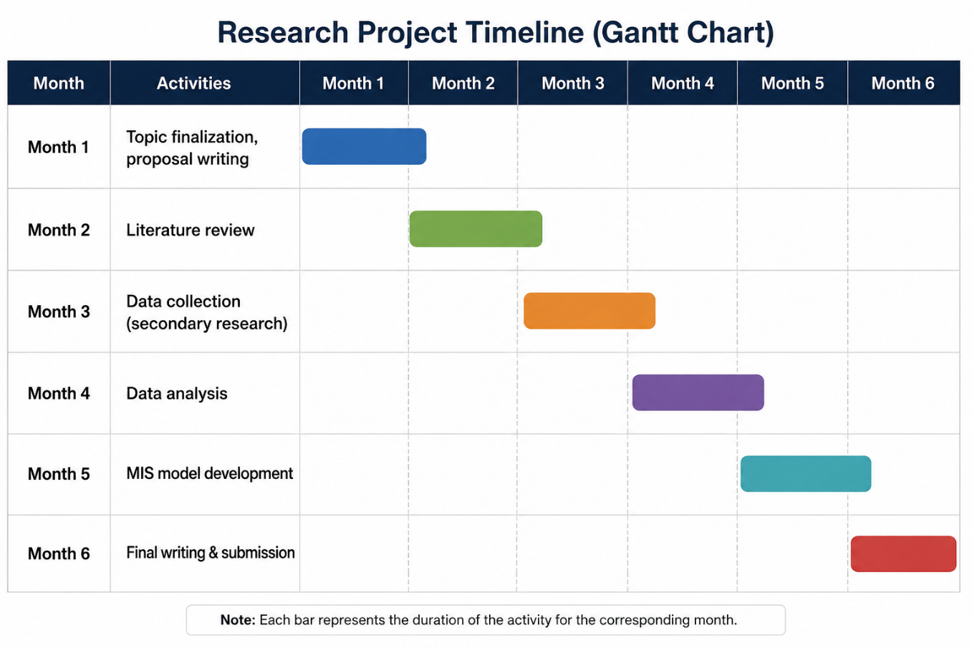
Figure 1: Research Project TimeLine (Gantt Chart). Source: Self-Generated.

Reference list
Cahoon, M. C. (2023). Research methodology (6th ed.). Churchill Livingstone.
Carvalho, H. M., & Gonçalves, C. E. (2023). Talent identification and development in youth sports. Frontiers in Sports and Active Living, 5, 1189355. https://doi.org/10.3389/fspor.2023.1189355
Dominowski, R. L. (2020). Research methods. Prentice-Hall.
Güllich, A., Barth, M., Hambrick, D. Z., & Macnamara, B. N. (2023). Participation patterns in talent development in youth sports. Frontiers in Sports and Active Living, 5, 1175718. https://doi.org/10.3389/fspor.2023.1175718
Kruger, F., & Mitchell, B. (2022). Research methodology. Oxford University Press.
Laudon, K. C., & Laudon, J. P. (2021). Management information systems: Managing the digital firm (17th ed.). Pearson.
Saunders, M., Lewis, P., & Thornhill, A. (2023). Research methods for business students (9th ed.). Pearson.
Aspen Institute. (2025). What is youth development?
https://www.aspeninstitute.org/wp-content/uploads/2025/05/Aspen_YD_FINAL_2_web-11.18.pdf
BRAC. (2025). Youth empowerment in Bangladesh.
https://www.bracusa.org/solutions/development/education-youth/youth-empowerment-bangladesh/
Cosentino, C. (2022). Data fragmentation and data linking: A threat and an opportunity. Harvard Data Science Review. https://doi.org/10.1162/99608f92.946ef791
Feldacker, C., et al. (2024). Crossing the digital divide: The workload of manual data entry and integration. Oxford Open Digital Health, 2(Supplement_2), ii9–ii17. https://doi.org/10.1093/oodh/oqae025
MedTech News. (2025). Data fragmentation: A cross-disciplinary analysis of challenges and impacts.
https://medtechnews.uk/research-reports/data-fragmentation-a-cross-disciplinary-analysis-of-challenges-solutions-and-impacts/
The Business Standard. (2024). Cultural affairs ministry unveils youth initiatives in Bangladesh.
https://www.tbsnews.net/bangladesh/cultural-affairs-ministry-unveils-seven-priority-projects-inspire-youth-after-july
Inside Bangladesh. (2025). Notun Kuri returns: Reviving Bangladesh’s iconic talent show.
https://inside-bangladesh.com/notun-kuri-returns/
Baker, J., Cobley, S., & Fraser-Thomas, J. (2009). What do we know about early sport specialization? High Ability Studies, 20(1), 77–89. https://doi.org/10.1080/13598130902860507
Collings, D. G., Mellahi, K., & Cascio, W. F. (2019). Global talent management and performance in multinational enterprises: A multilevel perspective. Journal of Management, 45(2), 540–566. https://doi.org/10.1177/0149206318757018
Davenport, T. H., & Harris, J. G. (2017). Competing on analytics: The new science of winning. Harvard Business Review Press.
Janssen, M., van der Voort, H., & Wahyudi, A. (2017). Factors influencing big data decision-making quality. Journal of Business Research, 70, 338–345. https://doi.org/10.1016/j.jbusres.2016.08.007
Kavanagh, M. J., & Johnson, R. D. (2018). Human resource information systems: Basics, applications, and future directions (4th ed.). Sage Publications.
O’Brien, J. A., & Marakas, G. M. (2011). Management information systems (10th ed.). McGraw-Hill Education.
Redman, T. C. (2013). Data driven: Profiting from your most important business asset. Harvard Business Review Press.
Stair, R., & Reynolds, G. (2020). Principles of information systems (13th ed.). Cengage Learning.
UNESCO. (2022). Culture and youth: Building social inclusion through cultural participation. https://www.unesco.org
UNICEF. (2023). Youth engagement and participation for social development. https://www.unicef.org

