Tamzid Sheakh Sani​ |  | ​ | 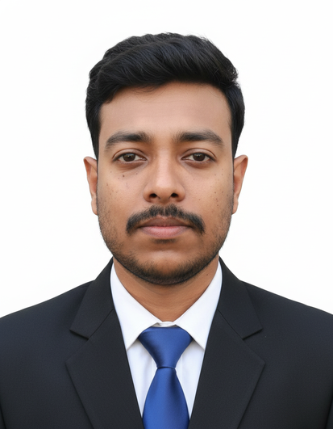
Present Address​ | : Bank Town, Savar, Dhaka​
Phone No.​ | : +8801981888469​
Email​ | : ​
LinkedIn​ | :
CAREER OBJECTIVE:
To secure a challenging role in IT Infrastructure Management, leveraging a strong Computer Science background and a keen interest in maintaining, optimizing, and securing enterprise IT environments for sustained operational excellence.
EDUCATION:
Dhaka City College
Bachelor of Science (BSc.)​ ​CGPA: 3.16 out of 4 Computer Science & Engineering​ Passing Year: 2025​
Savar Model College
Higher Secondary Certificate (HSC)​ |  | ​ | ​ | ​ | ​ | ​ | GPA: 4.33 out of 5.0
Group: Science​ | ​ |  |  |  |  |  | Passing Year: 2017​
Agrani High School
Secondary School Certificate (SSC)​ |  | ​ | ​ | ​ | ​ | ​ | GPA: 5.0 out of 5.0
Group: Science​ | ​ |  |  |  |  |  | Passing Year: 2015
WORK EXPERIENCES:
Avery Dennison Corporation (Paxar Bangladesh Ltd.):
Designation: GTS Trainee (IT)​ | ​ | Duration: September 2025 - Present
Job Responsibilities:
●​Execute enterprise operating system deployments across the network, utilizing PXE boot for automated, large-scale installations.
●​Configure and manage Cisco Catalyst (2960 & 9200 series) switches, MikroTik routers, and Cisco/Meraki Access Points to ensure high-speed network availability.
●​Provision and troubleshoot IP Phones and IP-based printers to maintain seamless office communication and document workflows.
●​Diagnose and resolve complex network connectivity issues, including device-level troubleshooting for end-users.
●​Manage high-volume service requests through the ticketing system (ServiceNow), ensuring all user support issues are resolved within SLA (Service Level Agreement) timelines.
●​Provide dedicated technical support to end-users, focusing on hardware, software, and secure network access.
●​Support Zero Trust initiatives, such as the deployment of Okta Verify (FastPass) and digital certificates via Manage Engine to secure company-managed PCs.
●​Enforce organizational Health and Safety protocols, ensuring all technical installations and maintenance tasks comply with corporate safety standards.
Projects:​
●​GTS Procurement Hub |Avery Dennison Corp.: Automated Procurement Tracking System developed using JavaScript, HTML, and CSS.
●​Digital Classroom Management Application | Dhaka City College: Android application for digitally tracking, monitoring classroom operations developed using Flutter framework.

SKILLS:​
Technical Skills: Flutter, JavaScript, Google AppScript, MS Suite, Cisco IOS.
Soft Skills: Communication, Adaptability, Critical Thinking & Problem Solving
Language: Bengali, English (Fluent), Hindi (Speaking & Listening)
PERSONAL DETAILS:​
Date of Birth ​  Present Address​ | : 22/08/1999  : 7/10, Bank Town, Savar, Dhaka
Permanent Address​: Bilnalia, Nagarkanda, Faridpur (Zip – 7841)
Nationality​ : Bangladeshi
REFERENCES:​
Abu Saleh Musajjee
GTS Site Support Lead, Bangladesh
CRPAP, Information Technology, AP
Avery Dennison Corporation
+88 02 778 8901-12, +88 01324 414 495
3/F, Uday Tower, 57, Gulshan Avenue, Gulshan -1, Dhaka -1212

