SMARTHIRE
Hackathon Demo Playbook
A complete presenter guide for the AI-powered recruitment platform

Demo objective | Audience | Suggested duration
Demonstrate an explainable, multi-tenant recruitment product from sign-up to admin governance. | Hackathon judges, recruiters, technical reviewers, and potential users. | 12-15 minutes live demo + 3-5 minutes Q&A.

Presenter promise: SmartHire does not automate hiring or rejection. It gives people structured, explainable decision support and keeps final decisions with recruiters.

1. Product at a glance
SmartHire is a role-based recruitment platform built for applicants, employers, and platform administrators. It combines job discovery, candidate management, explainable resume matching, workspace controls, subscription governance, and auditability in one product.
Role | Primary value | What to demonstrate
Applicant | Find relevant work and understand applications. | Profile, job board, salary, resume upload, match report, notifications.
Employer | Run a structured hiring process. | Workspace, jobs, ATS pipeline, scorecards, candidates, plan requests.
Administrator | Protect platform quality and commercial governance. | Admin setup, user controls, operations, SaaS plans, approvals, auditability.

2. Demo setup before recording
- Start the backend and frontend. Confirm /health returns healthy and open the application in a fresh browser session.
- Prepare one Employer account, one Applicant account, and one Admin account. Use realistic but safe demo data.
- Create at least one published job: Senior Backend Engineer, salary PKR 150,000-250,000/month, skills Python, FastAPI, PostgreSQL.
- Prepare a text-based PDF resume containing some, but not all, required skills.
- Prepare one pending plan-change request so the approval flow can be shown without waiting.
- Open the app in a private/incognito browser for applicant sign-up if you want to demonstrate separate sessions.
Recording tip: Keep three tabs open: Employer workspace, Applicant workspace, and Admin Control Center. This makes role switching fast and prevents accidental logout.

3. Suggested live-demo story
Use a simple story: “A growing university or technology company needs a backend engineer. The employer creates a transparent job posting. An applicant applies. SmartHire analyzes the resume with evidence. The recruiter manages the candidate. The employer requests a plan upgrade. The platform admin reviews and approves it.”

4. Employer flow

4.1 Employer account creation and verification
- Open Register and select Employer.
- Enter name, work email, company name, and password; alternatively show Google registration.
- Verify the email with the code or verification link.
- Explain that an employer workspace is created and the owner receives workspace management permissions.

4.2 Employer dashboard
- Active jobs, total applicants, average match score, and total jobs provide the opening operational summary.
- Recent jobs provide access to candidate lists.
- The left navigation exposes My Jobs, Post a Job, Hiring Pipeline, Recruiter Team, AI Scorecards, Workspace & Billing, Notifications, and Profile.

4.3 Post a transparent job
- Open Post a Job.
- Enter the title, detailed description, required skills, location, employment type, experience level, and status.
- Enter minimum and maximum monthly salary in PKR. Explain that salary is shown to applicants before they apply.
- Publish the job. Then open My Jobs and show the salary column and applicant count.
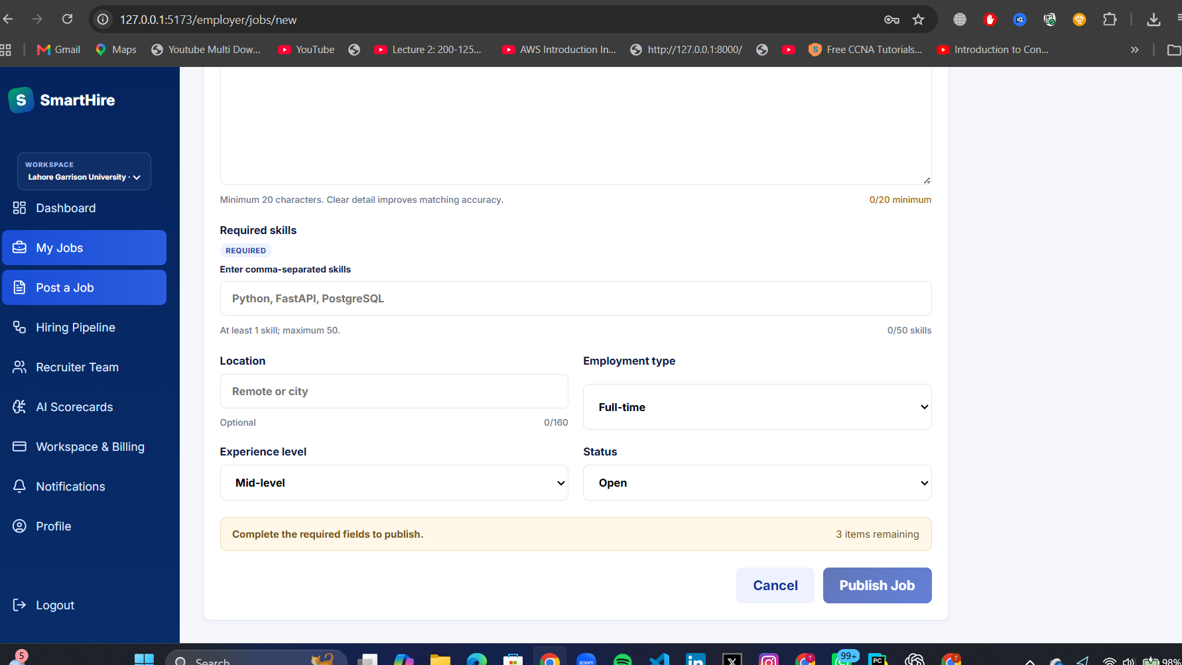
Figure 1. Employer job-posting experience. Salary fields are included in the current product flow.

4.4 Employer ATS and AI scorecard
- Hiring Pipeline supports recruiter workflow stages, such as Applied, Screening, Interview, Offer, Hired, and Rejected.
- Candidate workspace supports assignments, tags, private notes, and an activity timeline.
- AI Scorecards let the employer configure relevance, skills, experience, role alignment, domain knowledge, and education/certification weights.
- Explain that score changes do not make automatic hiring decisions; human review remains required.

5. Applicant flow

5.1 Applicant registration and profile
- Open Register and choose Applicant.
- Create the account or use Google registration.
- Verify the email.
- Open Profile and show the applicant fields: contact information, headline, skills, education, languages, experience, availability, work preferences, and portfolio links.

5.2 Browse, inspect, and apply
- Open Job Board and search for the backend role.
- Open job details. Highlight company, location, employment type, skills, experience level, and salary range.
- Upload the prepared PDF/DOCX resume and submit.
- Explain the duplicate-application protection: the applicant cannot apply twice to the same job.

5.3 Applicant results and transparency
- My Applications shows processing state, final match score, and AI insight.
- The job details page keeps salary visible at application time.
- The explainable report shows component scores, matched skills, evidence, missing evidence, strengths, gaps, provider state, and recommendation.
- If an application is already submitted, the user sees a clear status rather than another upload form.

6. Explainable AI matching
Every valid resume is evaluated by a deterministic evidence engine. Gemini enrichment is optional and never replaces the deterministic result.
Deterministic component | Default weight | How it is measured
Skills evidence | 35% | Explicit skill evidence, alias normalization, and mandatory/preferred/optional priorities.
Experience | 25% | Explicitly stated years compared with role seniority.
Semantic relevance | 15% | TF-IDF cosine similarity: 70% word n-grams and 30% character n-grams.
Role alignment | 15% | Meaningful job-title term coverage in the resume.
Domain knowledge | 5% | Employer-configured domain keyword evidence.
Education/certifications | 5% | Configured requirement coverage.

Formula: Deterministic score = sum(component score x component weight). A missing mandatory skill caps the deterministic score at 55%.
Hybrid guardrail | Current behavior
Maximum Gemini influence | 35% before confidence adjustment.
Effective AI influence | Maximum AI weight x Gemini confidence.
Manual review trigger | Difference of 25 points or more between deterministic and AI scores.
AI failure behavior | Safe deterministic fallback; the application still completes.
Protected traits | Name, email, age, gender, nationality, and other protected traits are excluded from scoring.

Judge-ready explanation: “The score is not a hiring decision. It is an auditable evidence summary. Recruiters can see why it scored that way and must retain human judgment.”

7. Admin Control Center

7.1 Secure first-admin creation
- Open /admin/setup only when the database has no administrator.
- Enter name, email, strong password, and the private ADMIN_BOOTSTRAP_TOKEN stored in environment configuration.
- Create the first administrator, then sign in at /admin/login.
- Explain that public registration never creates administrators and the setup route closes once an admin exists.
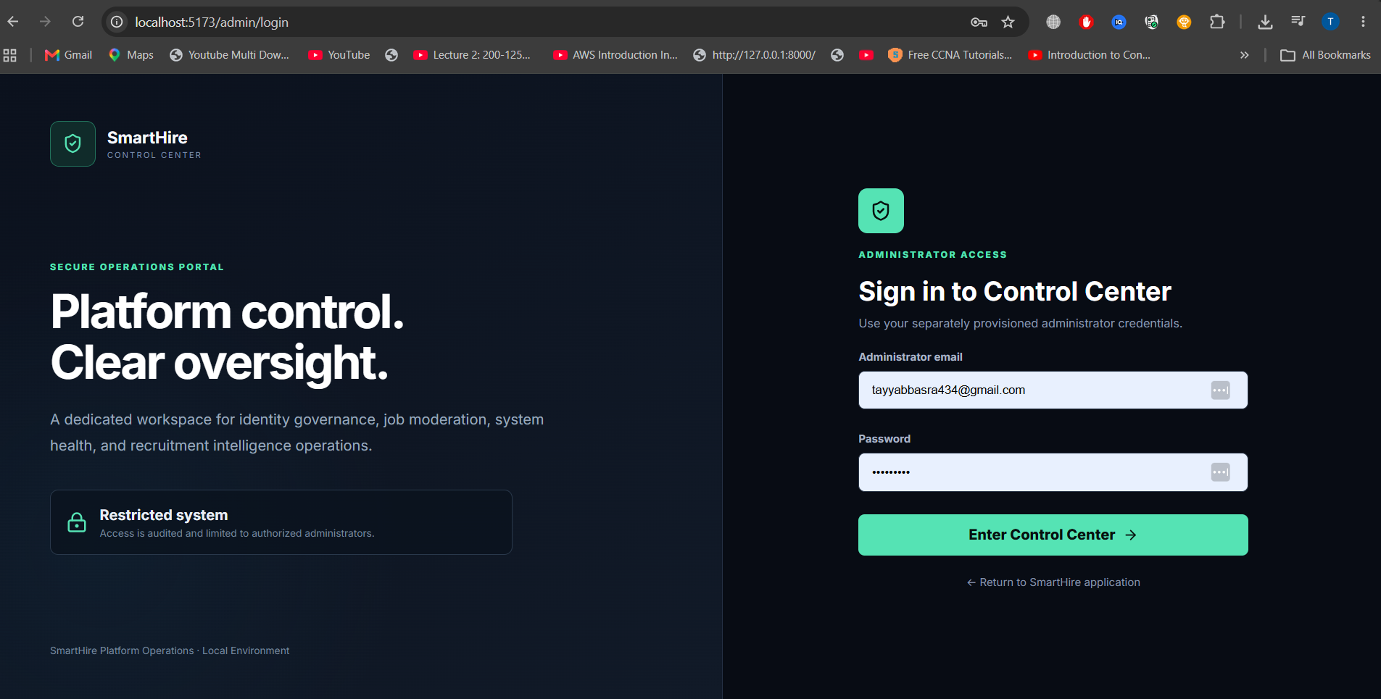
Figure 2. Separate Admin Control Center login experience.

7.2 Admin capabilities and protections
Area | Admin capability | Protection
Identity & Access | View users; activate or suspend Applicants and Employers; create additional admins. | Admins cannot change an Employer/Applicant into an Admin. Admin accounts, including the current admin, cannot be suspended, activated, or role-changed through user management.
Content Control | Moderate platform job content and review job/application state. | Administrative RBAC is enforced by backend endpoints.
Operations & Audit | Review activity, job processing, queue state, and platform health. | Audit records capture sensitive actions.
Intelligence Monitor | Review score distribution, AI completion, disagreement, manual-review volume, and overrides. | Protected characteristics are intentionally excluded.
SaaS Accounts | View organizations, plans, status, plan mix, and estimated MRR. | Commercial changes require approval workflow.

8. SaaS plan governance demo
- As Employer, open Workspace & Billing. Show Starter, Growth, and Scale plan cards, pricing, entitlement limits, current plan, and usage.
- Select a different plan. Explain that this now creates a request rather than activating immediately.
- Show the immediate browser confirmation and the employer Notification Center item.
- As Admin, open the dedicated Plan Requests sidebar item. Show workspace, requester, current plan, requested plan, timestamp, and status.
- Approve or reject the request. On approval, explain that the requested plan activates and the employer receives an in-app notification.
- Return to Employer Workspace & Billing and show the updated plan only after approval.
Plan | Price | Entitlements
Starter | $0/month | 3 active jobs; 3 team members; 50 AI analyses/month; 500 MB storage.
Growth | $99/month | 25 active jobs; 15 team members; 1,500 AI analyses/month; 10 GB storage.
Scale | $299/month | Unlimited active jobs; unlimited team members; unlimited AI analyses; 100 GB storage.

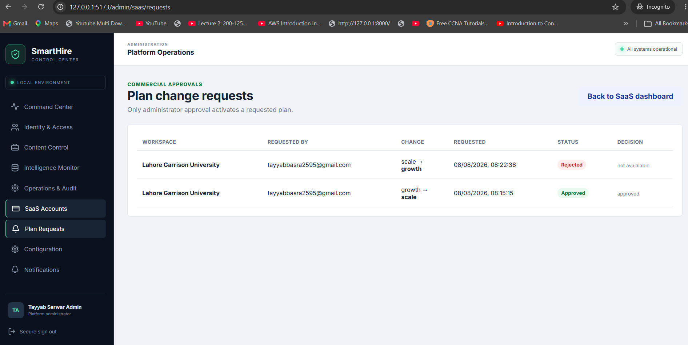
Figure 3. Dedicated Plan Requests navigation in the Admin Control Center.

9. Authentication, privacy, and notifications
- Password sign-in uses hashed passwords and JWT access/refresh sessions.
- Email verification is required for normal password registration.
- Google OAuth supports Applicant and Employer registration/login; administrators use the separate Control Center login.
- Forgot Password creates one-time, expiring reset links and revokes existing refresh sessions after a successful password reset.
- Notifications are stored in-app. Plan requests notify the employer and all active administrators; approval/rejection notifies the requesting employer.
- Resumes are private; employers access only authorized candidate data within their workspace.

10. Recording script and timing
Time | Screen / action | Presenter line
0:00-0:45 | Landing + role overview | “SmartHire supports the full hiring journey: applicants, employers, and governed platform administration.”
0:45-2:30 | Employer registration + dashboard | “A verified employer gets an isolated workspace and structured hiring tools.”
2:30-4:00 | Post job with salary | “Transparency begins before application: salary, requirements, and experience expectations are visible.”
4:00-6:00 | Applicant registration + application | “Applicants discover roles, inspect salary and requirements, then submit a private resume.”
6:00-8:30 | Match report | “This is explainable decision support: evidence, weights, missing skills, and human-review guardrails.”
8:30-10:00 | Employer ATS pipeline | “Recruiters move from scored application to collaborative candidate workflow.”
10:00-12:00 | Employer plan request + Admin approval | “Commercial actions are governed: employers request; admins review; only approval activates.”
12:00-13:30 | Admin controls + close | “The Control Center protects identities, content, operations, intelligence, and subscriptions.”

11. Hackathon Q&A preparation
Likely question | Short answer
Does AI make the hiring decision? | No. SmartHire is decision support. Recruiters remain responsible for hiring decisions, and score disagreement triggers manual review.
How is the score explainable? | The platform stores weighted components, evidence snippets, skill coverage, scorecard snapshot, AI confidence, and hybrid weights.
How is tenant data isolated? | Jobs, candidates, pipelines, memberships, notifications, and plan data are organization-scoped; permissions are checked server-side.
How do you prevent unauthorized admin access? | No public admin registration. The first admin requires a private bootstrap token; later admins are created only by authenticated admins.
How does monetization work? | Employer workspaces have Starter, Growth, and Scale entitlements. Plan changes require admin approval in the current controlled workflow.
What is next after the hackathon? | Persistent private object storage, real payment-provider checkout, production email, managed workers, observability, and evaluation against human-reviewed hiring outcomes.

12. Final pre-demo checklist
- Backend health endpoint is healthy and frontend is open in a clean browser.
- All demo accounts are verified and passwords are known.
- A job with salary is published.
- A resume is ready and text-based.
- At least one applicant application has completed analysis.
- At least one plan request is pending or ready to create.
- Admin Control Center is available and Plan Requests is visible in the sidebar.
- No API keys, tokens, passwords, or database credentials are visible in the recording.
- Use the demo story, not every feature: clarity is stronger than feature volume.
Closing line: “SmartHire brings transparent job discovery, explainable AI assistance, collaborative ATS workflows, and platform governance into one recruitment experience.”

