Validation Errors

**Missing alt tags**

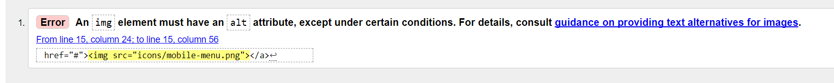

Fix: For all the images which did not have alt tags I added them and the error was fixed.

**Id used multiple times**

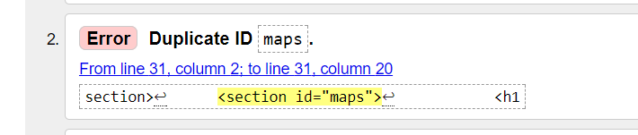

Fix: On the race calendar the same id was used for multiple sections. To fix this I changed the id in to a class and updated the css to the style still applies.

**Warnings**

Sections without headings – this can be fixed by adding headers however headers aren’t required for the sections which have this error.

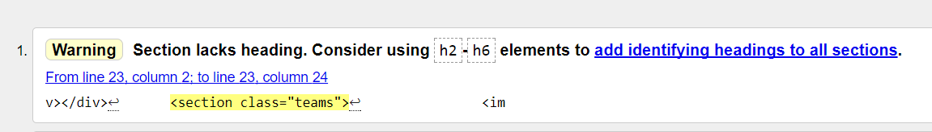

**Image with no source**

This error is drivers page. Its needed so when you click on the image a model image appears (a bigger version of the drivers image in the timeline) To fix this error I’ve added a image source which will show a no image picture

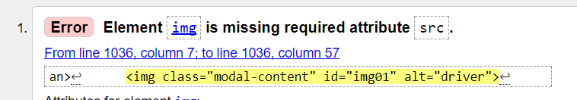

**CSS**

In the standings page when you hover over the driver in the driver’s standings and in the teams in the constructor’s page the drivers image shows and the teams logo. I couldn’t find a fix for this however the hover is working as expected.

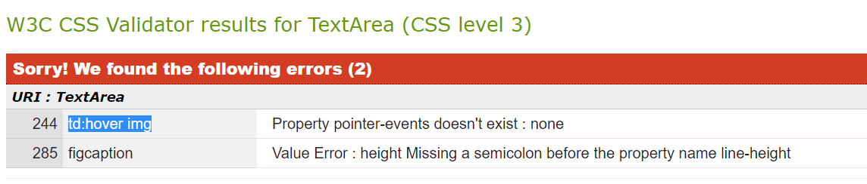

Other then the CSS error listed above there are no CSS errors

For the HTML there’s not HTML errors other then headings warning.

There are no JavaScript errors.