Tester: Asim

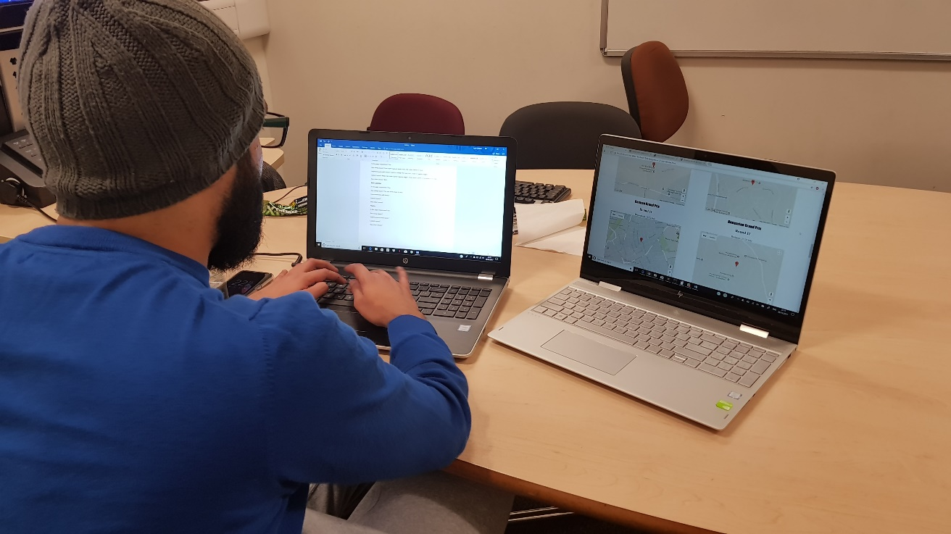

**Homepage**

Is the page responsive? Yes

Any sizing issues? Size of fonts very clear, image sizes are big and clear to see

Improvements with fonts? Choose a different font style to make the website look more professional

Layout issues? The layout could be improved making certain aspects spread out from each other to make it look neater. Right now, it looks slightly cramped at the bottom of the page

Any other issues? N/A

**Actions:** Changed heading fonts and made the text size bigger

**Standings**

Is the page responsive? Yes

Any sizing issues? Font style is good, looks neat, the table layout is neat

Improvements with fonts? Look to change the font size, make it slightly bigger

Layout issues? Make the table layout slightly bigger, keep more space in between the rows

Any other issues? N/A

**Actions:** No Changes made

**Race Calendar**

Is the page responsive? Yes

Any sizing issues? The size of the font is big enough and the map is also well sized

Improvements with fonts? The font style needs to be improved as it is difficult to see the grand prix name

Layout issues? N/A

Any other issues? N/A

**Actions:** Changed the font so it’s more user friendly and easier to read

**Teams**

Is the page responsive? Yes

Any sizing issues? N/A

Improvements with fonts? N/A

Layout issues? Look to space the logos out a bit more as it seems slightly cramped

Any other issues? Look to add brief text on each team

**Actions:** increased the spacing between each team.

**Drivers**

Is the page responsive? Yes

Any sizing issues? N/A

Improvements with fonts? Make the font slightly bigger as people with poor eye sight may struggle to see

Layout issues? N/A

Any other issues? N/A

**Actions:** Increased font size on the whole website overall.