V2 — As-Is Process Guide
Table of Contents

Version 2 — Business Process Guide

How We Work Today: The As-Is KYC Process
Document Type: Business Process Guide
Audience: Compliance Team, Management
Source: Requirements Gathering Session — Head of Enterprise Risk & Compliance
Status: Current manual process — basis for all future improvements
This document faithfully captures how the compliance team currently operates — including every manual step, every tool used, and every known difficulty. It is not a criticism; it is an honest baseline from which to improve.

Overview
Today, the KYC process at Qatari Diar is a mostly manual process. The existing KYC Report Application (a JSF-based web system) is used only at the end: the officer enters the completed report data and the system manages the approval workflow and record storage. Everything before that — receiving requests, collecting documents, conducting due diligence, and compiling the full report — is done entirely outside the system through email, Excel, WorldCheck, and personal judgment. The system never sees the work; it only sees the finished output.
This creates real risks: inconsistency between departments, reliance on personal memory, difficulty onboarding new staff, and no reliable way to answer basic management questions like “how many KYC reports did we complete this quarter?” without first requesting a data export.
Single source of truth
Maintained in draw.io. See the As-Is Process diagram page for all 9 pages, or edit directly at docs/diagrams/drawio/asis-process.drawio.
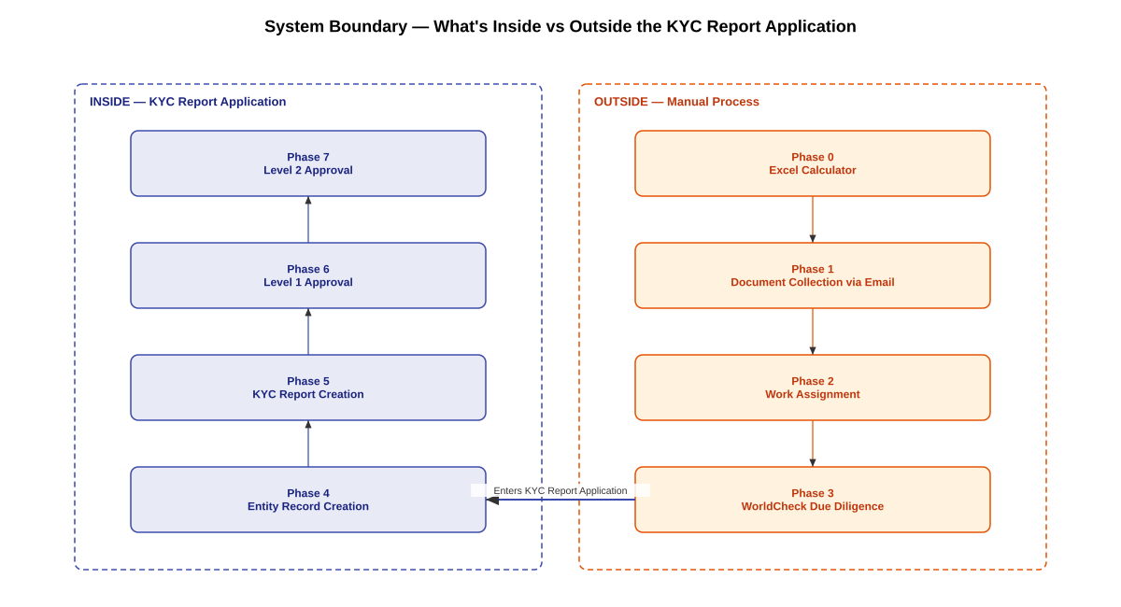
Key Point
The process only enters the KYC Report Application once all manual work is complete — documents validated, due diligence researched, entity data ready. Everything before that point is invisible to the system.

Complete As-Is Process — One Page
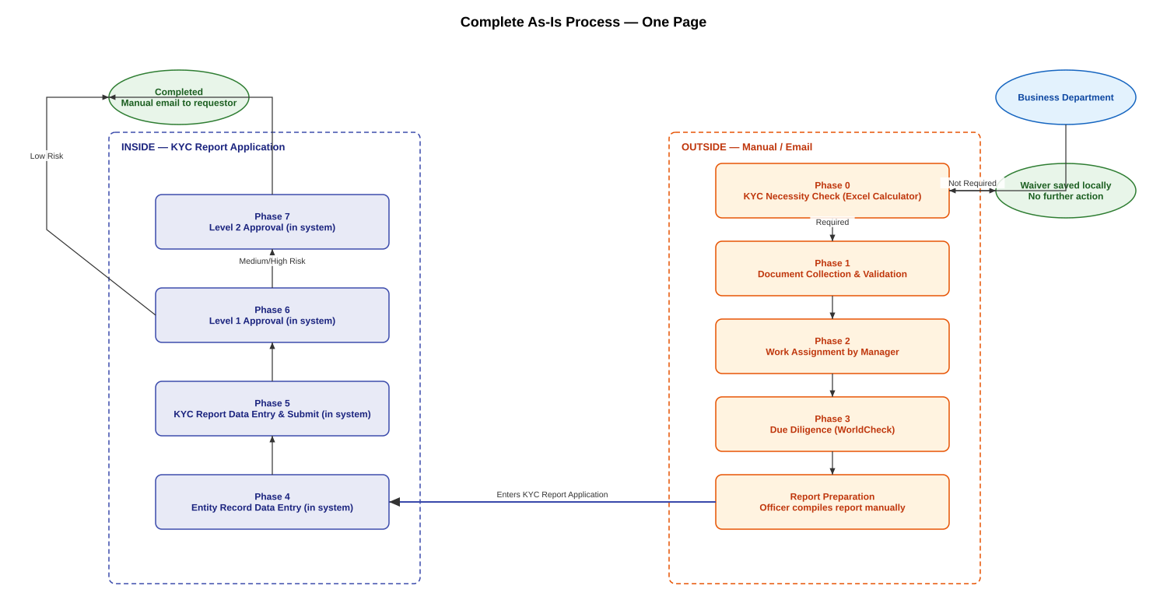

Who Is Involved
Person | Role | Tools Used
Business Department (e.g., Procurement, Sales, Egypt office) | Identifies the need, runs initial check, submits documents | Excel Risk Calculator, Email
Compliance Officer (Hessa, Latifa, and others) | Validates documents, conducts research, creates reports | WorldCheck, KYC System, Local folders, Email
Compliance Manager / Head (Carlos) | Assigns work, manages pipeline, approves reports | Email, KYC System, Excel
System Administrator | Manages user accounts and reference data inside the KYC Report Application only — has no role in the manual intake, document collection, or due diligence work upstream | KYC System

Phase 0: Deciding Whether a KYC is Needed
Who does this: The business department that wants to engage a new counterparty
Before the compliance team is even involved, the requesting department runs a check using an Excel-based Risk Calculator. This spreadsheet was built to match QD’s internal KYC policy and asks a series of questions about the counterparty:
- Who are they? (a company or an individual)
- Where are they from? (Qatari, majority-Qatari, minority-Qatari, foreign)
- What type of relationship does QD plan to have with them? (supplier, buyer, tenant, investor, etc.)
- Is there any financial involvement, current or proposed?
- Are there any known connections to related parties?
Based on the answers, the Excel says either “KYC Required” or “KYC Not Required”.
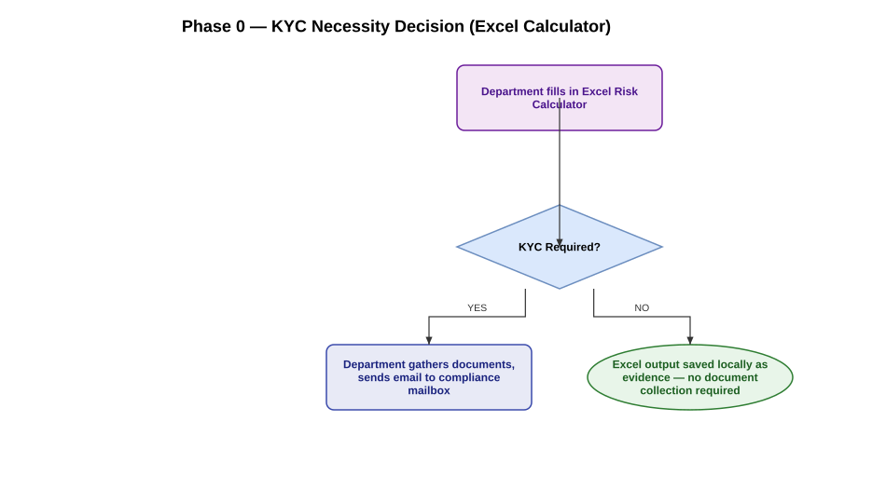
What goes wrong here
- Different departments send requests in completely different formats — there is no standard
- When KYC is not required, the Excel output is saved locally but there is no formal evidence record that the check was done
- The Excel can be changed manually, so the output depends on the honesty and judgment of the person filling it in

Phase 1: Receiving and Validating Documents
Who does this: Compliance Officer
The compliance team receives an email in their shared mailbox. The email contains the Risk Calculator and attached documents. The officer opens everything and checks whether the documentation is sufficient to conduct proper due diligence.
What “sufficient” means:
For an individual person: A government-issued photo ID (Qatar ID or passport) is generally enough.
For a company: The officer needs an official document that shows — clearly and completely — who owns the company and who controls it. In Qatar, a Commercial Registration (CR) usually does this. In other countries (Egypt, UK, Tajikistan), different documents serve this purpose — so there is no single fixed checklist.
What the officer is always looking for is: “Can I trace the ownership all the way to a real person?”
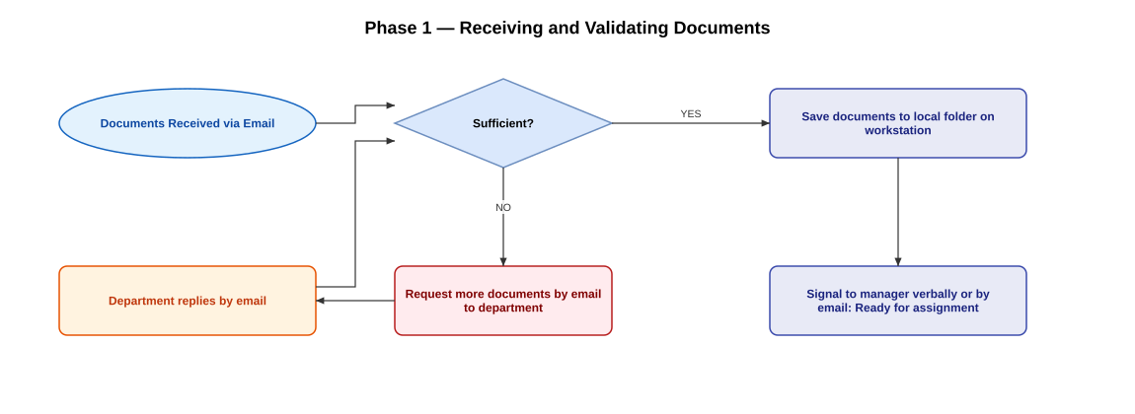
What goes wrong here: - Everything is tracked in email threads — there is no system record of how many rounds of back-and-forth happened - Documents are saved to the officer’s local workstation. At the end of the day, they must be manually moved to a QDocs folder — but there is no check for whether a folder for that entity already exists, and no standard naming convention - New staff (e.g., Hessa) have no way to know if a report has been done before for the same entity. Institutional knowledge lives only in people’s memories

Phase 2: Assigning the Work
Who does this: Compliance Manager
The manager looks at who is available (not on leave, not overloaded) and assigns the case to a compliance officer. This is done verbally or by email — there is no assignment record in the system.
What goes wrong here: - Assignment happens outside the system — there is no record of when or to whom a case was assigned - The manager has no workload view; they must ask each officer individually how many active cases they have - If the manager is absent, there is no way for the team to know how work should be prioritised or distributed

Phase 3: Conducting the Due Diligence (WorldCheck)
Who does this: Compliance Officer
Once assigned, the officer opens WorldCheck — an external international database — in their web browser. This is a separate tool, entirely disconnected from the KYC system.
For each entity and each significant individual (UBO), the officer: 1. Searches by name 2. Reviews the results for matches 3. Determines whether a match is genuine or a false positive 4. Notes whether the entity or person is a PEP (Politically Exposed Person) — for example, a state-owned company is connected to the government, which counts as a PEP link 5. Looks at shareholders and connected entities
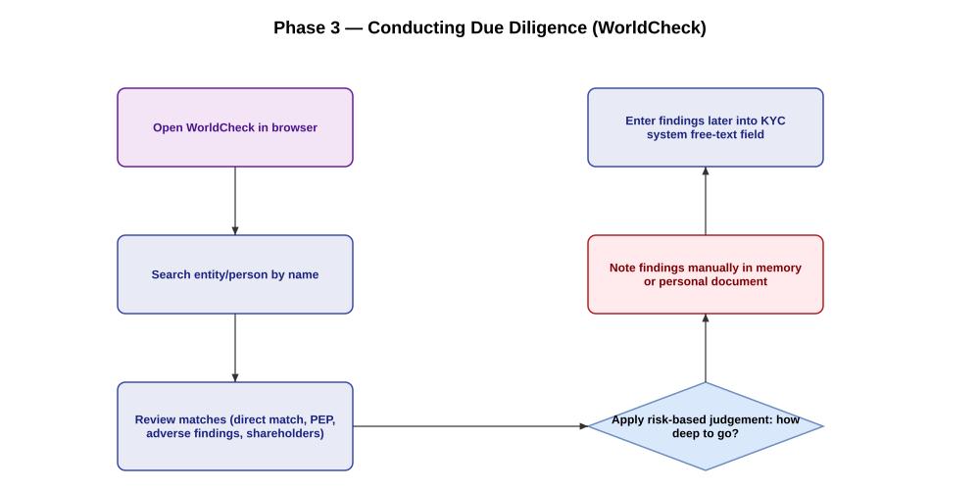
What goes wrong here: - There is no structured way to record what was found — it goes into a free-text field in the system later - There is no record of when the screening was done or which databases were checked - The officer carries the findings in their head until they sit down to enter them into the system

Phase 4: Recording the Entity in the System
Who does this: Compliance Officer
The officer logs into the KYC system and creates an Entity record for the counterparty, entering all the details from their research. For companies, they add each UBO and authorised signatory as a separate sub-record.
What goes wrong here: - The system does not check whether this entity was already recorded before. If the same company was screened six months ago, the officer won’t know unless they remember or happen to search - Screening results go into a single free-text box — there is no structure for recording the date, the source, whether it was a match or not, or whether the person is a PEP - Date fields (like date of birth) accept any text — the system will happily accept “12-0-2024” or “32/13/2025” without warning

Phase 5: Creating the KYC Report
Who does this: Compliance Officer
Next, the officer creates the formal KYC report in the system. This involves entering many fields that could theoretically be pre-filled from the entity record — but the system requires re-entering them from scratch.
One particular pain point: the final conclusion. Around 95% of the time, the conclusion follows a standard template. But those templates are stored in Word documents on shared drives, not in the system. The officer opens Word, copies the relevant template, pastes it into the system, and adjusts it.
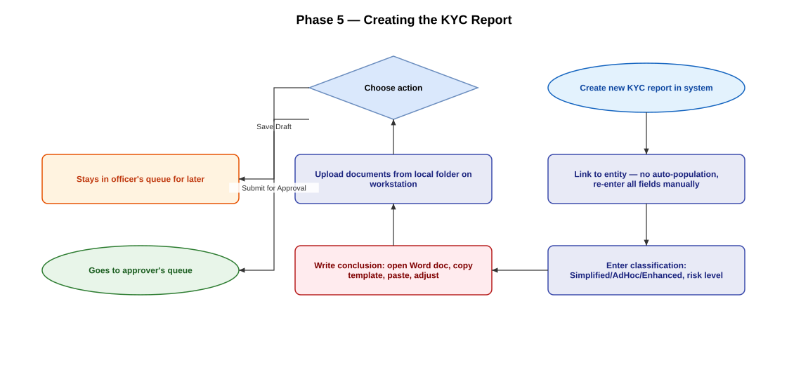
What goes wrong here: - The request date field has no validation — an officer under pressure might inadvertently enter a wrong year and not notice - The system does not warn when the entered date does not match the actual chronology of events - Documents must be uploaded from the local workstation — they cannot be linked from QDocs

Phase 6: Level 1 Approval
Who does this: Level 1 Approver (currently Latifa)
Where this happens: Inside the KYC Report Application (the existing JSF system). The approver logs into the application and sees the submitted report in their approval queue.
The approver reviews the full report, reads the conclusion, checks the attached documents, and then acts directly in the application:
- Approve — satisfied with the work; status moves to Approved (L1)
- Request For Information (RFI) — something is unclear; sends the report back to the officer with a comment recorded in the application
- Reject — the report is closed with a stated reason recorded in the application
Approval routing by risk (handled by the application): - Low risk → Level 1 approval is the final approval — report status moves to Final Approved - Medium or High risk → report automatically routes to Level 2 queue
Four-eyes control — already enforced today: The application blocks a user from approving a report they created themselves (contributor and approver must be different accounts). This one control does work reliably in the current system; it is not one of the gaps this document raises.
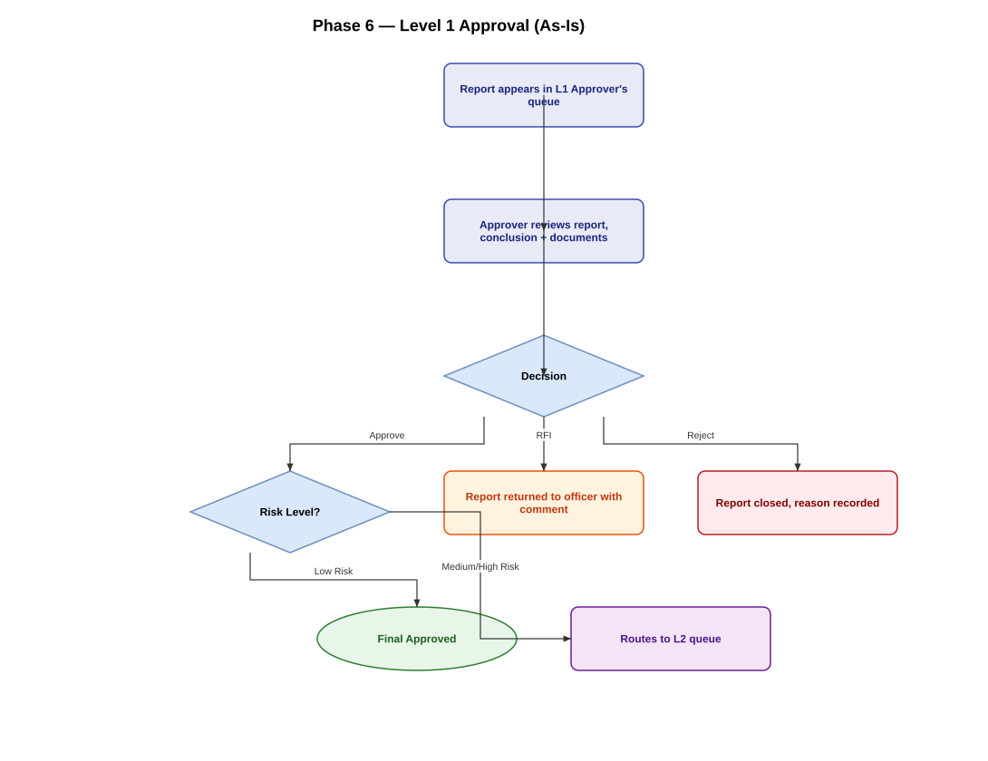
What goes wrong here: - If the Level 1 Approver is unavailable (on leave, travel), a substitute must be manually arranged by phone or email — the system has no delegation mechanism - There is no way in the system to see how many reports are waiting for approval at any given time

Phase 7: Level 2 Approval (Medium/High Risk Only)
Who does this: Level 2 Approver / Head of Compliance (Carlos)
Where this happens: Inside the KYC Report Application — the report appears in Carlos’s queue after L1 approval.
Same actions as Level 1 — full review inside the application, then Approve / RFI / Reject. Once approved at Level 2, the report status is set to Final Approved in the application.
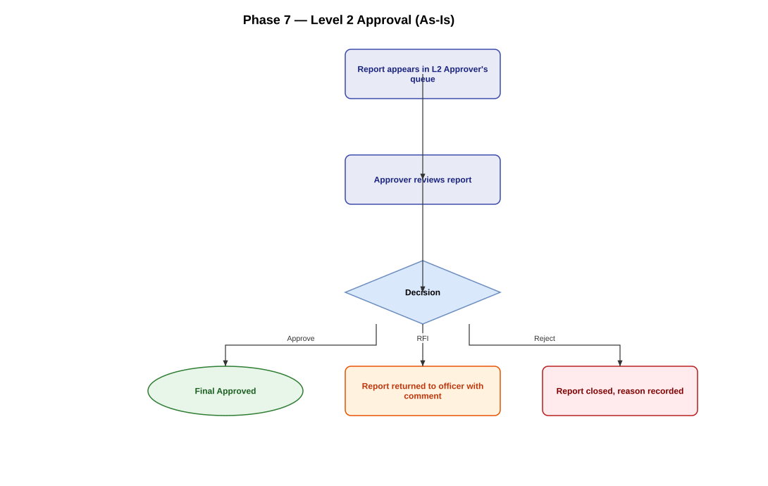
What goes wrong here: - If the Level 2 Approver (Carlos) is unavailable, a substitute must be manually activated by phone — the system has no delegation or deputy mechanism - There is no mandatory checkpoint for Suspicious Activity Reports (SARs) — the question of whether a SAR should be filed is not formally built into the approval step
What should happen but doesn’t:
The requesting department should automatically receive the completed report and a notification that the KYC is done. Currently, this does not happen — someone on the compliance team has to remember to email them.

Phase 8: Reporting and Tracking
Current reality:
There is no live dashboard. When management needs to know: - How many KYCs were completed this month? - How long is our average turnaround time? - Which cases are overdue?
The answer is always: “Madi, send me an export.” A data extract is requested, downloaded to Excel, and manually analysed.
Additionally, there is no system to flag when a previously approved KYC is due for periodic review. This is managed — imperfectly — by memory and the manager’s judgment.

Process Status Labels (Current)
The compliance team informally categorises their pipeline using these statuses — some are in the system, some exist only in email folder labels:
Status | Where It Lives | Meaning
In Progress | Email / memory | Officer actively working on it
Waiting for More Information | Email flag | Documents requested from department
Waiting for Approval | KYC System | Report submitted, in approver’s queue
Draft | KYC System | Saved but not yet submitted
Submitted | KYC System | Sent to Level 1
Approved (L1) | KYC System | Passed Level 1 review
Approved (Final) | KYC System | All approvals complete
Rejected | KYC System | Closed — not proceeding
RFI | KYC System | Information requested by approver

Summary of Known Problems
Problem | Consequence
No standard intake form — requests arrive by email in any format | Officers spend time decoding inconsistent submissions
Documents saved locally, moved manually to QDocs | Risk of loss, no naming standard, no institutional memory
No duplicate entity detection | Same company screened multiple times with no link
Screening results are free text with no structure | Cannot audit what was checked or when
Date fields accept invalid values | KPI data is unreliable
Conclusion writing requires external Word document | Slow, inconsistent, error-prone
No approver delegation | Approvals stall when approver is absent
No completion notification | Requestors don’t know when KYC is done
No live KPI reporting | Management can only view data through manual exports
System has no source code | If it breaks, it cannot be fixed — urgent risk

