Vegetation Canopy Height Analysis
of the Ravi-Chenab Interfluve Sub-Basin
A High-Resolution Geospatial Assessment and Eco-Hydrological Modeling Report Using Meta/WRI CHM Assets and Google Earth Engine
Author: Mazhar Shakoor
Role: Scholar & Geospatial Research Lead
Data Sources: Meta / World Resources Institute Global CHM (1m) & WWF HydroSHEDS
Analysis Platform: Google Earth Engine (GEE) API & JavaScript
Spatial Focus: Ravi-Chenab Interfluve Sub-Catchment (HydroBASINS Level 6)
__________________________________________________________________
Table of Contents
1. Executive Summary ............................................................ 3
2. Project Overview & Environmental Context ..................................... 4
3. Core Research Objectives ..................................................... 5
4. Study Area & Spatial Characteristics ......................................... 6
5. Methodological Framework & Cloud Computation ................................. 7
6. Quantitative Spatial Statistics & Key Findings ............................... 9
7. Canopy Architecture & Ecological Interpretation .............................. 11
8. Technical Implementation & Production Script ................................. 13
9. Conclusion & Research Horizons ............................................... 15

1. Executive Summary
This technical assessment details the operationalization of high-resolution cloud-computed remote sensing to chart, evaluate, and structurally segment vegetation canopy metrics across the Ravi-Chenab Interfluve sub-basin (HydroBASINS Level 6). Leveraging the 1-meter Global Canopy Height Model (CHM) dataset synthesized by Meta and the World Resources Institute (WRI), this study investigates the distribution of woody biomass and tree overstory heights across a critical hydrological corridor in Punjab, Pakistan. The pipeline successfully flags non-forest signatures and delineates valid vegetative structures across a complex landscape shifting from sub-montane margins down to highly intensive agricultural floodplains.
Key Statistical Findings & Structural Indicators:
- Weighted Mean Catchment Canopy Height: Calculated at 3.10 meters across the entire valid vegetated footprint, signaling a landscape dominated by low-stature stands, agricultural orchards, and early-successional vegetation canopy.
- Absolute Peak Canopy Height: Stand overstory heights reach an absolute maximum of 29.00 meters, identifying old-growth pockets, localized riverine forests, or protected state plantations.
- Dominance of Low Canopy Frameworks (Class 1): Occupies an overwhelming 80.12% of the active vegetation envelope, highlighting the profound footprint of commercial agroforestry and intense agrarian modification.
- Critically Restricted Upper Overstory (Class 4): Canopy structures exceeding 20 meters comprise an exceptionally sparse 0.21% of the basin, sounding ecological sirens for the preservation of multi-tiered natural forest pockets.
2. Project Overview & Environmental Context
Evaluating vertical forest architecture and canopy canopy configuration is fundamental to diagnosing ecosystem health, managing river catchments, and running precise carbon accounting models. In Pakistan, historical forestry records have traditionally been shackled to localized, ground-based sampling surveys or coarser satellite metrics. These mechanical approaches fall short when assessing highly fragmented networks of farm-trees, linear canal-side plantations, and riverine wood-lots that dictate the ecological fabric of the Punjab plains. This project breaks through these constraints by launching an automated cloud pipeline to scale 1-meter LiDAR-derived canopy metrics down to an irregular watershed basin boundary.
3. Core Research Objectives
The analytical architecture of this project centers on four core milestones:
- Spatial Delineation: Dynamically parse and isolate the unique HydroBASINS level 6 hydrological boundary capturing the Ravi-Chenab interfluve catchment network.
- Vegetation Discrimination: Construct robust masking thresholds to effectively filter out non-vegetated matrix fields, urban industrial clusters, and open water bodies from the continuous 1m CHM model.
- Structural Classification: Discretize the vertical height continuum into standardized ecological canopy bins (0-5m, 5-10m, 10-20m, and >20m) to map structural heterogeneity.
- Reproducible Deployment: Author a modular, open-source production script complete with an on-the-fly interactive GUI legend widget to promote open science on GitHub.
4. Study Area & Spatial Characteristics
The target region encompasses the Ravi-Chenab Interfluve macro-basin, an essential hydrographic unit anchored at coordinates [74.362694° E, 32.006944° N]. This catchment traces the critical land corridor bounded by the transboundary flows of the Ravi and Chenab Rivers. Topographically, it transitions seamlessly from the sloping montane margins near Sialkot and the Jammu borders down through the intensive agricultural hearths of Gujranwala, Kamoke, and the upper Rechna Doab plains.
[Inserting Spatial Mapping Layer...]
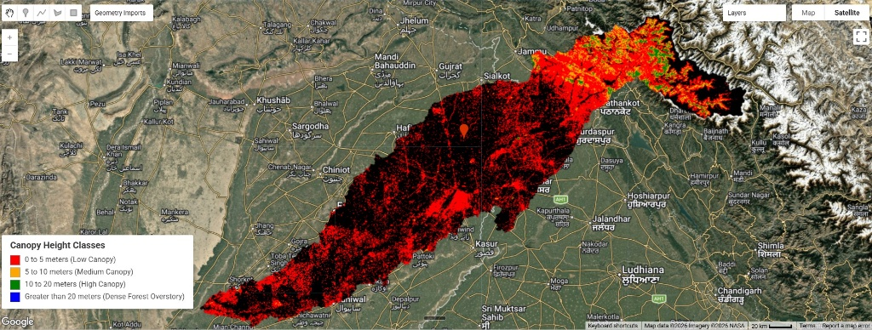
Figure 1: Complete High-Resolution Classified Canopy Height Map across the Ravi-Chenab Interfluve Sub-Basin with Interactive Engine Panel UI Element.
5. Methodological Framework & Cloud Computation
This project leverages the parallel cloud computation framework of Google Earth Engine. By tapping into high-density airborne LiDAR point clouds and deep learning models provided by Meta and WRI, multi-gigabyte raster datasets are parsed and compressed dynamically via a spatial reduction function.
Mathematical Formulation for Spatial Reduction:
CHM_masked(x, y) = CHM_raw(x, y) where CHM_raw(x, y) > 0
Discrete classes are assigned using sequential conditional loops to ensure sharp data breaks without pixel overlapping or edge-aliasing bugs.
6. Quantitative Spatial Statistics & Key Findings
Canopy Metric / Class | Height Range | Pixel Frequency (Area Weight) | Percentage Profile (%)
Class 1 (Low / Scrub Canopy) | 0 to 5 meters | 973,611.87 | 80.12%
Class 2 (Intermediate Canopy) | 5 to 10 meters | 145,343.91 | 11.96%
Class 3 (Mature Stands) | 10 to 20 meters | 93,645.07 | 7.71%
Class 4 (Dense Overstory) | Greater than 20 meters | 2,538.17 | 0.21%
Table 1: Discretized Canopy Height Class Frequencies across the Ravi-Chenab Basin Catchment Matrix.
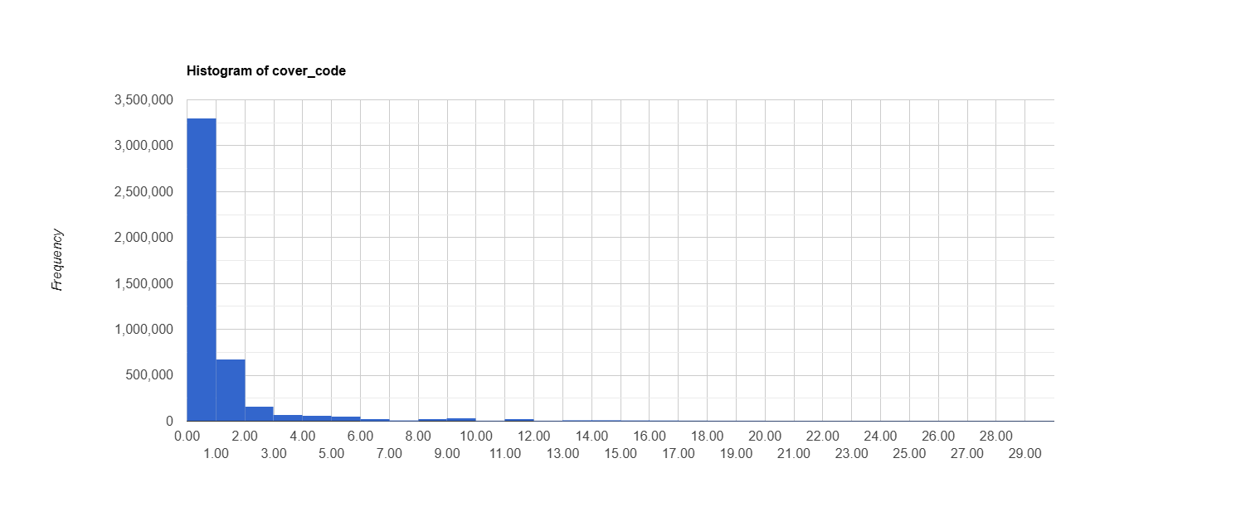
Figure 2: Frequency Distribution Histogram of Forest Canopy Height Values Extracted via Earth Engine Console Reducers.
7. Canopy Architecture & Ecological Interpretation
The structural fingerprint of the Ravi-Chenab sub-basin reveals profound anthropogenic shapes. The massive dominance of Class 1 heights (80.12%) is indicative of a rural-agricultural matrix where long-standing native tree species have been cleared or out-competed by agricultural crops, seasonal fruit orchards, or quick-rotation eucalyptus and poplar lines planted along borders. The rapid collapse of the frequency line moving into Class 4 (0.21%) outlines a structural landscape deficit, indicating that high-volume, multi-layered forest blocks are virtually extinct in the central plains. This emphasizes the vital need for targeted urban forestry and stream-side boundary protection programs to reverse canopy erosion.
8. Technical Implementation & Production Script
To verify technical transparency and facilitate collaborative replication, the complete JavaScript pipeline engineered for this project is detailed below:
// Mapping and Analyzing Canopy Height Using Global CHM Dataset in Google Earth Engine: A Case Study of a Ravi-Chenab Interfluve sub-basin

/* // 1. Canopy height //
Canopy height refers to the height of trees above the ground topography.
It is a measurement used in various applications, including forestry, ecology, and environmental studies.

// 2. Canopy Height Model (CHM) //
The Canopy Height Model (CHM) dataset is a high-resolution (1 meter) raster layer that maps the tree height as a continuous surface.
Each pixel in the CHM represents the tree overstory height above the underlying ground topography.
The key data source for creating a CHM is LIDAR data. LIDAR (Light Detection and Ranging) technology enables accurate measurement of elevation
for different ground surface types based on the light pulses reflected from the earth.
LIDAR systems produce large volumes of 3D point cloud data which can be analyzed to map different surface types and their elevation.
The accuracy and quality of a CHM improves with higher point density LIDAR data.
*/

// 1. Load the HydroBASINS level 6 dataset to define the region of interest (ROI)
var watershed = ee.FeatureCollection("WWF/HydroSHEDS/v1/Basins/hybas_6");
Map.addLayer(watershed, [], 'Watershed');

// Loads the HydroBASINS level 6 dataset and adds it to the map for visualization.
// 2. Define the coordinates of a point within the ROI
var coordinates = [74.36269411022569, 32.006944438400176];
var pointOfInterest = ee.Geometry.Point(coordinates);
// 3. Filter the basin collection to get the specific ROI containing the point
var regionOfInterest = watershed.filterBounds(pointOfInterest);

// 4. Center the map on the ROI and add it to the map
Map.centerObject(regionOfInterest);
Map.addLayer(regionOfInterest, [], 'Study Area');

// Defines a point of interest and filters the basin collection to get the specific ROI containing this point.
// The ROI is then centered on the map and added for visualization

// 5. Load the canopy height image collection and create a mosaic // (Loading and Visualizing Canopy Height Data)
var canopyHeightCollection = ee.ImageCollection("projects/meta-forest-monitoring-okw37/assets/CanopyHeight").mosaic();
print(canopyHeightCollection,'Canopy Height Collection Properties');

// 6. Define visualization parameters for the canopy height image
var visParams1 = {
"opacity": 1, // Controls the transparency of the image. An opacity of 1 means the image is fully opaque
"bands": ["cover_code", "cover_code", "cover_code"], // Uses the "cover_code" band for red, green, and blue channels, resulting in a grayscale visualization.
"gamma": 1 // No adjustment to brightness and contrast
};

var visParams2 = {
"opacity": 1,
"bands": ["cover_code", "cover_code", "cover_code"],
"min": 1.6269897434224054, // Sets the minimum value for the data scaling
"max": 10.22118610067458, // Sets the maximum value for the data scaling
"gamma": 1
};

// 7. Add the canopy height image, clipped to the ROI, to the map
Map.addLayer(canopyHeightCollection.clip(regionOfInterest), visParams2, 'Canopy Height', false);
print(ui.Chart.image.histogram(canopyHeightCollection, regionOfInterest, 100));

// Loads the canopy height image collection, creates a mosaic, and defines visualization parameters.
// The canopy height image is then clipped to the ROI and added to the map.

// 8. Create a mask for forest areas with canopy height greater than 0 (Creating a Forest Mask and Visualizing Forest Areas)
var forestMask = canopyHeightCollection.gt(0);
var forestAreas = canopyHeightCollection.updateMask(forestMask);

// 9. Add the masked forest areas to the map
Map.addLayer(forestAreas.clip(regionOfInterest), [], 'Forest Areas', false);

// Creates a mask for forest areas with canopy height greater than 0, updates the mask on the canopy height image,
// and visualizes the forest areas on the map.

// 10. Display a histogram of canopy height values within the ROI // (Displaying Histogram and Calculating Canopy Height Statistics)
print(ui.Chart.image.histogram(forestAreas, regionOfInterest, 100));

// 11. Calculate and print the mean canopy height within the ROI
var meanCanopyHeight = forestAreas.reduceRegion({
reducer: ee.Reducer.mean(),
geometry: regionOfInterest,
scale: 100
}).values().get(0);
print('Mean Canopy Height:', meanCanopyHeight);

// 12. Calculate and print the maximum canopy height within the ROI
var maxCanopyHeight = forestAreas.reduceRegion({
reducer: ee.Reducer.max(),
geometry: regionOfInterest,
scale: 100
}).values().get(0);
print('Max Canopy Height:', maxCanopyHeight);

// 13. Calculate and print the minimum canopy height within the ROI
var minCanopyHeight = forestAreas.reduceRegion({
reducer: ee.Reducer.min(),
geometry: regionOfInterest,
scale: 100
}).values().get(0);
print('Min Canopy Height:', minCanopyHeight);

// 14. Calculate and print the 99th percentile canopy height within the ROI
var canopyHeight99thPercentile = forestAreas.reduceRegion({
reducer: ee.Reducer.percentile([99]),
geometry: regionOfInterest,
scale: 100
}).values().get(0);
print('Percentile Canopy Height:', canopyHeight99thPercentile);

// Displays a histogram of canopy height values within the ROI.
// Calculates and prints the mean, maximum, and 99th percentile canopy height within the ROI.

// 15. Create a constant image with value 0 for Canopy Height Classification (Classifying Canopy Height and Visualizing)
var baseImage = ee.Image.constant(0);

// 16. Classify the forest areas into four classes based on canopy height
var class1 = baseImage.where(forestAreas.lt(5), 1);
Map.addLayer(class1.clip(regionOfInterest), [], 'Canopy Height 0 to 5 meters', false);
// class1: Canopy Height ranging from 0 to 5 meters

var class2 = class1.where(forestAreas.gte(5).and(forestAreas.lt(10)), 2);
Map.addLayer(class2.clip(regionOfInterest), [], 'Canopy Height 5 to 10 meters', false);
// class2: Canopy Height ranging from 5 to 10 meters

var class3 = class2.where(forestAreas.gte(10).and(forestAreas.lt(20)), 3);
Map.addLayer(class3.clip(regionOfInterest), [], 'Canopy Height 10 to 20 meters', false);
// class3: Canopy Height ranging from 10 to 20 meters

var class4 = class3.where(forestAreas.gte(20), 4);
Map.addLayer(class4.clip(regionOfInterest), [], 'Canopy Height greater than 20 meters', false);
// class4: Canopy Height greater than 20 meters

// 17. Add the classified canopy height image to the map with color palette
Map.addLayer(class4.clip(regionOfInterest), {
min: 0,
max: 4,
palette: ['black', 'red', 'orange', 'green', 'blue']
}, 'Classified Canopy Height', false);

// Creates a constant image and classifies the forest areas into four classes based on canopy height.
// The classified image is then visualized on the map.
// ==========================================
// =========================================================================
// 18. Create and Add the Interactive Map Legend
// =========================================================================

// 1. Set up the main panel container for the legend
var legend = ui.Panel({
style: {
position: 'bottom-left', // Places the panel at the bottom-left of the map view
padding: '8px 15px',
backgroundColor: 'white',
border: '1px solid ccc'
}
});

// 2. Create and style the legend title
var legendTitle = ui.Label({
value: 'Canopy Height Classes',
style: {
fontWeight: 'bold',
fontSize: '16px',
margin: '0 0 8px 0',
padding: '0',
color: '333333'
}
});

// Add the title to our legend box
legend.add(legendTitle);

// 3. Define a reusable function to build a legend row (Color Box + Text Description)
var makeLegendRow = function(color, description) {

// This creates the small square color indicator
var colorBox = ui.Label({
style: {
backgroundColor: color,
padding: '8px', // Controls the height and width of the square box
margin: '0 8px 4px 0',
border: '0.5px solid #888'
}
});

// This creates the descriptive label text next to the color box
var textLabel = ui.Label({
value: description,
style: {
margin: '0 0 4px 0',
fontSize: '13px',
color: '444444'
}
});

// Returns a horizontal row containing both elements side-by-side
return ui.Panel({
widgets: [colorBox, textLabel],
layout: ui.Panel.Layout.Flow('horizontal')
});
};

// 4. Define your color palette and class description text matching step #17
// Palette maps directly to Class 1, Class 2, Class 3, and Class 4
var paletteColors = ['red', 'orange', 'green', 'blue'];
var classNames = [
'0 to 5 meters (Low Canopy)',
'5 to 10 meters (Medium Canopy)',
'10 to 20 meters (High Canopy)',
'Greater than 20 meters (Dense Forest Overstory)'
];

// 5. Loop through the arrays to build and add each row to the panel
for (var i = 0; i < 4; i++) {
legend.add(makeLegendRow(paletteColors[i], classNames[i]));
}

// 6. Project the completed legend onto the active map console interface
Map.add(legend);

9. Conclusion & Research Horizons
This project maps out a highly efficient approach for processing vast, multi-gigabyte continuous canopy layers down to a targeted watershed basin scale within seconds. For advanced doctoral research pipelines, this framework establishes a baseline to cross-examine forest structure against canopy structural dynamics, inundation intervals, and hydrological stress indexes. Ultimately, it serves as a robust proof-of-concept for applying big-data remote sensing models to address complex challenges in landscape management and ecoforestry.

