Creating shell script

1. Create a file with .sh extention
2. Execute follow steps

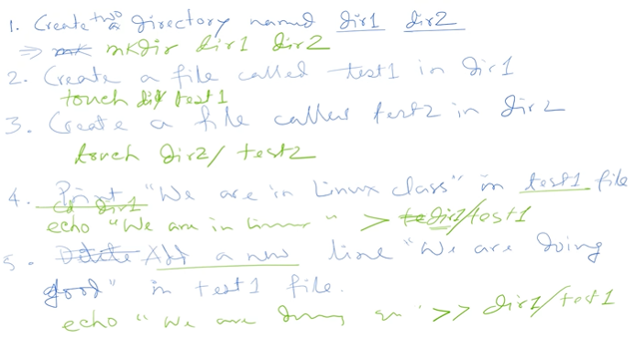

1. Nano filename.sh enter
2. Inside nano editor:

#!/bin/bash

Mkdir dir1 dir2

Touch dir1/test1 dir2/test2

Echo “We are in Linux class” > dir1/test1

Echo “We are in doing good” > >dir1/test1