1. **What is the difference between a test plan and a test strategy?**

Answer:

1. A test plan is a document that describe the scope, approach, resource, and schedule of intended testing activities.
2. Test Plan is a document that collects and organizes test cases by functional areas and/or types of testing in a form that can be presented to the other teams and/or customer where as the Test Strategy is the documented approach to testing.
3. Test Plan is prepared by the tester whereas the Test Strategy is prepared by the QA Manager or QA lead.
4. Test pan identifies test items, the features that to be tested, features that not to be tested, the testing tasks, and who will do each task (roles and responsibilities) and any risks and its solution. Test strategy includes introduction, scope, resource and schedule for test activities, acceptance criteria, test environment, test tools, test priorities, test planning, executing a test pass and types of test to be performed.
5. A test plan includes heading, revision History, table of contents, introduction, scope, approach, overview, different types of testing that will be carried out, what software and hardware will be required, issues, risks, objections, environment, glossary, the features that to be tested, features that not to be tested, assumptions and sign off section. Whether a test strategy explain high level of business needs to carry out on the project.

Both are important pieces of Quality Assurance processes since they help communicate the test approach scope and ensure test coverage while improving the efficiency of the testing effort.

1. **Create test scenarios and test cases for 5 functional requirements for YouTube**

**Answer: See attached spreadsheet**

1. **Explain the bug life cycle.**

Answer: I would describe the bug life cycle as below:   
***Recreate it:*** Whenever a defect is found, QA must recreate it for multiple times (use different system or browser if applicable) to make sure this is a real bug.

***Log it:*** Then QA should log the defect in the Test Management tool. Write a detail “Steps to reproduce” of the bug.

* Explain **what** happened, **when**, **where** as an end user and/or customer
* Clear, concise, correct
* Attach a screenshot

***Approved/Rejected:*** The defect will now being approved or disapproved by the Test Lead. Test lead will verify this is not a cosmetic bug.  
(*If it is disapproved, then the test lead will might ask for more details and QA have explain to him why it is a bug*)

***Assign it:*** After the Test Lead approves the bug, it is now assigned to a development Team. He/she now assigns that bug to the concerned developer. In some company QA can directly assign the defect to the developer who created the functionality.

***Fix it:*** The developer now looks into the bug and fixes it. Once the bug is fixed, developer will push the code to QA environment for QA to retest.

***Retest it:*** The tester now retest the defect. It the defect is fixed, then the tester closes the defect in defect management tool, with a screenshot as a proof of the bug fix. A smart QA will test other surrounding functionalities as well. Developer often break a code when they fix one.

If the retest is failed then the QA will reopen the defect or bug and follow the same bug life cycle again.

1. **Write a bug report for the login process. (You can assume any website of your choice)**

Answer:

1. Open a browser (Chrome/IE)

2. Enter "<https://konylearning.com/>" in url and hit enter

3. Kony learning app home page should be displayed.

4. Enter a valid Username in the “User Name” text box

5. Enter a valid Password in the “Password” text box

6. Click Log in button

7. User unable to log in and as a new page displayed with the error message “Something went wrong” along with a Request ID

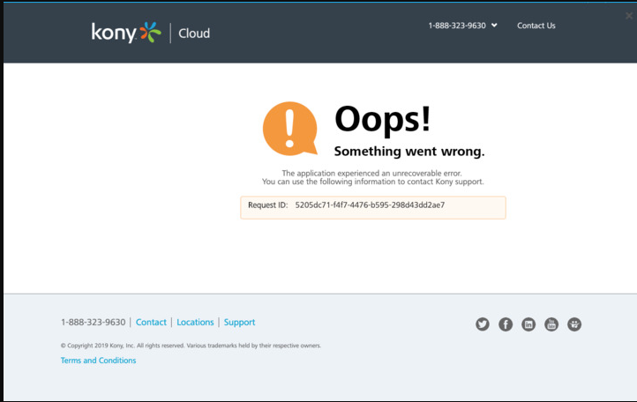

1. **Write 10 test scenarios for Facebook**

Answer: *here are the list of scenarios*

1. User able to log in to facebook using a valid user name and password.
2. User able to log in to facebook using a valid phone number and password.
3. User cannot be able to sign in to facebook using only the user name.
4. User cannot be able to sign in to facebook using only the password.
5. User able to search for a friend using a name.
6. User able to search for a friend using an email address.
7. User able to filter the search for a friend using location.
8. User able to send a friend request.
9. User able to accept a friend request.
10. User able to reject a friend request.
11. **What is the Requirement Traceability Matrix (RTM)? How to create RTM? Create RTM for the Gmail login page.**

Answer:

Requirement Tractability Matrix or RTM is used to cross check the test cases as per the requirement of the test cases. In other words, it checks whether the each functionality is covered in the Test Cases as per requirement document. Some test management tool automatically generate RTM if the test cases are linked with the Requirements. It can also be created manually in MS Excel.

User can create a RTM in MS Excel using a chart that has a column name (vertically) ***Requirements*** and another listing as ***Test Case*** name (horizontally. User tick mark that Test cases and Requirements and use cases to which are covered by which. So, with the help of Traceability Matrix user can make sure that they includes all the functionalities in our test cases according to the requirement document.

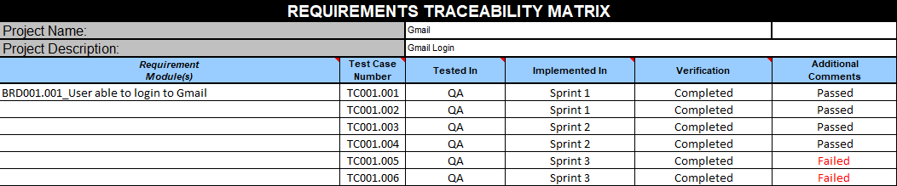

Additional Info:

Test Case

TC001.001: User able to login to Gmail using a valid user name and password

TC001.002: User unaable to login to Gmail using only a valid user name

TC001.003: User unaable to login to Gmail using only a valid Password

TC001.004: User able to sign up gmail in Login page

TC001.005: User can not choose the username which is taken already

TC001.006: Under 16 years old need parental consent to sign up to Gmail