Declaration of interests
☒ The authors declare that they have no known competing financial interests or personal relationships that could have appeared to influence the work reported in this paper.
☐ The authors declare the following financial interests/personal relationships which may be considered as potential competing interests:

Manuscript details
Title: CR-SHE: Oblivious homomorphic aggregation for collusion-resilient search and analytics over encrypted multi-cloud IoT data
Authors: Md Mazharul Islam, Mubasshir Ahmed, Md Redowan Zaman Anik
Journal: Future Generation Computer Systems
Corresponding author: Md Mazharul Islam, mazharul.islam1@northsouth.edu

Signature (on behalf of all authors)
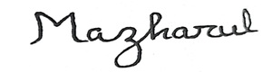
Name: Md Mazharul Islam
Date: 12 September 2026

