CR-SHE: Oblivious homomorphic aggregation for collusion-resilient search and analytics over encrypted multi-cloud IoT data
Md Mazharul Islam*, Mubasshir Ahmed, Md Redowan Zaman Anik
Department of Electrical and Computer Engineering, North South University, Dhaka, Bangladesh
* Corresponding author: mazharul.islam1@northsouth.edu
Abstract
Internet of Things deployments increasingly replicate telemetry across independent clouds for availability and vendor independence, and it must stay encrypted once it leaves the device domain. Replication buys privacy only if the providers cannot pool what they observe. Systems that split trust across providers to hide search access patterns exist, but they operate on plaintext, stop at retrieval, or need an honest majority and server-to-server interaction. The unsolved step is composition: selecting the matching records privately is worthless if aggregating over them hands the matched set back to the providers. We present CR-SHE, in which retrieval and analytics are both oblivious to a coalition of up to t=n-1 colluding providers, over data encrypted at rest under one owner's key and with no communication between providers. The core construction is oblivious homomorphic aggregation: each provider folds its distributed point function share into the encrypted record column and returns one ciphertext, so the matched set is never materialised and its cardinality never leaves the client. A precomputed-column fast path removes the dependence on record count, and a one-time-pad index mask, cancelled inside the ciphertext, removes posting-list-length leakage at rest. We prove correctness and adaptive leakage security against t=n-1 collusion, and evaluate a prototype on two real IoT corpora. On 405,184 sensor records a registered aggregate costs 39,ms per provider irrespective of record count, with a fixed 526,kB response and 617× less work than a faithful homomorphic equality scan; a frequency attack recovering every non-temporal metadata tag from an unmasked index recovers none from the masked one.
Highlights
- Oblivious homomorphic aggregation hides the matched record set from every provider.
- Search and analytics stay oblivious under t=n-1 collusion, with no server link.
- A precomputed-column fast path makes single-keyword aggregates flat in record count.
- A one-time-pad index mask removes posting-list-length leakage from the stored index.
- 39 ms per aggregate on 405,184 IoT records, 617× below a homomorphic scan.
Keywords
Cloud computing; Distributed point function; Function secret sharing; Homomorphic encryption; Internet of Things; Oblivious analytics; Searchable encryption

1. Introduction
The proliferation of connected sensors, wearables and cyber-physical systems has made the Internet of Things (IoT) one of the largest and fastest-growing sources of continuously generated data [1]. Bedside monitors, smart meters, traffic and environmental sensors and industrial controllers emit measurements continuously, and the people who need to query them, among them clinicians, grid operators, city agencies and maintenance contractors, are rarely the ones who own the devices. The natural response is to serve this data from the cloud, and modern deployments increasingly replicate it across several providers. Multi-cloud operation supplies elastic query capacity, improves availability through redundancy across independent infrastructures, and frees data owners from single-vendor lock-in [2,3]. Yet much of this data is acutely sensitive, including physiological telemetry in connected healthcare, mobility traces in smart cities and diagnostic streams from connected vehicles, so it must be encrypted before leaving the IoT trust domain and stay encrypted in the cloud, even as multiple stakeholders need to query and analyse it.
Encrypting outsourced data with conventional schemes neutralises the reason it was sent to the cloud. A provider holding only ciphertexts can neither locate the records a query needs nor compute over them, forcing either decryption in the cloud, which reintroduces exposure, or a wholesale download to the client, which defeats the purpose of outsourcing. Searchable encryption lets a provider identify records matching an encrypted keyword [4,5,6], and leveled homomorphic encryption lets it evaluate bounded-depth arithmetic directly on ciphertexts [7,8]. Both, in their single-server form, leak the access pattern, and a substantial body of leakage-abuse work converts that leakage into plaintext recovery [9,10,11].
Replicating data across independent providers offers an escape that single-server cryptography cannot. If the client splits its query so that no provider sees it, the access pattern stays hidden as long as one provider abstains from collusion. Splinter [12] established this model with function secret sharing, DORY [13] brought it to encrypted documents, and Waldo [14] extended it to rich predicates over time series. The model is therefore not new, and framing a “cross-cloud collusion adversary” as an unexplored threat would misstate the state of the art. What remains open is narrower and, for IoT analytics, decisive.
Selection and computation are not the same problem, and hiding the first is worthless if the second gives it back. A scheme can privately determine which records match a keyword and then, in order to aggregate over them, hand the matched index set to the providers, at which point the coalition learns the access pattern exactly, and across repeated queries the search pattern. Existing distributed-trust systems avoid this by not computing at all (DORY), by computing over data the servers can already read (Splinter, whose databases are public), or by moving to a three-party honest-majority setting with secret-shared data and server-to-server interaction (Waldo). None of them gives analytics over singly-encrypted, owner-keyed data under a t=n-1 collusion bound without inter-provider communication. This paper identifies that composition leak and eliminates it under a constraint set of replicated, owner-keyed storage, t=n-1 collusion and no server-to-server channel, which rules out the standard fix of secret-sharing the data (Section 6.2).
We propose CR-SHE (Collusion-Resilient Searchable Homomorphic Encryption). The data owner replicates a one-time-pad-masked pseudonymous index and a homomorphically encrypted record column to n providers. A query is one distributed point function (DPF) key per provider. Rather than returning the selection vector so the client can name the matched records, each provider contracts its own share of that vector against the encrypted column and returns a single ciphertext; the client adds the n ciphertexts and decrypts once. The matched set is never assembled at any provider, its cardinality never leaves the client, and per-query downlink for an aggregate is O(1) ciphertexts rather than linear in the record count. The contributions are as follows.
- End-to-end obliviousness under t=n-1 collusion. We give a construction in which the analytics phase inherits the access-pattern hiding of the selection phase, over data encrypted at rest under a single owner's key, with no server-to-server communication, and we argue why replication rather than secret sharing is the right storage model for this setting (Section 6.2). Section 6.3 presents the mechanism and Remark 3 explains why the two-round alternative admits no simulator with empty per-query leakage.
- Oblivious homomorphic aggregation, and a precomputed-column fast path. We make explicit the compatibility condition (Lemma 1) under which DPF shares and the homomorphic plaintext ring compose without wraparound. The condition is elementary in isolation, but its violation is silent and data-dependent in practice. We then give a variant (Section 6.5) in which single-keyword aggregates over pre-registered templates cost a symmetric full-domain pass plus O(N/ℓ) packed ciphertext operations, independent of the record count.
- Index masking compatible with oblivious aggregation. A one-time-pad mask makes the stored index perfectly hiding, and the resulting mask term is cancelled inside the ciphertext using an encrypted correction column retrieved by the same DPF, so no provider ever sees an unmasked row or a mask value (Section 6.4, Theorem 1).
- Detection of inconsistent providers, an authorisation requirement, and streaming ingest. A MAC'd ciphertext column lets the client reject a response inconsistent with its tag except with probability 1/p≈2⁻³⁶, which is fault detection rather than integrity, and we state exactly which deviations it cannot see. We show that providers cannot restrict which rows a DPF-hidden query reads, measure the index extraction this permits, and identify the key-carried authorisation proof it requires. An append-only two-tier index supports IoT streams, with forward and backward privacy immediate because the coalition's per-query view is query-independent.
- Evaluation on two real IoT corpora, one of environmental sensor telemetry and one a twelve-site air-quality corpus with three times the tag domain, against ORAM, single-server searchable encryption, distributed-trust search and a faithful homomorphic equality scan, together with an empirical leakage-abuse attack quantifying what index masking removes. Succinct keys are evaluated for n=2; for n∈{3,4} the prototype uses a non-succinct instantiation that shows provider compute is flat in n.
The remainder of this paper is organised as follows. Section 2 reviews related work. Section 3 fixes notation and primitives. Sections 4 and 5 present the system and threat models. Section 6 details the construction, Section 7 the security analysis, and Section 8 the asymptotic costs. Section 9 describes the implementation, Section 10 reports and discusses results, and Section 11 concludes.
2. Related work
2.1. Distributed-trust query systems
The line of work closest to ours splits a query across replicated servers so that no server sees it. Splinter [12] established the model: the client splits a query into function-secret-sharing shares, each provider evaluates its share against its replica, and the query stays hidden as long as one provider does not collude. Splinter supports sum, count, max and topk, and pads result sets to a public bound. Its databases, however, are public, so the providers hold plaintext, confidentiality of the data at rest is out of scope, and the aggregates are computed over records the providers can already read.
DORY [13] moves to encrypted data. It masks each bit of a Bloom-filter search index so that an attacker compromising every trust domain does not immediately recover the index, hides search access patterns and the number of matching documents from an attacker controlling all but one server, and detects servers that deviate. DORY stops at retrieval: there is no computation over the matched documents, which is precisely the step at which a naive extension leaks.
Waldo [14] adds rich functionality for time-series data, supporting multi-predicate filtering while protecting contents, filter values and access patterns, with malicious security. It does so in a three-party honest-majority setting with secret-shared data and server-to-server interaction, that is, a collusion bound of t=1 rather than t=n-1, and without a single-owner key under which the data remains encrypted at rest. CR-SHE trades Waldo's predicate expressiveness and full malicious security for a stronger collusion bound, no inter-provider communication, and owner-keyed encryption at rest; Table 1 makes the comparison precise.
Adjacent systems built on function secret sharing target different problems: metadata-hiding communication [15], private aggregate statistics that stay robust to malformed client submissions [16,17], and private access control for FSS dealers [18], which is the kind of mechanism Section 6.7 shows CR-SHE's authorisation requirement calls for. The underlying primitives are due to Gilboa and Ishai [19] and Boyle, Gilboa and Ishai [20,21], and verifiable DPFs [22] let servers check that a key encodes a point function. At bottom, DPF-based selection is multi-server private information retrieval [23]: our fast path (Section 6.5) is exactly a PIR query into an owner-encrypted table of precomputed aggregates, and its linear server work is the price that PIR without preprocessing must pay [24]. What CR-SHE adds to that primitive is the ciphertext-side contraction that keeps the general path oblivious, and the mask cancellation that makes a replicated index safe at rest. More recent FSS systems push throughput [25] or remove the trusted dealer [26]; both are orthogonal to the composition studied here.
2.2. Private information retrieval
PIR with preprocessing breaks the linear lower bound: offline hints let the online phase run in sublinear time, with two servers [27] or one [28,29]. Those hints are client state computed over the whole database and invalidated by updates, which suits a stable table read by one client better than a stream ingested continuously and queried by many stateless data users; we keep the linear pass and list preprocessing as future work. Single-server PIR from lattice-based encryption [30,31,32,33] removes the non-collusion assumption altogether. For the fast path in isolation it is a genuine alternative, being a PIR query into a table of owner-encrypted aggregates, at comparable homomorphic cost; its analogue for ad-hoc weights over a hidden row is the homomorphic scan of baseline (v) in Section 9, and it forgoes the durability that replication provides.
2.3. Encrypted search and its leakage
Symmetric searchable encryption gives sublinear search at the cost of search- and access-pattern leakage, which leakage-abuse attacks convert into query and plaintext recovery given modest auxiliary information [9,10,11]. The standard mitigations are padding, ORAM [34], volume-hiding structured encryption [35,36], or distributed trust. Volume-hiding schemes are the direct counterpart of our index mask: they hide response volumes from a single server, whereas the mask hides the whole membership index at rest from every provider and leaves query-time hiding to the DPF. Multi-cloud SSE variants [37,38] reduce leakage but scale their hiding overhead with the number of clouds and keep the index within a single trust domain; other work broadens expressiveness or adds committee-based authorisation [39,40,41]. Rather than asserting that our residual leakage is benign, Section 10.7 reproduces a frequency-based attack against the unmasked variant of our own index and measures what masking removes.
2.4. Computation over encrypted IoT data
Leveled homomorphic encryption [7,8] supports bounded-depth arithmetic on ciphertexts and underpins encrypted analytics for time-series and industrial IoT workloads [42,43]. Encrypted time-series systems such as Timecrypt [44] and Zeph [45] provide efficient aggregation but filter only on time and reveal the queried interval to the server. Purely homomorphic keyword search is possible in principle, but a homomorphic equality scan costs many ciphertext operations per item, which is why CR-SHE keeps symmetric-key work on the selection path and spends homomorphic operations only on the aggregate. Within IoT, privacy-preserving search has been studied for sensing platforms [46] and vehicular networks [47], and multi-party computation with homomorphic encryption addresses the multi-owner case [48].
2.5. Multi-cloud storage
Hybrid cryptosystems, secret sharing and attribute-based access control disperse trust across providers [49,50], SHAMC combines secure computation with partial homomorphic encryption for cross-cloud database operations [51], and systematisations of multi-cloud cryptography note the absence of standardised trust-model definitions [52]. These designs largely treat providers as independent storage and do not process queries over the ciphertexts. Encrypted and oblivious database systems [53,54,55] do process queries, but rely on a trusted proxy or trusted hardware in front of the store rather than on non-colluding providers.
Table 1. CR-SHE against distributed-trust query systems and encrypted-search baselines. Oblivious analytics means the servers learn neither which records feed the aggregate nor how many.
System | Storage at | Search / | Oblivious | Collusion | Server | Malicious | Hides
 | the servers | filter | analytics | bound | channel | security | |S|
Splinter [12] | plaintext replica | ✓ | ∘ (plaintext) | n-1 | no | × | pad to k
DORY [13] | encrypted replica | ✓ | × | n-1 | no | detect | ✓
Waldo [14] | secret-shared | ✓ | ✓ | 1 (h. maj.) | yes | ✓ | ✓
Timecrypt, Zeph [44,45] | encrypted, 1 server | time only | ✓ | n/a | n/a | × | ×
Multi-cloud SSE [37] | encrypted | ✓ | × | × | no | × | ×
Pattern-hiding SSE [38] | encrypted | ✓ | × | ∘ | no | × | ∘
SHAMC [51] | encrypted | ∘ | ✓ | × | yes | × | ×
(n,n)-shared (Section 6.2) | secret-shared | ✓ | ✓ | n-1 | no | detect | ✓
CR-SHE (this work) | encrypted replica | ✓ | ✓ | n-1 | no | detect | ✓ / pad†

3. Preliminaries
This section fixes notation (Table 2) and recalls the primitives CR-SHE combines: a pseudorandom function for the index mask, additive secret sharing, distributed point functions for private selection across the replicated index, and leveled homomorphic encryption for aggregation on ciphertexts.
Table 2. Notation.
Symbol | Meaning
λ | security parameter
PPT, negl | probabilistic poly. time; negligible function
≈ | computational indistinguishability
n, t | number of providers; collusion bound (t=n-1)
N, N_{d} | index (tag) domain size; number of records
p | HE plaintext modulus; also the DPF output group
ℓ | number of SIMD slots per ciphertext
Q | number of adaptive queries
D | secret, append-only tag dictionary, w↦α_{w}
F', K' | PRF for the index mask; its key, fresh per static tier
I, I' | membership index in {0,1}^{N× Nd}; masked index
P | one-time-pad mask, P[x][i]=F'_{K'}(x|i) mod p
ω | bit width of a mask value before reduction mod p
α_{w} | row of keyword w, α_{w}=D(w)
b | record selection vector, b=I[α_{w}]∈{0,1}^{Nd}
b_{j} | provider CP_{j}'s additive share of b+P[α_{w}]
(Gen,Eval) | distributed point function (DPF)
κ_{j} | DPF key sent to provider CP_{j}
e_{j} | full-domain evaluation vector, e_{j}[x]=Eval(j,κ_{j},x)
𝒮_{DPF} | DPF simulator
pk, sk | HE public / secret key
L_{HE} | HE multiplicative-depth bound
m_{i}, CT_{i} | computable field of record i; its ciphertext
δ, ĈT_{i} | MAC scalar; MAC ciphertext column Enc(δ m_{i})
f, w_{f} | aggregate template; its public weight vector
A_{f}, Â_{f} | precomputed aggregate column; its MAC column
U_{f}, G_{f} | mask-correction column; G_{f} is U_{f} of a count template
S | matched record set; |S| its cardinality
ℒ | leakage profile
C | corrupted provider coalition (|C|≤ t)
DO, DU, CP_{j} | data owner; data user; j-th cloud provider

Pseudorandom functions. F:{0,1}^{λ}×{0,1}*→ {0,1}^{λ} is a PRF if for every PPT distinguisher ℬ, Adv^{prf}_{F,ℬ}(λ)=|Pr[ℬ^{Fk(·)}=1]- Pr[ℬ^{R(·)}=1]|≤negl(λ) for a uniformly random key k and a truly random function R [56].
Additive secret sharing. An (n,n) additive sharing splits m∈ℤ_{p} into (m₁,…,m_{n}) with ∑_{j} m_{j}=m; any n-1 shares are uniform and independent of m.
Distributed point functions. An n-party DPF [19,20,21] for point functions f_{α,β}:[N]→𝔾 is a pair (Gen,Eval) with correctness ∑_{j∈[n]}Eval(j,κ_{j},x)= f_{α,β}(x) for all x, and (n-1)-privacy: a PPT simulator 𝒮_{DPF} exists such that for every C⊆[n] with |C|≤ n-1, {κ_{j}}_{j∈ C}≈ 𝒮_{DPF}(1^{λ},C,N). The two-party instantiation has keys of size O(λlog N) and admits full-domain evaluation in O(N) pseudorandom-generator calls through a single traversal of the GGM tree, rather than the O(Nlog N) that N independent Eval calls would cost. For n>2, succinct (n-1)-private constructions exist whose key size grows with both n and √(N) [20]. Our prototype does not implement one: it instantiates n>2 with a simpler sharing in which n-1 providers hold a λ-bit seed whose counter-mode expansion is their share, and one provider holds the explicit difference vector. That construction is correct by inspection and (n-1)-private under the PRF assumption: any coalition of n-1 providers is missing at least one seed expansion, which would hide α perfectly were it truly random, and is a PRF output in fact. Its per-provider key is λ bits for n-1 providers and N⌈log p⌉ bits for one. This is not function secret sharing in the succinct sense, being the additive sharing of a unit vector familiar from multi-server PIR, so our key-size claims are for n=2, and we use n∈{3,4} only to show that provider compute is flat in n; the uplink it costs is reported separately (Section 10.6).
Leveled homomorphic encryption. (KGen,Enc,Eval,Dec) is correct for arithmetic circuits of multiplicative depth ≤ L_{HE} over plaintext ring ℤ_{p} and IND-CPA secure with advantage Adv^{cpa} [7,8]. We write ⊞,⊟ for ciphertext addition and subtraction and ⊡ for plaintext-to-ciphertext multiplication, and use SIMD packing with ℓ slots. Providers hold only pk; sk never leaves the DO or DU. Opaque payloads use an IND-CPA symmetric scheme.
4. System model
CR-SHE spans an IoT trust domain and an untrusted multi-cloud back-end across five classes of entities (Table 3). The Data Owner (DO), an IoT-domain authority such as a hospital or fleet operator, is the root of trust, holding the tag dictionary D, the mask key K', the MAC scalar δ, and the HE secret key sk. The DO also retains the plaintext records, in cold storage, since it serves no queries, because it needs them to precompute columns and rebuild tiers; outsourcing therefore buys availability and query access for many data users, not a smaller footprint at the owner. Data Producers and Edge relays lie inside the DO trust domain, generating and transporting raw records with no secret material. The n Cloud Providers CP₁,…,CP_{n} are independent and semi-honest: each holds only pk and a replicated copy of the masked index, the ciphertext columns and the precomputed columns, executing selection and homomorphic aggregation but never decrypting. Authorised Data Users (DU) issue queries, combine the per-provider ciphertexts, and hold delegated decryption.
Table 3. Entities, trust status, and what each holds.
Entity | Role | Trust | Holds
Data owner | builds, outsources, authorises | trusted | D, K', δ, sk; plaintext
Producers | generate records | trusted | raw data
Edge relays | transport, buffering | untrusted | nothing secret
Providers | store, select, HE-evaluate | semi-honest, ≤ t collude | I', CT, ĈT, A_{f}, Â_{f}, U_{f}, G_{f}, pk, κ_{j}
Data users | query, combine, decrypt | authorised | queries, D, K', delegated sk

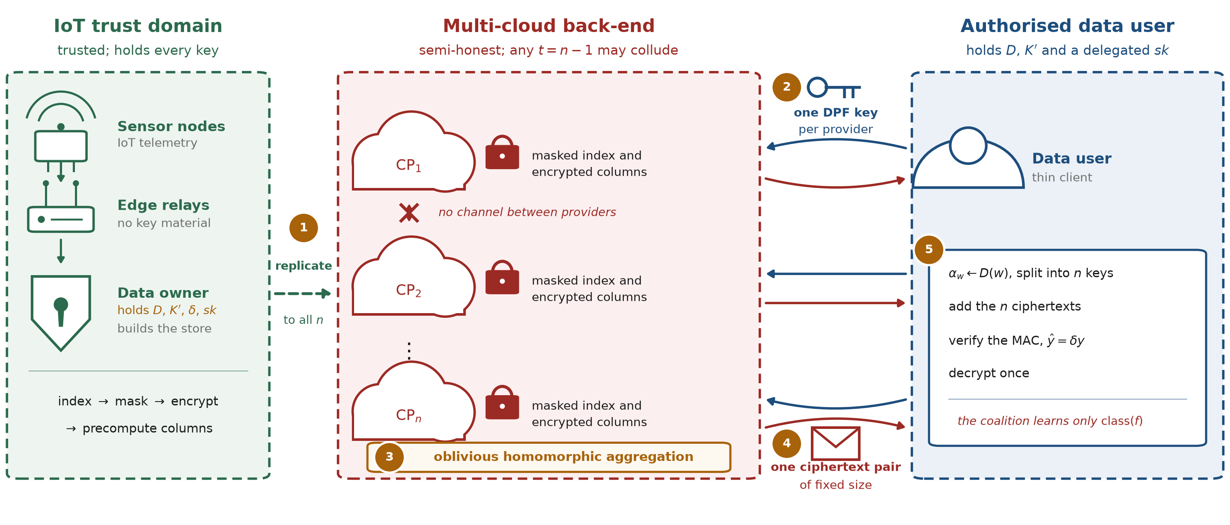
Fig. 1. Overview of CR-SHE. The owner replicates a masked index and encrypted columns to n providers (1). A query is split into one DPF key per provider (2), each provider aggregates obliviously over its own share (3) and returns one ciphertext pair (4), and the user combines, verifies and decrypts (5). No provider ever sees the matched set or its size.
The workflow (Fig. 1) has four stages. In setup (Algorithm 1), the DO derives keys, builds the pseudonymous membership index and masks it, encrypts the computable field of every record and its MAC counterpart, precomputes the aggregate and correction columns for each registered template, and replicates everything to the n providers. To query, an authorised DU looks up the keyword's row in D and sends one DPF key per provider together with the template identifier. Each provider performs a full-domain evaluation and, without ever assembling the matched set, returns a single ciphertext. The DU combines the n ciphertexts and decrypts once. Because the per-provider keys are individually meaningless and every response is a fixed-size ciphertext, no network-visible message depends on the queried keyword, the matched set, or its size.
A concrete deployment. Consider a city environmental-monitoring network like the second corpus of Section 10.12. Sensor stations (producers) publish readings through gateways (edge relays) to the municipal data office (DO), which replicates the encrypted, masked store to two or three commercial clouds. Analysts at a health agency, a transport authority and a university (DUs) run registered templates, such as the mean temperature at a named site, the number of hours with carbon monoxide in the top decile, or a weighted exposure score, without any cloud learning which site or condition was asked about, or how many hours matched. Gateways only forward records over authenticated channels; all key material stays with the DO and the analysts.
5. Threat model
The adversary 𝒜 is probabilistic polynomial-time, static, and semi-honest: every corrupted party follows the protocol faithfully but pools and analyses everything it observes. Before execution, 𝒜 fixes a corruption set C⊆[n] with |C|≤ t; the headline guarantee is t=n-1, so security holds as long as at least one provider stays out of the coalition. The defining feature is collusion: the corrupted providers act as a single coalition sharing state, keys, tokens and transcripts. For its chosen C, the adversary observes the full static state and complete per-query transcript of every corrupted provider,
View_{C} = ( I', CT, ĈT, pk, pp,
{A_{f},Â_{f},U_{f},G_{f}}_{f}, {κ_{q,j}}_{j∈ C,q∈[Q]} ),
together with the responses those providers themselves generate. Queries are adaptive. The security goal is that this coalition view be simulatable from data-independent leakage revealing neither the keyword, the access pattern, the result-set size, nor the result.
The surrounding trust assumptions are explicit. The DO and authorised DUs are honest and hold the secret keys; data producers and in-domain edge relays hold no secret material. All channels are authenticated and confidential, so wiretapping yields nothing beyond what the corrupted providers already see, and messages cannot be tampered with.
Four boundaries delimit the model. First, providers are semi-honest for the main theorem; Section 6.6 adds detection of responses inconsistent with their MAC, but full malicious security, in particular against a provider that applies a consistent but different contraction, requires verifiable function secret sharing and is left to future work. Second, collusion between a data user and a provider is excluded, since an authorised user already holds decryption capability. We do, however, treat a client that exceeds its authority as in scope: Section 6.7 shows that providers can neither restrict which rows a hidden query reads nor reject keys for arbitrary linear combinations, which the semi-honest provider model does not cover. Third, a single compromised DU exposes all data, because decryption capability is delegated in full; threshold or attribute-based key delegation is a natural extension we do not evaluate. Fourth, side channels and traffic-volume leakage outside the message sizes accounted for here are assumed mitigated by orthogonal system-level defences.
6. The CR-SHE construction
6.1. Overview
The DO builds a membership index I∈{0,1}^{N× Nd} in which keyword w occupies row α_{w} and I[α_{w}][i]=1 if and only if record i contains w. Rows are assigned by a secret, append-only dictionary D: a keyword receives the next free row when it first appears and keeps it for the lifetime of the deployment, so rows never move when keywords are added (Section 6.8). The DO shares D with authorised DUs and keeps it from the providers, because the vocabulary itself, being device and site names, is sensitive. Which row a keyword gets carries no security weight, since providers see neither addresses nor unmasked rows; only injectivity matters, for correctness. Rows are fixed width, so no row is distinguishable by size, and the index is stored masked as I'[x][i]=I[x][i]+P[x][i] mod p with P[x][i]=F'_{K'}(x|i), an ω-bit PRF output reduced modulo p. The computable field of each record is encrypted as CT_{i}=Enc_{pk}(m_{i}), with a MAC column ĈT_{i}=Enc_{pk}(δ m_{i}); opaque payloads are encrypted symmetrically.
A design that first recovers the selection vector at the client and then asks the providers to evaluate f over {CT_{i}}_{i∈ S} destroys in the second step exactly what the first protected, because the providers are handed S. CR-SHE therefore never materialises S at a provider. Each provider contracts its own share of the selection vector against the encrypted column and returns one ciphertext.
6.2. Why replication rather than secret sharing
Replication is a choice, and the obvious alternative must be answered. If the DO instead dealt an (n,n) additive sharing of each column A_{f} over ℤ_{p}, every provider could answer a DPF query over its share in the clear, giving t=n-1 privacy with no homomorphic encryption, no circular-security assumption, and a response of ⌈log p⌉ bits rather than two ciphertexts. We keep replicas for three reasons, and pay for them in response size.
Durability. A sharing with privacy threshold n-1 is lost when any one share is lost, whereas a replica set survives the loss of n-1 providers, which is the reason multi-cloud deployments replicate at all. Threshold sharing does not escape the trade-off: a (t+1,n) scheme tolerates n-t-1 losses, so at t=n-1 it degenerates to the (n,n) case.
Graceful degradation. A query needs every provider in the set it is addressed to. With replicas, queries continue over any surviving set of at least two providers, at that set's collusion bound, without touching stored state; a shared store cannot answer until the dealer re-shares.
Key management and churn. Encryption under one owner key lets the owner rotate keys, revoke a provider, or add one by copying ciphertexts. Under sharing, every change to the provider set re-deals the whole store, and the dealer must hold the plaintext to do it.
Table 1 lists the shared alternative as its own row. Where durability is provided by other means and response size dominates, it is the better design.
6.3. Oblivious homomorphic aggregation
Let e_{j}[x]=Eval(j,κ_{j},x) denote provider j's full-domain evaluation vector, so that ∑_{j} e_{j}[x]=1 if x=α_{w} and 0 otherwise. Provider j forms
b_{j} = ∑_{x∈[N]} e_{j}[x]· I'[x] ∈ℤ_{p}^{Nd},
∑_{j∈[n]} b_{j} = b + P[α_{w}],
where b=I[α_{w}] is the 0/1 selection vector. It then contracts b_{j} against the ciphertext column under the public weight vector w_{f} of the requested template and subtracts the mask correction described in Section 6.4:
ct_{j} = (⊞_{i∈[Nd]} (w_{f}[i]b_{j}[i])⊡ CT_{i})
⊟ (⊞_{x∈[N]} e_{j}[x]⊡ U_{f}[x]).
The DU computes ⊞_{j} ct_{j} and decrypts once. Nothing that leaves a provider depends on b: the response is one ciphertext of fixed size whatever the matched set and its cardinality.
Lemma 1 (Algebraic compatibility). If the DPF output group and the HE plaintext ring are the same ℤ_{p}, and ∑_{i}|w_{f}[i]m_{i}| < p for every admissible template, then for shares b₁,…,b_{n}∈ℤ_{p}^{Nd} with ∑_{j} b_{j} = β mod p, multline* _{sk}(_{j∈[n]} _{i∈[N_d]} b_j[i] CT_i) =; ∑_{i∈[N_d]} β[i],m_i mod p . multline*
Proof. ⊡ and ⊞ are homomorphisms over the same ring ℤ_{p}, so summation commutes with decryption and no reduction is lost: share addition and plaintext addition are taken modulo the same modulus. The magnitude bound prevents plaintext overflow. What remains is decryption correctness, which is a noise-budget question rather than a depth question. A plaintext-to-ciphertext product consumes no multiplicative level but scales the noise by up to the norm of the plaintext, here as large as p≈2³⁶, because DPF shares are uniform in ℤ_{p}, and the contraction sums ⌈ N_{d}/ℓ⌉ such products before a rotate-and-sum. The parameters must leave room for that growth. We check the worst case, full-magnitude coefficients across several packed chunks, empirically rather than assume it (Section 10.1).
Lemma 1 is what makes the two primitives compose. Instantiating the DPF over ℤ_{2k} and the homomorphic scheme over an unrelated plaintext modulus, which is the natural default since the two libraries are chosen independently, silently breaks correctness through wraparound, and the failure is data-dependent and therefore easy to miss in testing.
6.4. Cancelling the index mask
Because ∑_{j} b_{j} = b + P[α_{w}], the contraction above yields ∑_{i} w_{f}[i]b[i]m_{i} + u_{f}(α_{w}) where the mask term is u_{f}(x)=∑_{i} w_{f}[i]P[x][i]m_{i}. The DO can compute u_{f}(x) for every x∈[N] at setup, since it holds both K' and the plaintext records, and publishes the encrypted correction column U_{f} = (Enc_{pk}(u_{f}(x)))_{x∈[N]}, packed into ⌈ N/ℓ⌉ ciphertexts. Providers retrieve the shared correction at α_{w} using the same evaluation vector e_{j} they already computed, so the mask is cancelled inside the ciphertext and no provider learns either a mask value or which correction was used. The count correction G_{f} is this same column for a count template (m_{i}≡1), so it needs no separate path; Remark 1 shows why it too must be encrypted.
Theorem 1 (Index hiding). Let each mask value be an ω-bit output of F' reduced modulo p. For any two membership indexes I₀,I₁∈{0,1}^{N× Nd}, no PPT distinguisher tells I₀+P from I₁+P with advantage greater than Adv^{prf}_{F'}+N N_{d}2^{-ω}. In particular the coalition learns no posting-list length, no keyword-frequency multiset, and no membership relation, at a storage cost of ⌈ N/ℓ⌉ ciphertexts per registered template and O(N/ℓ) additional ciphertext operations per provider per query.
Proof. Replace F' by a truly random function at the cost of Adv^{prf}. The entries of P are then independent, each distributed as X=U mod p for U uniform on {0,1}^{ω}. Writing 2^{ω}=qp+r with 0≤ r<p, Pr[X=v] is (q+1)/2^{ω} for v<r and q/2^{ω} otherwise, so the distributions of X and X+1 mod p differ only at v=0 and v=r, by 2^{-ω} at each, and their statistical distance is at most 2^{-ω}. Since I₀ and I₁ differ in at most N N_{d} entries, a hybrid over those entries gives the bound. Costs follow by inspection of Algorithm 2.
The implementation reduces ω=64-bit words, so for the full telemetry index the statistical term is N N_{d}2⁻⁶⁴≈ 2^{-31.9}, far below anything measurable but short of 2^{-λ}. Reducing a 128-bit block per value, as the DPF's output conversion already does, lowers it to about 2⁻⁹⁶ at the cost of one extra AES call per two mask values.
Remark 1 (Why the correction column must be encrypted). It is tempting to publish the count correction g_{f}(x)=∑_{i} w_{f}[i]P[x][i] in the clear, since it is a sum of pseudorandom values and looks uniform. It must not be. Given I' and g_{f} in the clear, the coalition computes ∑_{i} w_{f}[i]I'[x][i]-g_{f}(x)=∑_{i} w_{f}[i]I[x][i], which for w_{f}≡ 1 is exactly the row Hamming weight, restoring the volume leakage the mask was introduced to remove. The correction columns U_{f} and G_{f} are therefore stored under HE, and the count is returned as a ciphertext like any other aggregate.
6.5. Precomputed columns: the single-keyword fast path
The contraction of Section 6.3 costs Θ(N N_{d}) ring operations per provider per query, which is the price of hiding the access pattern without preprocessing, by the lower bounds underlying ORAM and PIR [24,34]. For the common case, an aggregate over the whole posting list of a single keyword under a template registered at setup, this cost is avoidable. The DO precomputes, for every x∈[N],
A_{f}[x] = ∑_{i∈[Nd]} I[x][i]w_{f}[i]m_{i} mod p ,
and publishes it as ⌈ N/ℓ⌉ packed ciphertexts. A query then reduces to an oblivious retrieval of one element of an encrypted length-N array:
ct_{j} = ⊞_{x∈[N]} e_{j}[x]⊡ A_{f}[x],
costing O(N) pseudorandom-generator calls for the full-domain evaluation plus O(N/ℓ) packed ciphertext-plaintext multiplications and O(log ℓ) rotations, independent of N_{d}. No mask correction is needed on this path, because A_{f} is derived from the unmasked I held by the DO and is itself encrypted.
The fast path supports the templates registered at setup, namely count, sum, per-sensor-band sums, and fixed plaintext-weighted inner products, applied to a single keyword. Conjunctive queries and ad-hoc weight vectors chosen at query time fall back to the general path of Section 6.3. Insertion is cheap: a new record carrying τ tags updates A_{f} at τ addresses and U_{f} at all N addresses in plaintext at the DO, followed by re-encryption of all of the column's packed ciphertexts, for the reason given in Section 6.8; no decryption is involved.
6.6. Verification of the aggregate
Providers run the same contraction against the MAC column ĈT (or Â_{f} on the fast path) and return ĉt_{j} alongside ct_{j}. The DU decrypts both and aborts unless ŷ=δ y. The check is linear, and that fixes precisely what it covers. A provider that perturbs its response by anything it cannot also MAC, such as adding a constant, returning a stale or foreign ciphertext, or corrupting one of the two halves, is detected except with probability 1/p≈2⁻³⁶ over the unknown δ, which is adequate for catching faults but is not a cryptographic integrity guarantee. Two independent MAC columns would lower this to 1/p²≈2⁻⁷² for one further ciphertext per response. A provider that applies the same linear substitution to both halves passes: replacing its evaluation vector e_{j} by any e'_{j}, for instance ke_{j}, shifts y by ∑_{x}(e'_{j}-e_{j})[x]A_{f}[x] and ŷ by δ times as much, so the tag still verifies. The provider cannot aim the shift, since it knows neither A_{f} nor α_{w}, but it can make the output wrong undetectably. The MAC therefore protects against faulty and non-adaptive corruption, not against a provider that deviates on purpose; Section 10 measures both cases.
Remark 2 (Per-row MAC keys on the fast path). Replacing the single δ by per-row keys δ_{x}=F''_{K''}(x), storing Â_{f}[x]=δ_{x} A_{f}[x] and checking ŷ=δ_{αw}y, costs no additional ciphertexts or operations. A substitution e'_{j}=e_{j}+d then passes only if [ ∑_{x≠α_w}d[x],(δ_x-δ_{α_w}),A_f[x]=0 . ] For any d that touches a row with A_{f}[x]≠ 0 this is a non-zero linear form in independent uniform keys, which vanishes with probability 1/p. What remains undetected is a deviation concentrated on the queried row itself, which rescales the answer; because the provider's view is independent of α_{w}, it succeeds with probability at most max_{x}Pr[α_{w}=x], the predictability of the query. We have not implemented or measured this variant.
6.7. Record retrieval and query authorisation
When the DU needs payloads rather than an aggregate, providers return b_{j} directly. The DU recovers b+P[α_{w}], subtracts P[α_{w}], which it can derive locally from K', and obtains b; no correction ciphertext is involved. This response is O(N_{d}log p) bits of fixed size, independent of |S|, so the coalition learns nothing from its length. The DU then issues a batch of k_{max} DPF-based payload retrievals padded to a public bound, as in Splinter [12], so the coalition learns only k_{max}.
Authorisation interacts with obliviousness in a way that is easy to overstate. DPF privacy hides α_{w} from every provider, so no provider can check which keyword a query targets: a client permitted any query can read any row, and N honest-format queries recover I', hence I for a client that holds K'. Keys that do not encode a point function add a second capability, that of arbitrary linear combinations of rows or of A_{f}, such as a single aggregate over the union of many keywords, and cannot be rejected locally either: under the n-party instantiation of Section 3 a key is an additive share vector, so no forgery is needed, and a well-formed two-party key is pseudorandom by the privacy property. For a fully trusted DU, which holds sk and the dictionary, none of this exceeds its authority. It matters as soon as authority is partial, for a DU entitled to some keywords or templates and not others, and the remedy is a proof, carried with the key, that it encodes a point function at a permitted address, as in PACL [18], or a verifiable DPF [22] for well-formedness alone. In the constructions we are aware of, including the sketching checks of client-robust aggregation [17], the servers compare a short verification message, so adopting one relaxes CR-SHE's no-interaction property to a single short exchange per query; whether that exchange can be avoided is open. Our prototype checks key shape only, and Section 10.11 measures what unrestricted query access extracts. We state per-user authorisation as a requirement rather than a solved problem.
6.8. Dynamic ingest
IoT streams are append-only. CR-SHE keeps a static tier and a hot buffer of at most B records scanned by the same oblivious contraction; every B insertions the buffer is folded into a rebuilt static tier. Because the coalition's per-query view is independent of the query (Theorem 3), forward and backward privacy hold trivially: there is no query-dependent state for an update to correlate against. Three rules keep the update path itself from leaking.
Rows never move. A new keyword takes the next free row of D. The DO provisions N above the current vocabulary, and free rows are all-zero rows masked like any other, so a new keyword changes no public quantity; only exhausting the headroom, which re-provisions a larger N, is visible. Time-window tags make the vocabulary grow for as long as the deployment runs, at one tag per minute on our primary corpus, so a deployment bounds N by retention, keeping one static tier per epoch (a day is 1,440 minute tags) and querying the epochs a template covers.
A fresh mask key per static tier. A rebuild re-lays the record axis, so reusing K' would reuse mask values at new positions, and the difference of two masked indexes would expose the change in membership. The DO therefore draws a fresh K' for every static tier, recomputes U_{f} and G_{f} under it, and gives authorised DUs the current key.
Whole columns are replaced. An insertion changes A_{f} only at the τ rows its tags occupy, so re-encrypting only the affected packed ciphertexts would tell the coalition which blocks of ℓ rows those tags fall in. The DO re-encrypts all ⌈ N/ℓ⌉ ciphertexts of each column per update batch, which is 2 to 5 at our corpus sizes, leaving batch times and the public dimensions as the only dynamic leakage.
A rebuild's cost R grows with the store. On the fast path it is dominated by recomputing the precomputed columns from the postings and re-encrypting ⌈ N/ℓ⌉ ciphertexts per template; a deployment that also serves the general path must rebuild and re-replicate the Θ(N N_{d}) masked index. Amortisation of R/B therefore holds within one tier generation, and a long-lived deployment should merge tiers geometrically, as log-structured stores do, to keep the amortised cost logarithmic in the store size. Section 10.8 reports both costs.
Algorithm 1. Outsourcing at the data owner.
procedure Setup(1^{λ},n,t,p)
1: D←∅; K'←{0,1}^{λ}; δ←ℤ_{p}*
2: (pk,sk)←KGen(1^{λ},L_{HE},p,ℓ)
3: pp←(n,t,N,N_{d},p,ℓ,{w_{f}})
4: return (D,K',δ,pk,sk,pp)
procedure BuildIndex(D,K',DB)
5: D(w)←|D| for each new w // rows never move
6: I[D(w)][i]← 1 for each keyword w of record i
7: I'[x][i]← I[x][i]+F'_{K'}(x|i) mod p
for all x∈[N],i∈[N_{d}]
8: return I' // replicated to all CP}
procedure Precompute(pk,K',DB,{w_{f})}
for all registered templates f
9: A_{f}[x]←∑_{i} I[x][i]w_{f}[i]m_{i}
10: Â_{f}[x]←δ A_{f}[x]
11: U_{f}[x]←∑_{i} F'_{K'}(x|i)w_{f}[i]m_{i}
12: G_{f}[x]←∑_{i} F'_{K'}(x|i)w_{f}[i] // U_{f}, m_{i}≡ 1
13: encrypt and pack each column into
⌈ N/ℓ⌉ ciphertexts
procedure EncData(pk,DB)
14: CT_{i}←Enc_{pk}(m_{i}); ĈT_{i}←Enc_{pk}(δ m_{i})
15: symmetric-encrypt opaque payloads

Algorithm 2. Query, at the data user and at provider CP_{j}.
procedure Token(D,w,f) // at the DU
1: α_{w}← D(w)
2: (κ₁,…,κ_{n})←Gen(1^{λ},α_{w},1) over ℤ_{p}
3: return (κ_{j},f)→CP_{j}
procedure FastAgg(κ_{j},f,A_{f},Â)} // single keyword
4: check the shape of κ_{j} // Section 6.7
5: e_{j}[x]←Eval(j,κ_{j},x), x∈[N] // O(N) PRG
6: ct_{j}←⊞_{x} e_{j}[x]⊡ A_{f}[x] // O(N/ℓ) HE
7: ĉt_{j}←⊞_{x} e_{j}[x]⊡ Â_{f}[x]
8: return (ct_{j},ĉt_{j}) // O(1) ct
procedure GenAgg(κ_{j},w_{f},I',CT),U} // ad-hoc w_{f}
9: e_{j}[x]←Eval(j,κ_{j},x), x∈[N]
10: b_{j}←∑_{x} e_{j}[x]· I'[x] // Θ(N N_{d})
11: ct_{j}←⊞_{i} (w_{f}[i]b_{j}[i])⊡CT_{i}
12: 2em ⊟ ⊞_{x} e_{j}[x]⊡ U_{f}[x]
13: return ct_{j} and its MAC counterpart
procedure Retrieve(κ_{j},I')
14: return b_{j}←∑_{x} e_{j}[x]· I'[x] // fixed size
procedure CombineDec(sk,K',δ,·) // at the DU
15: y←Dec(sk,⊞_{j}ct_{j})
16: ŷ←Dec(sk,⊞_{j}ĉt_{j})
17: abort if ŷ≠δ y // missed w.p. 1/p
18: retrieval: b←(∑_{j} b_{j})-P[α_{w}]
19: 2em S←{i: b[i]=1}
20: return y, and S if retrieving

6.9. Worked instance
A clinician queries the tag arrhythmia with the registered template mean. The DU derives α_{w} and sends one DPF key per provider. Each provider performs a full-domain pass, contracts against the packed sum and count columns, and returns two ciphertexts plus their MAC counterparts. The DU adds the shares, verifies the MACs, decrypts, and divides. No provider, and no coalition of up to n-1, learns the tag queried, which records contributed, how many did, or the mean itself.
7. Security analysis
Leakage profile. We define ℒ=(ℒ_{Setup},ℒ^{CP},ℒ^{DU}) with an observer split:
ℒ_{Setup}(DB) = (n,t,N,N_{d},p,ℓ,{w_{f}}),
ℒ^{CP}_{Query} = class(f),
ℒ^{DU}_{Query} = (|S|, f(records(S))).
The coalition learns which registered template was requested and the public dimensions of the deployment, and nothing else: not the keyword, not the access pattern, not |S|, not the result. In contrast to a design in which the matched set is returned to the providers for evaluation, and in contrast to an unmasked index, ℒ_{Setup} here contains no posting-list lengths and no membership structure, by Theorem 1. Retrieval adds the public padding bound k_{max} to ℒ^{CP}. A conjunctive query is two selections intersected at the DU, adding only result sizes to ℒ^{DU}, never to the coalition.
Definition 1 (\Leak-security against t-collusion). In Real_{𝒜,Π}(1^{λ}): (1) 𝒜 outputs (DB,C) with |C|≤ t; (2) the challenger runs Setup, BuildIndex, Precompute, EncData and gives 𝒜 the static view (I',CT,ĈT,{A_{f},Â_{f},U_{f},G_{f}}_{f},pk,pp); (3) for q=1,…,Q, 𝒜 adaptively issues a keyword w_{q} with template f_{q} and receives the coalition's per-query view ({κ_{q,j}}_{j∈ C},{ct_{q,j}}_{j∈ C}); (4) 𝒜 outputs a bit. In Ideal_{𝒜,𝒮,ℒ}(1^{λ}) a PPT simulator 𝒮 produces the views given only ℒ_{Setup} and the per-query leakage. Π is ℒ-adaptively-secure against t-collusion if for every PPT 𝒜 corrupting ≤ t providers there is a PPT 𝒮 with |Pr[Real=1]-Pr[Ideal=1]|≤negl(λ).
Theorem 2 (Correctness). Fix a database DB, a keyword w, and a registered template f satisfying the magnitude bound of Lemma 1. Then CombineDec returns y=∑_{i∈ S} w_{f}[i]m_{i} with S={i: I[α_{w}][i]=1} on both the fast and general paths, and Retrieve returns exactly S, except with the negligible probability that leveled-HE decryption fails.
Proof. By DPF correctness ∑_{j} e_{j}[x]=1 at x=α_{w} and 0 elsewhere.
Fast path. ⊞_{j}ct_{j} decrypts, by Lemma 1 applied with β=(∑_{j} e_{j}) over the array A_{f}, to A_{f}[α_{w}]=∑_{i} I[α_{w}][i]w_{f}[i]m_{i}=∑_{i∈ S}w_{f}[i]m_{i}.
General path. ∑_{j} b_{j}=∑_{x}(∑_{j} e_{j}[x]) I'[x]=I'[α_{w}]=b+P[α_{w}]. By Lemma 1 the first term of ⊞_{j} ct_{j} decrypts to ∑_{i} w_{f}[i](b[i]+P[α_{w}][i])m_{i} and the second to u_{f}(α_{w})=∑_{i} w_{f}[i]P[α_{w}][i]m_{i}; their difference is ∑_{i∈ S}w_{f}[i]m_{i}.
Retrieval. (∑_{j} b_{j})-P[α_{w}]=b exactly, and the DU derives P[α_{w}] from K'.
The dictionary is injective by construction, so row α_{w} is exactly the records containing w. Decryption correctness under the noise growth discussed in the proof of Lemma 1 contributes the negligible failure term. The MAC check passes with certainty for honest providers, since δ distributes over the linear contraction.
Theorem 3 (t-collusion leakage security). If F' is a secure PRF, (Gen,Eval) is an (n-1)-private DPF, and the homomorphic and symmetric schemes are IND-CPA, then CR-SHE is ℒ-adaptively-secure against t-collusion in the sense of Definition 1, for t=n-1 and ℒ^{CP}_{Query}=class(f). Concretely, for every PPT 𝒜 there exist PPT 𝒮 and B₁,…,B₃ with multline* |[=1]-[=1]| ≤ Adv^{PRF}_{B_1} + N N_d,2^{-ω} + Q·Adv^{DPF}_{B_2} + m·Adv^{CPA}_{B_3}, multline* where m is the number of ciphertexts in the coalition view. As is standard for BFV, IND-CPA is assumed to hold even given the relinearisation and rotation keys the providers need (circular security). The theorem is stated for one static tier; with a fresh K' per tier (Section 6.8) it applies to each tier independently, with one PRF term per tier.
Proof. Take |C|=n-1 without loss of generality; a smaller coalition holds a subset of the same state. Let H₀=Real.
H₁ (PRF to random, index to zero). Replace F' by a truly random function, at cost Adv^{PRF}_{B1}. Then build I' from the all-zero index instead of I, which by the statistical step of Theorem 1 costs at most N N_{d}2^{-ω}; I' now depends only on (N,N_{d}).
H₂ (DPF keys to simulated). Replace {κ_{q,j}}_{j∈ C} by 𝒮_{DPF}(1^{λ},C,N), licensed by (n-1)-privacy; a hybrid over the Q queries costs Q·Adv^{DPF}_{B2}. The per-query key material now depends only on (C,N).
H₃ (ciphertexts to encryptions of 0). Replace each of the m ciphertexts in the coalition view, namely CT, ĈT and the columns A_{f},Â_{f},U_{f},G_{f}, by encryptions of 0 under pk, at cost m·Adv^{CPA}_{B3}, since the coalition holds only pk.
Simulator. The responses ct_{q,j} need not be simulated separately: each is a deterministic function of κ_{q,j}, the template identifier, and the provider's stored state, all of which 𝒮 possesses in H₃. 𝒮 therefore regenerates the entire coalition view from ℒ_{Setup} and class(f) alone, so Ideal_{𝒜,𝒮,ℒ} matches H₃; summing the four terms proves the theorem.
Remark 3 (Why the two-round design admits no such bound). Suppose the client recovers S and then requests Compute(pk,{CT_{i}}_{i∈ S},f) from the providers. The coalition's per-query view then contains S itself, which is a function of the queried keyword and the database. No simulator given only data-independent leakage can produce it, so an empty per-query leakage profile is unattainable in that design rather than merely loose. Contracting at the provider is what makes Theorem 3 true as stated.
Remark 4 (Content confidentiality and graceful degradation). For two databases of equal public dimensions differing only in contents, Theorem 3 makes each coalition view indistinguishable from a distribution depending only on ℒ_{Setup}, which is identical for both; the executions differ by at most m·Adv^{CPA}, with the content dependence isolated in H₃. The same proof applies for any |C|≤ n-1, since (n-1)-privacy holds for every strict subset; a coalition of all n providers is outside the model, and against it the guarantee degrades to IND-CPA confidentiality of the records with the index still masked under F'.
Remark 5 (Beyond semi-honest). Section 6.6 detects a response inconsistent with its MAC except with probability 1/p. It does not detect a provider that applies the same linear substitution to both halves, that is, a contraction against any vector other than its evaluation share, nor does it guarantee output delivery. Full malicious security through verifiable function secret sharing remains future work, which is why Table 1 records detect rather than ✓.
8. Complexity analysis
Table 4 summarises the asymptotic costs. Three entries deserve comment because they correct the intuitive accounting.
First, the selection contraction on the general path is Θ(N N_{d}) ring operations, not Θ(N): a full-domain evaluation produces N share values, each of which multiplies an index row of width N_{d}. Counting only the O(N) pseudorandom-generator calls of the evaluation omits the dominant term. With a small modulus and vectorised arithmetic these are cheap word operations, and the pass is embarrassingly parallel, but the asymptotic is what it is: this is the ORAM and PIR lower-bound price for hiding the access pattern from a coalition without preprocessing [24,34]; preprocessing PIR avoids it at the cost of client hints that updates invalidate [27].
Second, the fast path of Section 6.5 removes the N_{d} factor entirely, at O(N) generator calls plus O(N/ℓ) packed ciphertext operations, at the cost of restricting queries to single keywords and templates registered at setup.
Third, the aggregate response is O(1) ciphertexts and, crucially, independent of |S|. A response whose size grew with the result set would leak the result-set size to the coalition and contradict ℒ^{CP}. Retrieval responses are O(N_{d}log p) bits of fixed size for the same reason.
Table 4. Asymptotic costs. γ is the per-provider DPF key size, O(λlog N) at n=2; ℓ is the SIMD slot count.
Resource | Per provider | Data user
Index storage | O(N N_{d}log p) | n/a
Ciphertext storage | O(N_{d})+O(N/ℓ) per f | n/a
Query uplink | O(γ) | O(nγ)
Aggregate downlink | O(1) ct | O(n) ct
Retrieval downlink | O(N_{d}log p), fixed | O(nN_{d}log p)
Selection, fast | O(N) PRG, O(N/ℓ) HE | 1 decrypt
Selection, general | O(N) PRG, Θ(NN_{d}) ring | 1 decrypt
Aggregate HE ops | O(N_{d}/ℓ) or O(N/ℓ) | O(n) adds
Owner precomputation | O(NN_{d}) per f per tier | n/a
Insertion, τ tags | O(N) plaintext updates | n/a

9. Implementation
We implement CR-SHE end to end in C++17, together with the corpus builder and one benchmark script per figure.
Distributed point function. The two-party DPF is the Boyle-Gilboa-Ishai GGM-tree construction with a fixed-key AES-128 pseudorandom generator in the Matyas-Meyer-Oseas form G(s)=AES_{k}(s)⊕ s under three independent fixed keys, giving two child seeds and one conversion block per node. Three code paths are provided, for x86-64 AES-NI, ARMv8 crypto extensions, and a portable software fallback, and every binary reports at start-up which one it took; the measurements below were taken with AES-NI. Full-domain evaluation traverses the tree once, processing nodes in pairs so that four independent AES chains are in flight, and converts leaves four at a time. The implementation is verified exhaustively against the point function at every point of the domain for depths up to 12 and for n∈{2,3,4,5}.
Homomorphic layer. Leveled BFV through OpenFHE 1.2.3 [57], at plaintext modulus p=68,724,326,401, a 37-bit prime with p≡ 1 mod 2¹⁷ so that batching is available at every ring dimension up to 65,536, ring dimension 8,192, ℓ=8,192 SIMD slots, multiplicative depth 1, at the 128-bit classical security level. The one contraction is a plaintext-to-ciphertext product followed by a rotate-and-sum over the batch.
Lemma 1 as a type, not a comment. The DPF output group and the BFV plaintext ring are the same object in the code: a single modulus type is constructed once and consumed by the DPF, the index mask, and the homomorphic backend. The failure mode the lemma warns about, a DPF over ℤ_{2k} composed with an unrelated plaintext modulus, is therefore unrepresentable rather than merely documented. The magnitude bound is checked against the corpus at setup, and a corpus that would violate it is rejected rather than silently wrapped.
Selection arithmetic. The general-path contraction accumulates in 128 bits and reduces once per output: each product is below p²<2⁷⁴ and at most N≤ 2¹⁶ of them are summed on either corpus, so the accumulator cannot overflow and the inner loop is a single multiply-add. The pass is parallelised over tag blocks with per-thread accumulators.
Deployment. The implementation separates a deployment bundle along the trust boundary: the public half carries the crypto context, the evaluation keys, pk and the precomputed columns, and the provider process loaded from it holds no secret key and refuses decryption. We exercise this with n∈{2,3,4} independent provider processes and a client communicating over TCP. We report it as a single-host deployment (Section 10.5): the processes are genuinely separate and the protocol is the real one, but they run on one machine over the loopback interface, so the transport component is framing and serialisation only and excludes wide-area latency. Section 10.14 returns to what this omits.
Randomness and keys. Every secret the protocol samples, from DPF root seeds to the seeds of the n-party construction and the owner's K' and δ, is drawn from the operating system's CSPRNG, never from a seeded generator. The benchmark harness is the one exception: it derives the owner's keys from a fixed public seed so that the leakage experiment and the correctness tests reproduce bit for bit, and such keys are never used in a deployment bundle. Mask values are ω=64-bit AES-CTR words reduced modulo p (Theorem 1). The dictionary assigns rows in sorted tag-name order when a corpus is built; it does not implement the insertion of new keywords or the per-tier re-keying of Section 6.8, which the static benchmarks below do not exercise.
Corpora. The primary corpus is the Environmental Sensor Telemetry dataset of 405,184 MQTT messages from three Raspberry-Pi sensor arrays, each carrying a device identifier, a timestamp, and readings for carbon monoxide, humidity, liquid petroleum gas, smoke, temperature, light and motion [58]. Records are indexed under the metadata tags a deployed IoT platform would attach: the device identifier, a one-minute time window, decile bands of each of the five continuous sensor channels, and the two boolean flags. This yields N=11,580 tags over 3,646,656 postings, with heavy-tailed posting lists of median 35, mean 314.9 and maximum 404,702 (Fig. 8). Aggregation operates on the real temperature readings, scaled to hundredths of a degree, so one coherent dataset drives both retrieval and analytics. The largest admissible single-tag aggregate is 908,575,470, leaving 75.6× headroom below p.
That corpus has only three physical devices, so the whole evaluation is repeated on a second one, the UCI Beijing Multi-Site Air-Quality dataset of 420,768 hourly records from twelve monitoring sites over four years [59], which triples the tag domain and supplies the device diversity the first corpus lacks. Section 10.12 reports it in full; both corpora are built by the same script, from the published raw files, with no hand curation.
Baselines. We compare against (i) a plaintext linear scan; (ii) a single-server searchable-encryption scheme with PRF tokens and AES-CTR posting lists, which leaks the search pattern, the access pattern and |S|; (iii) non-recursive Path ORAM with bucket size Z=4 and a client-side position map, charging one access per matched record plus one for the index entry; (iv) a distributed-trust, search-only baseline in the style of DORY [13], which is our own selection path stopped at the selection vector and therefore isolates exactly the cost of adding oblivious analytics to oblivious selection; and (v) a faithful homomorphic equality scan, which pays the cost of a homomorphic equality per record, eq(a,b)=1-(a-b)^{q-1} by Fermat over a plaintext prime q, at the multiplicative depth that implies; a cheaper proxy that charged one homomorphic addition per item would understate this alternative by orders of magnitude. For (v) one full batch of ℓ slots is measured and the corpus total is obtained by multiplying by the batch count; both the measured batch cost and the extrapolation factor are reported, and extrapolated quantities are marked as such throughout.
Hardware. All measurements were taken on one AMD EPYC 7J13 machine with 64 cores and 64,GB of RAM running Ubuntu 24.04, with AES-NI, GCC 13 and OpenMP. Latencies are medians of 11 runs unless stated otherwise, with the interquartile range recorded per run and drawn as error bars in the figures. Every binary prints the CPU, thread count, AES backend and homomorphic parameters it ran under, and every results row repeats them, so no number in this section can be separated from the machine that produced it.
What a fast-path latency includes. The protocol always computes both contractions, value and MAC, so every fast-path figure includes the MAC and every aggregate response is two ciphertexts; we did not measure a MAC-free variant. The fast-path figures differ in two respects only: whether the timed region includes the provider's full-domain DPF evaluation, and how many threads that evaluation uses, which matters because its OpenMP team competes with OpenFHE's own thread pool. With the evaluation on all 64 threads (Tables 6, 7 and 10) a query costs 38.8–41.2,ms across the two corpora; with it on one thread, as the deployed provider runs it, 34.3–35.5,ms on the primary corpus (Section 10.9, Table 8); and the two contractions alone, without the evaluation, 33.6,ms. Serialisation is excluded everywhere except the transport column of Table 8.
10. Results analysis and discussion
10.1. Correctness
Every measurement below is taken against an implementation that first has to compute the right answer, so we report that check first. On a 5,000-record subsample of the primary corpus, for n∈{2,3,4} and all four registered templates, the decrypted aggregate equals the plaintext ground truth exactly and the MAC verifies for 1,000 randomly drawn tags per template on the fast path and 50 on the general path; retrieval returns exactly the posting list; and the aggregate downlink is byte-identical for matched sets of size 0 and 4,999. The homomorphic test suite separately multiplies full-magnitude ℤ_{p} coefficients across several packed chunks, the general path's worst case for noise. The same battery passes unchanged when the same build is repeated on a second, 16-core host. This is Theorem 2 in practice, including the mask cancellation of Section 6.4, which is the step most likely to fail silently. Section 10.12 repeats the same battery on the second corpus.
10.2. Selection latency and key size
Table 5 and Fig. 3 report the per-provider full-domain evaluation, which is the whole of the selection phase. Selection depends on the tag domain alone, so one table covers both corpora. At the primary corpus's N=11,580 it costs 0.336,ms on one thread and 0.177,ms at sixteen; at N=10⁶ it costs 45.7,ms on one thread and 18.8,ms at thirty-two. The two-party key is 266,B at that domain, growing to 368,B at N=10⁶, consistent with the O(λlog N) bound.
Selection does not scale past about sixteen to thirty-two threads and then regresses: at N=11,580 it improves from 0.336,ms to 0.177,ms at sixteen threads but returns to 0.211,ms at sixty-four, and at N=10⁶ from 45.7,ms to 18.8,ms at thirty-two and back to 24.4,ms at sixty-four. The per-level work at these domain sizes is too small to amortise thread dispatch across all cores of a 64-core part. A deployment should pin the selection pass to the knee.
These are sub-millisecond quantities on a shared cloud host, and they carry correspondingly loose error bars: repeated runs of the identical binary differ by up to 25% at N≈10⁴, while the N=10⁶ figures, where each measurement is tens of milliseconds, repeat to within 1%. The table gives medians of 21 runs, and the interquartile range is recorded for every cell. Conclusions in this subsection are drawn only at the order-of-magnitude level, which is robust to that variation; the like-for-like comparison that matters is made in Section 10.3, where the quantities are tens of milliseconds.
Set against the homomorphic half of the same query, the scale is what matters: selection is under 0.2,ms while the packed contraction that follows it is tens of milliseconds (Section 10.3). The symmetric-key half of CR-SHE is not the bottleneck, which is the design's intent: symmetric work on the selection path, homomorphic operations only on the aggregate.
Table 5. Per-provider selection latency and two-party key size against N. Medians of 21 runs.
N | {Latency (ms), T threads} | Key
 | T=1 | 4 | 16 | 32 | 64 | (B)
1,000 | 0.032 | 0.032 | 0.032 | 0.032 | 0.032 | 198
10,000 | 0.290 | 0.175 | 0.156 | 0.161 | 0.183 | 266
11,580 | 0.336 | 0.200 | 0.177 | 0.181 | 0.211 | 266
100,000 | 4.418 | 2.487 | 1.909 | 1.928 | 2.420 | 317
10⁶ | 45.741 | 25.701 | 19.711 | 18.769 | 24.401 | 368

10.3. Oblivious aggregation
This is the central claim of the paper, and Table 6 and Fig. 5 test it directly.
On the fast path the provider's aggregate latency is 38.8–39.2,ms across a 405× range of record counts, from N_{d}=10³ to the full N_{d}=405,184, a spread of ±0.5%, that is, flat. An initial sweep taken in increasing N_{d} showed the first four points near 53,ms and the last four near 38.5,ms; because that step is anti-correlated with N_{d}, we repeated the sweep in decreasing order, which reproduced 38.8–39.2,ms at every point including N_{d}=10³. The step was therefore a warm-up artefact of run ordering and not a dependence on N_{d}, and Table 6 quotes the order-controlled run.
On the general path the same aggregate costs 103.7,ms at N_{d}=10³ and 1,378.2,ms at the full corpus, which is 35.5× the fast path. The growth is mild up to N_{d}≈5×10⁴, where the fixed homomorphic cost still dominates, and then tracks the Θ(N N_{d}) contraction, giving 196.8, 539.5 and 1,378.2,ms at 10⁵, 2×10⁵ and 4.05×10⁵: a factor of 2.74 for the doubling and 2.55 for the 2.03× step that follows. The slight superlinearity is memory bandwidth: at full scale the masked index is 37.5,GB and every query streams all of it.
That storage is the general path's real constraint. The masked index is N× N_{d} elements of ℤ_{p}, which is 9.26,GB at N_{d}=10⁵ and 37.5,GB at the full corpus, per provider and replicated n times. It fits on a 64,GB machine and not on a smaller one, and it must be resident for every query. This is the price of a fully general oblivious selection and it is the reason the fast path exists.
Per-query downlink is 525,950,B per provider, being two ciphertexts, the aggregate and its MAC, and is byte-identical for every N_{d} and, more importantly, for every |S|. We verify this directly by querying a tag whose posting list is empty and one that matches 4,999 of the 5,000 records in the test subsample, and comparing the serialised responses byte for byte. A design that returned the selection vector instead would send O(N_{d}log p) bits, 800,000,B at N_{d}=10⁵, and would leak |S| through the response size itself.
Table 6. Aggregate latency and storage, fast against general path, N=11,580, template sum. Medians of 11 runs (fast) and 3 (general).
N_{d} | Fast | General | I' / provider | Downlink
 | (ms) | (ms) | (GB) | (B)
10³ | 38.8 | 103.7 | 0.09 | 525,950
5×10³ | 39.0 | 106.9 | 0.46 | 525,950
10⁴ | 38.8 | 111.9 | 0.93 | 525,950
2×10⁴ | 38.8 | 121.7 | 1.85 | 525,950
5×10⁴ | 39.1 | 120.7 | 4.63 | 525,950
10⁵ | 39.2 | 196.8 | 9.26 | 525,950
2×10⁵ | 39.1 | 539.5 | 18.53 | 525,950
4.05×10⁵ | 38.8 | 1,378.2 | 37.54 | 525,950

10.4. Comparison against baselines
Table 7 places CR-SHE against the five baselines on the primary corpus, the same machine and the same probe tag, whose posting list has that corpus's median length |S|=35.
The ordering is the expected one and the magnitudes are the point. A plaintext scan is free and private against nobody. Single-server searchable encryption is also essentially free and leaks the search pattern, the access pattern and |S|; its downlink grows with the result set. Path ORAM hides the access pattern from one server at 1.6μs per access, but pays per matched record, so its cost and its 373,kB downlink both scale with |S| while CR-SHE's do not. The DORY-style distributed-trust baseline, our own selection path stopped at the selection vector, costs 130.4,ms, and two comparisons against it answer different questions. Like for like, the general path computes the same selection and then aggregates obliviously over it in 196.8,ms at the same N_{d} (Table 6): oblivious analytics adds about half again to oblivious selection, not an order of magnitude. The fast path answers the narrower question of a registered single-keyword aggregate in 39.2,ms, which is 3.3× less than materialising the selection vector, because it never touches the N× N_{d} index; that gain is bought by restricting the query class, not by a cheaper selection.
The faithful homomorphic equality scan is the comparison that depends most on charging the right operation. At q=65,537 a single digit suffices for the tag domain, but the Fermat exponentiation needs 16 squarings, plus one level for the product with the record value: multiplicative depth 17, and ring dimension 32,768. One batch of 32,768 slots costs 1.86,s and the corpus needs 13 batches, giving 24.2,s per query, extrapolated, which is 617× the CR-SHE fast path. Charging one homomorphic addition per item instead would place this baseline in the tens of milliseconds and invert the conclusion.
Table 7. Baselines, same corpus and machine, N_{d}=10⁵, probe tag with the median |S|=35. † marks an extrapolated value.
System | Server | Downlink | Leakage to the
 | (ms) | (B) | server(s)
Plaintext scan | <0.001 | 8 | everything
SSE, 1 server | <0.001 | 560 | search and access pattern, |S|
Path ORAM | 0.059† | 373,248 | |S|, via access count
DORY-style search | 130.4 | 800,000 | none; no analytics
FHE equality scan | 24,157† | n/a | none; 1 server
CR-SHE, fast | 39.2 | 525,950 | class(f) only

10.5. Multi-cloud deployment
We ran the full protocol between independent provider processes and a client, in the deployment split described in Section 9, for n∈{2,3,4}, 100 queries each.
Provider compute is flat in n (Table 8): 34.82, 34.85 and 35.48,ms for n=2,3,4. This is the measurement that supports the central structural claim about cost, namely that the client waits on the slowest provider and not on their sum. End-to-end latency rises only from 44.1,ms to 52.5,ms across the same range, and the increase is transport, at 8.3, 9.1 and 15.5,ms, because the client receives n responses of 525,950,B each and deserialises them. Client-side combine, MAC verification and decryption cost 1.37–1.63,ms and are essentially independent of everything else, which is what makes the design viable for a thin data user.
The caveat is the one stated in Section 9: all providers ran on one machine over loopback, so the transport figure is framing, serialisation and the loopback stack, and contains no wide-area latency. A real deployment adds the inter-region round-trip to the transport component and leaves provider compute and client cost unchanged. We do not extrapolate a wide-area number from this measurement.
Table 8. Single-host deployment over loopback, medians of 100 queries. Transport excludes wide-area latency.
n | End-to-end | Provider | Transport | Client
 | (ms) | (ms) | (ms) | (ms)
2 | 44.12 | 34.82 | 8.30 | 1.37
3 | 45.40 | 34.85 | 9.09 | 1.52
4 | 52.53 | 35.48 | 15.48 | 1.63

10.6. Communication
At N=11,580 the two-party construction sends a 266,B key to each provider, 532,B of uplink in total. The non-succinct n-party instantiation used for n>2 sends 32,B to each of n-1 providers and 92,656,B to one, so total uplink is 92,688,B at n=2, 92,720,B at n=3 and 92,752,B at n=4. Tolerating more collusion is therefore nearly free in this instantiation, but moving beyond two providers at all costs a factor of 174 in uplink over the succinct two-party tree. Fig. 4 plots both against N. A succinct (n-1)-private instantiation would reduce the heavy key from O(Nlog p) to O(2^{n/2}√(N)λ).
Downlink is 525,950,B per provider for an aggregate and a fixed N_{d}⌈log p⌉ bits for a retrieval, which is 800,000,B at N_{d}=10⁵, neither depending on |S|.
10.7. Leakage evaluation
We mount a frequency and volume leakage-abuse attack in the style of [9] and [10] against our own index, twice: once against an unmasked replicated index, whose rows expose their Hamming weight and hence every posting-list length, and once against the masked index of Section 6.4, whose row statistics we compute with the real PRF over all 11,580×405,184 entries. The adversary's auxiliary knowledge is the tag-frequency distribution of a similar deployment, modelled by binomially thinning the true posting lengths to a sampled fraction of the records, so the attack is not handed the answer.
Aggregated over the whole tag universe (Fig. 6) the unmasked index yields 4.27% re-identification under perfect auxiliary knowledge, against 0.0086% for random guessing, a 500× lift but low in absolute terms. That aggregate is misleading, and Table 9 shows why: 11,523 of the 11,580 tags are one-minute time buckets of near-identical length, which volume leakage genuinely cannot separate. Every other tag class, meaning the device identifiers, the light and motion flags and all five sensor-band families, is re-identified completely, at 100%. These are precisely the tags that carry semantic meaning: which device, which sensor condition.
Against the masked index the same attack recovers 0.00% in every class and at every level of auxiliary knowledge. The masked row statistics are not distinguishable from uniform over ℤ_{p} by a 64-bin chi-square test (χ²=72.27 on 63 degrees of freedom, p_{χ2}=0.198). This is the empirical counterpart of Theorem 1, evidence for it rather than a proof of it. We note that this experiment is deterministic given the corpus and the key seed, and reproduced to the digit on two different machines and microarchitectures. Section 10.12 repeats the attack on a twelve-site corpus with three times the tag domain and obtains the same per-class picture (Table 11), so neither the 100% unmasked recovery nor the 0% masked recovery is an artefact of this corpus's three devices.
Table 9. Tag re-identification by metadata class, primary corpus, under perfect auxiliary knowledge.
Tag class | Tags | Unmasked | Masked
Device identifier | 3 | 100% | 0%
Light flag | 2 | 100% | 0%
Motion flag | 2 | 100% | 0%
CO band | 10 | 100% | 0%
Humidity band | 10 | 100% | 0%
LPG band | 10 | 100% | 0%
Smoke band | 10 | 100% | 0%
Temperature band | 10 | 100% | 0%
One-minute window | 11,523 | 3.80% | 0%
Random guessing | n/a | {0.0086%}

10.8. Setup, masking and ingest costs
Masking costs a factor of 64 in index storage over a plaintext bitmap, which is ⌈log p⌉ rounded to the stored word width and is exactly what Theorem 1 buys. The mask itself is cheap to generate, since one AES call in counter mode yields two ℤ_{p} values, so building the masked index takes 5.6,s at N_{d}=10⁵ and is bounded by memory rather than by time. Precomputing a correction column U_{f} is Θ(N N_{d}) and takes 171–218,ms per template at the same size; the fast-path column A_{f} costs 1.2–12,ms, since it touches only the postings, and occupies 2 ciphertexts (0.53,MB) regardless of N_{d}. A complete provider bundle for the full corpus, comprising context, evaluation keys, pk and all eight precomputed columns, is 12,MB and takes 0.8,s to produce.
For dynamic ingest, insertion into the hot buffer runs at 4.5–14.1 million records per second, since a record carrying τ tags updates A_{f} at τ addresses in plaintext at the owner with no decryption. A fast-path static-tier rebuild, recomputing A_{f} from the postings and re-encrypting its ⌈ N/ℓ⌉=2 ciphertexts for one template, costs 14.7–14.9,ms, which amortises to 58.0μs per insertion at B=256 and 0.91μs at B=16,384, and re-replicates 1.05,MB per template (the column and its MAC column) to each provider. A deployment that also serves the general path must in addition rebuild the masked index and its correction columns under the fresh K', at 5.6,s and 171–218,ms per template at N_{d}=10⁵ as above, and re-replicate the index itself, which is 9.26,GB per provider at that size; that, not the fast-path rebuild, is the general path's ingest cost. The online price is the buffer scan, which is the same oblivious contraction over a B-record index and adds 98.8–100.0% to a query, near-independently of B, because the buffer index shares the tag domain and its cost is dominated by the same fixed homomorphic contraction as the static tier. Buffer size therefore trades amortised rebuild cost against a near-doubling of online latency, and the knee is broad.
10.9. Core scaling and throughput
Per-query latency is 34.3, 34.4 and 38.4,ms at 1, 8 and 64 threads: a single fast-path query does not speed up with cores, and degrades slightly once the thread count exceeds the work available. This is not a defect in the selection code, which does scale (Table 5), but a consequence of where the time goes, since the packed homomorphic contraction and its rotate-and-sum dominate, and those are governed by the library's own parallelism.
Throughput does scale, and is the number a deployment cares about: 29.1 queries/s with one client, 56.9 with two, 110.2 with four, and a plateau of 121.6–127.7 from sixteen to sixty-four clients. Median latency rises from 34.4,ms to 516,ms across that range as concurrency saturates the machine, so the useful operating point is around four to sixteen concurrent clients, where throughput is already within 15% of its maximum and latency is still under 135,ms. Fig. 7 plots both.
10.10. Verification, and what it does not cover
By construction the MAC column doubles the homomorphic contraction, and it exactly doubles the downlink, from 262,975,B to 525,950,B. Because the protocol always computes it, every fast-path latency in this section already includes it; timed without the DPF pass, the verified contraction costs 33.6,ms (Section 9).
We measure two distinct deviations over 200 trials each. A provider that returns an aggregate inconsistent with the MAC ciphertext it also returns is detected in 200/200 trials, as Section 6.6 predicts, the residual 1/p≈2⁻³⁶ being far below what 200 trials could resolve. A provider that performs a well-formed contraction against a different selection vector, consistently in both the value and the MAC column, is detected in 0/200 trials, necessarily, since ŷ=δ y still holds. We report both. The second number is the linearity gap of Section 6.6 made concrete: it is why Table 1 records detect rather than a tick, and what per-row MAC keys (Remark 2) or a verifiable DPF would narrow.
10.11. Query authorisation
Section 6.7 argues that providers cannot restrict which rows a client reads. We measure it on a synthetic index of N=512 tags and N_{d}=1,024 records. A client that submits raw additive shares of the basis vectors e_{x}, which is the n-party key format, so no tree-shaped key is ever produced and the shape check never runs, recovered 512/512 rows and 100% of membership bits with N two-provider queries (1,024 provider evaluations), and neither provider could distinguish the queries from honest traffic, since each share is individually uniform. The cost is linear in N, so the same extraction against the full telemetry index would take 11,580 queries on any deployment that serves retrieval. This is what any client with query access can do against the prototype as it stands, and it is what a per-user authorisation mechanism must prevent.
10.12. Second corpus: twelve devices and a larger tag domain
The primary corpus has three physical devices, so its tag universe is dominated by time buckets and a reader is entitled to ask whether the results depend on that. We therefore repeat the entire evaluation, every correctness test and every experiment above, on the UCI Beijing Multi-Site Air-Quality corpus [59]: 420,768 hourly records from twelve monitoring sites over four years, each carrying six pollutant channels (PM_{2.5}, PM₁₀, SO₂, NO₂, CO, O₃) alongside meteorological readings. Records are indexed under the site identifier, the hour, the wind direction, and decile bands of the six pollutant channels together with pressure and dew point. Temperature is the aggregated field; because it goes below zero, it is shifted by +50∘C before scaling to hundredths of a degree, which keeps every value non-negative as Lemma 1 requires and is removed exactly at the client after a sum is divided by its count. One dataset again drives both retrieval and analytics.
Missing readings are handled explicitly rather than silently. A channel reading NA receives its own :na tag instead of falling into the lowest quantile band, because CO is missing in 4.92% of records, so band-0 folding would have merged “sensor down” with “clean air”, and the 398 records (0.09%) with a missing temperature are dropped, because temperature is the aggregated field and an aggregate must not sum an imputed value. The result is N_{d}=420,370 records and N=35,162 tags over 4,624,070 postings, with posting lengths of median 12, mean 131.5 and maximum 102,344: three times the tag domain of the primary corpus, and a much flatter posting distribution (Fig. 2). The largest admissible single-tag aggregate is 698,963,226, leaving 98.3× headroom below p.
Every correctness check passes unchanged: exact agreement with the plaintext ground truth on both paths for n∈{2,3,4} and all four templates, exact retrieval of the posting list, MAC verification, and a byte-identical 525,950,B downlink for |S|=0 and |S|=5000.
The fast path is unaffected by the larger tag domain. It costs 40.2–41.2,ms from N_{d}=5×10³ to N_{d}=4.05×10⁵ (Table 10), against 38.8–39.2,ms on the primary corpus: a 5% increase for 3.04× the tags. The ⌈ N/ℓ⌉ packed products grow from 2 ciphertexts to 5, but the fixed rotate-and-sum, encryption and serialisation dominate, so the online cost grows far more slowly than N. The first point of this increasing-N_{d} sweep (54.6,ms at N_{d}=10³) carries the warm-up artefact identified in Section 10.3; the order-controlled protocol that removed it on the primary corpus was not re-applied here, so the range above starts at the second point.
The general path degrades exactly as its complexity predicts. At N_{d}=10⁵ it costs 382.0,ms against 196.8,ms on the primary corpus (1.94× for 3.04× the tags), and its masked index grows linearly in N, from 9.26 to 28.13,GB at that record count. At full scale it would be 118.2,GB per provider. The harness refuses any point whose masked index would exceed 75% of the memory available when it runs, that is, 47.5 of 63.3,GB, the remainder being needed for per-thread accumulators and the encrypted columns, so the last two points, 56.3 and 114.0,GB, are refused, and the refusals recorded. That refusal is the result: on a corpus of this tag cardinality the general path is storage-bound before it is time-bound, which is precisely the argument for the fast path.
The leakage conclusion is not an artefact of three devices. Under perfect auxiliary knowledge the unmasked index gives up every one of the ten non-temporal tag classes at 100%, including the twelve site identifiers and the seventeen wind-direction tags, which are device and condition labels in the sense that matters, while the 35,046 hour-bucket tags yield 0.31%. Against the masked index the same attack recovers 0.00% in every class and at every level of auxiliary knowledge, and the masked row sums remain indistinguishable from uniform over ℤ_{p} under the same 64-bin chi-square test (χ²=62.38 on 63 degrees of freedom, p_{χ2}=0.4986). Table 11 gives the breakdown: the per-class structure of Table 9 reproduces exactly on a corpus with four times as many devices.
The remaining measurements track the primary corpus with no change of conclusion. Provider compute in the single-host deployment is flat in n (38.67, 37.65, 38.47,ms for n=2,3,4), with end-to-end latency rising from 48.17 to 56.04,ms in transport alone. The DORY-style search-only baseline costs 305.6,ms against 41.2,ms for the complete CR-SHE fast path at the same N_{d}, so the gap widens to 7.4× as N grows, because that baseline materialises a selection vector the fast path never touches. The faithful homomorphic equality scan is 24.4,s, essentially unchanged, since it scales with the record count and the Fermat depth rather than with N; that is 592× the fast path. Verification detects 200/200 inconsistent aggregates and 0/200 well-formed contractions against a different selection vector, and the extraction experiment again recovers 512/512 rows with N queries. Throughput plateaus at 117–124 queries/s. Dynamic ingest is likewise unchanged in character: insertion into the hot buffer runs at 4.5–11.1 million records per second, a fast-path static-tier rebuild costs 28.7–29.1,ms, twice the primary corpus and again linear in N, and the buffer scan adds 98.9–99.6% to a query at every buffer size, as before. The one cost that grows materially is setup: building the masked index at N_{d}=10⁵ takes 16.6,s against 5.6,s, linear in N as expected, while the fast-path column A_{f} remains 5 ciphertexts (1.3,MB) independent of N_{d}.
Two quantities are deliberately not restated for this corpus. Selection latency is a function of the tag domain alone and not of the records, so it is governed by Table 5, whose 10⁴ and 10⁵ rows bracket N=35,162; we do not quote a figure at that domain because our sweep measured the primary corpus's N. Uplink is likewise a property of N, and both keys follow exactly from the constructions: the two-party tree key is 300,B, by the same formula that gives the measured 266 and 317,B, and the n-party heavy key is 8N+16=281,312,B. Both are computed rather than measured. The latter is a further 3× on the factor of 174 discussed in Section 10.6, which strengthens the case for a succinct multi-party instantiation.
Table 10. Second corpus (N=35,162, N_{d}=420,370): aggregate latency and storage, template sum. Sweep taken in increasing N_{d}, so the first fast-path point carries the warm-up artefact of Section 10.3. “n/a” marks a point the harness refused on its memory budget; the size it needed is still given.
N_{d} | Fast | General | I' / provider | Downlink
 | (ms) | (ms) | (GB) | (B)
10³ | 54.6 | 106.3 | 0.28 | 525,950
5×10³ | 40.4 | 86.9 | 1.41 | 525,950
10⁴ | 40.2 | 99.7 | 2.81 | 525,950
2×10⁴ | 40.5 | 145.5 | 5.63 | 525,950
5×10⁴ | 40.7 | 220.8 | 14.06 | 525,950
10⁵ | 41.2 | 382.0 | 28.13 | 525,950
2×10⁵ | 40.9 | n/a | 56.26 | 525,950
4.05×10⁵ | 40.9 | n/a | 113.98 | 525,950

Table 11. Tag re-identification by class, second corpus. The per-class structure of Table 9 reproduces on twelve devices.
Tag class | Tags | Unmasked | Masked
Monitoring site | 12 | 100% | 0%
Wind direction | 17 | 100% | 0%
CO band | 11 | 100% | 0%
NO₂ band | 11 | 100% | 0%
O₃ band | 11 | 100% | 0%
PM_{2.5} band | 11 | 100% | 0%
PM₁₀ band | 11 | 100% | 0%
SO₂ band | 10 | 100% | 0%
Pressure band | 11 | 100% | 0%
Dew-point band | 11 | 100% | 0%
One-hour window | 35,046 | 0.31% | 0%
Random guessing | n/a | {0.0028%}

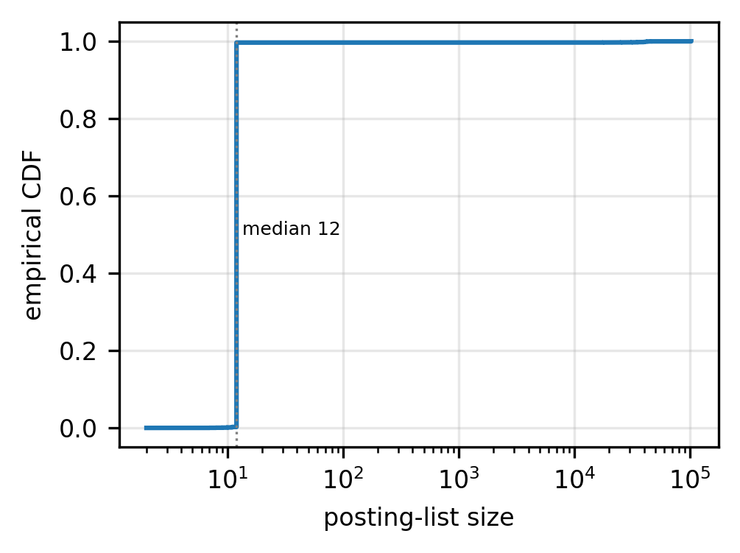
Fig. 2. Posting-list size CDF, second corpus. Flatter than the primary corpus (Fig. 8): median 12 against 35.
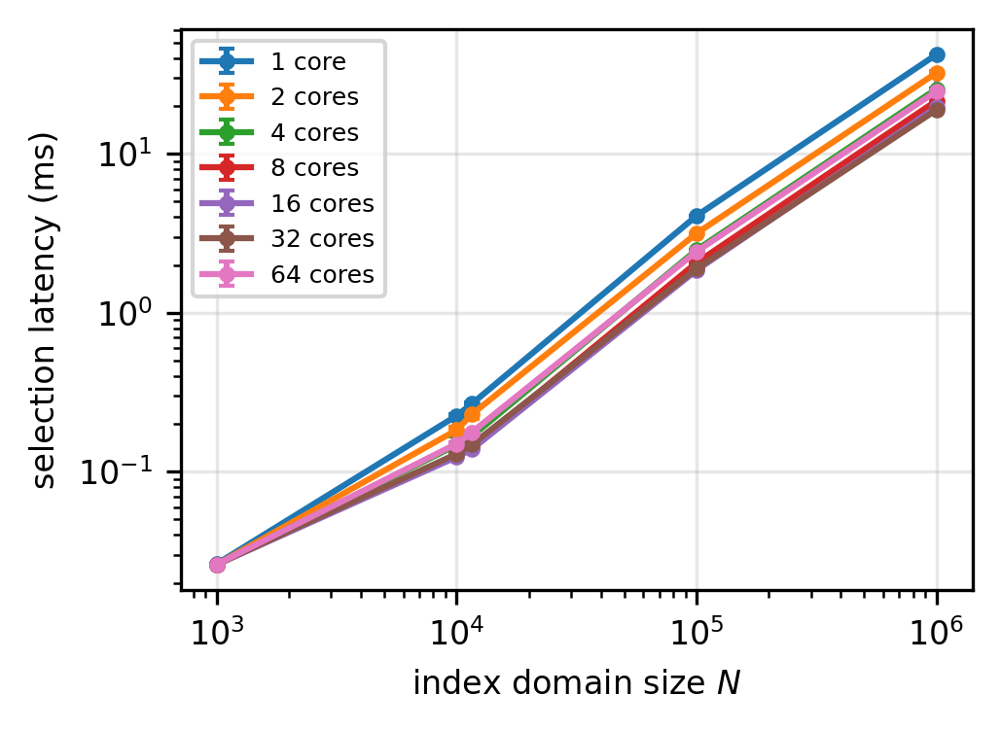
Fig. 3. Selection latency against N at several thread counts. Medians of 21 runs; error bars are the interquartile range.
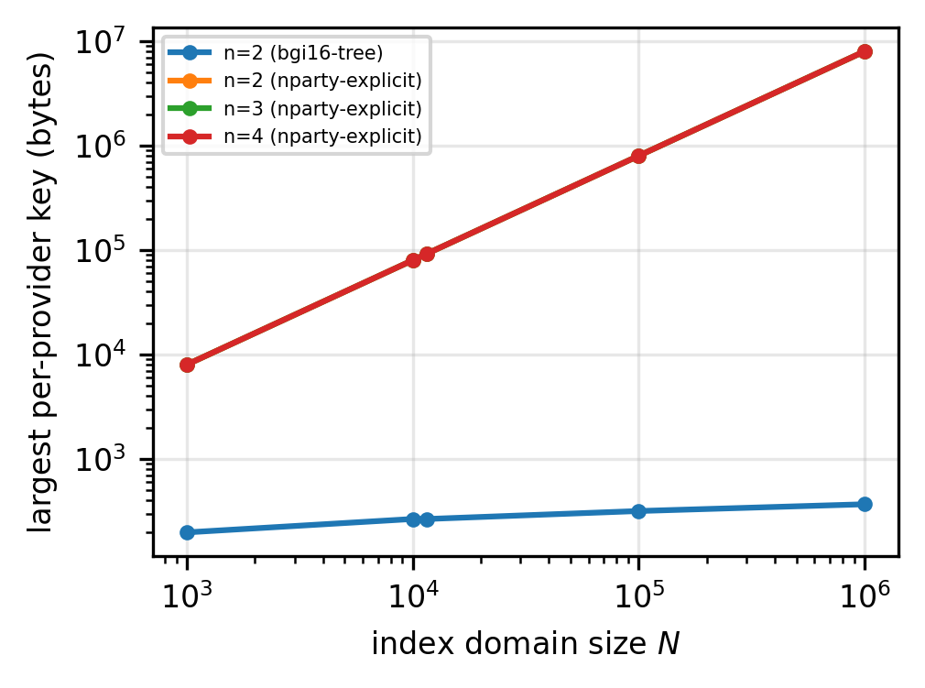
Fig. 4. Largest per-provider DPF key against N, for the two-party tree and the non-succinct n-party instantiation.
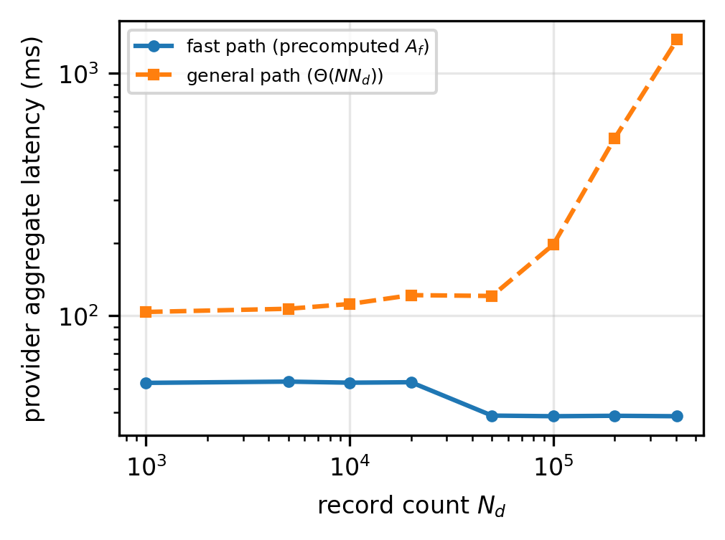
Fig. 5. Aggregate latency, fast against general path. The x-axis is N_{d}, not |S|: cost no longer depends on the matched-set size. The fast path is flat to ±0.5% over a 405× range.
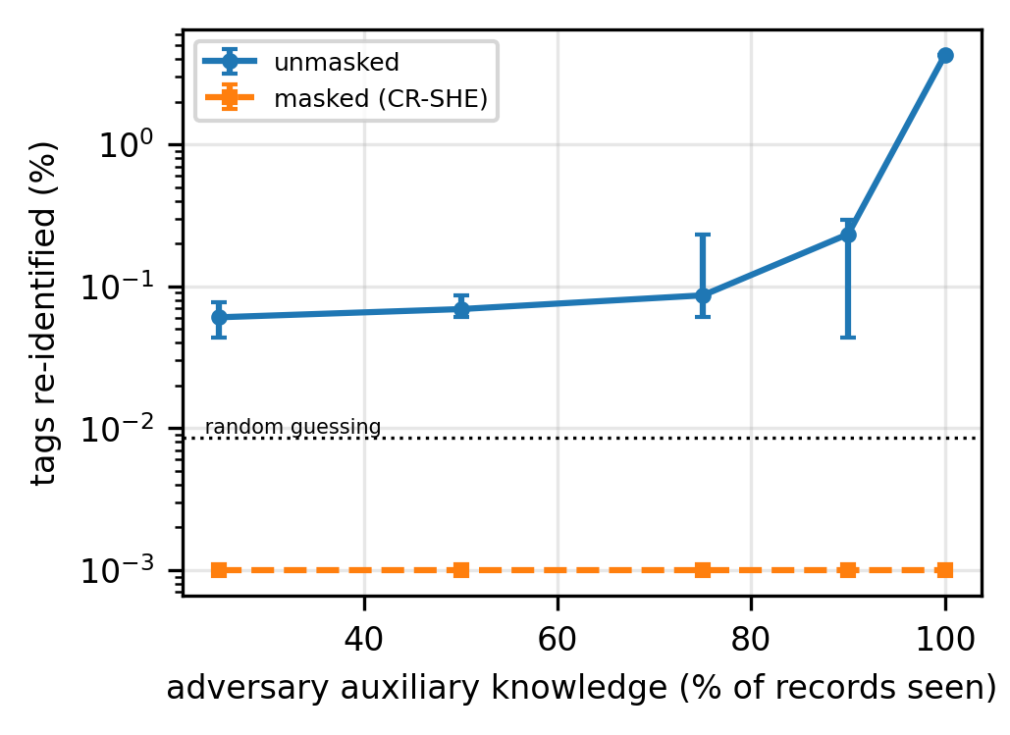
Fig. 6. Tag re-identification against the unmasked and masked index, against the adversary's auxiliary knowledge. Table 9 breaks it down by class.
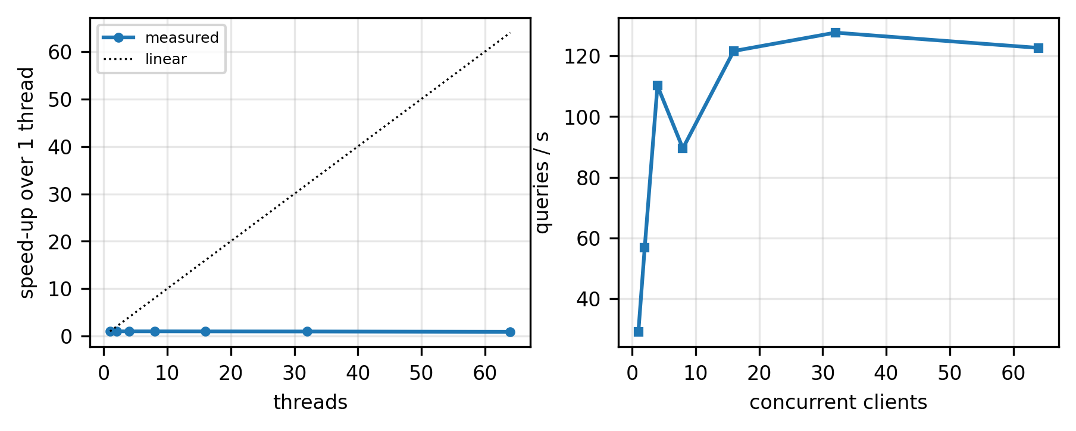
Fig. 7. Left: speed-up of one fast-path query with thread count. Right: sustained throughput against concurrent clients.
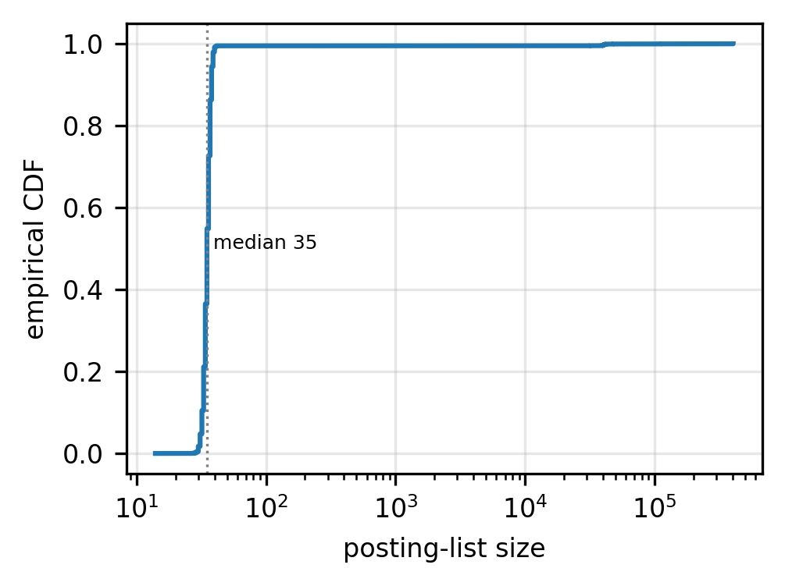
Fig. 8. Posting-list size CDF, primary corpus. Retained to characterise the corpus and to set the retrieval padding bound k_{max}.
10.13. Discussion
The fast path does what it was designed to do. Aggregate latency is flat to ±0.5% over a 405× range of N_{d}, per-query downlink is two ciphertexts independent of |S|, and provider compute is flat in n. A registered single-keyword aggregate costs 3.3× less than a distributed-trust baseline that only selects and 617× less than a faithful homomorphic scan, and on the general path oblivious analytics adds about half again to the cost of oblivious selection. Selection is linear-work per provider on both paths; the fast path removes the dependence on record count but restricts queries to single keywords and templates registered at setup.
The general path is bounded by storage, not by time. Its Θ(N N_{d}) contraction reaches 1.38,s at the full corpus, but its masked index is 37.5,GB per provider on the primary corpus and 118.2,GB on the second, replicated n times and resident for every query. Ad-hoc weight vectors and conjunctions pay that price. Streaming the index from storage in blocks would bound resident memory at the cost of I/O, though not the work, since an aggregate needs every record's contribution; a ℤ_{p} with p<2³² would halve the index at the cost of magnitude headroom.
Device diversity does not change the picture. The primary corpus has three physical devices. The twelve-site corpus, with three times the tag domain, reproduces the per-class leakage result exactly and costs 5% more on the fast path (Section 10.12).
10.14. Limitations
We collect here what the evaluation does not establish.
Deployment and hardware. Providers ran as separate processes on one host, so transport excludes wide-area latency, and no component was measured on gateway-class hardware. The data user's share of the work is one DPF key generation, 2(n-1) ciphertext additions and two decryptions, at 1.4–1.6,ms on our server (Table 8), and it is the part that would run at the edge. Measuring it, with energy, on a gateway, and running providers in distinct cloud regions, are the evaluations still to do.
Adversary. Providers are semi-honest. The MAC detects inconsistent responses except with probability 1/p, not a consistent linear substitution (Section 6.6), and per-user query authorisation is a requirement the prototype does not meet (Section 10.11).
Collusion beyond two providers. For n>2 the prototype uses a non-succinct sharing whose heavy key is 8N+16 bytes, 174× the two-party key on the primary corpus. Our key-size claims are for n=2.
Response size. An aggregate returns two BFV ciphertexts, 526,kB, for one scalar, and 8,191 of 8,192 slots go unused. Switching to a smaller ciphertext modulus before returning, and packing several templates into the slots of one response, are standard reductions we have not applied or measured.
Leakage baseline. Our attack contrasts the masked index with an unmasked one. A comparison against a padded or volume-hiding index [35,36] would be more demanding and remains to be run.
Owner and ingest. The owner retains the plaintext and rebuilds each static tier under a fresh mask key. The prototype implements neither the insertion of new keywords nor per-tier re-keying (Section 6.8), and its rebuild measurement covers the fast-path columns only.
Statistical term. Theorem 1 carries N N_{d}2^{-ω}≈2^{-31.9} at the prototype's ω=64; sampling mask values by rejection would remove it.
Model. The construction assumes a single data owner and full delegation of decryption to authorised users; multi-owner sharing and threshold or attribute-based delegation are natural extensions. Post-quantum instantiation follows from the lattice-based homomorphic layer for confidentiality, though the DPF's concrete security must be revisited.
11. Conclusion
This paper addressed a composition leak in distributed-trust query systems: hiding which records a query selects is of limited value if aggregating over them hands the selection back to the servers. CR-SHE removes that leak with oblivious homomorphic aggregation, in which each provider contracts its own distributed-point-function share directly against the homomorphically encrypted record column and returns a single ciphertext, so the matched set is never assembled at any provider and its cardinality never leaves the client. A precomputed-column variant makes single-keyword aggregates independent of the record count, and a one-time-pad index mask, cancelled inside the ciphertext, removes the posting-list leakage a replicated index otherwise exposes at rest. We proved correctness and adaptive security against a coalition of up to t=n-1 providers with a per-query leakage profile revealing only the requested aggregate class, over data encrypted under a single owner's key and without any communication between providers. On two real IoT corpora the prototype answers a registered single-keyword aggregate in 39,ms per provider, independently of the record count and of the matched-set size, which places end-to-end obliviousness within reach of a multi-cloud IoT deployment rather than beyond it. Future work will pursue sublinear preprocessing, verification and authorisation proofs compatible with non-interacting providers, a wide-area multi-cloud and edge-hardware evaluation, multi-owner multi-key deployment, and richer predicates than single-keyword selection.
Declaration of competing interest
The authors declare that they have no known competing financial interests or personal relationships that could have appeared to influence the work reported in this paper.
Declaration of generative AI and AI-assisted technologies in the writing process
The authors did not use generative AI or AI-assisted technologies in the preparation of this work beyond routine language and grammar checking, and they reviewed and edited the content as needed and take full responsibility for the content of the published article.
CRediT authorship contribution statement
Md Mazharul Islam: Conceptualization, Methodology, Software, Formal analysis, Investigation, Validation, Writing – original draft, Writing – review and editing.
Mubasshir Ahmed: Software, Data curation, Investigation, Writing – review and editing.
Md Redowan Zaman Anik: Software, Data curation, Visualization, Validation, Writing – review and editing.
References
[1] Atzori, L., Iera, A., Morabito, G., The Internet of Things: A Survey, Computer Networks, 54 (15), pp. 2787–2805, 2010.
[2] Petcu, D., Multi-Cloud: Expectations and Current Approaches, Proc. Int. Workshop on Multi-Cloud Applications and Federated Clouds (MultiCloud), pp. 1–6, 2013.
[3] Grozev, N., Buyya, R., Inter-Cloud Architectures and Application Brokering: Taxonomy and Survey, Software: Practice and Experience, 44 (3), pp. 369–390, 2014.
[4] Song, D. X., Wagner, D., Perrig, A., Practical Techniques for Searches on Encrypted Data, Proc. IEEE Symposium on Security and Privacy (S&P), pp. 44–55, 2000.
[5] Curtmola, R., Garay, J., Kamara, S., Ostrovsky, R., Searchable Symmetric Encryption: Improved Definitions and Efficient Constructions, Proc. 13th ACM Conference on Computer and Communications Security (CCS), pp. 79–88, 2006.
[6] Islam, M., Palit, R., A Keyword Based Searching and Sharing Scheme on the Encrypted Cloud Data, 2023 14th International Conference on Computing Communication and Networking Technologies (ICCCNT), pp. 1–6, 2023.
[7] Fan, J., Vercauteren, F., Somewhat practical fully homomorphic encryption, Cryptology ePrint Archive, 2012.
[8] Cheon, J. H., Kim, A., Kim, M., Song, Y., Homomorphic Encryption for Arithmetic of Approximate Numbers, Cryptology ePrint Archive, Paper 2016/421, 2016.
[9] Islam, M. S., Kuzu, M., Kantarcioglu, M., Access Pattern Disclosure on Searchable Encryption: Ramification, Attack and Mitigation, Proc. Network and Distributed System Security Symposium (NDSS), 2012.
[10] Cash, D., Grubbs, P., Perry, J., Ristenpart, T., Leakage-Abuse Attacks Against Searchable Encryption, Proc. 22nd ACM SIGSAC Conference on Computer and Communications Security (CCS), pp. 668–679, 2015.
[11] Grubbs, P., Sekniqi, K., Bindschaedler, V., Naveed, M., Ristenpart, T., Leakage-Abuse Attacks against Order-Revealing Encryption, Proc. IEEE Symposium on Security and Privacy (S&P), pp. 655–672, 2017.
[12] Wang, F., Yun, C., Goldwasser, S., Vaikuntanathan, V., Zaharia, M., Splinter: Practical Private Queries on Public Data, Proc. 14th USENIX Symposium on Networked Systems Design and Implementation (NSDI), pp. 299–313, 2017.
[13] Dauterman, E., Feng, E., Luo, E., Popa, R. A., Stoica, I., DORY: An Encrypted Search System with Distributed Trust, Proc. 14th USENIX Symposium on Operating Systems Design and Implementation (OSDI), pp. 1101–1119, 2020.
[14] Dauterman, E., Rathee, M., Popa, R. A., Stoica, I., Waldo: A Private Time-Series Database from Function Secret Sharing, Proc. IEEE Symposium on Security and Privacy (S&P), 2022.
[15] Eskandarian, S., Corrigan-Gibbs, H., Zaharia, M., Boneh, D., Express: Lowering the Cost of Metadata-Hiding Communication with Cryptographic Privacy, Proc. 30th USENIX Security Symposium, 2021.
[16] Corrigan-Gibbs, H., Boneh, D., Prio: Private, Robust, and Scalable Computation of Aggregate Statistics, Proc. 14th USENIX Symposium on Networked Systems Design and Implementation (NSDI), pp. 259–282, 2017.
[17] Boneh, D., Boyle, E., Corrigan-Gibbs, H., Gilboa, N., Ishai, Y., Lightweight Techniques for Private Heavy Hitters, Proc. IEEE Symposium on Security and Privacy (S&P), pp. 762–776, 2021.
[18] Servan-Schreiber, S., Beyzerov, S., Yablon, E., Park, H., Private Access Control for Function Secret Sharing, Proc. IEEE Symposium on Security and Privacy (S&P), 2023.
[19] Gilboa, N., Ishai, Y., Distributed point functions and their applications, Annual International Conference on the Theory and Applications of Cryptographic Techniques, pp. 640–658, 2014.
[20] Boyle, E., Gilboa, N., Ishai, Y., Function Secret Sharing, Advances in Cryptology – EUROCRYPT 2015, 9057, pp. 337–367, 2015.
[21] Boyle, E., Gilboa, N., Ishai, Y., Function secret sharing: Improvements and extensions, Proceedings of the 2016 ACM SIGSAC conference on computer and communications security, pp. 1292–1303, 2016.
[22] de Castro, L., Polychroniadou, A., Lightweight, Maliciously Secure Verifiable Function Secret Sharing, Advances in Cryptology – EUROCRYPT 2022, 13275, 2022.
[23] Chor, B., Kushilevitz, E., Goldreich, O., Sudan, M., Private Information Retrieval, Journal of the ACM, 45 (6), pp. 965–981, 1998.
[24] Beimel, A., Ishai, Y., Malkin, T., Reducing the Servers' Computation in Private Information Retrieval: PIR with Preprocessing, Advances in Cryptology – CRYPTO 2000, 1880, pp. 55–73, 2000.
[25] Storrier, K., Vadapalli, A., Lyons, A., Henry, R., Grotto: Screaming Fast $(2+1)$-PC for $_2^n$ via $(2,2)$-DPFs, Proc. ACM SIGSAC Conference on Computer and Communications Security (CCS), 2023.
[26] Doerner, J., shelat, a., Scaling ORAM for Secure Computation, Proc. ACM SIGSAC Conference on Computer and Communications Security (CCS), 2017.
[27] Corrigan-Gibbs, H., Kogan, D., Private Information Retrieval with Sublinear Online Time, Advances in Cryptology – EUROCRYPT 2020, 2020.
[28] Corrigan-Gibbs, H., Henzinger, A., Kogan, D., Single-Server Private Information Retrieval with Sublinear Amortized Time, Advances in Cryptology – EUROCRYPT 2022, 2022.
[29] Zhou, M., Park, A., Zheng, W., Shi, E., Piano: Extremely Simple, Single-Server PIR with Sublinear Server Computation, Proc. IEEE Symposium on Security and Privacy (S&P), 2024.
[30] Angel, S., Chen, H., Laine, K., Setty, S., PIR with Compressed Queries and Amortized Query Processing, Proc. IEEE Symposium on Security and Privacy (S&P), 2018.
[31] Mughees, M. H., Chen, H., Ren, L., OnionPIR: Response Efficient Single-Server PIR, Proc. ACM SIGSAC Conference on Computer and Communications Security (CCS), 2021.
[32] Menon, S. J., Wu, D. J., Spiral: Fast, High-Rate Single-Server PIR via FHE Composition, Proc. IEEE Symposium on Security and Privacy (S&P), 2022.
[33] Davidson, A., Pestana, G. C. S., FrodoPIR: Simple, Scalable, Single-Server Private Information Retrieval, Proceedings on Privacy Enhancing Technologies, 2023 (1), 2023.
[34] Goldreich, O., Ostrovsky, R., Software protection and simulation on oblivious RAMs, Journal of the ACM (JACM), 43 (3), pp. 431–473, 1996.
[35] Kamara, S., Moataz, T., Computationally Volume-Hiding Structured Encryption, Advances in Cryptology – EUROCRYPT 2019, 2019.
[36] Patel, S., Persiano, G., Yeo, K., Yung, M., Mitigating Leakage in Secure Cloud-Hosted Data Structures: Volume-Hiding for Multi-Maps via Hashing, Proc. ACM SIGSAC Conference on Computer and Communications Security (CCS), 2019.
[37] Xu, W., Zhang, J., Yuan, Y., Li, Z., Privacy-preserving multi-cloud based dynamic symmetric searchable encryption, 2021 2nd International Conference on Computer Communication and Network Security (CCNS), pp. 176–181, 2021.
[38] Xu, W., Zhang, J., Yuan, Y., Wang, X., Symmetric searchable encryption with supporting search pattern and access pattern protection in multi-cloud, Concurrency and Computation: Practice and Experience, 35 (9), pp. e7651, 2023.
[39] Zhang, X., Huang, C., Su, Y., Qin, J., Secure, dynamic, and efficient keyword search with flexible merging for cloud storage, IEEE Transactions on Services Computing, 17 (5), pp. 2822–2835, 2024.
[40] Yang, N., Tang, C., Zhou, Q., He, D., Dynamic consensus committee-based for secure data sharing with authorized multi-receiver searchable encryption, IEEE Transactions on Information Forensics and Security, 18, pp. 5186–5199, 2023.
[41] Du, R., Jiang, H., Li, M., Lightweight Searchable Encryption with Small Clients on Edge Cloud, 2022 17th Asia Joint Conference on Information Security (AsiaJCIS), pp. 41-48, 2022. doi:10.1109/AsiaJCIS57030.2022.00017.
[42] Halder, S., Newe, T., Enabling secure time-series data sharing via homomorphic encryption in cloud-assisted IIoT, Future Generation Computer Systems, 133, 2022. doi:10.1016/j.future.2022.03.032.
[43] Kamble, A., Jiet, M. M., Puri, C., Homomorphic encryption and its applications in multi-cloud security, 2024 International Conference on Inventive Computation Technologies (ICICT), pp. 1493–1499, 2024.
[44] Burkhalter, L., Hithnawi, A., Viand, A., Shafagh, H., Ratnasamy, S., TimeCrypt: Encrypted Data Stream Processing at Scale with Cryptographic Access Control, Proc. 17th USENIX Symposium on Networked Systems Design and Implementation (NSDI), pp. 835–850, 2020.
[45] Burkhalter, L., K\"uchler, N., Viand, A., Shafagh, H., Hithnawi, A., Zeph: Cryptographic Enforcement of End-to-End Data Privacy, Proc. 15th USENIX Symposium on Operating Systems Design and Implementation (OSDI), pp. 387–404, 2021.
[46] Xu, C., Wang, N., Zhu, L., Sharif, K., Zhang, C., Achieving searchable and privacy-preserving data sharing for cloud-assisted E-healthcare system, IEEE Internet of Things Journal, 6 (5), pp. 8345–8356, 2019.
[47] Wu, D., Nie, C., Yang, Z., Zhang, P., Wang, R., Distributed Secure Data Sharing Method for Internet of Vehicles Based on Homomorphic Hash Tree, IEEE Transactions on Vehicular Technology, 73 (11), pp. 17572-17585, 2024. doi:10.1109/TVT.2024.3422974.
[48] Verma, A. K., Patel, P., Bhatia, V. S., Rastogi, A., Prasad, A., Ranjan, P., Secure Federated Multi-Party Computation with Homomorphic Encryption and Blockchain for Preserving Privacy in Cloud Storage of Medical Records, 2025 2nd International Conference on Intelligent Algorithms for Computational Intelligence Systems (IACIS), pp. 1–6, 2025.
[49] Bharot, N., Mehta, N., Breslin, J. G., Verma, P., Cloudlock: secure data sharing using a hybrid cryptosystem in multi-cloud data storage, Cluster Computing, 28 (7), pp. 464, 2025.
[50] Muthuvel, S., Priya, S., Kumar, K., Design of a multi-layered privacy-preserving architecture for secure medical data exchange in cloud environments, Scientific Reports, 16, 2026. doi:10.1038/s41598-026-40122-4.
[51] Wang, L., Yang, Z., Song, X., SHAMC: A Secure and highly available database system in multi-cloud environment, Future Generation Computer Systems, 105, pp. 873–883, 2020.
[52] Horkos, D., Perret, L., $$: On Cryptography for Multi-Cloud Storage, Cryptology ePrint Archive, Paper 2026/207, 2026.
[53] Poddar, R., Boelter, T., Popa, R. A., Arx: An Encrypted Database Using Semantically Secure Encryption, Proceedings of the VLDB Endowment, 12 (11), 2019.
[54] Crooks, N., Burke, M., Cecchetti, E., Harel, S., Agarwal, R., Alvisi, L., Obladi: Oblivious Serializable Transactions in the Cloud, Proc. 13th USENIX Symposium on Operating Systems Design and Implementation (OSDI), 2018.
[55] Dauterman, E., Fang, V., Demertzis, I., Crooks, N., Popa, R. A., Snoopy: Surpassing the Scalability Bottleneck in Oblivious Storage, Proc. 28th ACM Symposium on Operating Systems Principles (SOSP), 2021.
[56] Goldreich, O., Goldwasser, S., Micali, S., How to construct random functions, providing sound foundations for cryptography: On the Work of Shafi Goldwasser and Silvio Micali, pp. 241–264, 2019.
[57] Al Badawi, A., Bates, J., Bergamaschi, F., Cousins, D. B., others, OpenFHE: Open-Source Fully Homomorphic Encryption Library, Proc. 10th Workshop on Encrypted Computing & Applied Homomorphic Cryptography (WAHC), pp. 53–63, 2022.
[58] Stafford, G. A., Environmental Sensor Telemetry Data, Kaggle Datasets, 2020.
[59] Zhang, S., Guo, B., Dong, A., He, J., Xu, Z., Chen, S. X., Cautionary Tales on Air-Quality Improvement in Beijing, Proceedings of the Royal Society A, 473 (2205), pp. 20170457, 2017. doi:10.1098/rspa.2017.0457.

