CPS Testbed Cluster
GridPACK on MPI (power flow and dynamic simulation), NS-3 and HELICS co-simulation with a Node-RED dashboard
System Description, Installation and User Guide
Remotely Accessible Cyber-Physical System Testbed and Open Architecture Synchrophasor Systems
NSU–PGCB project (EPRC/58-2018-007-01)
Md. Mazharul Islam
October 2026 · Version 1.1 (dynamic simulation)
github.com/mazharulmd/cps-testbed-cluster
Contents

The table of contents is filled in when the document is opened in Microsoft Word (if Word asks to update fields, answer Yes) or with right-click → Update Field. The PDF version has it already.

1. Introduction

1.1 Why this testbed
The power grid is watched by phasor measurement units (PMUs): devices at substations that measure voltage and current about 30 times a second and send these measurements over a communication network to a phasor data concentrator (PDC) and on to the control center. The control center estimates the state of the whole grid from them and acts when something is wrong, for example by lowering the voltage setpoint of a generator.
Two things can go wrong between the grid and the control center: the network can delay or lose measurements, and an attacker can change them (a false data injection, FDI) so that the control center sees a safe grid while the real one is in danger. Such situations cannot be tried on the real grid. The testbed reproduces the grid, the network and the control center in software so that they can be studied safely and repeatably.

1.2 Target of the project
Goal | How the testbed meets it
Run the grid simulation (GridPACK) on a cluster with MPI | GridPACK runs as one persistent MPI job per experiment, partitioned over the MPI ranks of the cluster nodes (Section 3.5).
Couple grid, communication network and control center | GridPACK, NS-3 and the control center are HELICS federates on a common simulated clock, in a closed loop (Section 3.2).
Remotely accessible testbed | Users work in a web dashboard (Node-RED) with a login, reached over a VPN or SSH tunnel (Section 6).
Users bring their own scenarios and grids | Scenario files (YAML/JSON) and grid models (MATPOWER) are uploaded on the dashboard; results and a live view are shown there (Section 6).
Run on Ubuntu servers with or without containers | One installer for Ubuntu 24.04 and a Docker image built by the same scripts (Section 4).

1.3 This document
Section 2 explains the ideas in plain language. Section 3 describes the architecture, Section 4 the installation, Section 5 the cluster set-up, Section 6 the dashboard with screenshots, Section 7 the output files and Section 8 the test results. Sizing, limitations and troubleshooting follow.

2. Key concepts in plain language
A useful picture: electricity in the grid is like water in pipes, and voltage is like water pressure. Too high and equipment is damaged; too low and devices stop working. Everything in the testbed exists to keep watching that "pressure" and to correct it, even when the messages carrying the measurements are late, lost or forged.
In one line: the testbed is a safe "playground" of the power grid inside computers, where network problems and cyber attacks can be tried, many computers share the heavy calculation, and anyone can run experiments from a browser.
Table 1. The main terms
Term | What it is | Role in the testbed
Power grid, bus | The network of power lines; a bus is a connection point (substation). | Simulated by GridPACK on IEEE test grids (14 to 300 buses) or uploaded grids (up to 10 000 buses tested).
PMU | A measuring device that reports voltage and current phasors 30 times per second. | Placed at the buses chosen by an optimal placement; simulated inside NS-3.
PDC | Collects the PMU frames of the same instant into one measurement set. | Simulated in NS-3 with a wait window for late frames.
Control center | The operator's system that estimates the grid state and acts. | Python federate: state estimation, bad data detection, generator setpoint control.
State estimation | Computing all bus voltages from the PMU measurements. | Weighted least squares on the linear PMU model.
Bad data detection | A chi-square test that flags measurements that do not fit together. | Detects and removes falsified PMUs when it can.
False data injection (FDI) | An attacker changes measurements to hide a problem. | Simple (one channel) and stealthy (consistent changes) attacks in NS-3; also delay and drop attacks.
Cluster, head, node | A group of computers working together; the head coordinates, nodes do the work. | Head: dashboard, API, HELICS broker. Nodes: GridPACK MPI ranks, NS-3, control center.
MPI | The standard way for programs on many computers to split one large calculation. | Used by GridPACK to solve the power flow on several ranks/nodes.
GridPACK | A power-system simulation library from PNNL built for MPI. | The "real" grid: a power flow every grid step (0.5 s), or a dynamic simulation of the generators every few milliseconds.
Quasi-steady state / dynamic | Two ways to simulate the grid: a series of balanced snapshots, or the machines' motion over time. | Scenario field mode: qss (power flow) or mode: dynamic (generators, exciters and governors integrated in steps of about 5 ms).
Frequency, rotor angle | How fast the generators turn (60 Hz when balanced) and where each rotor stands relative to the others. | Shown in dynamic runs: frequency falls when generation is lost; a growing angle spread means loss of synchronism.
NS-3 | A network simulator. | Simulates the PMU links, the PDC, attacks and the command path back to the generators.
HELICS | A co-simulation framework: a referee and post office for simulators. | Keeps GridPACK, NS-3 and the control center on one clock and passes their messages.
Federate | One simulator taking part in a HELICS co-simulation. | Grid, network, control center and observer.
Node-RED | A visual tool for building web dashboards and data flows. | The user interface: Experiments, Live, Results, Cluster and the IEEE 14 console.

3. Architecture

3.1 Overview
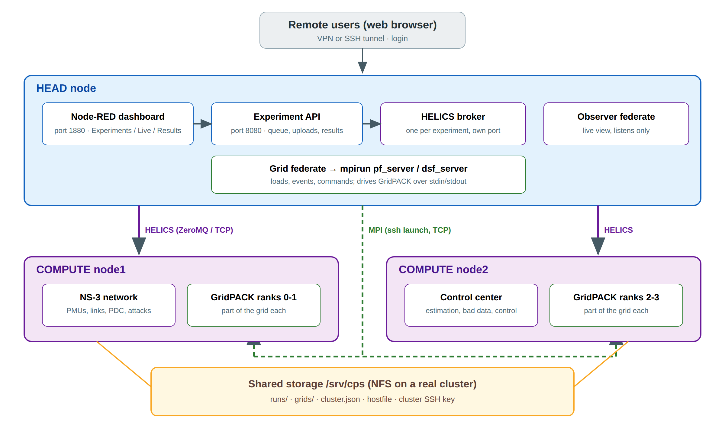
Figure 1. Architecture on a cluster with a head and two compute nodes. On a single server everything runs on one machine.
A head node hosts the user-facing services (Node-RED dashboard and experiment API), starts one HELICS broker per experiment and runs the grid federate, which launches GridPACK with mpirun on the compute nodes. The NS-3 and control-center federates can run on any node. All nodes share the data directory /srv/cps (NFS on a real cluster), where results, uploaded grids, the MPI hostfile and the cluster configuration are kept.
Table 2. Components
Component | Software | Where in the repository
Grid federate + MPI power flow or dynamic simulation | GridPACK 3.5 (patched), PETSc 3.19 (MUMPS), ParMETIS, Global Arrays 5.9, OpenMPI 4.1 | federates/grid_fed.py, gridpack/pf_server/, gridpack/dsf_server/, gridpack/patches/
Network federate | NS-3.48 with the HELICS C++ library | ns3-scratch/helicstest/
Control-center federate | Python (NumPy, SciPy sparse) | federates/cc_fed.py, federates/cpslib/estimation.py
Observer federate (live view) | Python | federates/observer_fed.py
Co-simulation | HELICS 3.6.1 (ZeroMQ core) | federates/run_experiment.py, federates/cpslib/cluster.py
Experiment API | FastAPI (Python) | webapp/app.py, webapp/scenario.py
Dashboard | Node-RED 4.1, FlowFuse Dashboard 2 | node-red/flows.json
Installation | Bash, systemd, Docker | install/, docker/

3.2 The closed loop
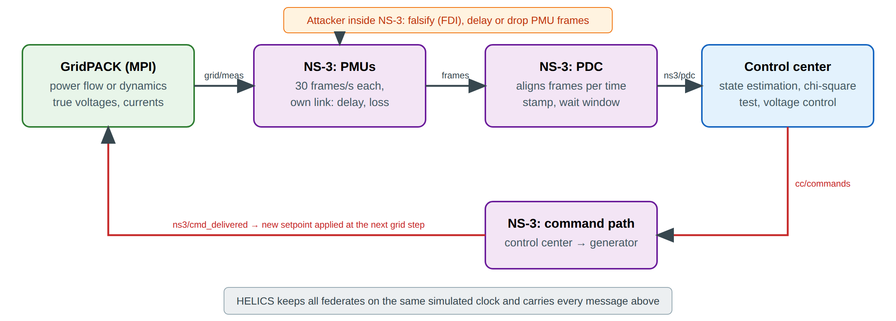
Figure 2. Data flow of one experiment. Measurements go from the grid to the control center; commands come back to the grid.
Every grid step GridPACK solves the power flow and the grid federate publishes the true phasors each PMU would measure. In NS-3 every PMU sends 30 frames per second over its own link, with its own delay, jitter and loss, to the PDC, which releases time-aligned sets to the control center. The control center estimates the state, runs the bad data test and, when a bus voltage is out of limits, sends a setpoint command to the nearest generator. The command travels back through NS-3 and GridPACK applies it at the next grid step. An attacker inside NS-3 can falsify, delay or drop the frames of selected PMUs.
In dynamic mode the grid step is one PMU frame (1/30 s): GridPACK integrates the machines up to the frame time, so every frame carries the transient (voltage dips, swings, frequency changes), and a command is applied by moving the exciter reference of the generator at the next frame.

3.3 HELICS messages
Table 3. HELICS publications
Topic | From → to | Content
grid/meas | grid → NS-3 | True voltage and current phasors of every PMU, each grid step
ns3/pdc | NS-3 → control center | Time-aligned PMU sets released by the PDC
cc/commands | control center → NS-3 | Generator setpoint commands
ns3/cmd_delivered | NS-3 → grid | Commands that reached the generator, with delivery time
grid/status | grid → observer | All true bus voltages and the commands applied; in dynamic mode also frequencies and rotor angles (live view only)
cc/status | control center → observer | Chi-square test, alarms, completeness, estimates (live view only)

3.4 Single server and cluster
Table 4. Where each part runs
Part | Single server | Cluster (example)
Node-RED, API, HELICS broker, observer | the server | head
Grid federate (starts mpirun) | the server | head
GridPACK MPI ranks | the server's cores | compute nodes listed in CPS_NODES (e.g. 2 ranks on node1, 2 on node2)
NS-3 federate | the server | node set by CPS_PLACE_NS3 (e.g. node1)
Control-center federate | the server | node set by CPS_PLACE_CC (e.g. node2)
Data /srv/cps | local disk | shared over NFS by all nodes

3.5 GridPACK power flow on MPI: pf_server
pf_server is a small GridPACK application written for the testbed. It is started once per experiment with mpirun -np N (and a hostfile on a cluster). GridPACK reads the grid and partitions it over the N ranks a single time. Each grid step the grid federate writes the changed loads and generator setpoints to rank 0's standard input; rank 0 broadcasts them, every rank updates its part of the grid, the power flow is solved in parallel (PETSc with the MUMPS direct solver), and the bus voltages are gathered back to rank 0 and returned.
Table 5. pf_server protocol (one exchange per grid step)
Direction | Line | Meaning
to rank 0 | LOAD <bus> <P MW> <Q Mvar> | new load at a bus
to rank 0 | VSET <bus> <gen id> <V pu> | new generator voltage setpoint
to rank 0 | SOLVE / QUIT | apply the batch and solve / stop
from rank 0 | @@READY nbus= nranks= t_setup= | network read and partitioned
from rank 0 | @@RESULT ok= nbus= t_apply= t_solve= | solve finished, with timings
from rank 0 | @@V <bus> <Vm> <Va> … @@END | voltage of every bus

3.6 GridPACK dynamic simulation on MPI: dsf_server
dsf_server is the dynamic counterpart of pf_server, built on GridPACK's full-Y dynamic simulation module. It is started once per experiment with mpirun -np N. GridPACK solves the initial power flow, initialises every machine from its PSS/E dynamic data (.dyr) and then integrates the machine equations with a predictor-corrector method in steps of about 5 ms (seven steps per PMU frame). Faults and trips are scheduled in its input file; setpoint changes are sent while it runs.
Table 6. dsf_server protocol (one exchange per PMU frame)
Direction | Line | Meaning
to rank 0 | DVREF <bus> <gen id> <dV pu> | move the exciter voltage reference to its start value + dV (commands, AVR faults)
to rank 0 | STEP <t> / QUIT | integrate up to time t and report / stop
from rank 0 | @@READY nbus= ngen= nranks= t_setup= dt= | machines initialised; integration step
from rank 0 | @@RESULT t= nbus= ngen= t_apply= t_solve= | time reached, with timings
from rank 0 | @@V <bus> <Vm> <Va> <f Hz> | voltage and frequency of every bus
from rank 0 | @@G <bus> <id> <speed> <angle> <P> <Q> <on> … @@END | state of every machine
Table 7. Dynamic models and events
Item | Supported
Machines | GENROU, GENSAL, GENCLS (and GridPACK's other models in a .dyr file)
Exciters / governors | IEEET1, SEXS, ESST1A, EXDC1 (reference changeable at run time) / TGOV1, GGOV1, HYGOV, WSIEG1 …
Machine data | IEEE 39: published data (GENROU, IEEET1, TGOV1). Any grid: its own dynamics.dyr + dynamics.json (machine bases) in the grid directory. Otherwise typical data: GENROU, SEXS exciter, TGOV1 governor on a machine base of 1.25 × output
Events | three-phase bus fault with clearing time, line trip, generator trip, AVR setpoint fault
Loads | constant impedance
GridPACK 3.5 is built with a small patch (gridpack/patches/dynamic-simulation.patch): exciter references can be read and changed at run time, the network can be read directly so that dsf_server gathers voltages, frequencies and machine states on every rank (GridPACK's own observation functions lose buses and can hang on more than one rank), and a line trip no longer crashes on ranks that do not hold the line.

3.7 What uses MPI
Part | MPI? | Why
GridPACK | Yes | The power flow and the network solution of each integration step are large systems of equations; GridPACK is built to split them over MPI ranks.
HELICS | No (ZeroMQ over TCP) | HELICS only synchronises clocks and passes messages; ZeroMQ works on any network. HELICS also has an MPI core for supercomputers.
NS-3 | No | The PMU network (up to thousands of PMUs) runs in seconds on one node. NS-3's MPI mode is useful for far larger networks.
Control center | No | Each estimation is small (23 ms for 10 000 buses with sparse matrices).

4. Installation
There are two ways to install the testbed, and both run the same build scripts (install/steps/), so they contain the same software in the same places: directly on Ubuntu 24.04 (native) or as a Docker container. GridPACK, HELICS and NS-3 are compiled from source; the first installation takes about an hour.

4.1 Requirements
Item | Minimum | Recommended (single server)
Operating system | Ubuntu 24.04 x86-64 | Ubuntu 24.04 LTS server
CPU | 4 cores | 16 cores
Memory | 8 GB | 32 GB
Disk | 15 GB free | 500 GB SSD (results accumulate)
Network | Internet access during the installation | VPN or SSH access for remote users

4.2 Layout on disk
Path | Contents | Size
/opt/cps/ga, gridpack, helics, ns-3 | Global Arrays, GridPACK (+ pf_server, dsf_server), HELICS, NS-3 (+ network federate) | 0.44 GB
/opt/cps/venv | Python environment (federates, API) | 0.44 GB
/opt/cps/node-red | Node-RED user directory: flows, settings, Dashboard 2 | 0.14 GB
/opt/cps/testbed | Testbed code | 2 MB
Ubuntu packages | PETSc, OpenMPI, Boost, compilers, Node.js, … | 1.6 GB
/srv/cps | Data: runs/, grids/, legacy/, cluster.json, hostfile | grows with use (Section 9)
/etc/cps/cps.env | Settings read by the services | –

4.3 Native installation on Ubuntu 24.04
git clone https://github.com/mazharulmd/cps-testbed-cluster.git
cd cps-testbed-cluster
sudo ./install/install.sh
The installer builds the software, creates the system user cps, writes /etc/cps/cps.env, installs the command cps-run and starts two systemd services. At the end it prints the addresses of the dashboard and the API.
Table 8. Installation steps (install/steps)
Step | What it does | Skipped on re-run?
00-packages | Ubuntu packages: compilers, OpenMPI, PETSc, ParMETIS, Boost, ZeroMQ, Python, Node.js, OpenSSH | no (apt is idempotent)
10-ga | Global Arrays 5.9 (GridPACK's data layer) | yes
20-gridpack | GridPACK 3.5 from GitHub with the testbed patches | yes, unless the patches changed
30-helics | HELICS 3.6.1 C++ library and helics_broker | yes
40-ns3 | NS-3.48 with the modules the network federate needs | yes
50-python | Python environment from requirements.txt | updated
60-nodered | Node-RED 4.1.11 and Dashboard 2 | updated
70-testbed | Code, NS-3 federate, pf_server, dsf_server, library paths, Node-RED flows, data directories | always rebuilt
Re-running sudo ./install/install.sh after git pull updates the testbed in about one minute; results and uploaded grids are kept. A changed Node-RED flow is saved as flows.json.bak-<date> first.

4.4 Settings
Table 9. /etc/cps/cps.env
Variable | Meaning | Default
CPS_ROLE | head (dashboard, API, brokers) or node (compute node) | head
CPS_NODES | MPI hosts and slots, e.g. node1:16,node2:16; empty on a single server | empty
CPS_PLACE_NS3, CPS_PLACE_CC, CPS_PLACE_GRID | Nodes that run the NS-3, control-center and grid federates | the head
CPS_MPI_NP | Default GridPACK MPI ranks per experiment | 1
CPS_MAX_JOBS | Experiments that may run at the same time | 1
CPS_WEB_USER, CPS_WEB_PASSWORD | Login of the experiment API (and of the dashboard's calls to it) | admin / none
NODERED_ADMIN_USER, NODERED_ADMIN_HASH | Login of Node-RED (bcrypt hash) | admin / none
CPS_SHARED | Shared data directory | /srv/cps
OMPI_MCA_btl_tcp_if_include | Network interface for MPI between nodes | all

4.5 Logins
Without a password anyone who can reach ports 1880 and 8080 can run experiments. Set one before giving others access:
sudo cps-passwd # asks for the password twice; --off removes it
The same password then protects the dashboard, the Node-RED editor and the experiment API (user admin). cps-passwd stores it in /etc/cps/cps.env (for Node-RED as a bcrypt hash) and restarts both services. Use at least 8 characters and no quotes, backslashes or spaces.

4.6 Services
Command | Purpose
systemctl status cps-api cps-nodered | State of the API (port 8080) and Node-RED (port 1880)
journalctl -u cps-api -f | API and experiment queue log
journalctl -u cps-nodered -f | Node-RED log
sudo systemctl restart cps-api cps-nodered | Apply changed settings
systemctl status cps-node | Compute node service (cluster)
sudo -u cps cps-run --help | Run experiments from the command line

4.7 Docker
The image is built from docker/Dockerfile with the same steps, or pulled from the GitHub container registry, where the Container image workflow publishes it.
docker build -f docker/Dockerfile -t cps-testbed-cluster .
# or: docker pull ghcr.io/mazharulmd/cps-testbed-cluster:latest

docker compose -f docker/compose.yml up -d # single server, one container
docker compose -f docker/compose.cluster.yml up -d # head + 2 compute nodes on one machine
Compose file | Containers | Use
docker/compose.yml | testbed (head role) | Single server; GridPACK on the container's cores
docker/compose.cluster.yml | head, node1, node2 (2 MPI slots each) | Try the cluster on one machine; GridPACK on 4 ranks over node1 and node2, NS-3 on node1, control center on node2
The virtual cluster runs all containers on the same CPUs, so it shows that the cluster works but does not make experiments faster. Speed-up needs separate machines.

5. Setting up a cluster

5.1 Recommended hardware
Machine | Role | Hardware
Head (1) | Node-RED, API, HELICS brokers, grid federate; NFS server for /srv/cps | 8 cores, 16–32 GB RAM, 500 GB–1 TB SSD
Compute nodes (2–4) | GridPACK MPI ranks; NS-3 on one node, control center on another | 16–32 cores, 32–64 GB RAM, 100 GB SSD each
Network | Connects the machines | 1 Gbit/s minimum, 10 Gbit/s better for MPI

5.2 Steps
- Install every machine: sudo ./install/install.sh on the head, sudo ./install/install.sh --role node on each compute node.
- Share /srv/cps from the head over NFS and mount it at /srv/cps on every node, writable for user cps (same UID on all machines).
- Make the host names resolvable (DNS or /etc/hosts) and allow TCP between the machines (ssh, HELICS ports 23500 and up, MPI).
- On the head set CPS_NODES, CPS_PLACE_NS3, CPS_PLACE_CC, CPS_MPI_NP and CPS_MAX_JOBS in /etc/cps/cps.env and run sudo systemctl restart cps-api.
- The head creates the cluster SSH key in /srv/cps/.ssh; the cps-node service on each node installs it. journalctl -u cps-api shows "node1 reachable".
- Check the Cluster panel on the Experiments page (Figure below). The Cluster page (Section 6.4) changes the nodes, their MPI slots and the placement from the dashboard instead of cps.env.
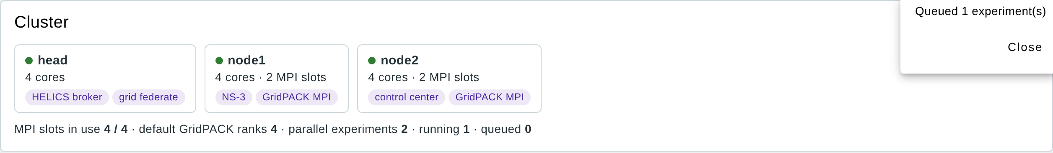
Figure 3. Cluster panel: the head runs the broker and the grid federate, node1 NS-3 and GridPACK ranks, node2 the control center and GridPACK ranks.

5.3 Scheduling
Up to CPS_MAX_JOBS experiments run at once, each with its own HELICS port. An experiment starts only when its GridPACK ranks fit in the free MPI slots; the others wait in the queue ("waiting for N MPI slots"). MPI ranks busy-wait, so running more ranks than slots slowed two parallel runs about ten times in a test (150 s instead of 13 s each).

6. Using the dashboard

6.1 Opening the dashboard
Address | What
http://<server>:1880/dashboard/experiments | Dashboard (Experiments, Live, Results, Cluster, IEEE 14 console)
http://<server>:1880 | Node-RED editor (flows)
http://<server>:8080/docs | Experiment API and its interactive documentation
From outside the institution use the VPN or an SSH tunnel, e.g. ssh -L 1880:localhost:1880 -L 8080:localhost:8080 user@server, then open http://localhost:1880/dashboard/experiments.

6.2 Experiments page
The page has five panels: Cluster (Figure in Section 5.2), New experiment (Section 6.3), Upload files, Grid models and Experiment queue.
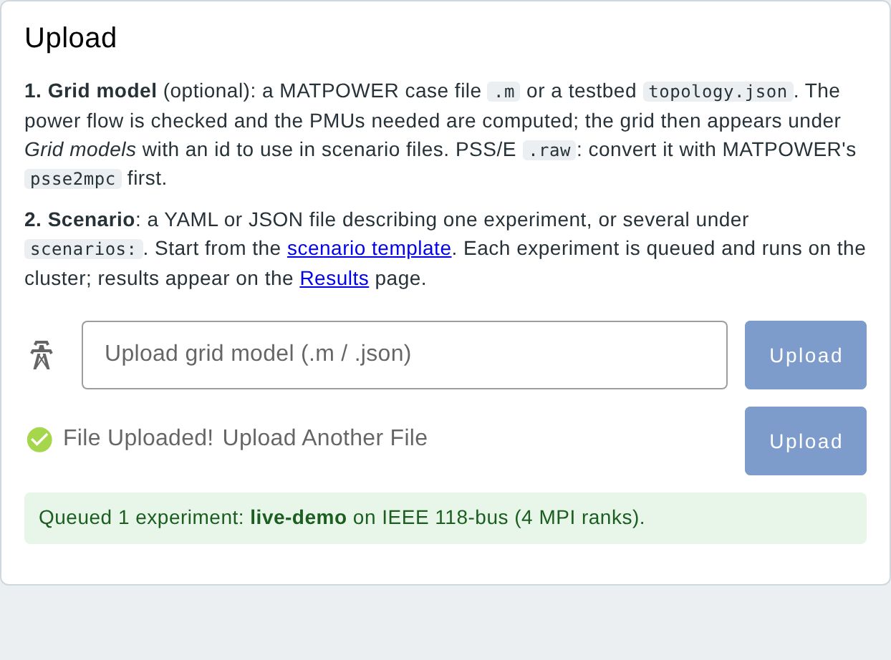
Figure 4. Upload panel after a scenario file was uploaded: the experiment was validated and queued with 4 MPI ranks.
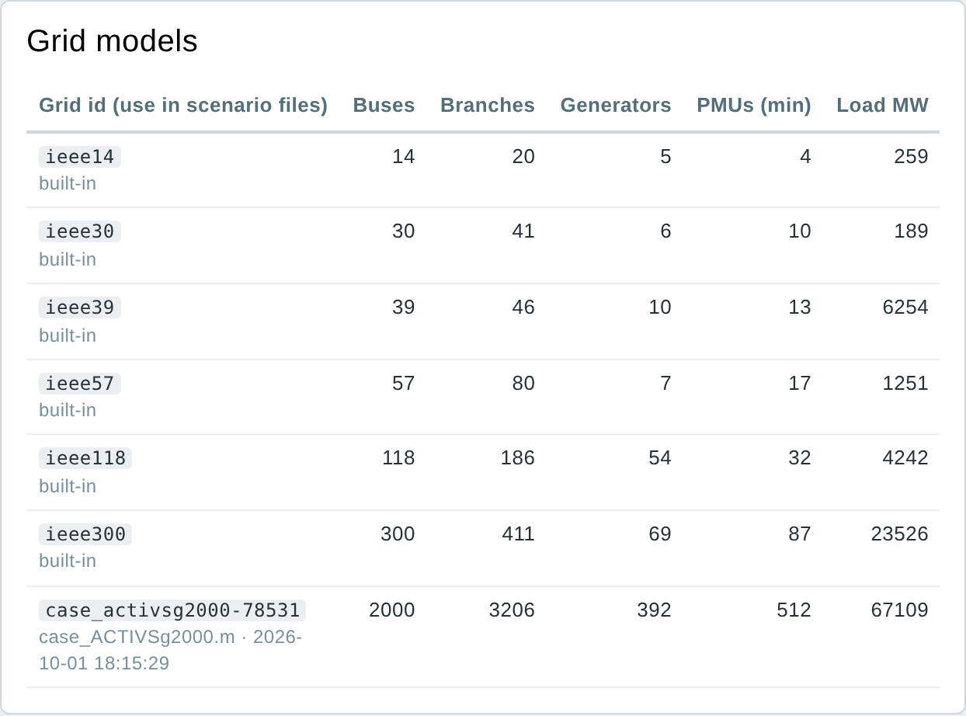
Figure 5. Grid models: the built-in IEEE grids and an uploaded 2000-bus grid with its id, size and the PMUs needed.
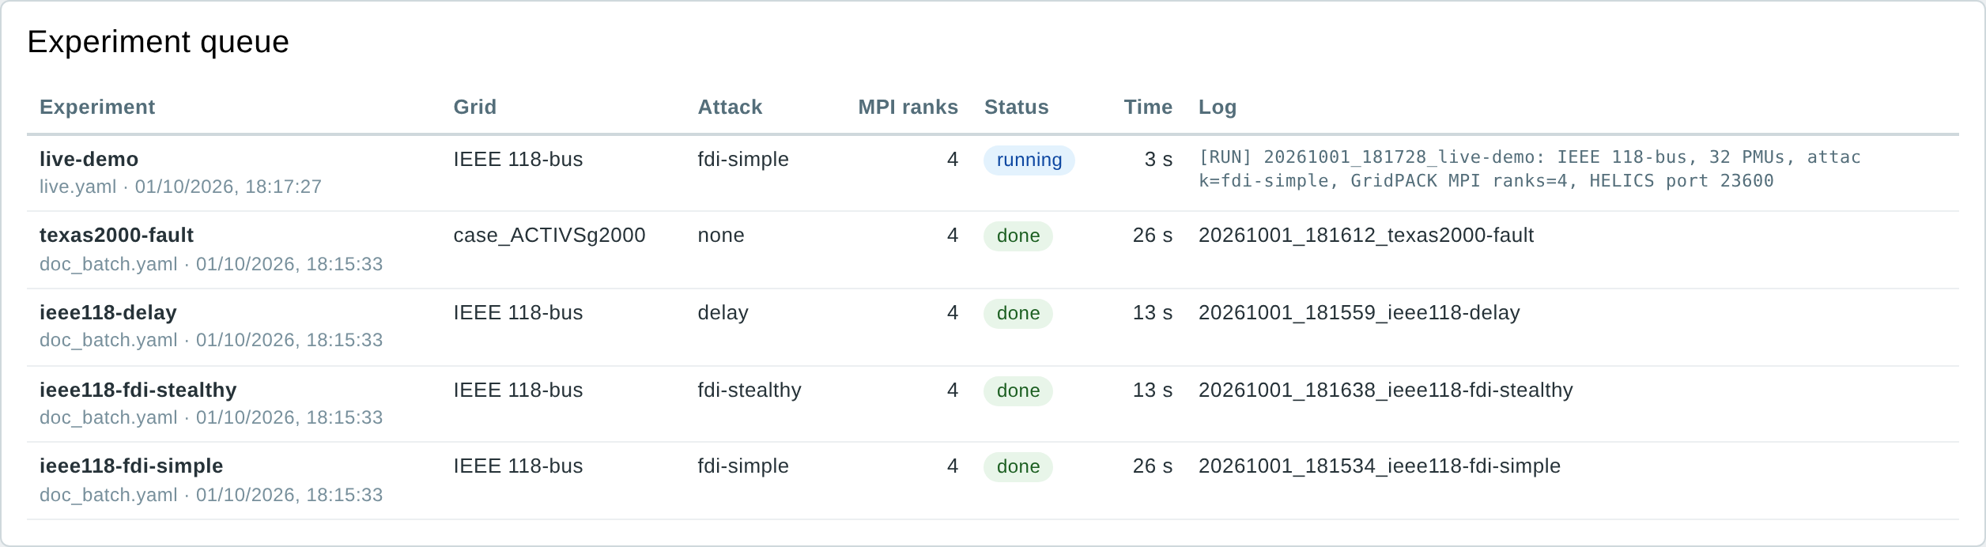
Figure 6. Experiment queue: status, MPI ranks, run time and the run directory of each experiment.

6.3 Running an experiment from the form
New experiment runs one experiment without writing a file. The buttons at the top fill the form with a ready-made scenario; every field can then be changed before pressing Run experiment. The form offers only what the chosen grid has: its generator buses for an AVR fault or a generator trip, its buses for a fault or a load step, its lines for a line trip.
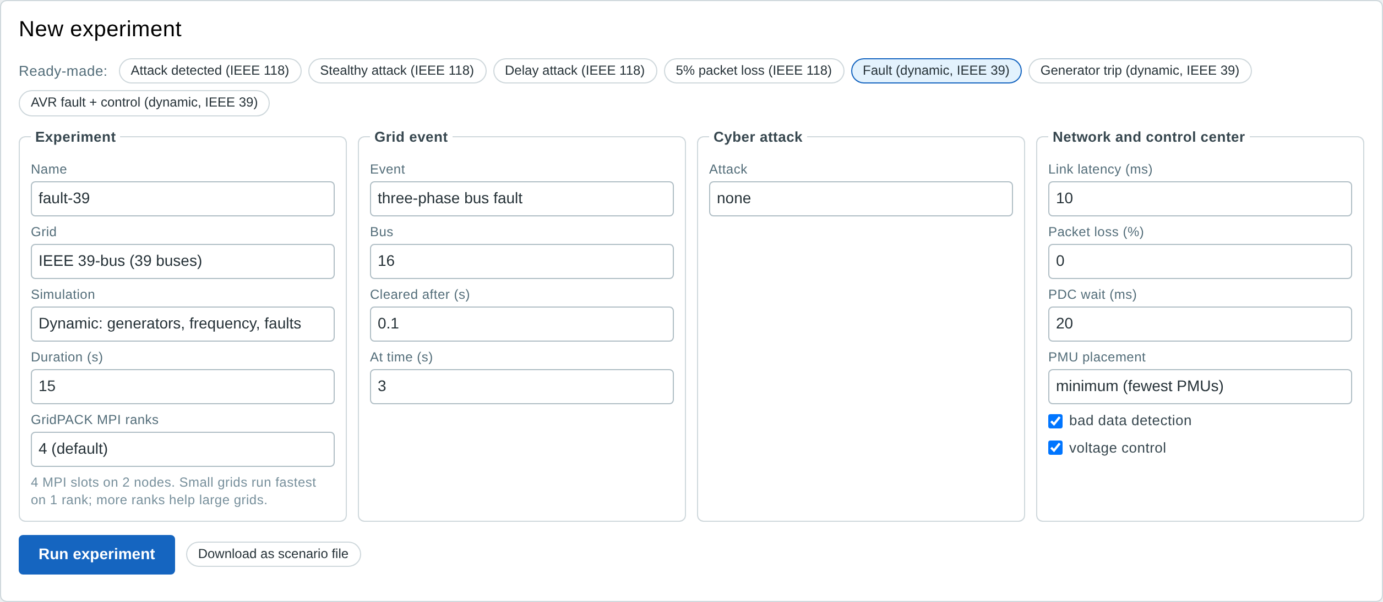
Figure 7. The New experiment panel after choosing the ready-made "Fault (dynamic, IEEE 39)".
Ready-made scenario | What it shows
Attack detected (IEEE 118) | AVR fault at generator 49 hidden by a simple false data injection; bad data detection finds the PMU and the control acts
Stealthy attack (IEEE 118) | All channels of the target changed consistently; not detected
Delay attack (IEEE 118) | PMU frames around bus 49 delayed by 100 ms; they miss the PDC window
5% packet loss (IEEE 118) | Lossy links without an attack
Fault (dynamic, IEEE 39) | Three-phase fault at bus 16, cleared after 0.1 s
Generator trip (dynamic, IEEE 39) | Generator 32 (650 MW) trips; frequency falls and recovers
AVR fault + control (dynamic, IEEE 39) | Generator 30 setpoint jumps to 1.12 pu; the control center corrects it

GridPACK MPI ranks lists the choices the cluster allows, with the default of the Cluster page marked. Download as scenario file saves the form as a YAML file that can be edited and uploaded later, for example to run it again or to build a file with several experiments. After Run experiment the answer appears under the buttons (or the reason the experiment was refused), with a link to the Live page.

6.4 Cluster page
The Cluster page shows the nodes and changes the cluster without editing files. Save applies the settings at once to the experiments started afterwards: MPI slots, the queue and the number of experiments at the same time follow immediately, and nodes that do not answer over ssh are named. The settings are kept in /srv/cps/cluster_settings.json and take precedence over /etc/cps/cps.env; Use the settings file goes back to it.
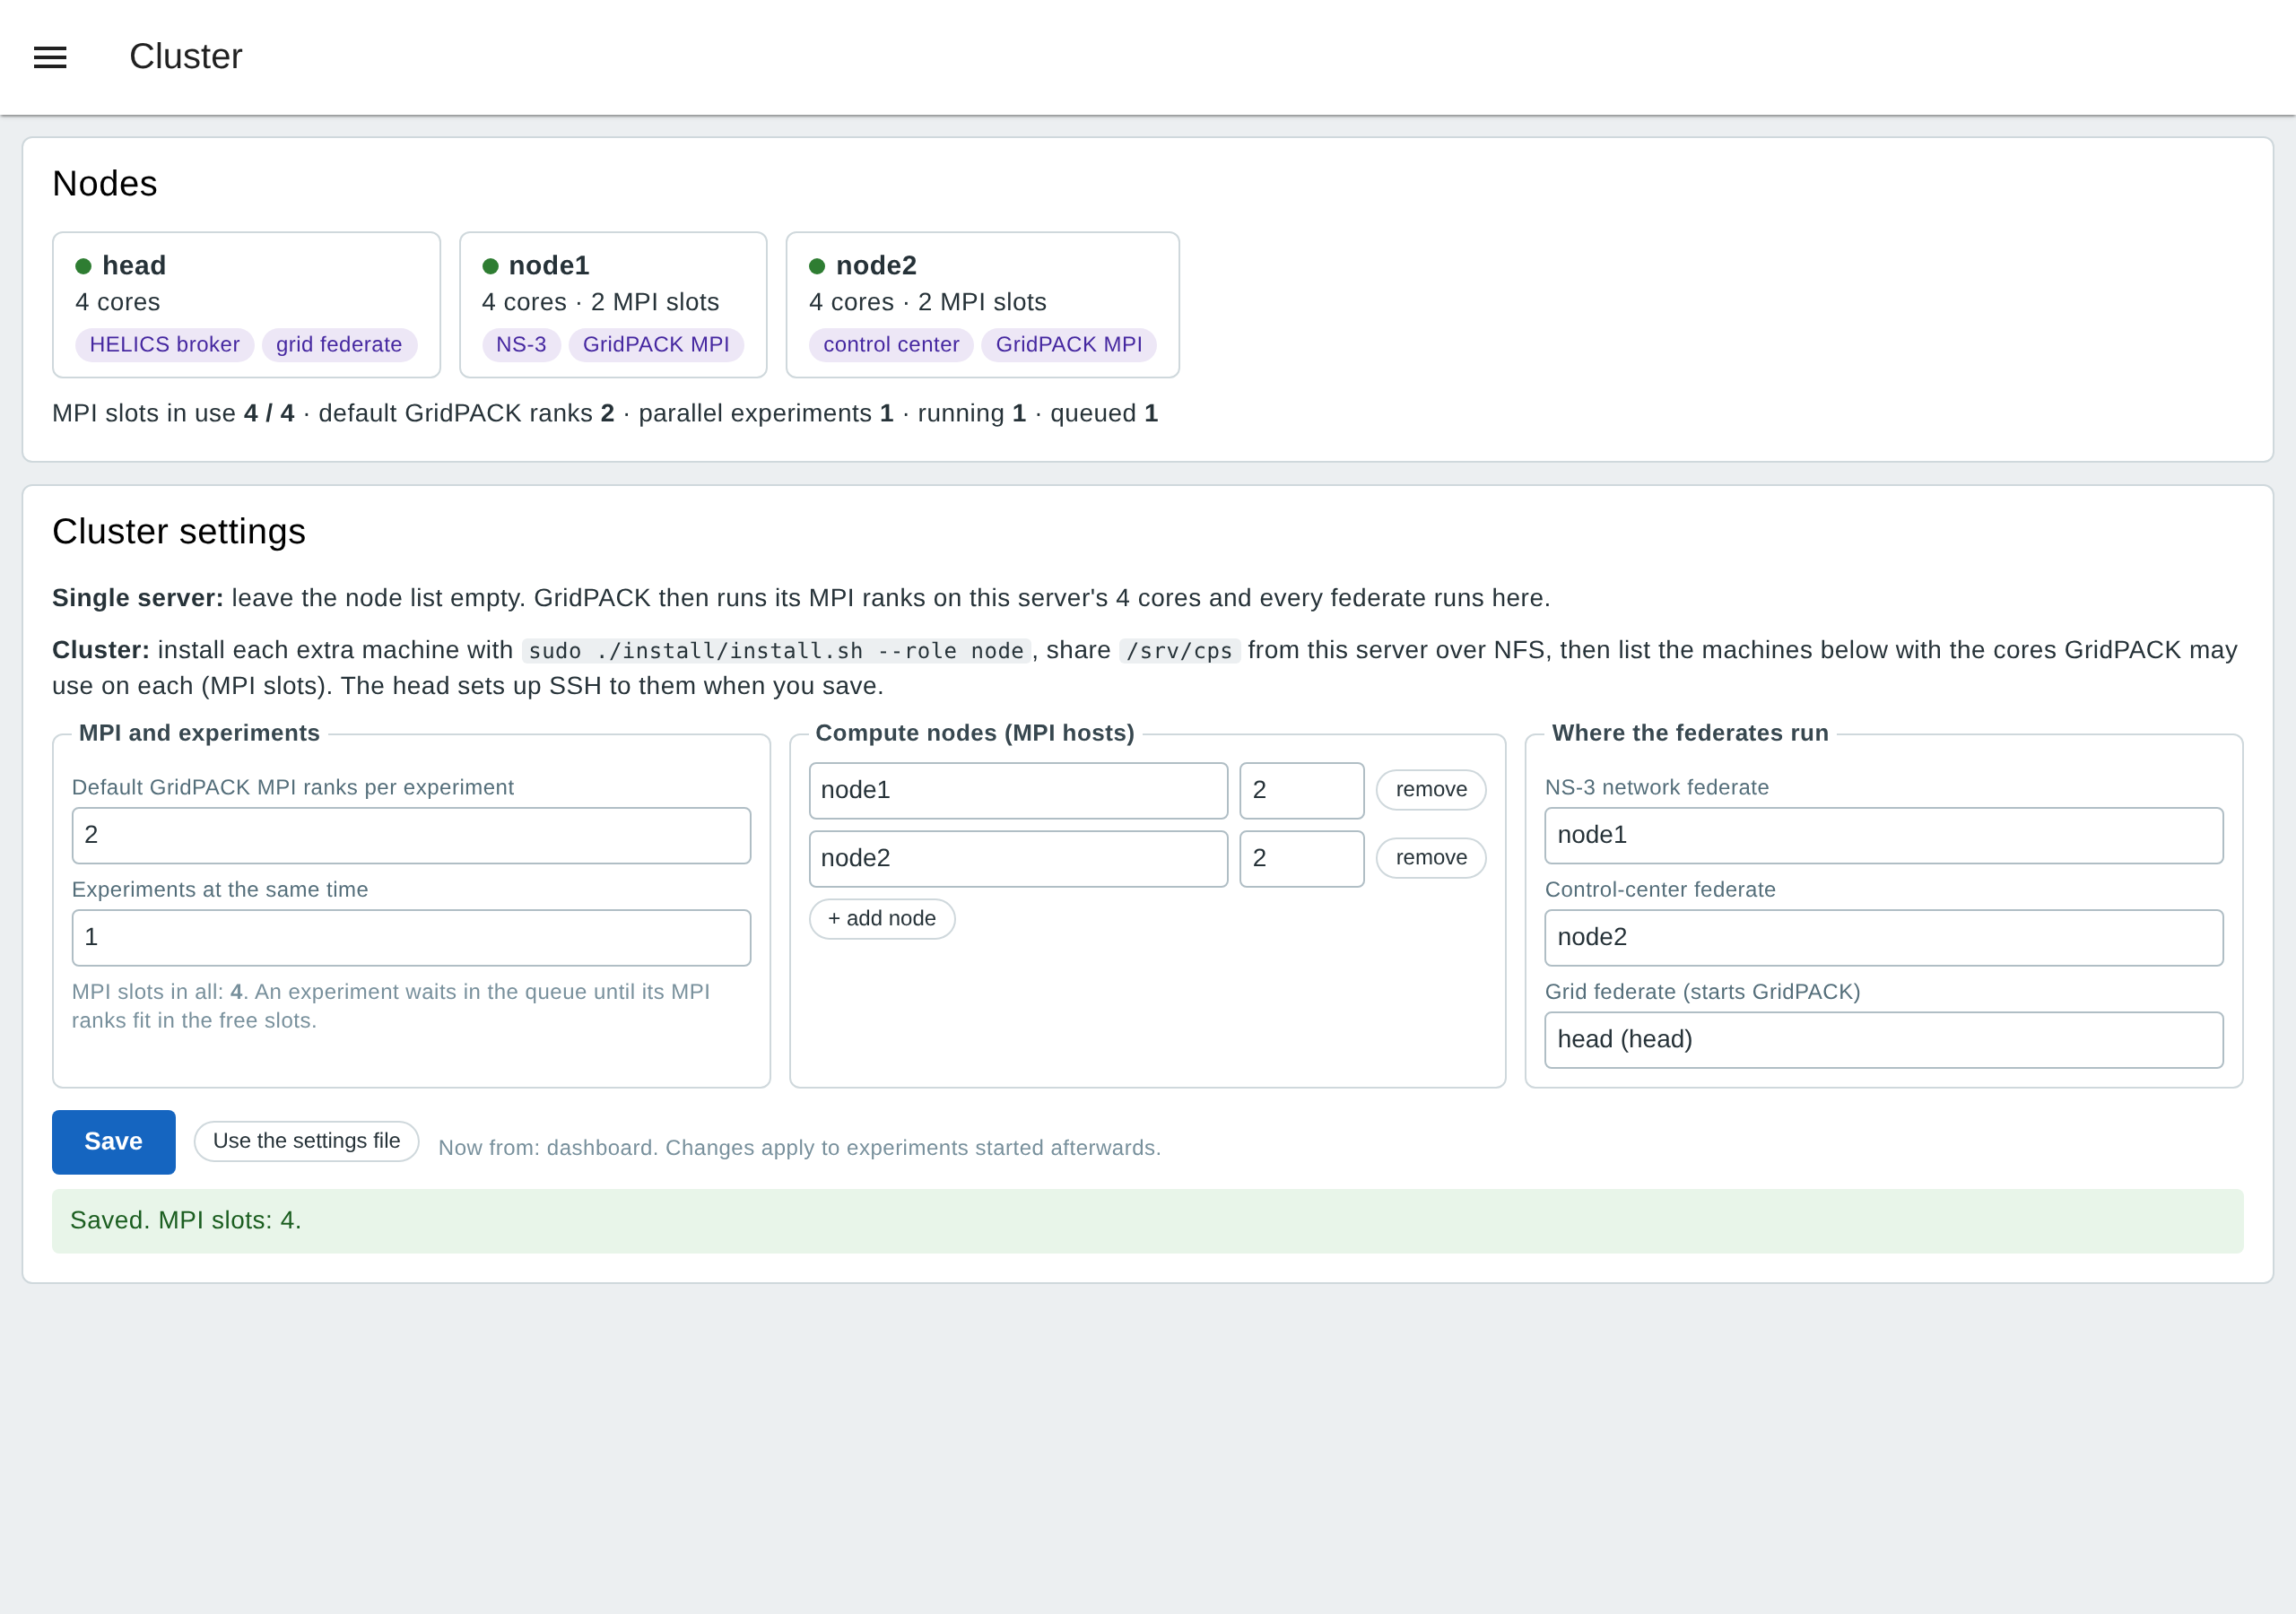
Figure 8. Cluster page: the nodes with their roles, and the settings (default MPI ranks, experiments at the same time, compute nodes and their MPI slots, node of each federate).
Each experiment checks the nodes when it starts. Nodes that do not answer are left out of its MPI hostfile (its log names them); if a federate is placed on such a node, or the remaining slots are too few for the requested MPI ranks, the experiment stops at once with that message.

6.5 Scenario files
A scenario file describes one experiment, or several under scenarios: (fields at the top are shared; each entry overrides them). Download the template with the scenario template link on the Upload panel.
name: gen-fault-fdi
grid: ieee118 # ieee14 ... ieee300 or an uploaded grid id
mode: qss # qss (power flow) or dynamic
duration: 10
mpi_np: 4 # GridPACK MPI ranks
pmu: {placement: minimum, rate: 30}
network: {latency_ms: 10, latency_spread: 0.5, jitter_ms: 2, loss: 0.0, pdc_wait_ms: 20}
event: {type: avr_fault, bus: 49, vset: 1.12, t: 4}
attack: {type: fdi-simple, target: 49, fake: 1.02, start: 4, end: 9}
control: {bdd: true, voltage_control: true, vmin: 0.94, vmax: 1.08}
Table 10. Scenario fields
Field | Meaning | Values (default)
name | Run name, used in the results folder | letters, digits, _ - (scenario)
grid | Grid to simulate | ieee14…ieee300 or uploaded id (ieee14)
mode | Quasi-steady state (power flow) or dynamic simulation | qss / dynamic (qss)
duration, grid_step | Simulated seconds; grid step (power flow interval, or one PMU frame in dynamic mode) | 1–120 (10); 0.5 s or 1/rate
solver, mpi_np | GridPACK with N MPI ranks, or the built-in solver | gridpack / builtin; 1 to the MPI slots (Cluster page default)
pmu.placement, pmu.rate | Minimum or redundant placement; frames per second | minimum / redundant; 1–120 (30)
network.* | Link latency, spread, jitter, loss, PDC wait window | 10 ms, 0.5, 2 ms, 0, 20 ms
event.* | AVR fault (setpoint), load step (percent, qss); bus fault (duration), line trip (bus, to), generator trip (dynamic); at time t | none / avr_fault / load_step / bus_fault / line_trip / gen_trip
attack.* | FDI simple or stealthy, delay or drop; target bus, fake voltage, window | none / fdi-simple / fdi-stealthy / delay / drop
control.* | Bad data detection, voltage control, voltage limits | true, true, 0.94, 1.08
Every field is checked before anything runs. A wrong value gives a clear message, for example "bus 50 is not a generator bus in IEEE 118-bus; generator buses: 1, 4, 6, …".

6.6 Uploading a grid model
Upload a MATPOWER case file (.m, the format of MATPOWER and of most published test systems) or a testbed topology.json. The testbed removes isolated buses, checks that the power flow converges (starting from the voltages stored in the case), computes the minimum PMU placement and lists the grid with an id such as case_activsg2000-78531. PSS/E .raw files are converted with MATPOWER first: mpc = psse2mpc('grid.raw'); savecase('grid.m', mpc).

6.7 Live page
While an experiment runs, the Live page follows it every second. The data come from the observer federate, which listens to the co-simulation without slowing it.
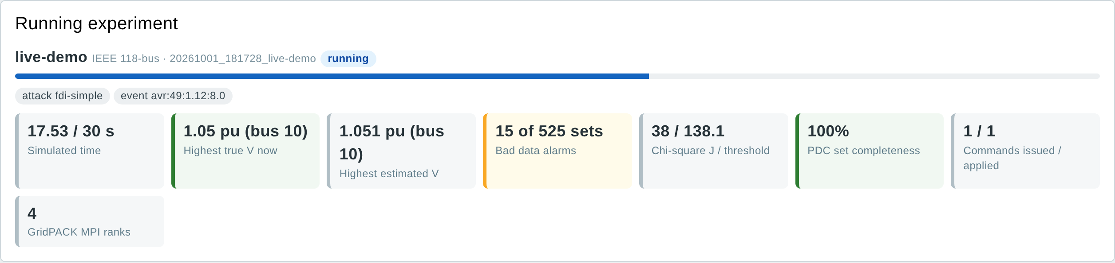
Figure 9. Live: progress, highest true and estimated voltage, alarms, chi-square value, PDC completeness, commands and MPI ranks, 12 s into a 30 s run.
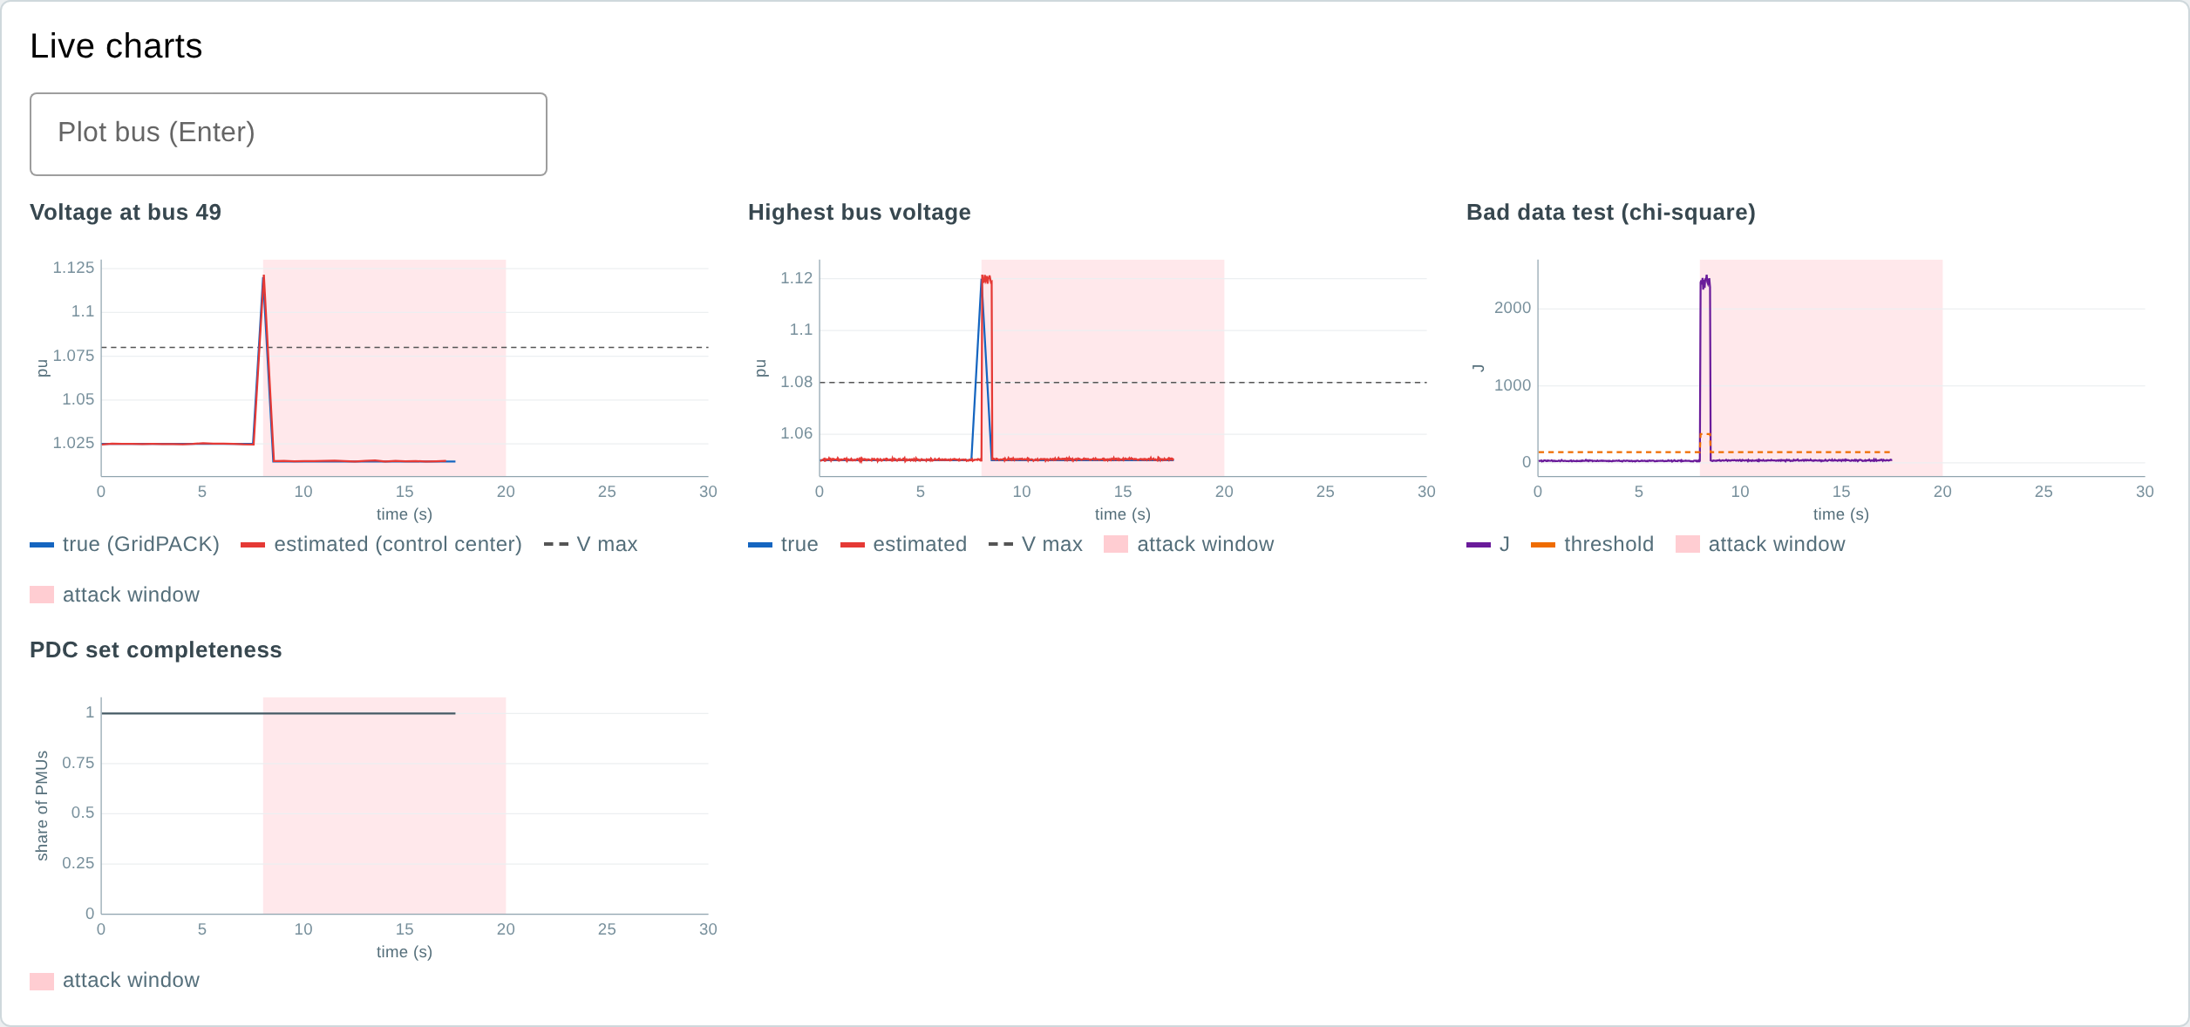
Figure 10. Live charts during the run: the fault at 8 s, the falsified channel making the chi-square value jump, and the correction. Enter a bus number to follow any bus.
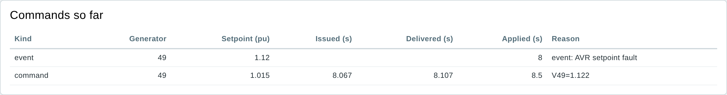
Figure 11. Commands so far: the AVR fault event, and the command issued at 8.067 s, delivered over the network at 8.107 s and applied by GridPACK at 8.5 s.
The panel Voltage at every bus now shows the whole grid at the last estimate (section 6.9 explains the chart).
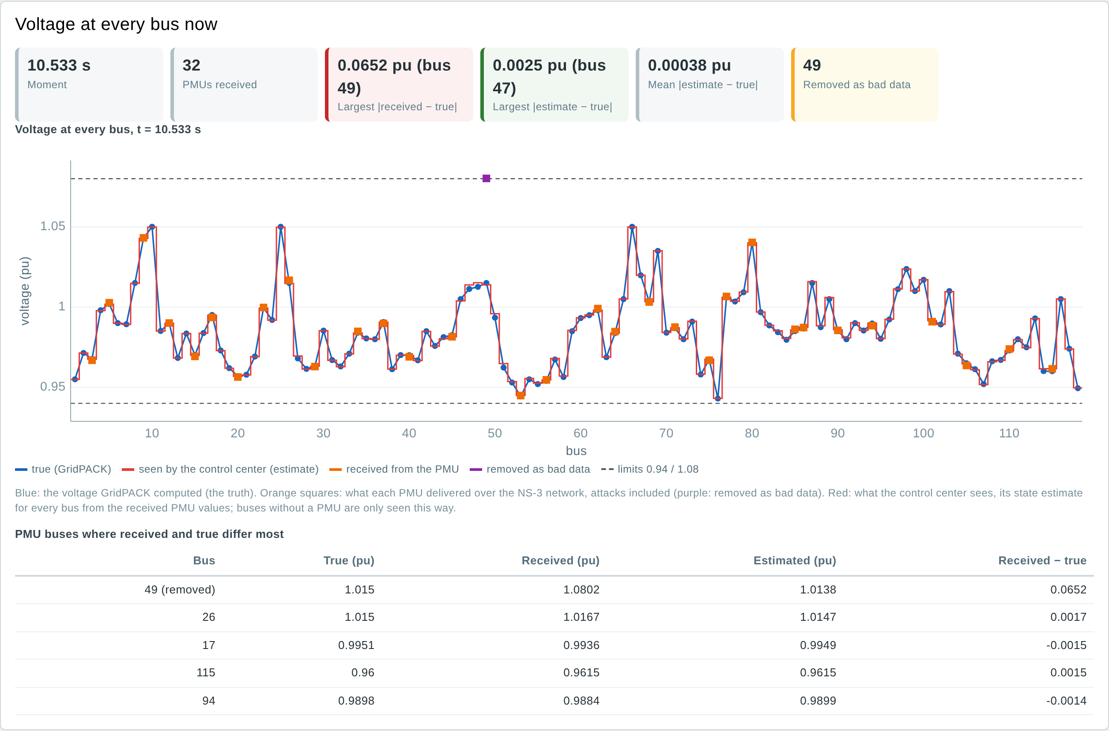
Figure 12. Voltage at every bus now, 10.5 s into an IEEE 118 run during a false data injection on bus 49: PMU 49 (purple) reports 1.080 pu for a true 1.015 pu; it is removed as bad data and the estimate (red) follows the truth (blue).

6.8 Inside page: what the engines compute
The Inside page opens the three engines while an experiment runs and shows what each one is computing, updated every second. The figures below were taken 12 s into a 30 s IEEE 118 run on the virtual cluster: an AVR fault at generator 49 at 6 s, a simple false data injection on bus 49 from 8 to 18 s, 1% packet loss and GridPACK on 2 MPI ranks.
Co-simulation (HELICS). A diagram of the federation: each federate with the node it runs on and the simulated time the HELICS broker has granted it, and each topic with the messages and bytes exchanged so far. HELICS keeps all federates on one simulated clock; a federate is granted its next time only when the data it needs has arrived, so the granted times stay within one step of each other.
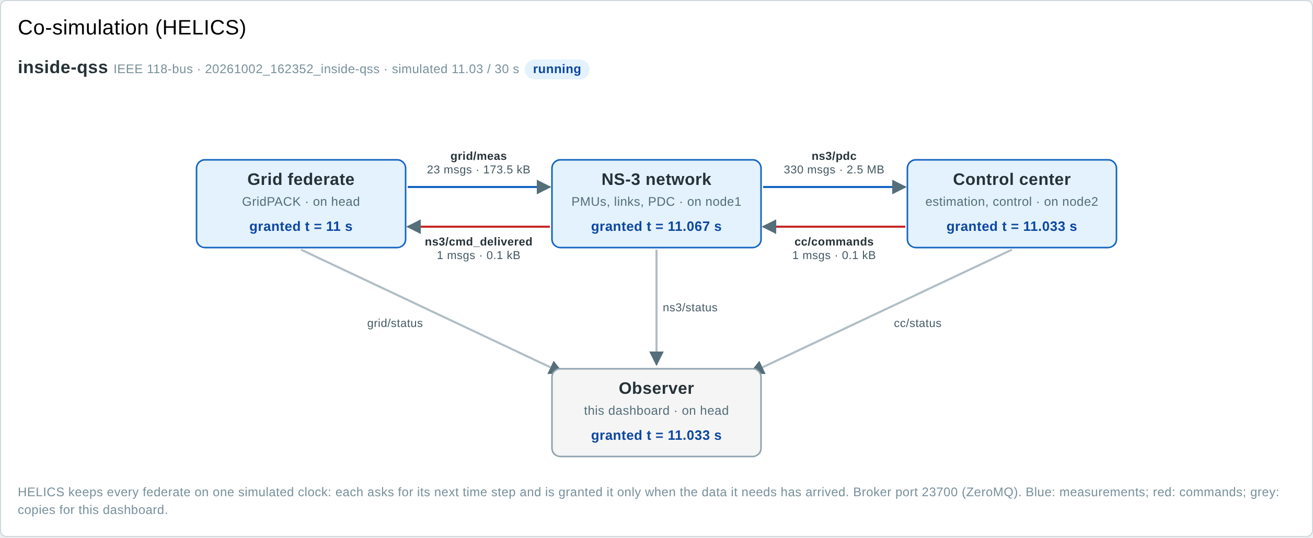
Figure 13. HELICS panel: grid federate on the head, NS-3 on node1, control center on node2, observer on the head, with their granted times; blue arrows carry measurements, red arrows commands, grey arrows copies for the dashboard.
GridPACK. The solver (pf_server for power flow, dsf_server for dynamic simulation), the number of MPI ranks and how GridPACK partitioned the grid over them (node, buses and branches of each rank), the times of the last step and a chart of the time per step. In power flow mode the chart in the middle is the Newton-Raphson convergence of the last power flow: the largest power mismatch after each iteration on a logarithmic scale, against the tolerance of 10⁻⁶ pu. In dynamic mode the panel shows the integration steps of the frame instead (for example 7 steps of 4.76 ms).
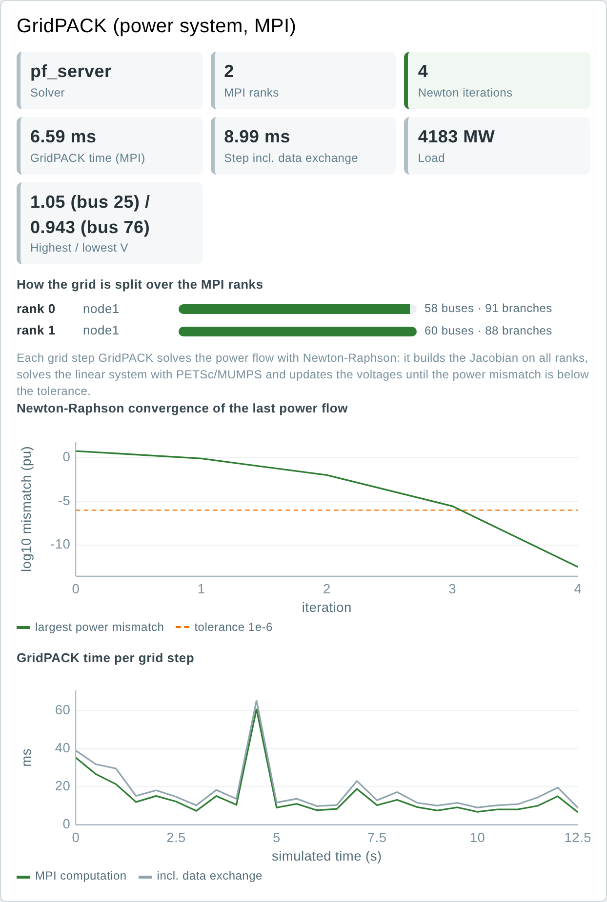
Figure 14. GridPACK panel in power flow mode: 2 ranks on node1 with 58 and 60 buses; Newton-Raphson needs 4 iterations, the mismatch falls from 5.9 to 3×10⁻¹³ pu.
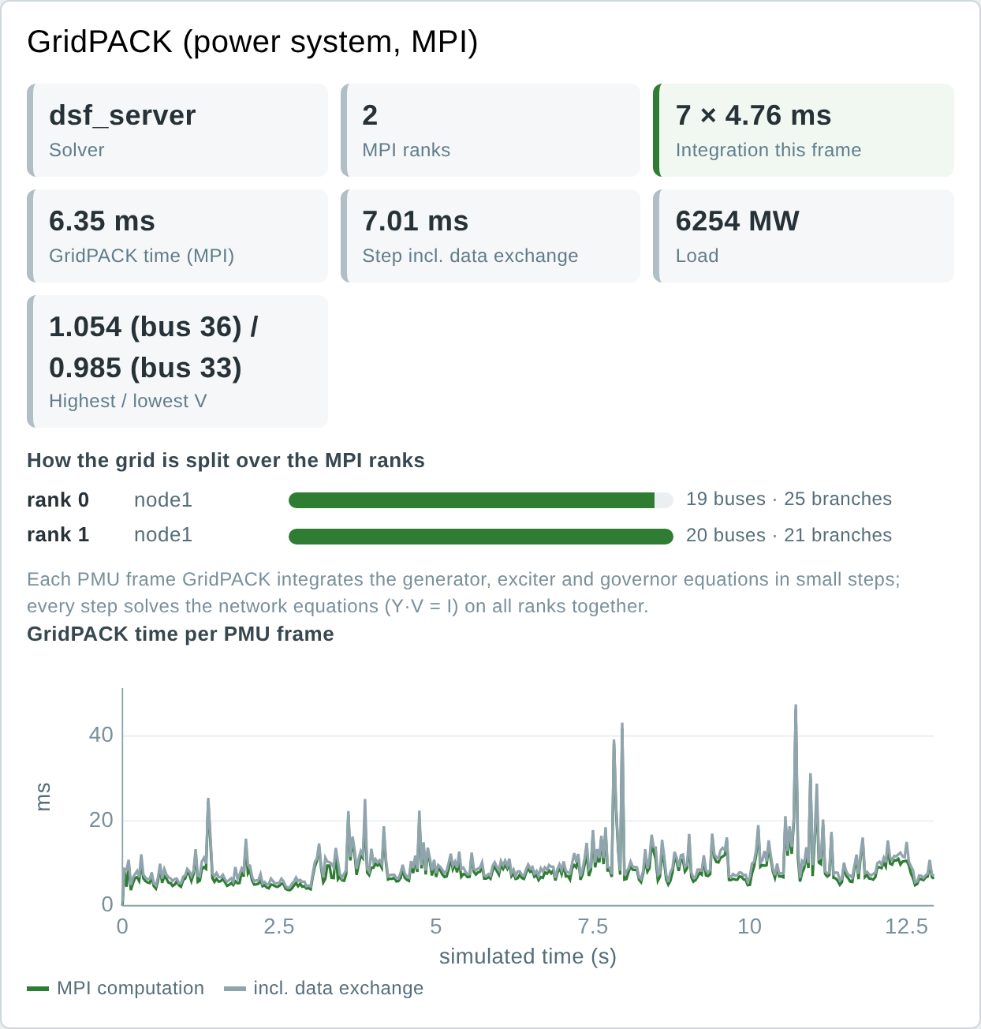
Figure 15. GridPACK panel in dynamic mode (IEEE 39, fault at bus 16 at 3 s): 7 integration steps of 4.76 ms per PMU frame, 6-10 ms of MPI time per frame.
NS-3. Frames sent by all PMUs and the share that reached the PDC in time; late, dropped and attacked frames; PDC sets released and how many were complete; the time the PDC waited; commands sent and delivered; the attacker; and the number of events the network simulator has processed. Each PMU is a tile coloured by what happened to its frames in the last 0.5 s (hover for its counters), and a chart shows the latency of the last frame of every PMU.
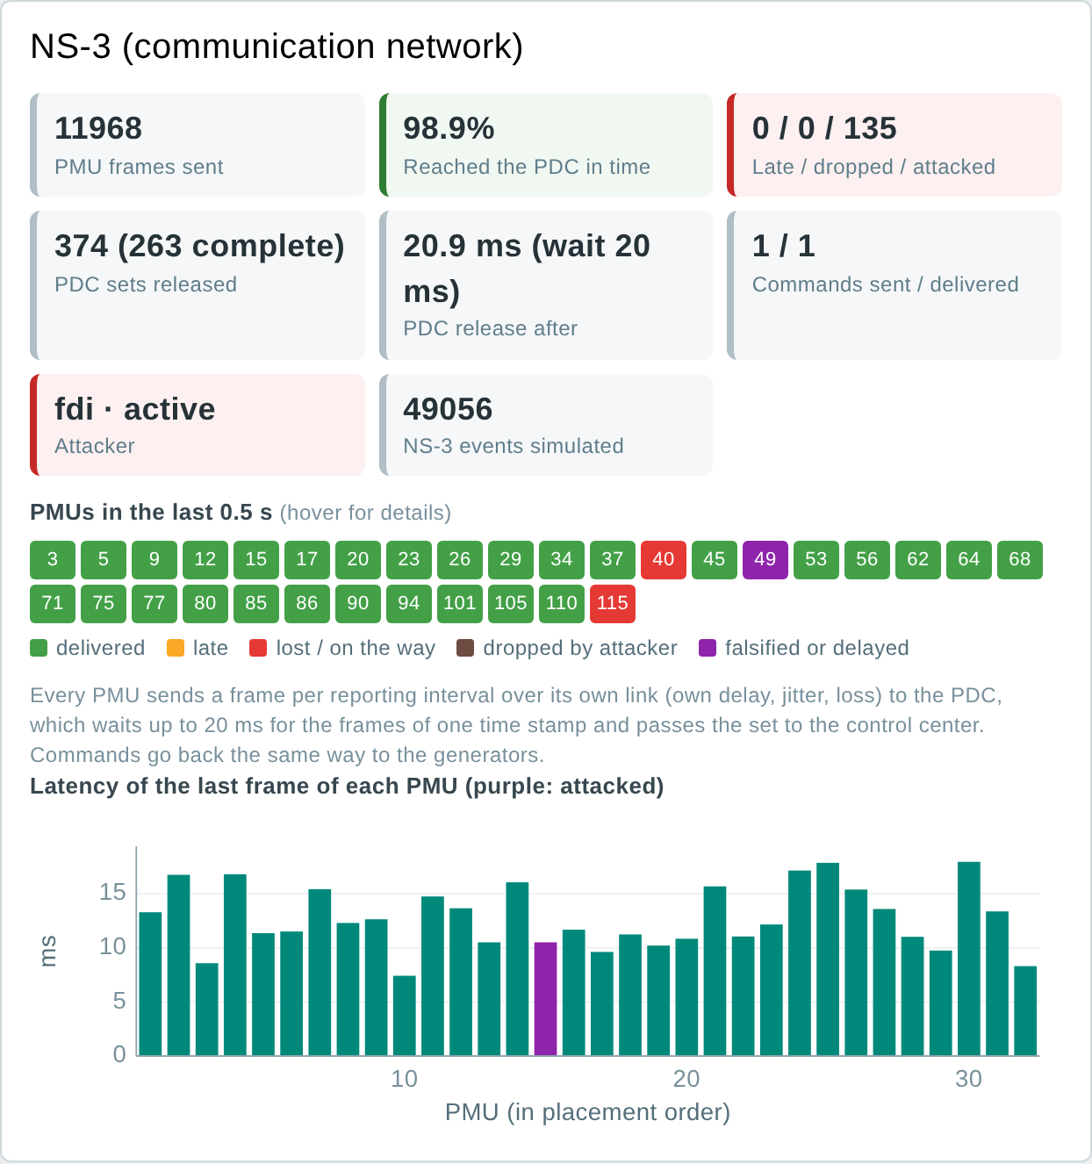
Figure 16. NS-3 panel: 98.9% of the frames arrive in time (1% loss: PMUs with a lost frame in the last 0.5 s are red); PMU 49 is attacked (purple); the PDC waits up to 20 ms for each set.
Control center. For the last measurement set: the measurements and PMUs used, whether the grid was observable, the chi-square value J against its threshold, the PMUs removed as bad data, J after the removal, the estimation time and the age of the set when it was processed. With the minimum PMU placement every PMU is needed, so a set that lost a frame leaves part of the grid unobserved; such a set cannot be tested for bad data and is skipped in the chart.
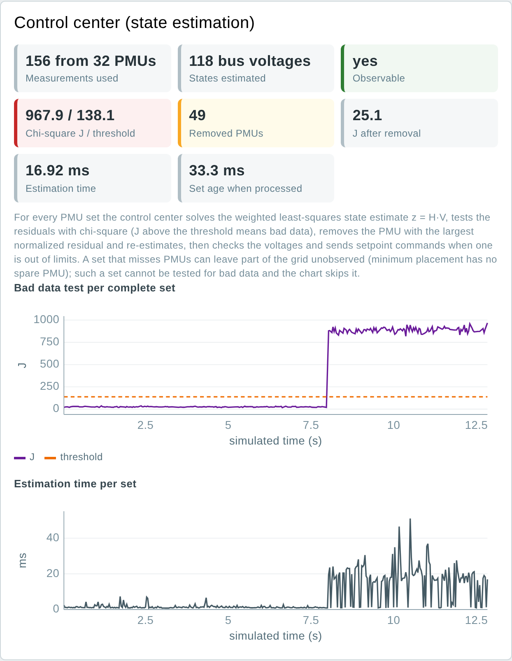
Figure 17. Control center panel: during the attack J is about 900 against a threshold of 138; PMU 49 is removed and J falls to 25; with the residual test and the second estimate a set takes 10-40 ms instead of about 1 ms.
Log. Everything that happens, in plain words, with the simulated time and the engine. Key events holds grid events, commands from issue to application, the attacker starting and stopping, bad data alarms and the PMUs removed; Every step summarises each power flow or integration and each half second of network traffic.
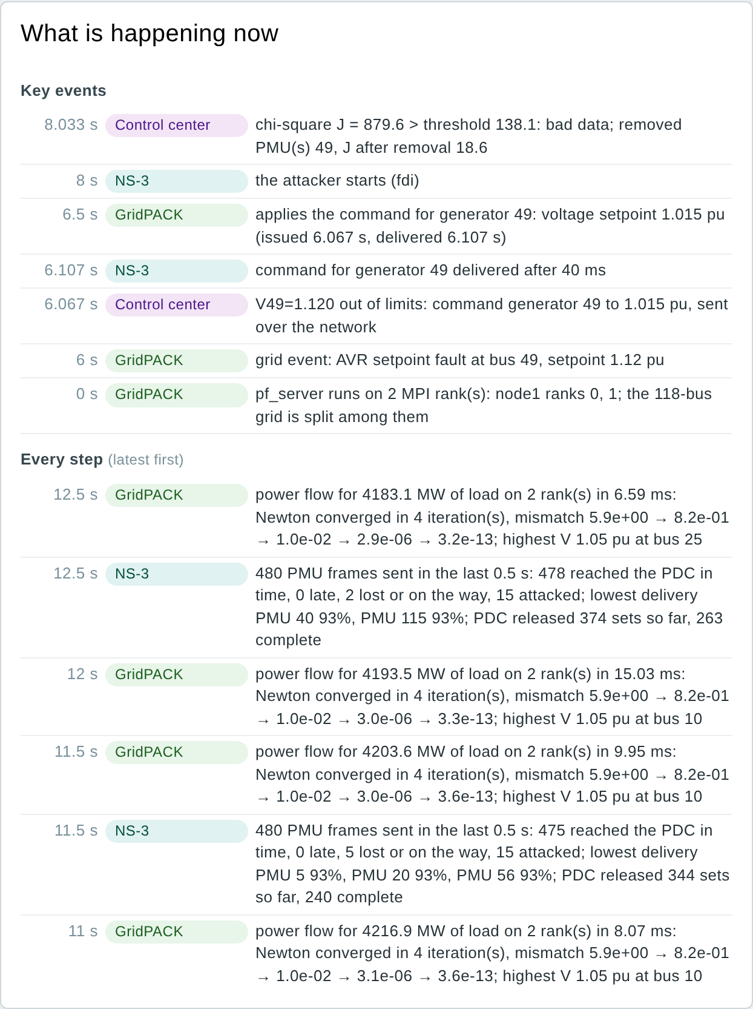
Figure 18. Log of the run: the AVR fault at 6 s, the command for generator 49 issued at 6.067 s, delivered after 40 ms and applied at 6.5 s, the attacker at 8 s and the alarm one frame later.
Table 11. Where the Inside data come from
Engine | Source
HELICS | The observer federate asks the broker for the granted time of every federate (global_time query) and counts the messages and bytes of each topic it receives
GridPACK | pf_server and dsf_server print each rank's node and partition at start-up (@@RANK), PETSc's Newton iteration lines and the integration steps; the grid federate reads them and publishes them with its step on grid/status
NS-3 | The NS-3 federate publishes its counters on ns3/status twice a second
Control center | The control-center federate adds the size, observability, test results and time of each estimation to cc/status

6.9 Results page
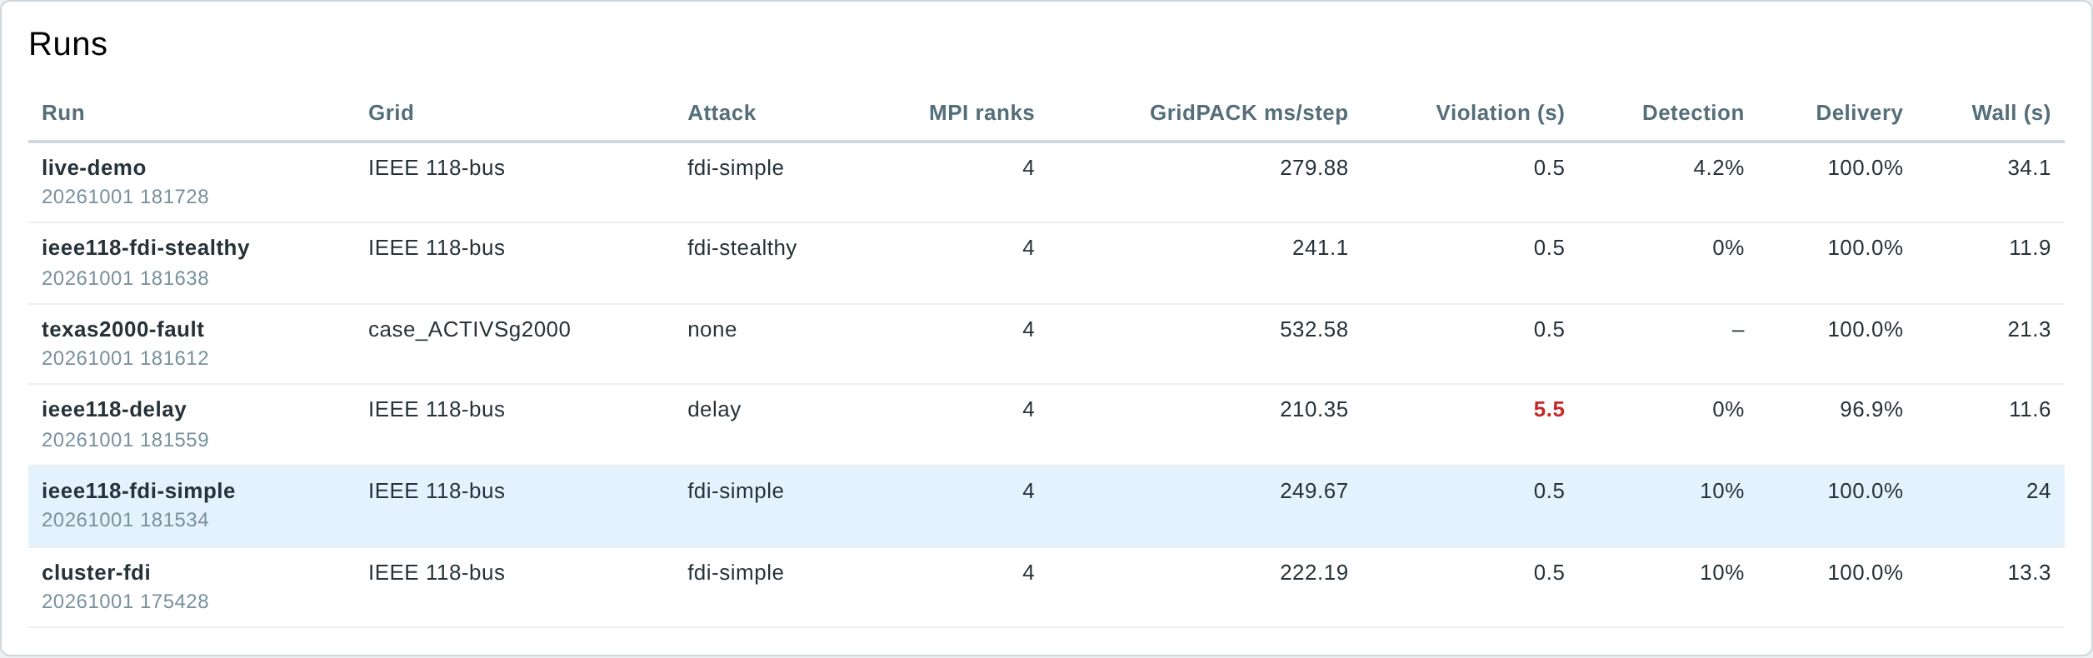
Figure 19. Runs: one row per finished experiment; click a row to open it.
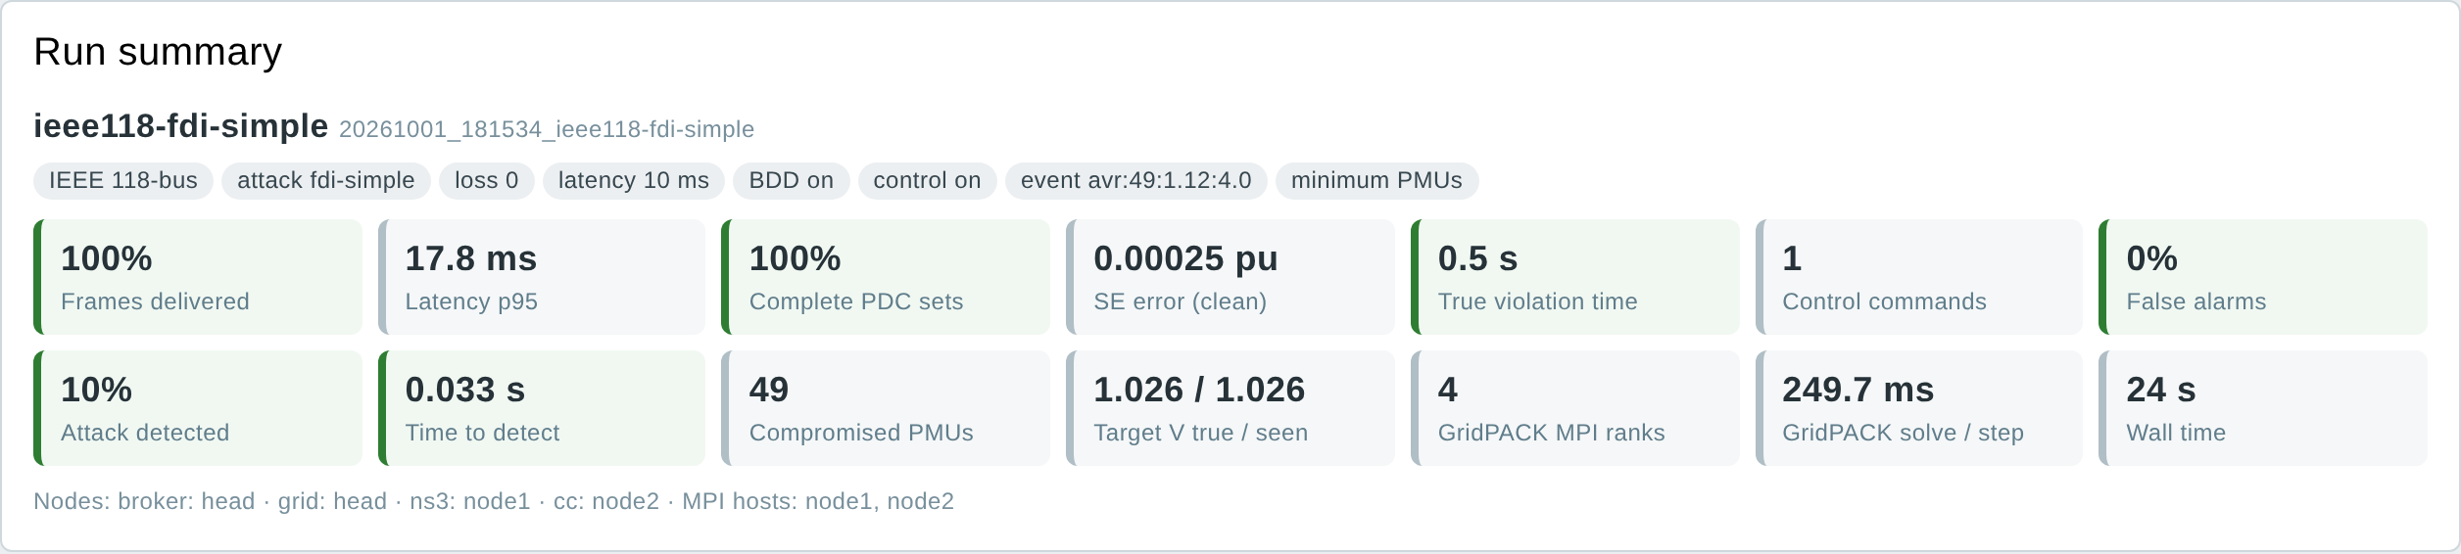
Figure 20. Run summary of the IEEE 118 simple FDI run, with colour-coded figures (green good, amber borderline, red problem).
Table 12. Summary figures
Figure | Meaning
Frames delivered, Latency p95 | Share of PMU frames that reached the PDC in time; 95th percentile of their delay
Complete PDC sets | Share of measurement sets with every PMU present
SE error (clean) | Mean difference between estimated and true voltages outside the attack window
True violation time | How long any real bus voltage was outside the limits
Control commands | Setpoint commands applied to the grid
False alarms | Alarms of the bad data test outside the attack window
Attack detected, Time to detect | Share of attacked sets with an alarm; delay to the first alarm
Compromised PMUs, Target V true / seen | PMUs the attacker changed; true and estimated voltage of the target bus
GridPACK MPI ranks, solve / step, Wall time | Ranks used, mean MPI solve time per grid step, total run time
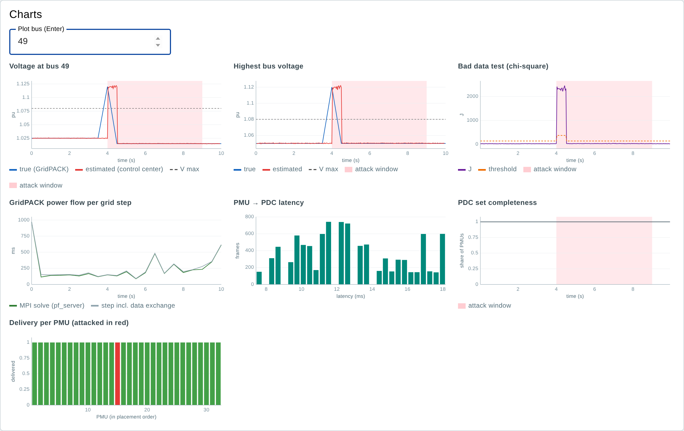
Figure 21. Result charts: voltage at bus 49, highest voltage, chi-square test, GridPACK solve time per grid step, PMU-to-PDC latency, PDC completeness and delivery per PMU (attacked PMU in red).
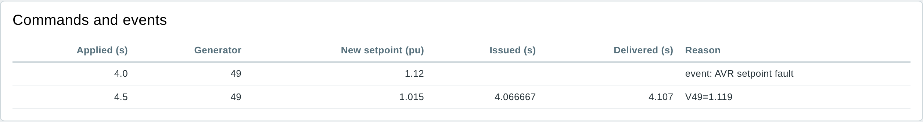
Figure 22. Commands and events of the run.

Voltage at every bus
The panel Voltage at every bus compares, for one moment of the run, what the grid really does with what reaches the control center, as Fig. 8 of the technical report of the single-server testbed did for the IEEE 14 console:
- Blue line (true): the voltage GridPACK computed for every bus, for the grid state the PMUs of that frame sampled.
- Orange squares (received): the bus voltage each PMU delivered over the NS-3 network, as it arrived, attacks included. Only buses with a PMU have one. A purple square was removed as bad data.
- Red step line (seen): the control center's state estimate for every bus, computed from the received PMU values. Buses without a PMU are only seen this way.
The slider and the arrows move through the run one grid step at a time (one PMU frame in dynamic mode); the buttons jump to the grid event, into the attack and to the end. Figures above the chart give the largest difference between received and true and between estimated and true, and a table lists the PMU buses where received and true differ most.
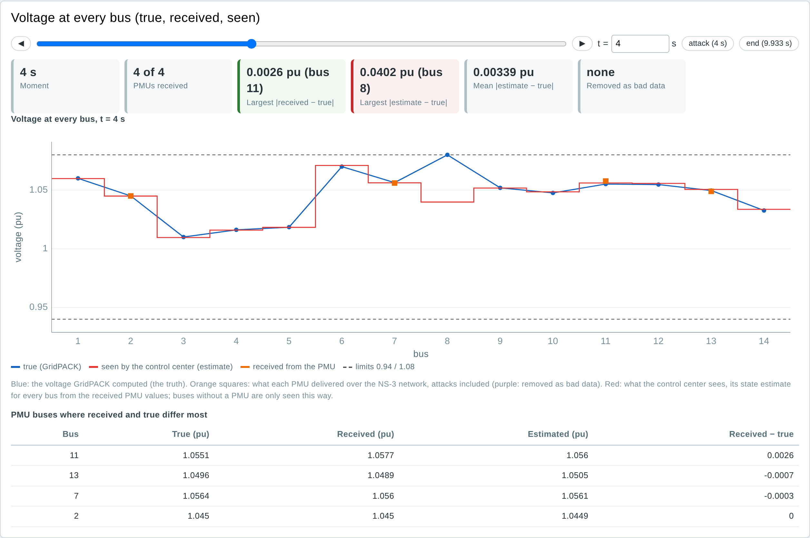
Figure 23. IEEE 14, simple false data injection on bus 8 from 3 to 8 s, minimum placement, at 4 s. The attacker changes the current that the PMU at bus 7 measures towards bus 8. This is a critical measurement, so the chi-square test cannot see it (J = 1.2 against 13.3): the control center sees bus 8 at 1.040 pu while it is at 1.080 pu.
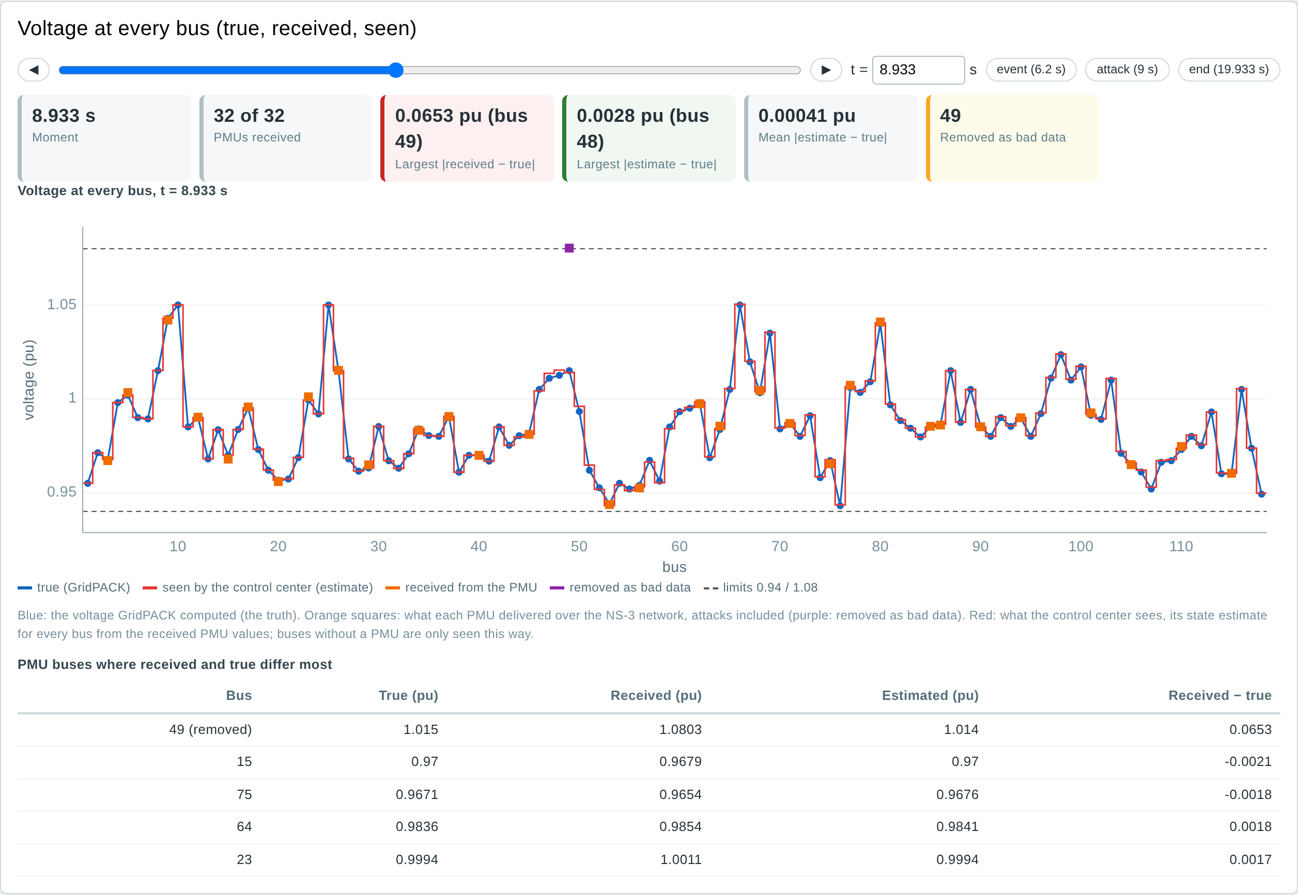
Figure 24. IEEE 118, simple false data injection on bus 49, at 8.9 s. PMU 49 delivers 1.080 pu for a true 1.015 pu; the test finds it and removes it, and the estimate stays within 0.003 pu of the truth at every bus.

6.10 Dynamic simulation runs
A scenario with mode: dynamic uses the same pages. Below, a file with two IEEE 39 experiments (a 100 ms fault at bus 16 and the trip of generator 32, both at 3 s) was uploaded; both ran at the same time. The Live page adds the system frequency, the lowest frequency so far and the rotor angle spread, and two charts.
grid: ieee39
mode: dynamic
duration: 15
mpi_np: 1
scenarios:
- name: ieee39-dyn-fault
event: {type: bus_fault, bus: 16, duration: 0.1, t: 3}
- name: ieee39-dyn-gentrip
event: {type: gen_trip, bus: 32, t: 3}
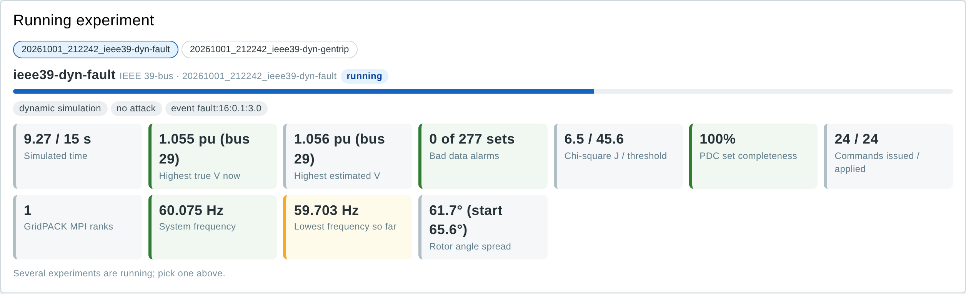
Figure 25. Live, dynamic run: frequency of the centre of inertia, lowest frequency so far and rotor angle spread next to the usual figures.
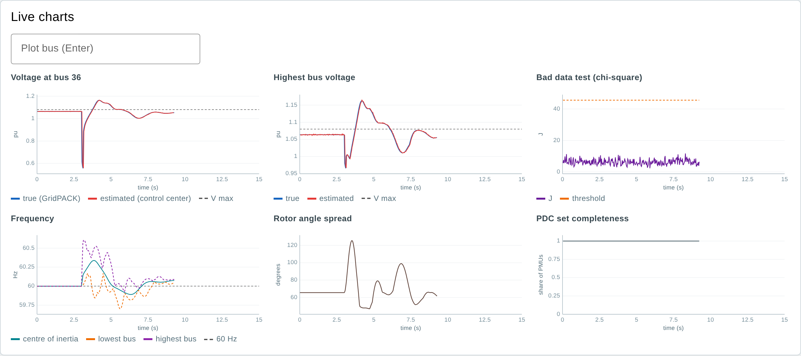
Figure 26. Live charts at 9.3 s: the fault at 3 s pulls bus 36 down to 0.56 pu; the exciters overshoot; frequency and rotor angles swing and settle.
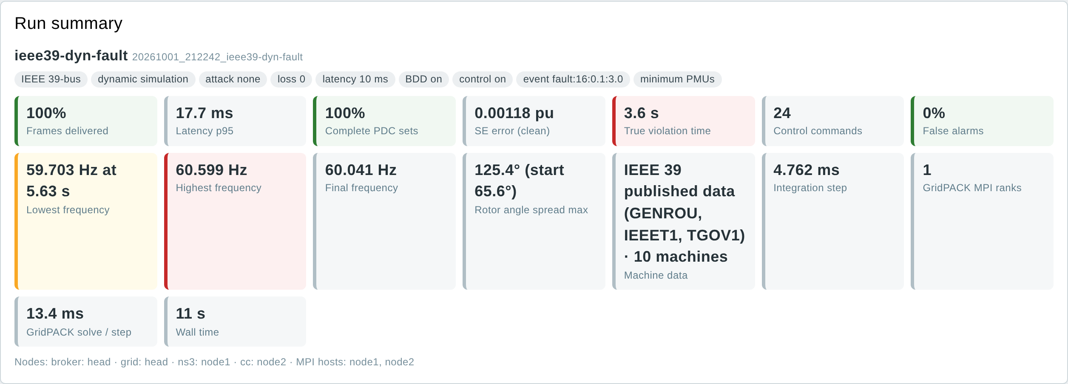
Figure 27. Results summary of the fault run: frequency range, final frequency, largest rotor angle spread, machine data and integration step.
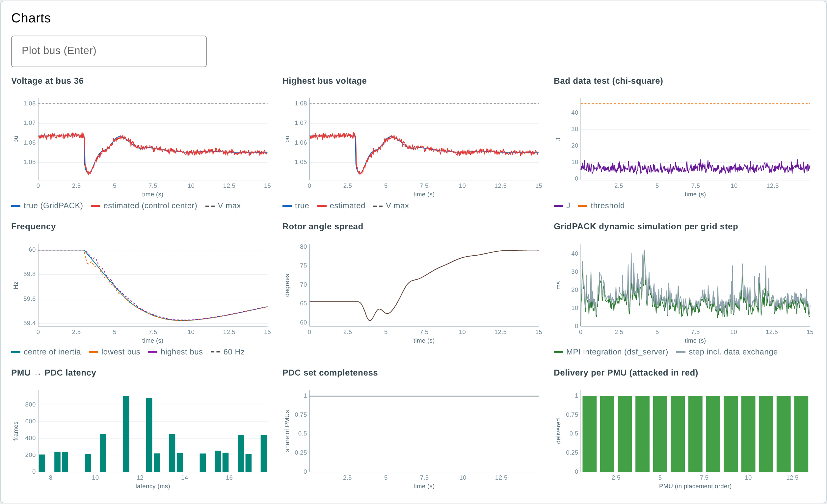
Figure 28. Results charts of the generator trip: frequency falls to 59.42 Hz and is arrested by the governors; GridPACK needs about 14 ms per frame on one rank.

6.11 IEEE 14 console (original prototype)
The original single-PMU IEEE 14 demonstration is kept as a page of its own. Set latency, loss, a bus to drop or the FDI switch and press Run scenario; the console updates in about 15 seconds.
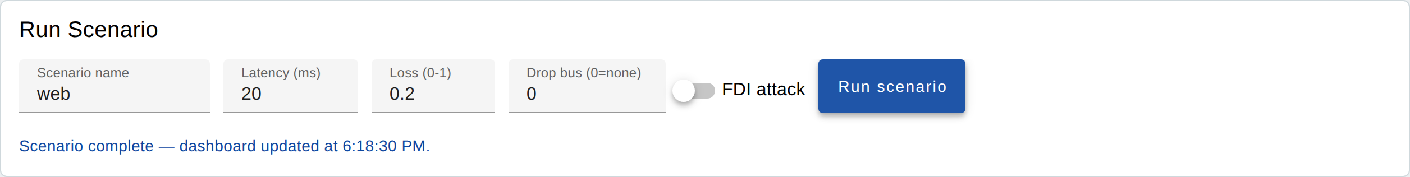
Figure 29. Run Scenario panel of the IEEE 14 console.
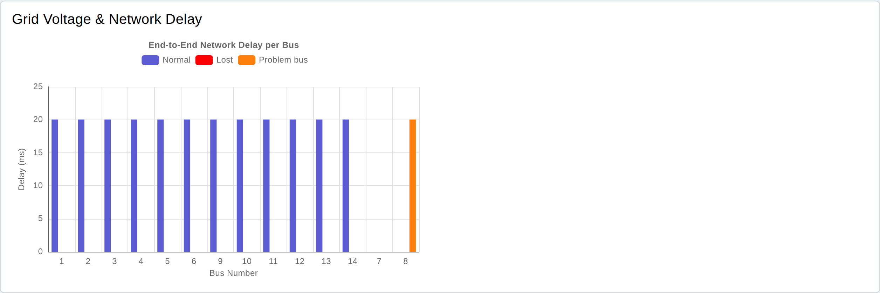
Figure 30. End-to-end network delay per bus. The voltage chart beside it loads its chart library from the internet and stays empty on servers without internet access.
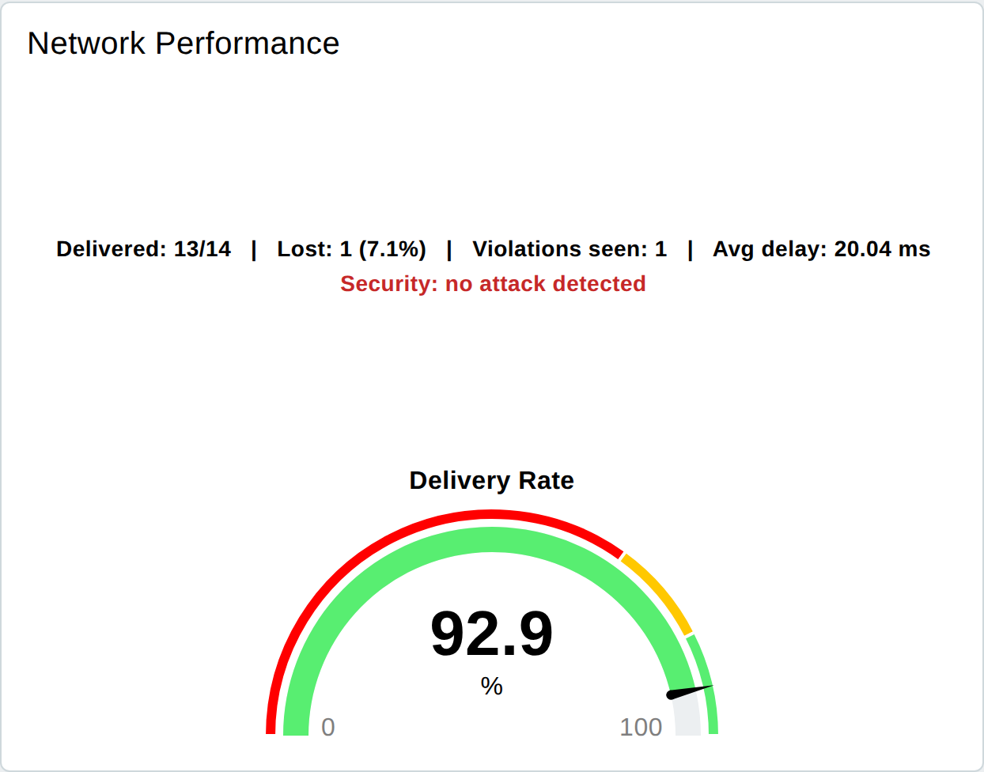
Figure 31. Network performance and delivery gauge.
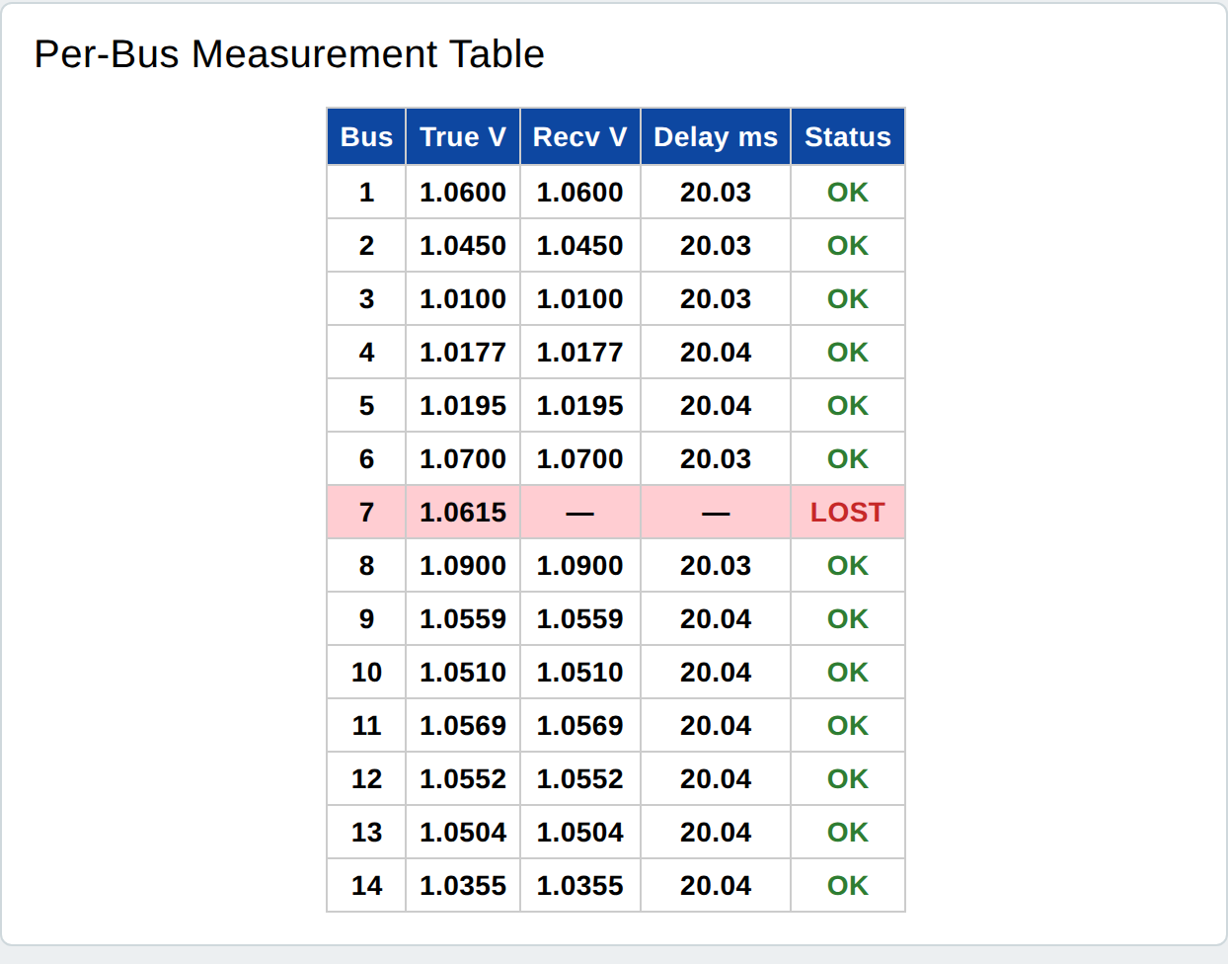
Figure 32. Per-bus measurement table: true and received voltage, delay and status.

6.12 Node-RED editor
Administrators can change the dashboard in the Node-RED editor without programming: the CPS Cluster tab holds the Experiments, Live and Results pages, the CPS Testbed Console tab the IEEE 14 console.
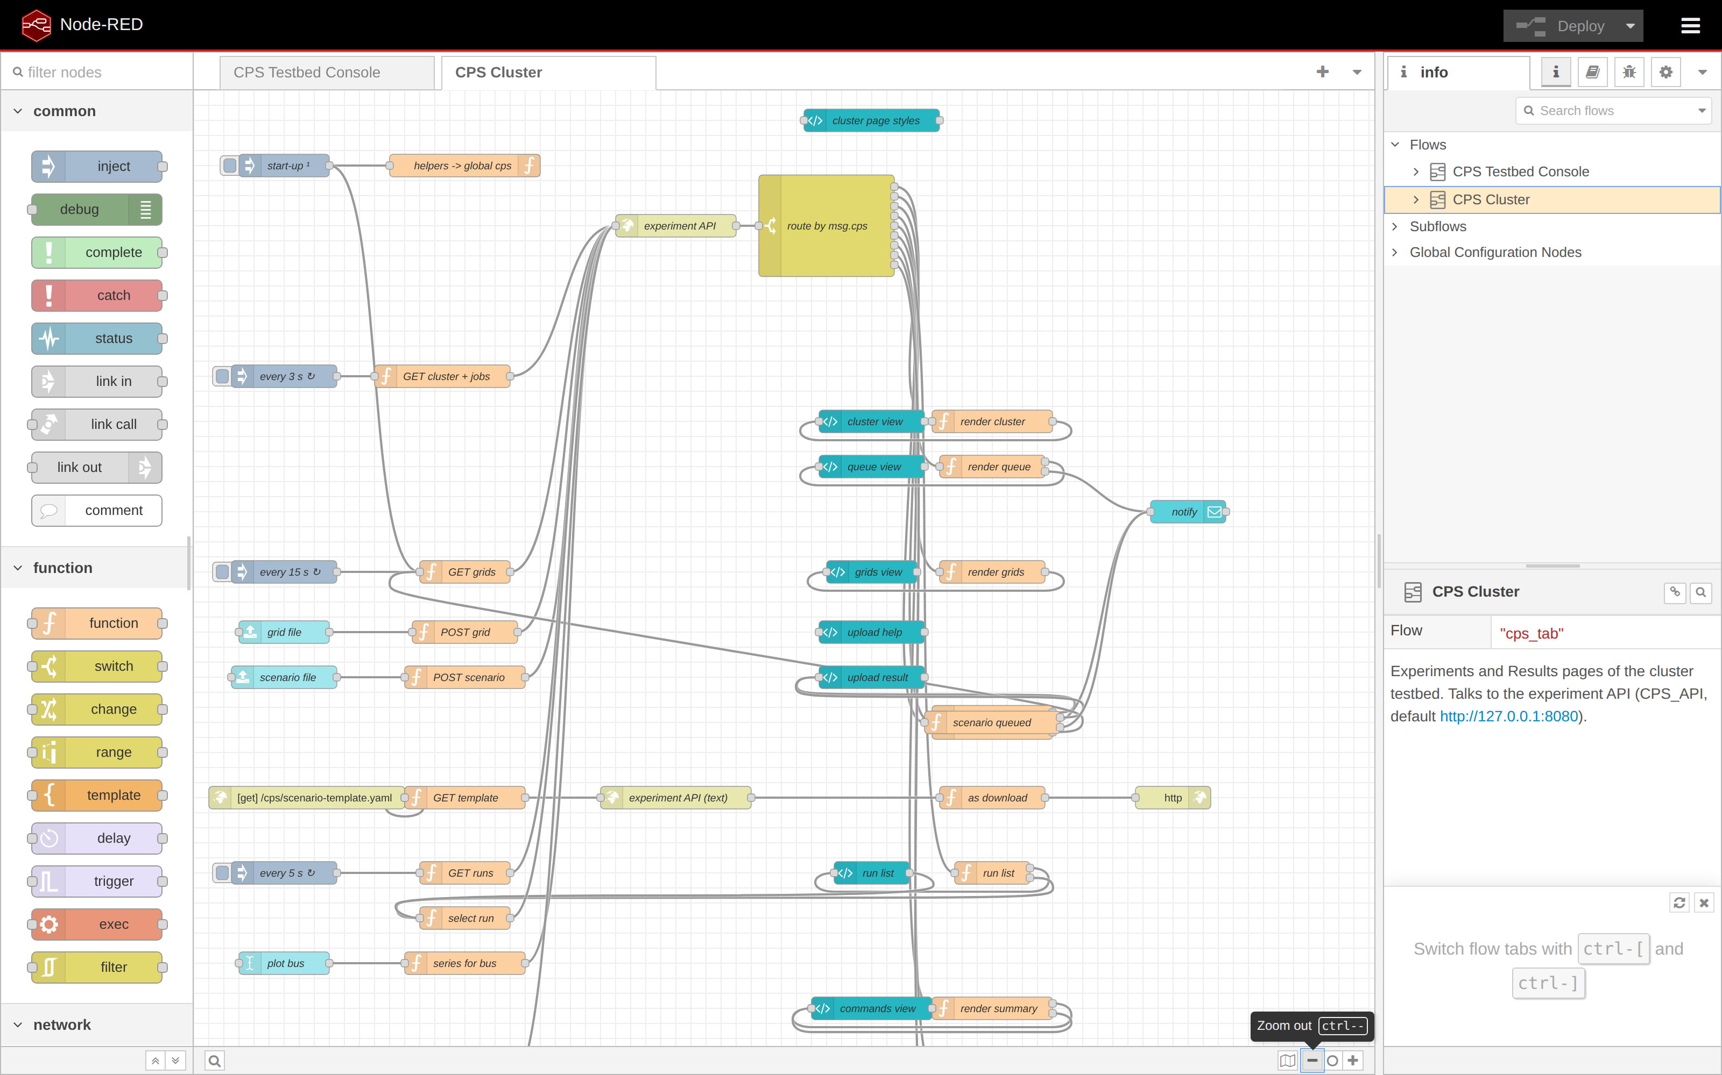
Figure 33. The CPS Cluster flow in the Node-RED editor.

6.13 API and command line
Table 13. Main API endpoints
Endpoint | Purpose
POST /api/scenarios/file | Upload a scenario file (multipart); queues its experiments
POST /api/grids/file | Upload a grid model (multipart)
GET /api/grids, GET /api/cluster, GET /api/jobs | Grids, cluster nodes and slots, queue
GET /api/runs, GET /api/runs/{id}, GET /api/runs/{id}/series | Finished runs, one run, chart data
GET /api/runs/{id}/profile?t=9 | Voltage of every bus at one moment: true, received from the PMUs, estimated
GET /api/live | State of the running experiment
GET /api/scenario-template | The scenario template
curl -u admin:PASSWORD -F file=@scenario.yaml http://server:8080/api/scenarios/file
sudo -u cps cps-run --case 118 --duration 10 --mpi-np 4 --event avr:49:1.12:4 \
--attack fdi-simple --target 49 --fake 1.02 --attack-start 4 --attack-end 9
sudo -u cps cps-run --case 39 --mode dynamic --duration 15 --event fault:16:0.1:3
For reports, tools/plot_profile.py draws the voltage of every bus at one moment of a finished run as a PNG (without --t: one second into the attack, or just after the grid event):
sudo -u cps /opt/cps/venv/bin/python /opt/cps/testbed/tools/plot_profile.py \
/srv/cps/runs/20261003_031629_inside-dyn --t 3.07 --out fault39.png
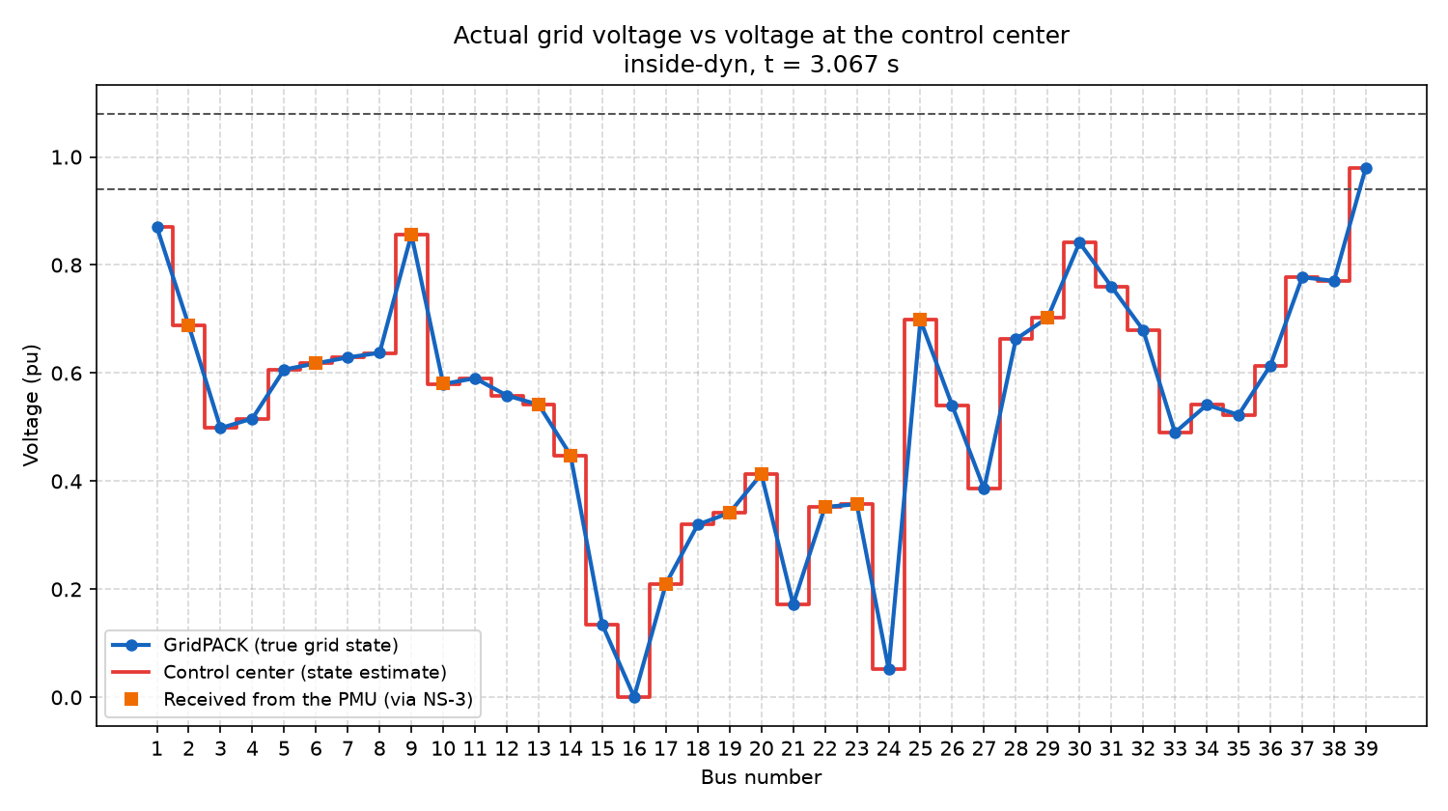
Figure 34. plot_profile.py on the dynamic IEEE 39 run, 67 ms after the three-phase fault at bus 16: bus 16 is at 0 pu, its neighbours between 0.1 and 0.6 pu; the PMU values and the estimate lie on the true curve.

7. Output files
Each experiment writes a directory /srv/cps/runs/<date>_<time>_<name>/. The CSV files open in Excel, Python or MATLAB.
File | Contents
summary.json | All summary figures (network, grid, control center, attack, GridPACK, cluster)
meta.json, run_config.json, ns3_config.json | Settings, PMU placement with channels, attack plan, placement of the federates
frames.csv | Every PMU frame: time stamp, PMU, send and arrival time, latency, status, attacked
cc_log.csv, cc_estimates.csv | Every measurement set: chi-square test, alarms, removed PMUs, violations; estimated voltage of every bus
cc_received.csv | Every measurement set: the bus voltage each PMU delivered, as received (attacks included); empty when its frame was missing
grid_truth.csv, grid_steps.csv | True voltage of every bus each step; solver, convergence, load, solve times, MPI ranks
commands_applied.csv | Events and commands applied to the grid, with issue, delivery and application times
live.json | Final state of the live view
grid_dynamics.csv, dynamics.json | Dynamic mode: frequency (centre of inertia, lowest and highest machine and bus), rotor angle spread, speed, angle and power of every machine each frame; machine data used and integration step
gridpack/ | pf_server or dsf_server input (.raw, .dyr, input.xml) and log
*.log | Output of the broker and each federate

8. Validation and results

8.1 Test environments
Installation | Environment | Result
Native, install/install.sh | Fresh Ubuntu 24.04 with systemd, single server | Services running as user cps; experiments, CLI, legacy console, grid upload and update (53 s, results kept) work
Docker, compose.yml | One container | Experiment and legacy console work
Docker, compose.cluster.yml | Head + 2 nodes on one 4-core machine | Federates and MPI ranks on the nodes; parallel experiments; dashboard pages work

8.2 IEEE 118-bus on the cluster
IEEE 118-bus, 10 s, AVR fault at generator 49 (setpoint 1.12 pu at 4 s), attack from 4 to 9 s, GridPACK on 4 MPI ranks over node1 and node2, NS-3 on node1, control center on node2.
Attack | Violation | Detection | Complete sets | What happened
Simple FDI on bus 49 | 0.5 s | in 0.033 s | 100% | Falsified PMU 49 found and removed; control acted within one grid step
Stealthy FDI on bus 49 | 0.5 s | none | 100% | PMUs 45 and 49 changed consistently; not detected (seen 1.08 pu), but the violation was corrected
Delay 100 ms on PMUs 45, 49 | 5.5 s | – | 49.7% | Frames missed the PDC window; the violation was seen late
5% packet loss (separate run) | 0.5 s | – | 18.1% | Estimation stayed usable

All federates (broker, grid, NS-3, control center, observer) finished with exit code 0 in every run; 9568 PMU frames were sent per run, p95 latency 17.8 ms, state estimation error 0.00025 pu, no false alarms. The results agree with the single-server testbed.

8.3 2000-bus Texas grid
The ACTIVSg2000 synthetic Texas grid (2000 buses, 3206 branches, 392 generator buses) was uploaded as a MATPOWER file; the testbed placed 512 PMUs. With an AVR fault at generator 1004, 76 288 PMU frames were delivered and the violation was corrected within one grid step.
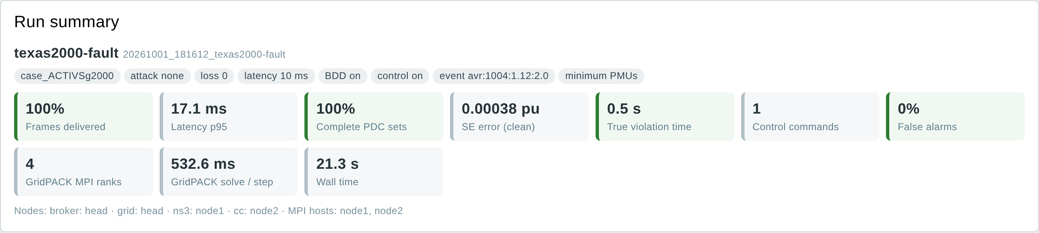
Figure 35. Summary of the 2000-bus run on the cluster.
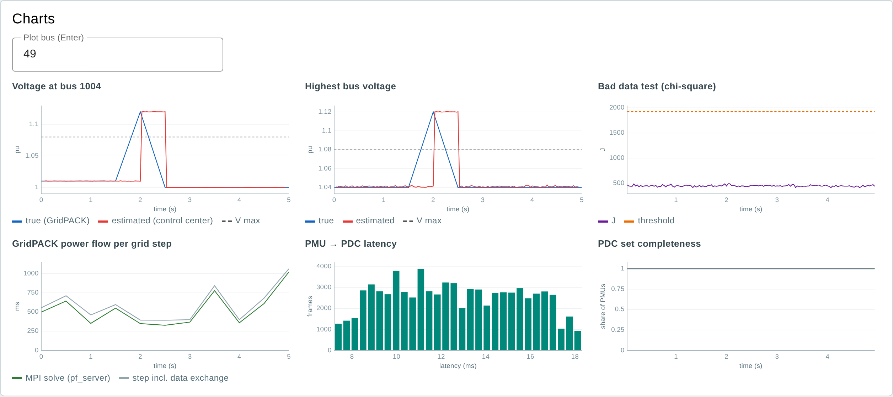
Figure 36. Charts of the 2000-bus run.

8.4 GridPACK on MPI: accuracy and time
pf_server was compared with the testbed's own Newton-Raphson solver at four operating points with load and setpoint changes.
Grid | Max. difference | 1 rank | 2 ranks | 4 ranks
IEEE 118, one container | 5×10⁻¹⁰ pu | 6–16 ms | 15–27 ms | 15–31 ms
IEEE 118, 4 ranks over 2 containers | 5×10⁻¹⁰ pu | – | – | 61–71 ms
ACTIVSg2000, one container | 5×10⁻¹⁰ pu | 104–120 ms | 78–116 ms | 55–97 ms
ACTIVSg10k, one container | 6×10⁻⁵ pu | 526–638 ms | 452–624 ms | 356–508 ms

Small grids are fastest on one rank, because each solve is tiny and every extra rank adds MPI messages. The 10 000-bus grid gets faster with more ranks even on four shared cores; on separate machines the gain is larger. Real speed-up figures need the physical cluster.

8.5 Dynamic simulation
IEEE 39-bus with its published machine data, 15 s, event at 3 s, GridPACK on one rank, NS-3 on node1, control center on node2.
Event | Lowest frequency | Violation | What happened
Three-phase fault at bus 16, cleared after 0.1 s | 59.70 Hz | 3.6 s | Voltages down to 0.56 pu; angle spread 66° → 125° and back; exciter overshoot to 1.16 pu; 24 control commands
Generator 32 trip (650 MW) | 59.42 Hz at 9.4 s | 12 s | Governors arrest the decline (59.54 Hz at 15 s); under-voltage near bus 32 remains
Line 16–17 trip | 59.96 Hz | 0 s | Small swing
AVR fault at gen 30 (1.12), control off | 59.86 Hz | 11.0 s | Exciter raises the voltage over about 2 s; it stays high
Same, control on | 59.92 Hz | 2.0 s | 3 commands; the exciter brings the voltage back

The same fault on 1, 2 and 4 ranks gives identical voltages, frequencies and angles. The 2000-bus grid (typical data for 432 machines, trip of the largest generator) reaches 59.81 Hz with identical results on 1 and 2 ranks.
Grid | 1 rank | 2 ranks (one node) | 4 ranks (node1 + node2)
IEEE 39, per PMU frame | 6.6 ms | 12.9 ms | 274 ms
ACTIVSg2000, per PMU frame | 152 ms | 118 ms | –

A small grid runs faster than real time on one rank (15 s simulated in about 7 s of wall time). The dynamic simulation exchanges many small messages in every integration step, so ranks spread over two containers of the shared 4-core test machine wait on each other; on separate machines this cost is far lower, and large grids already gain from more ranks.

9. Sizing and storage
Item | Measured size
Software per machine (/opt/cps + Ubuntu packages) | about 3 GB (plus about 10 GB for Ubuntu itself)
One IEEE 118 run, 10 s | about 1 MB
One 2000-bus run, 10 s (153 088 PMU frames) | about 14 MB
One 10 000-bus run, 10 s | about 70 MB (estimated)
One IEEE 39 dynamic run, 15 s | about 1 MB
One 2000-bus dynamic run, 5 s (true voltages every frame) | about 13 MB
An uploaded 2000-bus grid | about 2 MB

Run sizes grow linearly with duration. 1000 runs of the 2000-bus grid for 60 s need about 85 GB, so 500 GB on the head (or file server) hold several thousand experiments.

10. Limitations and next steps
Limitation | Next step
Tested on a virtual cluster (containers on one machine) | Install on separate machines with NFS; measure speed-up on 1, 2, 4 nodes
Simulated PMUs; frames are JSON, not IEEE C37.118 | Connect real PMUs and a real PDC (e.g. openPDC) through C37.118
Dynamic mode: constant-impedance loads; typical machine data for grids without a .dyr file; bolted faults | Load models; upload .dyr files from the dashboard; fault impedances
PMU frames carry phasors only | Add frequency and rate-of-change-of-frequency channels (the dynamic simulation computes them)
PSS/E files are converted through MATPOWER | Read PSS/E directly; import the PGCB grid model
One administrator login; access over VPN or SSH | HTTPS and individual user accounts for many users
IEEE 14 console voltage chart needs internet | Bundle its chart library

11. Troubleshooting
Problem | What to do
Login fails on the dashboard or editor | The user is admin; set the password again with sudo cps-passwd
Dashboard says "Experiment API not reachable" | systemctl status cps-api; journalctl -u cps-api
A job fails | Read the log under the job; the federate logs are in the run directory
A node is not reachable | sudo -u cps ssh node1 true on the head; check the NFS mount and systemctl status cps-node on the node
MPI hangs between nodes | Set OMPI_MCA_btl_tcp_if_include and OMPI_MCA_oob_tcp_if_include to the cluster interface; open the firewall
A grid upload is rejected | The message names the problem (missing mpc.gen, no slack bus, power flow does not converge)
An experiment waits in the queue | It needs more MPI slots than are free; it starts when a running experiment ends
A dynamic run stops with "the dynamic simulation failed" | Read gridpack/dsf_server.log in the run directory; check the machine data (gridpack/case.dyr) and that the grid's power flow converges

Appendix A. Repository layout
Directory | Contents
cases/ | IEEE 14–300 bus inputs, topology and reference solutions; IEEE 39 machine data (dynamics.dyr)
federates/ | grid_fed.py, cc_fed.py, observer_fed.py, run_experiment.py; cpslib/ (network model, PMU placement, state estimation, attacks, GridPACK client, uploaded grids, cluster placement)
gridpack/ | pf_server (power flow) and dsf_server (dynamic simulation): persistent MPI GridPACK servers; patches/ applied to GridPACK 3.5
ns3-scratch/helicstest/ | NS-3 network federate
webapp/ | Experiment API, scenario format and template
node-red/ | Dashboard flows and settings
legacy/ | Original single-PMU IEEE 14 demo used by the console
tools/ | make_cases.py (MATPOWER → testbed cases)
install/ | install.sh, build steps, configure.py, systemd units, settings example
docker/ | Dockerfile, entrypoint, compose files
documentation/ | This guide, install.md, cluster.md, user guide and technical report of the preceding version

Team. Principal Investigator: Dr. Hafiz Abdur Rahman (North South University). Co-PIs: Dr. Jahangir Hossain (University of British Columbia), Dr. Athula Kulatunga (Purdue University Northwest). Research team: Dr. Shohana Rahman Deeba, Ms. Rummana Rahman (North South University). Development: Md. Mazharul Islam. Funded by the Bangladesh Energy and Power Research Council (EPRC), grant EPRC/58-2018-007-01.

