CPS Testbed
Web Application and Node-RED Dashboard: User Guide
Remotely Accessible Cyber-Physical System Testbed and Open Architecture Synchrophasor Systems
NSU–PGCB project (EPRC/58-2018-007-01)
Md. Mazharul Islam
September 2026 · for testbed image ghcr.io/mazharulmd/cps-testbed:latest

Contents
1. Overview 3
2. Opening the Web App and the Dashboard 4
3. Web Application or Node-RED? 5
4. What Happens When You Click Run 6
5. The Web Application Page 7
6. Inputs: Setting Up an Experiment 8
6.1 Presets 8
6.2 Power system 10
6.3 PMUs and network 10
6.4 Attack 11
6.5 Control center and run settings 11
7. Outputs: Reading the Results 12
7.1 Queue 12
7.2 Runs 12
7.3 Run details: summary figures 12
7.4 Run details: charts 14
7.5 Commands and events 15
7.6 Result files 15
8. Worked Examples 16
8.1 A generator fault with a simple false data injection (IEEE 118) 16
8.2 The same attack made stealthy 18
8.3 Running the IEEE 300-bus system 18
8.4 Minimum versus redundant PMU placement (IEEE 14) 18
8.5 Latency and the PDC wait window 18
9. The Node-RED Dashboard 19
9.1 Inputs (Run Scenario panel) 19
9.2 Outputs 20
10. Troubleshooting 21

1. Overview
The CPS testbed simulates how PMU measurements travel from the power grid to a control center, how the control center uses them, and what happens when the communication network is slow, lossy or under attack. Three simulators run together, kept in step by the HELICS co-simulation broker:
- Grid (GridPACK): solves the power flow of the chosen IEEE bus system every grid step, with slowly varying load and optional faults, and applies the control center's commands.
- Network (NS-3): PMUs at the optimal buses send voltage and current phasors 30 times per second over their own links to a phasor data concentrator (PDC). Attacks are applied here.
- Control center: estimates the state of the whole grid from the PMU data, tests the data for falsification (bad data detection), and sends voltage setpoint commands to generators when a bus voltage is out of limits.
There are two browser interfaces:
- The web application (port 8080) runs the full testbed: any bus system from IEEE 14 to IEEE 300, many PMUs, attacks and defenses, and detailed results for every run.
- The Node-RED dashboard (port 1880) runs the original single-PMU IEEE 14-bus prototype described in Sections 2–6 of the technical report.

2. Opening the Web App and the Dashboard
Both services run on the testbed server and are reached from your own computer through an SSH tunnel. With MobaXterm on Windows:
- Click Tunneling in the toolbar, then New SSH tunnel, and choose Local port forwarding.
- Enter the Forwarded port on your computer (left), the SSH server address, user ubuntu and port 22 (bottom), and remote server localhost with the Remote port (right). Use the values in the table below.
- Click Save, attach your SSH private key with the key icon, and press Start. The row turns green when the tunnel is running.
- Open the address from the table in your browser and log in.
Service | Tunnel (local → remote) | Address in your browser | Login
Web application | 8080 → localhost:8080 | http://localhost:8080 | User admin; password in ~/.cps-web-password on the server
Node-RED dashboard | 1880 → localhost:1880 | http://localhost:1880/dashboard/console | User admin; password in ~/.cps-nodered-password on the server
Node-RED editor | 1880 → localhost:1880 | http://localhost:1880 | Same as the dashboard

Tip: the address works only while the tunnel is started. If port 8080 is already used on your computer, forward local port 18080 instead and open http://localhost:18080. Use http, not https.
To show the passwords, connect to the server with MobaXterm and run:
cat ~/.cps-web-password ; cat ~/.cps-nodered-password
If you run the published Docker image on your own computer instead, no tunnel is needed: start it with docker run -d -p 1880:1880 -p 8080:8080 -e CPS_WEB_PASSWORD=<password> ghcr.io/mazharulmd/cps-testbed:latest and open http://localhost:8080 (see the repository README).

3. Web Application or Node-RED?
Use the web application for experiments and results; use Node-RED to demonstrate the original prototype.
 | Web application (port 8080) | Node-RED dashboard (port 1880)
Purpose | The extended multi-PMU testbed | The original single-PMU prototype
Bus systems | IEEE 14, 30, 39, 57, 118, 300 | IEEE 14 only
Power flow | GridPACK solves the network live every grid step (default 0.5 s) | Replays one saved GridPACK solution, one bus per time step
PMUs | Many PMUs at the optimal buses (4 to 87; redundant option up to 202), 30 frames/s each | One PMU sending one bus value per step
Network | Own link per PMU: latency, spread, jitter, loss; PDC wait window | One link: latency and loss
Control | Closed loop: commands travel over the network and change the grid | Command is printed; the grid does not change
Attacks | Simple and stealthy false data injection, delay and drop, on any bus, with start and end times | False data injection on bus 8; drop one bus
Defenses | State estimation, chi-square bad data detection, removal of falsified PMUs, redundant PMU placement | None
Results | History of all runs; 11 summary figures and 6 charts per run; any bus can be plotted; all raw data saved | Latest run only: voltage and delay charts, gauge, table
Run time | 10–80 s depending on the bus system | About 15 s

4. What Happens When You Click Run
- Checking. The browser sends your settings to the server, which checks every value (ranges, and that the event and target buses exist in the chosen bus system). Problems are shown under the Run button and nothing is started.
- Queueing. The experiment joins the queue. Experiments run one at a time because they share the HELICS broker; the Queue panel shows its status.
- Preparing. The server loads the bus system, computes the optimal PMU placement, works out which PMU channels an attack must change, draws a latency for every PMU link, and writes the configuration files for the run.
- Starting the co-simulation. The HELICS broker and the three federates (grid, network, control center) start and connect.
- Every grid step (0.5 s): the grid federate applies any command that has arrived, updates the loads (and a scheduled fault, if any), runs GridPACK, and publishes the true phasors that each PMU measures.
- Every PMU frame (33 ms at 30 fps): each PMU samples the phasors, adds measurement noise and sends a frame over its link; an attack changes, delays or drops the frames of the targeted PMUs. The PDC collects the frames for each time stamp and releases the set when all PMUs have reported or the wait window has passed.
- For every measurement set: the control center estimates all bus voltages, runs the chi-square bad data test (removing a suspicious PMU and re-estimating if needed), checks the voltage limits and, if a bus is out of limits, sends a setpoint command to the nearest generator.
- Commands travel back through the NS-3 network to the generator's node and are applied by GridPACK at the next grid step, closing the loop.
- Scoring. When the simulated time is over, the server compares what the control center saw with the true grid state, computes the summary figures, and the page opens the new run automatically.
Approximate run times for 10 s of simulated time: IEEE 14 and 30 about 10 s, IEEE 57 about 15 s, IEEE 118 about 25–40 s, IEEE 300 about 80 s.

5. The Web Application Page
The header shows the project, the Principal Investigator and the grant, and a status light on the right: green Idle · ready, or amber Running while experiments are in the queue. Below it the page has three areas (Fig. 1): the New experiment form on the left, the Queue and Runs list at the top right, and the results of the selected run below them. The footer lists the research team and links to the GitHub repository, this guide and the technical report.
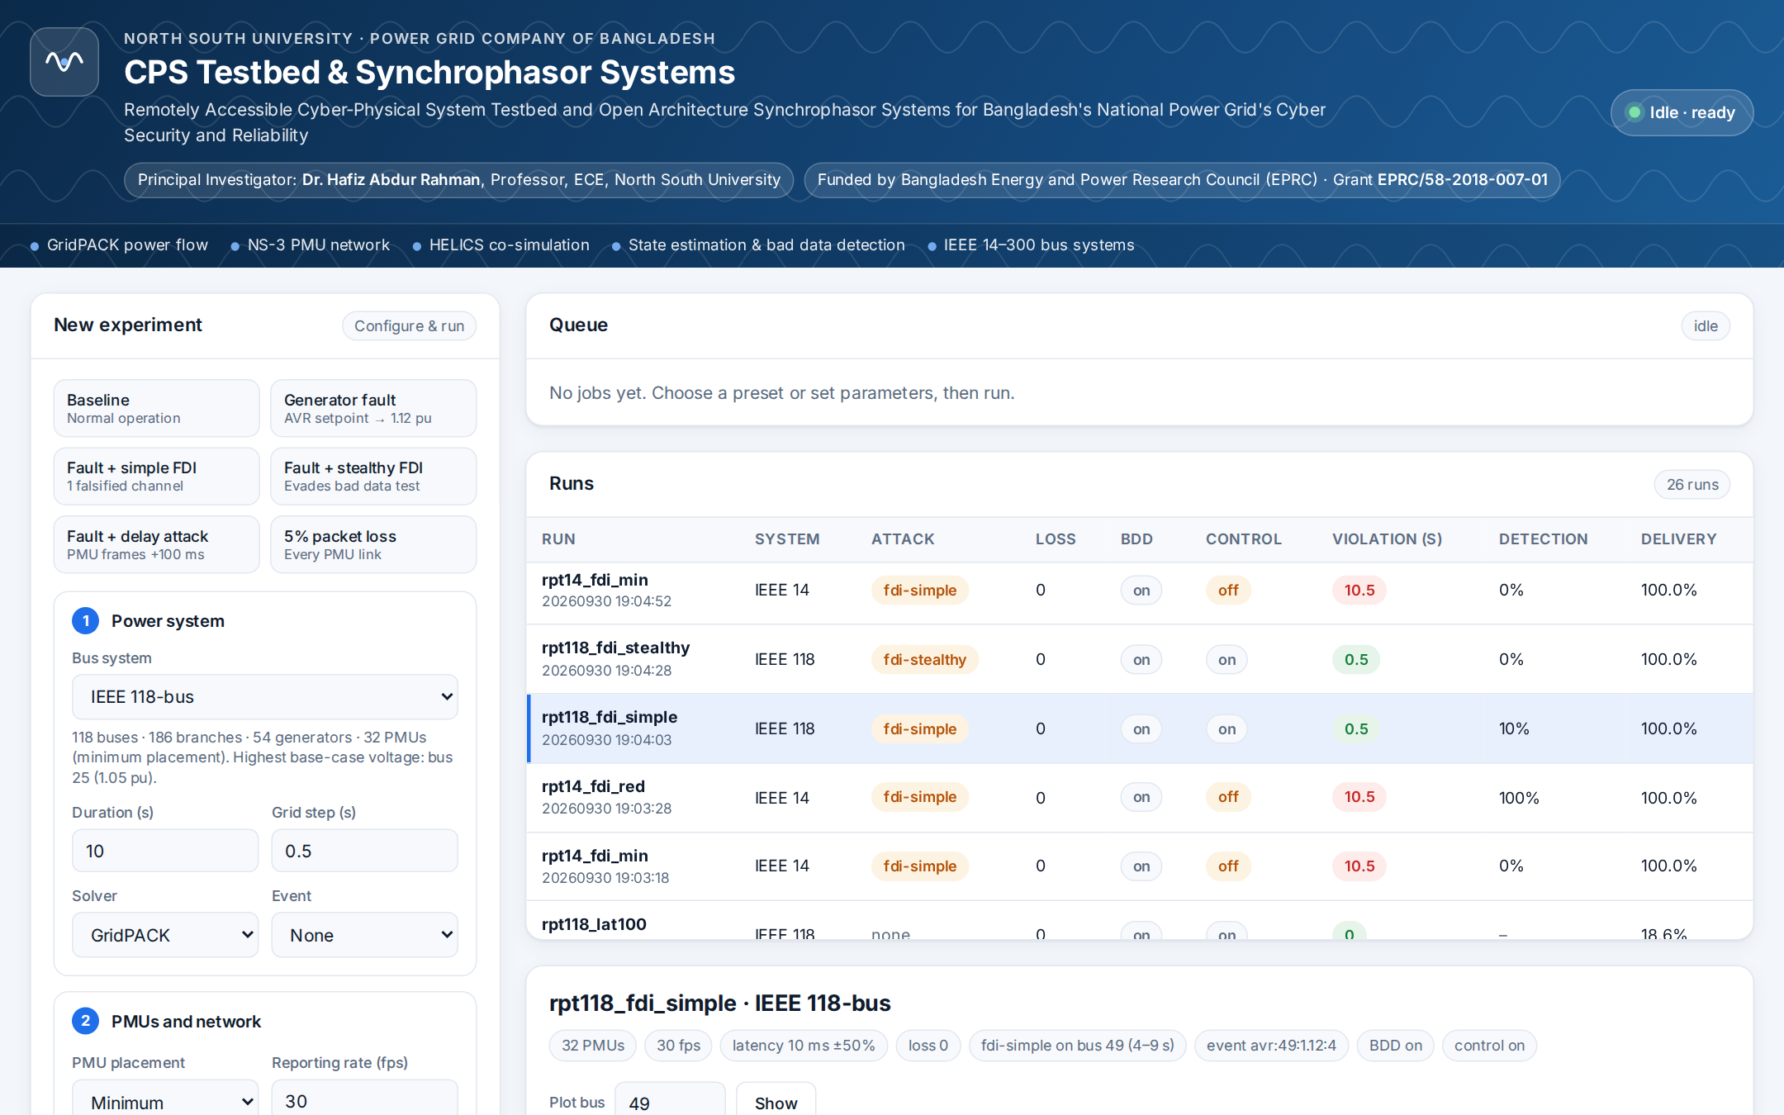
Figure 1: The web application: experiment form (left), queue and run list (top right), results of the selected run (bottom right).

6. Inputs: Setting Up an Experiment

6.1 Presets
The preset cards at the top of the form fill it in for common scenarios. They use the bus system currently selected, so choose the Bus system first. After clicking a preset you can still change any field.
Preset | What it sets up
Baseline | Normal operation: no fault, no attack, no loss.
Generator fault | At t = 4 s the voltage regulator (AVR) of a generator in the middle of the generator list fails and its setpoint jumps to 1.12 pu, causing an over-voltage.
Fault + simple FDI | The generator fault, and from 4 s to 9 s an attacker falsifies one PMU channel so the faulted bus appears to be at 1.02 pu.
Fault + stealthy FDI | As above, but the attacker falsifies every channel connected to the bus consistently, to avoid the bad data test.
Fault + delay attack | The generator fault, and the PMUs observing that bus are delayed by 100 ms from 4 s to 9 s.
5% packet loss | Normal operation with 5% of packets lost on every PMU link.

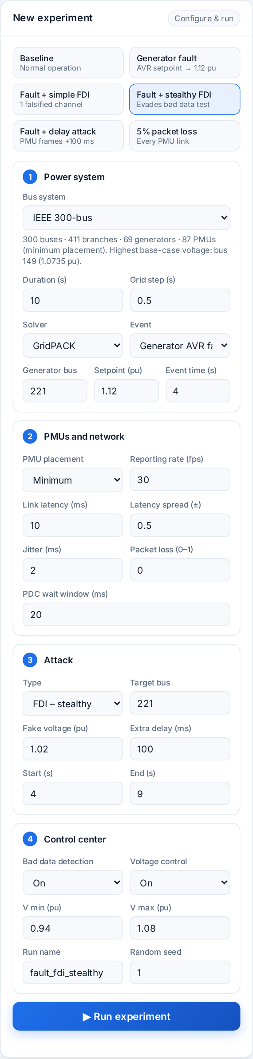
Figure 2: The form after choosing IEEE 300-bus and the “Fault + stealthy FDI” preset.

6.2 Power system
Field | Meaning | Default | Allowed values
Bus system | The IEEE test network to simulate. The line below it shows the number of buses, branches, generators and PMUs. | IEEE 118 | 14, 30, 39, 57, 118, 300
Duration (s) | Simulated time of the experiment. | 10 | 1–60
Grid step (s) | How often GridPACK re-solves the power flow. Commands take effect at the next step. | 0.5 | 0.1–5
Solver | GridPACK, or the built-in Newton-Raphson solver (same results; used automatically if GridPACK fails). | GridPACK | GridPACK, Built-in NR
Event | A disturbance during the run.  Generator AVR fault: a generator's voltage setpoint jumps to the faulty value.  Load step: a bus load changes by a percentage. | None | None, AVR fault, Load step
Generator / Load bus | Where the event happens. For an AVR fault it must be a generator bus. | Set by preset | A bus of the chosen system
Setpoint (pu) / Change (%) | The faulty generator setpoint, or the load change in percent (negative to reduce). | 1.12 | Any value
Event time (s) | When the event starts. | 4 | 0 – duration

6.3 PMUs and network
Field | Meaning | Default | Allowed values
PMU placement | Minimum: fewest PMUs that make every bus observable.  Redundant: every bus seen by two PMUs (about twice as many PMUs), which removes blind spots for bad data detection. | Minimum | Minimum, Redundant
Reporting rate (fps) | PMU frames per second. | 30 | 1–120
Link latency (ms) | Mean one-way delay of the PMU links. | 10 | 0.1–2000
Latency spread (±) | Each link's latency is drawn between mean×(1−spread) and mean×(1+spread). 0.5 means ±50%. | 0.5 | 0–0.95
Jitter (ms) | Extra random delay for every frame, between 0 and this value. | 2 | 0–500
Packet loss (0–1) | Probability that a frame is lost on each link. | 0 | 0–0.9
PDC wait window (ms) | After the first frame of a time stamp arrives, the PDC waits this long for the others before releasing the set. Frames arriving later are counted as late. | 20 | 1–2000

6.4 Attack
Field | Meaning | Default | Allowed values
Type | FDI – simple: falsifies the one channel that most directly measures the target bus.  FDI – stealthy: falsifies all channels connected to the target bus consistently with the network model.  Delay: holds back the frames of the PMUs observing the target bus.  Drop: discards those frames. | None | None, FDI simple, FDI stealthy, Delay, Drop
Target bus | The bus the attacker wants to hide. Leave empty for the bus with the highest voltage. | auto | A bus of the chosen system
Fake voltage (pu) | FDI only: the voltage the attacker wants the control center to see. Empty = true value − 0.04 pu. | auto | 0.5–1.5
Extra delay (ms) | Delay attack only: how much the frames are held back. | 100 | 0–5000
Start / End (s) | When the attack is active. | 4 / 9 | End must be after start

6.5 Control center and run settings
Field | Meaning | Default | Allowed values
Bad data detection | Chi-square test on the state estimation residuals; on an alarm the most suspicious PMU is removed (up to three). | On | On, Off
Voltage control | Send generator setpoint commands when a bus voltage is outside the limits. Off shows what happens without control. | On | On, Off
V min / V max (pu) | Voltage limits. The control center acts when an estimated voltage is outside them by more than 0.003 pu. | 0.94 / 1.08 | 0.5–1.0 / 1.0–1.5
Run name | Name shown in the run list and used in the results folder name. | Set by preset | Letters, digits, _ and -, up to 40
Random seed | Controls link latencies, noise and loss. The same seed and settings give the same result. | 1 | Any positive integer

Click Run experiment. The message under the button confirms that the job was queued, or explains what to correct.

7. Outputs: Reading the Results

7.1 Queue
Shows the latest jobs with their status: queued, running (with the live log of the co-simulation), done or failed (with the error). When a job finishes, the run list refreshes and its results open.
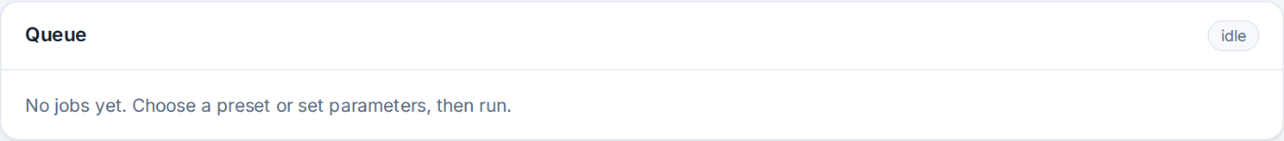
Figure 3: The queue panel when no experiment is waiting or running; the count at the top right shows active jobs.

7.2 Runs
Every finished experiment, newest first. Click a row to open its results.
Column | Meaning
Run | Run name and start time.
System | IEEE bus system.
Attack | Attack type.
Loss, BDD, Control | Packet loss rate; bad data detection on/off; voltage control on/off.
Violation (s) | How long a true voltage limit violation existed in the grid. Shown in red when longer than 1 s.
Detection | Share of measurement sets during the attack in which the bad data test raised an alarm (– when there was no attack).
Delivery | Share of PMU frames that reached the PDC in time.

7.3 Run details: summary figures
The tags under the run title repeat the main settings. The boxes below them summarise the run (Fig. 4). Their colour is a quick verdict: green for a good outcome (for example a violation corrected within a second, or an attack detected), amber for borderline and red for a problem (for example a long violation, an undetected attack or incomplete data); grey boxes are information only.
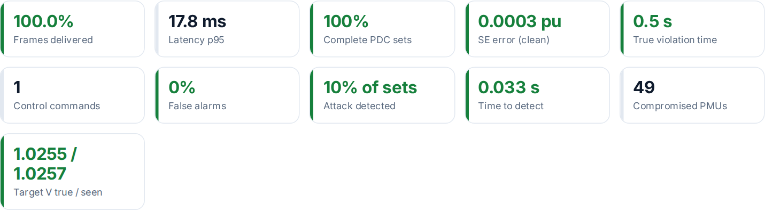
Figure 4: Summary figures of a run with a generator fault and a simple FDI attack on IEEE 118.
Figure | Meaning
Frames delivered | Share of PMU frames that reached the PDC before the wait window closed.
Latency p95 | 95% of delivered frames arrived within this time (PMU measurement to PDC).
Complete PDC sets | Share of measurement sets that contained every PMU.
SE error (clean) | Average difference between estimated and true bus voltages outside the attack window. About 0.0003 pu is normal.
True violation time | How long any bus voltage was really outside the limits.
Control commands | Setpoint commands applied to the grid.
False alarms | Share of sets outside the attack window with a bad data alarm. Should be about 0–1%.
Attack detected | Share of attacked sets with an alarm. An attack is usually detected only while it is hiding something, so this can be low even when detection was immediate.
Time to detect | Time from the attack start to the first alarm, or “never”.
Compromised PMUs | The PMUs whose frames the attacker changed, delayed or dropped.
Target V true / seen | Average true voltage of the target bus during the attack, and the average the control center estimated.

7.4 Run details: charts
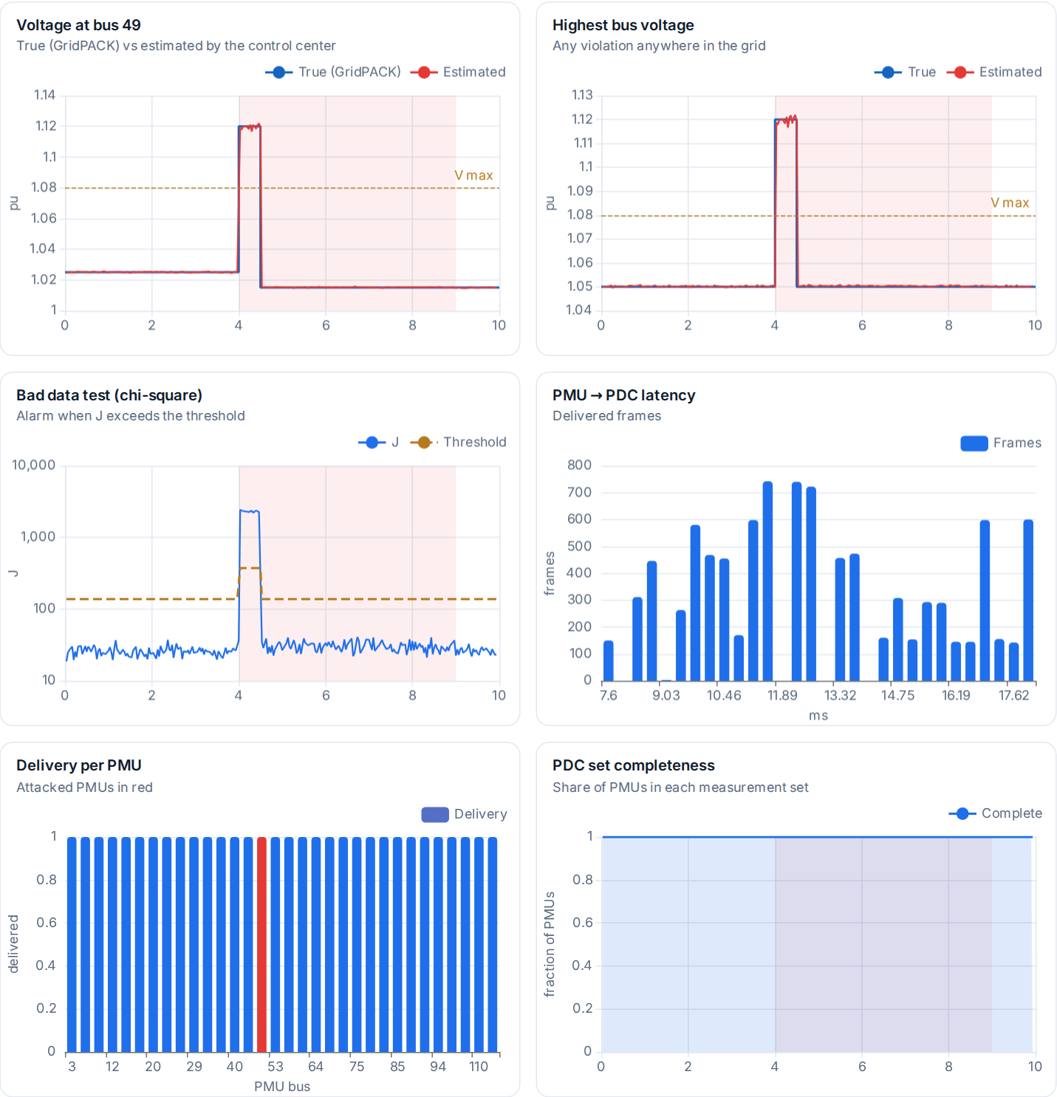
Figure 5: The six result charts. The shaded band marks the attack window.
Chart | How to read it
Voltage at bus N | Blue: true voltage from GridPACK. Red: voltage estimated by the control center. Dashed: V max. If red leaves blue during an attack, the attack is fooling the control center. Change the bus with the Plot bus box and Show (or press Enter).
Highest bus voltage | The highest true and estimated voltage over all buses. Shows whether any violation anywhere was seen.
Bad data test (chi-square) | J is the statistic of the measurement residuals; an alarm is raised when J is above the threshold. A simple FDI makes J jump; a stealthy FDI does not. The threshold can rise briefly while suspicious PMUs are removed.
PMU → PDC latency | Histogram of the delay of delivered frames. Its spread shows why the PDC wait window matters.
Delivery per PMU | Share of each PMU's frames that arrived in time. Attacked PMUs are red.
PDC set completeness | Share of PMUs present in each measurement set over time. Loss and delay attacks make it drop.

7.5 Commands and events
The table at the bottom lists the scheduled event and every command applied to the grid: when it was issued by the control center, when it arrived over the network, when GridPACK applied it, the generator, the new setpoint, and the reason (the violating bus and its estimated voltage).

7.6 Result files
Every run is stored in its own folder, results/runs/<date>_<time>_<name>/ (on the testbed server: ~/cps-results/). The files can be opened with Excel, Python or MATLAB for further analysis.
File | Contents
summary.json | All summary figures of the run.
meta.json | The settings, PMU placement with every PMU's channels, and the attack plan.
run_config.json, ns3_config.json | The configuration given to the federates.
frames.csv | Every PMU frame: time stamp, PMU, send and arrival time, latency, status (delivered, late, lost, dropped), attacked.
cc_log.csv | Every measurement set: PMUs received, chi-square statistic and threshold, alarms, removed PMUs, highest and lowest estimated voltage, violations, commands.
cc_estimates.csv | Estimated voltage of every bus for every measurement set.
grid_truth.csv, grid_steps.csv | True voltage of every bus at every grid step; solver, convergence and total load per step.
commands_applied.csv | Events and commands applied to the grid.
*.log | Output of the broker and each federate, for troubleshooting.

8. Worked Examples

8.1 A generator fault with a simple false data injection (IEEE 118)
- Choose IEEE 118-bus, click Fault + simple FDI, set the generator bus and target bus to 49, and click Run experiment.
- After about 30 s the results open (Fig. 6). In Voltage at bus 49 the true voltage jumps to 1.12 pu at 4 s and returns to about 1.015 pu at 4.5 s: the control center saw the violation and lowered the generator setpoint.
- In Bad data test J jumps far above the threshold at 4 s: the falsified channel is inconsistent with the other measurements. Time to detect is 0.033 s (one frame) and PMU 49 was removed from the estimate, so the control center still saw the real voltage.
- The Commands and events table shows the command issued at 4.067 s, delivered 40 ms later and applied at 4.5 s.
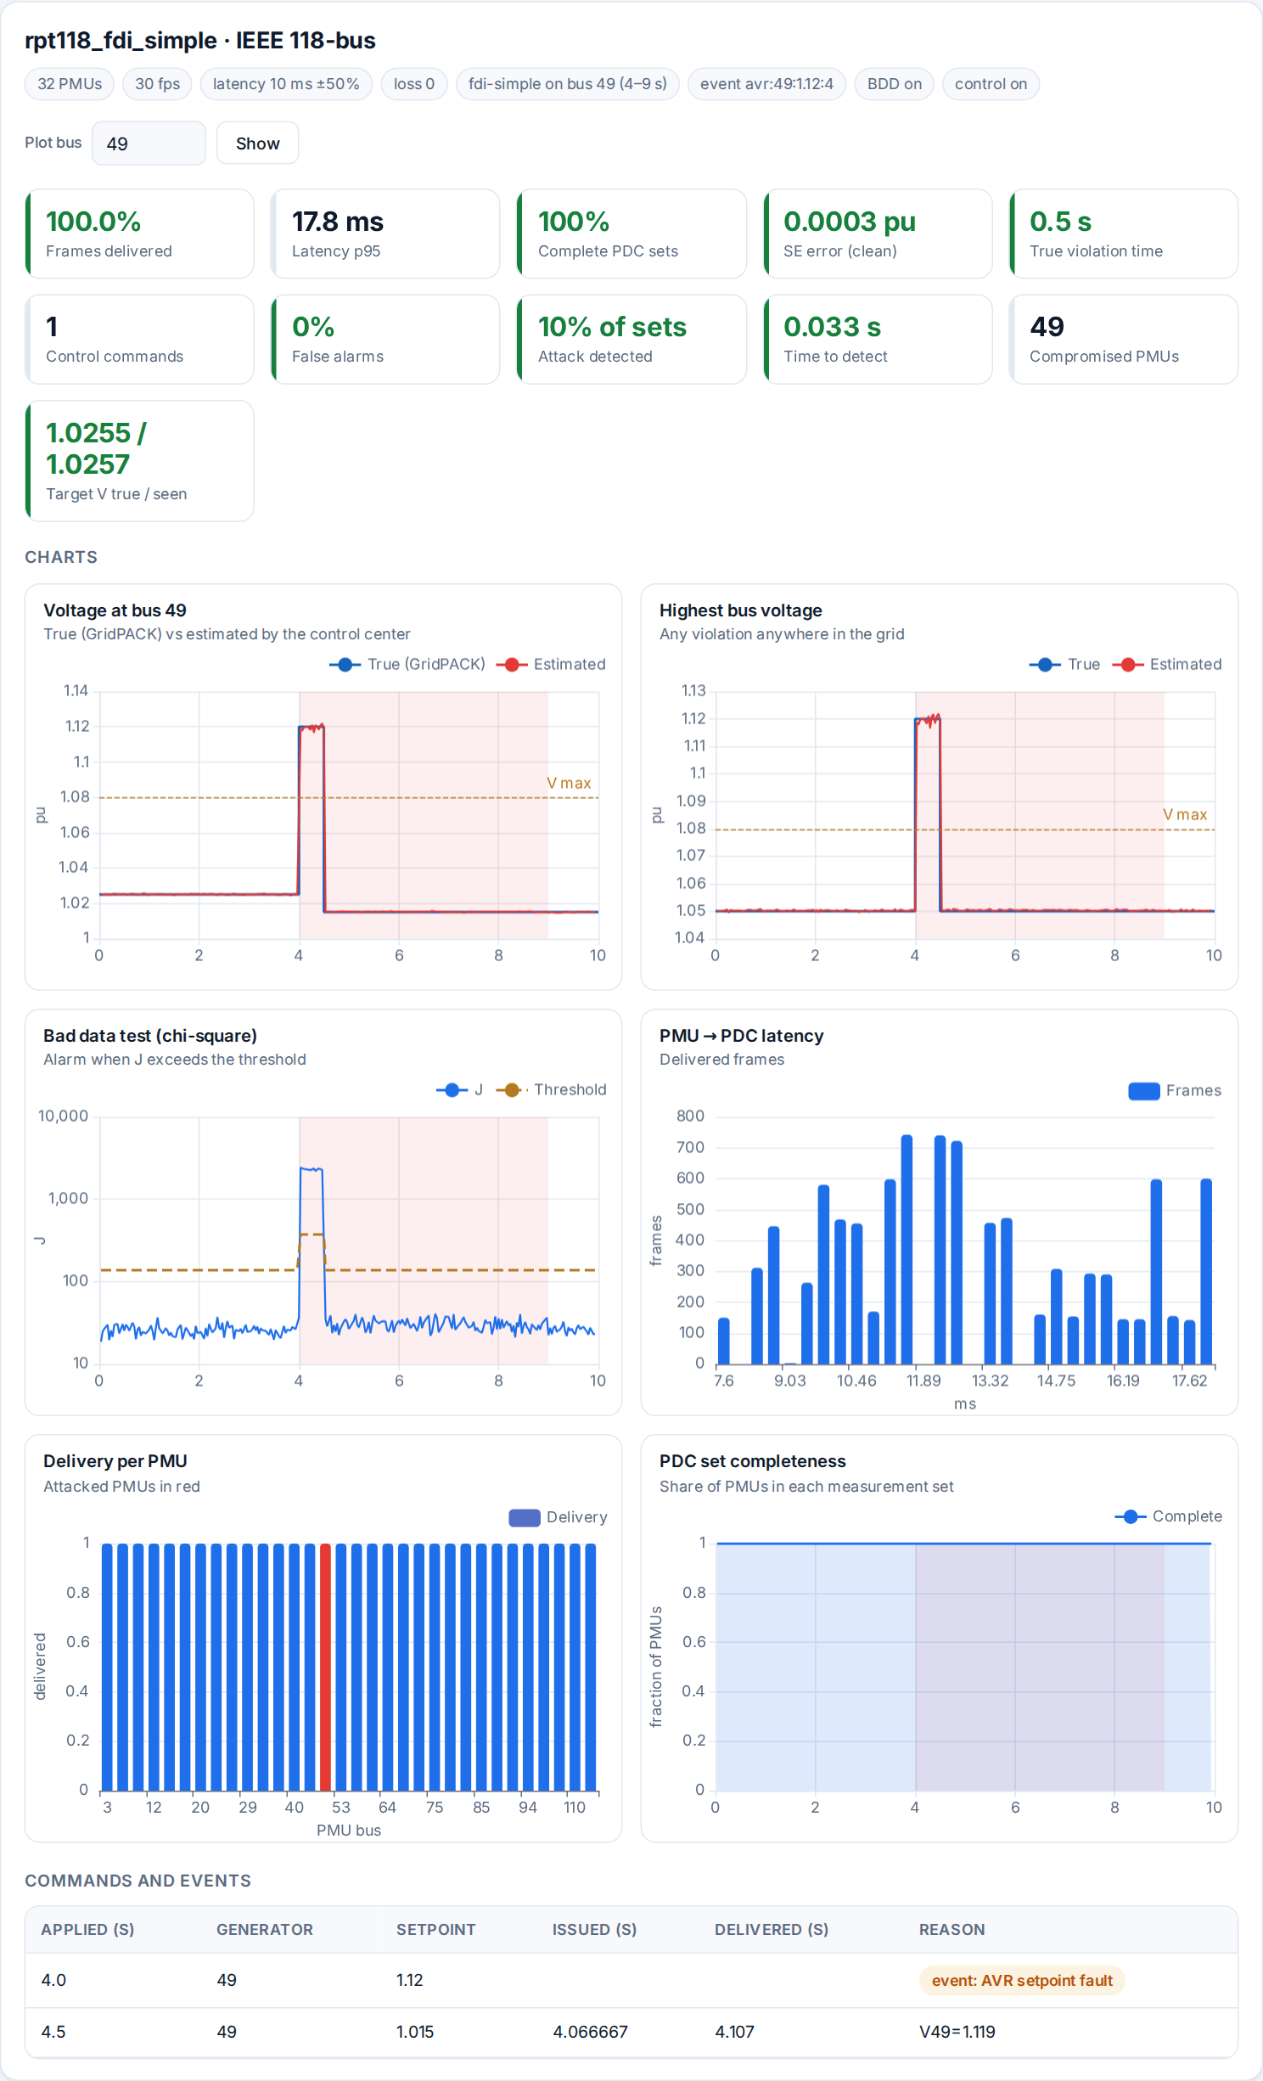
Figure 6: Results of the IEEE 118-bus generator fault with a simple FDI attack on bus 49.

8.2 The same attack made stealthy
Repeat with Fault + stealthy FDI. J no longer moves and the estimated voltage at bus 49 stays at the fake 1.02 pu: the bad data test is blind. The violation is nevertheless corrected, because neighbouring bus 48 also rises above the limit and the control center acts on it; plot bus 48 with the Plot bus box to see this.

8.3 Running the IEEE 300-bus system
- Choose IEEE 300-bus in Bus system (300 buses, 411 branches, 69 generators, 87 PMUs).
- Click a preset, for example Generator fault (it chooses generator 221), or Baseline.
- Click Run experiment. The run takes about 80 s; the queue shows the progress.
- Use the Plot bus box to plot any of the 300 buses.

8.4 Minimum versus redundant PMU placement (IEEE 14)
Run two experiments on IEEE 14-bus with FDI – simple, target bus 8, fake voltage 1.05, voltage control Off, attack 3–8 s: one with Minimum placement and one with Redundant placement. With 4 PMUs, bus 8 is observed through a single measurement, so the attack is not detected and the control center sees 1.05 pu instead of 1.09 pu. With 9 PMUs the same attack is detected in every set and the estimate stays at 1.09 pu. The Detection column of the run list shows 0% and 100%.

8.5 Latency and the PDC wait window
Run Baseline on IEEE 118 with link latency 5, 20, 50 and 100 ms. With the default 20 ms wait window, Complete PDC sets falls from 100% to 76%, and to 0% at 50 ms and above, and the state estimation error grows. Increasing the wait window so that it covers the spread of link latencies (for example 100 ms) should make the sets complete again, at the cost of a longer delay before each set reaches the control center.

9. The Node-RED Dashboard
The Node-RED dashboard runs the original prototype: one PMU on the IEEE 14-bus system, sending one bus voltage per time step from a saved GridPACK solution.
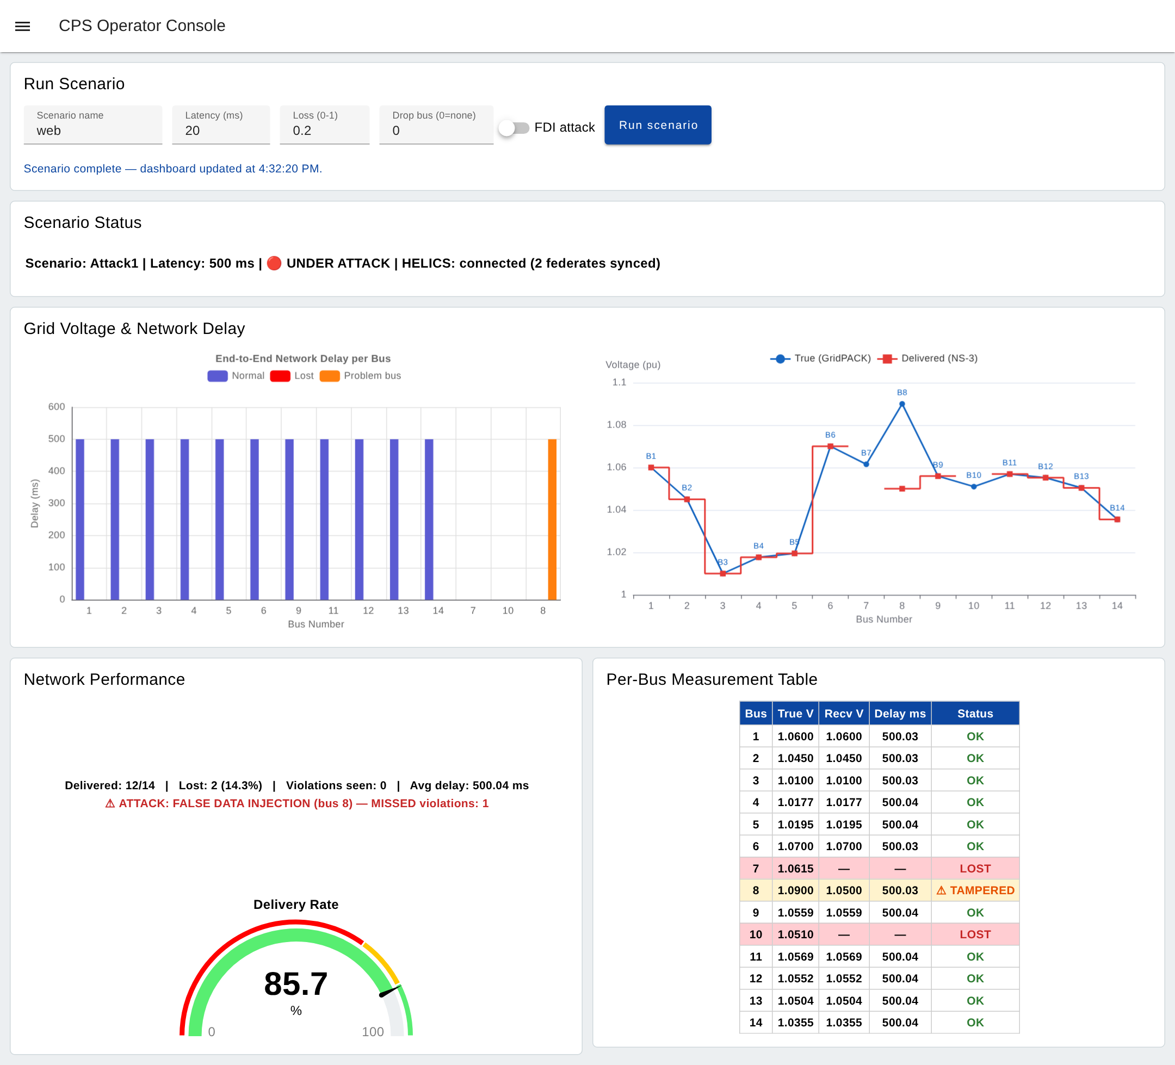
Figure 7: The Node-RED operator console after a run with an FDI attack and 500 ms latency.

9.1 Inputs (Run Scenario panel)
Field | Meaning
Scenario name | Name used for the result files.
Latency (ms) | Delay of the PMU–PDC link.
Loss (0–1) | Packet loss rate of the link.
Drop bus (0 = none) | Drop the measurement of one bus.
FDI attack | Falsify bus 8 (1.09 pu reported as 1.05 pu).
Run scenario | Starts the run; the charts update when it finishes (about 15 s).

9.2 Outputs
- Scenario Status: scenario name, latency, attack state and HELICS status.
- End-to-End Network Delay per Bus: delay of every bus's packet; lost packets and problem buses in colour.
- Voltage chart: true voltage (GridPACK) and delivered voltage (NS-3) for the 14 buses.
- Network Performance: delivered and lost packets, violations seen, missed violations, average delay, and the delivery-rate gauge.
- Per-Bus Measurement Table: true and received voltage, delay and status (OK, LOST, TAMPERED) of every bus.

10. Troubleshooting
Problem | What to do
The browser cannot reach http://localhost:8080 | Start the 8080 tunnel in MobaXterm (Section 2) and check that its row is green. Try http:// (not https://) or forward local port 18080 instead.
The browser asks for a login | User admin and the password from ~/.cps-web-password (web app) or ~/.cps-nodered-password (Node-RED).
“Could not start: bus … is not a generator bus” | Bus numbers differ between systems. Choose the bus system before the preset, or enter a generator bus from the list in the message.
A job shows “failed” | The error is shown under the job. The federate logs (*.log) are in the run folder.
A run takes long | Runs are queued one at a time; IEEE 300 takes about 80 s. Shorter durations run faster.
Where are my results after a restart? | They are kept in ~/cps-results on the server and appear in the run list again.
Node-RED charts do not change | Wait for “Scenario complete” under the Run button; a run takes about 15 s.

