**Lab 1**

**Introduction to Unity and a simple 2D game**

1. Hello Unity

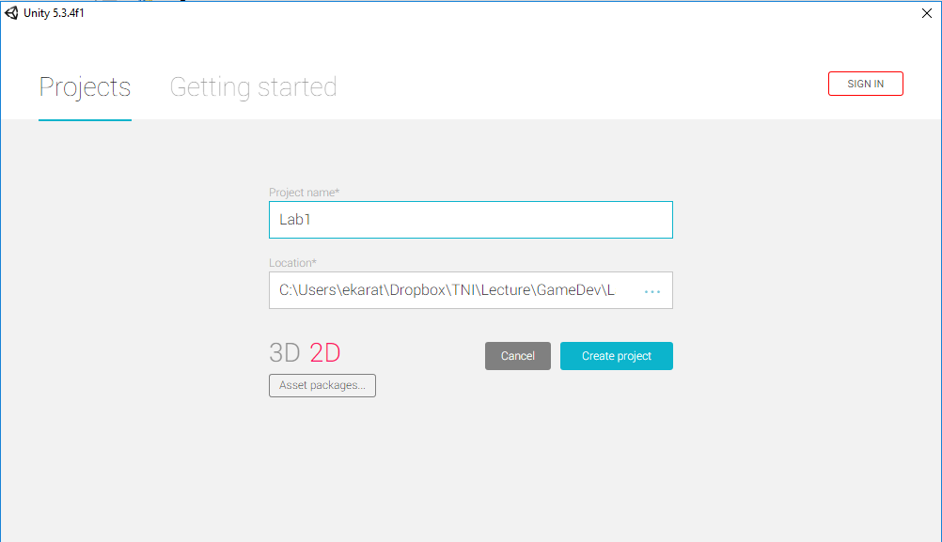

1. An overview of Unity’s User Interface

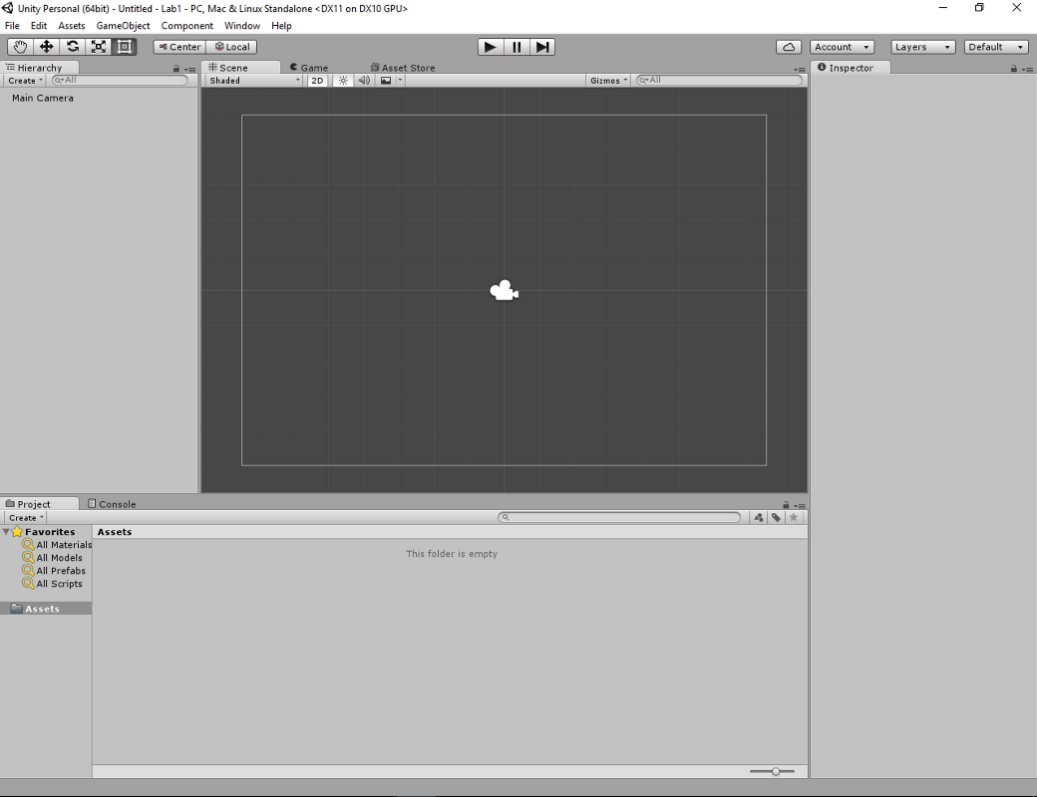

1. Creating assets
   1. Save scene as “Scene1”
   2. Sprite:
      1. Right click on Project panel
      2. Choose: create > sprites > square (Name “basket”)
   3. C# script:
      1. Right click on Project panel
      2. Choose: create > C# Script (named it as Main.cs)

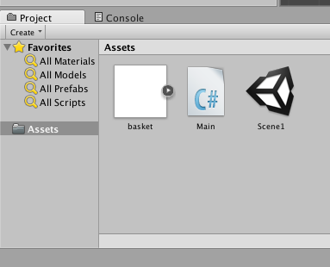

Example of C# code

using UnityEngine;

using System.Collections;

public class Main : MonoBehaviour {

// Use this for initialization

void Start () {

}

// Update is called once per frame

void Update () {

}

}

1. Control sprite in game
   1. Drag “Main.cs” onto “basket” game object.
   2. Move sprite to the right of x-axis

using UnityEngine;

using System.Collections;

public class Main : MonoBehaviour {

// Use this for initialization

void Start () {

}

// Update is called once per frame

void Update () {

transform.position += new Vector3(1.0f * Time.deltaTime, 0, 0);

}

}

1. Input

void Update ()

{

if (Input.GetKey (KeyCode.A))

{

transform.position -= new Vector3 (1.0f * Time.deltaTime, 0, 0);

}

else if (Input.GetKey (KeyCode.D))

{

transform.position += new Vector3 (1.0f * Time.deltaTime, 0, 0);

}

   else if(Input.GetKey(KeyCode.Q)) //Rotate  
      {  
           transform.Rotate(0,0, Time.deltaTime * 10);  
      }  
      else if(Input.GetKey(KeyCode.Z)) //Scale  
      {  
             transform.localScale = new Vector3(2, 2,0);          
         }

}

1. Exercise
   1. Add key “W” to move up and “S” to move down.
   2. Add Key to rotate another direction.
   3. Add Key to zoom out.