**Lab 1**

**Introduction to Unity and a simple 2D game**

1. Hello Unity

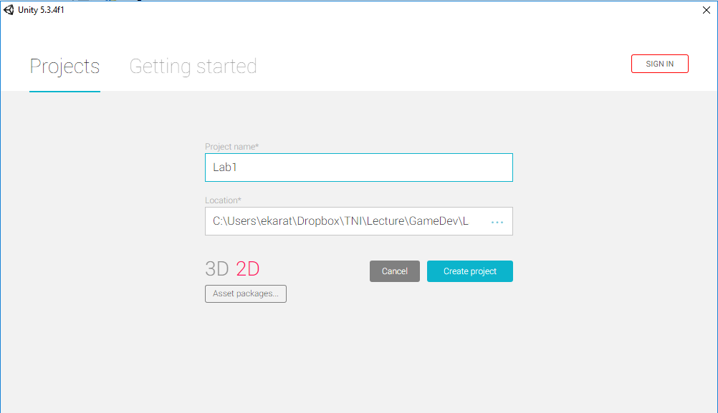

1. An overview of Unity’s User Interface

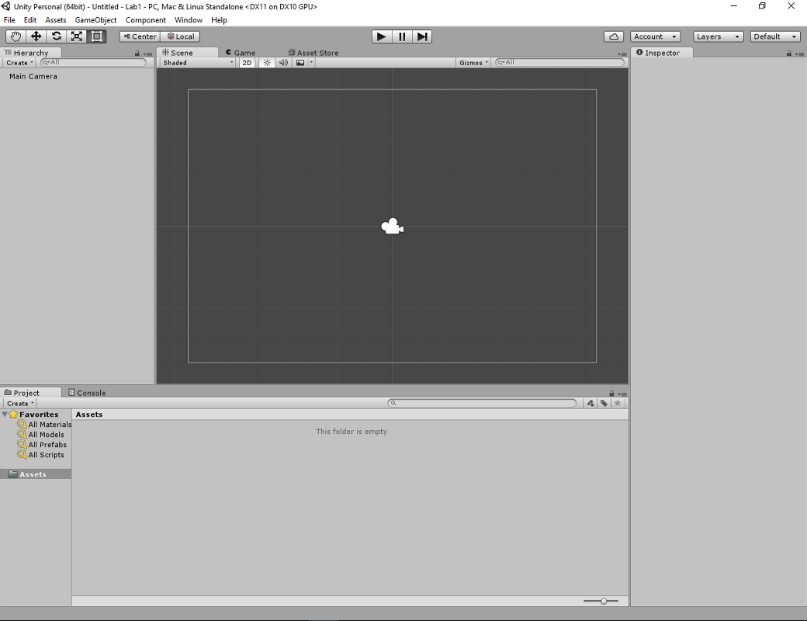

1. Creating and adding assets
   1. Sprite (show my drawing)
   2. Adding sprite into the assets

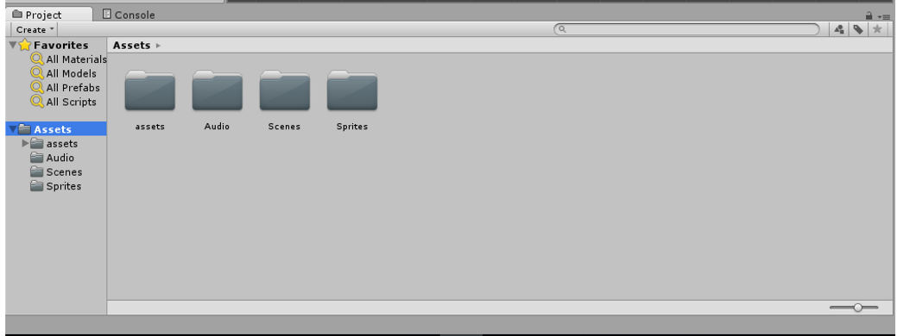

1. Setting up sprites
   1. Rename to player
   2. Add components
      1. Rigidbody 2D
      2. Collider 2D

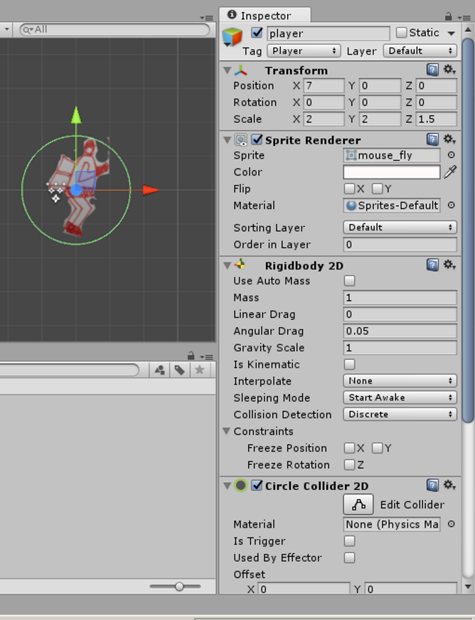

1. Control a player (C#)

5.1 Create a folder Script inside Assets folder → Create C# script.

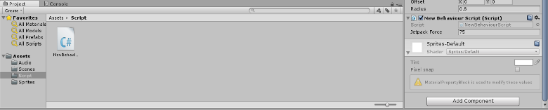

5.2 Initial code

using UnityEngine;

using System.Collections;

public class NewBehaviourScript : MonoBehaviour {

// Use this for initialization

void Start () {

}

// Update is called once per frame

void Update () {

}

}

5.2 Flying pig

using UnityEngine;

using System.Collections;

public class NewBehaviourScript : MonoBehaviour {

public float jetpackForce = 75.0f;

// Use this for initialization

void Start () {

}

// Update is called once per frame

void FixedUpdate () {

bool jetpackActive = Input.GetButton("Fire1");

if (jetpackActive)

{

GetComponent<Rigidbody2D>().AddForce(new Vector2(0, jetpackForce));

Debug.Log ("force = "+jetpackForce);

}

}

}

1. Adding floor and ceil

6.1 Create an empty object

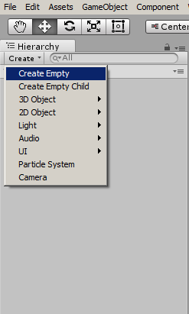

6.2 Rename it to “floor”

6.3 Add Box collider 2D to a floor

6.4 Adjust floor’s position

6.5 Repeat the above process in order to create a “ceil”

1. Adding particle effects

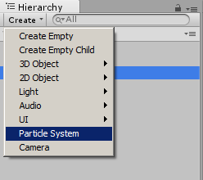

7.1 Rename it to jetFlame

7.2 Move it to under player object

7.3 Setting up particle system

7.3.1 jetFlame

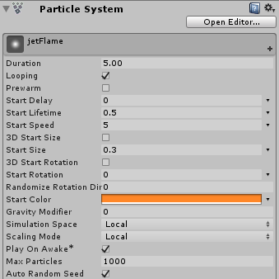

7.3.2 Emission

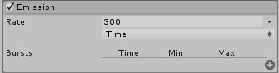

7.3.3 Shape

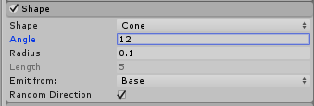

7.3.4 Color over Lifetime

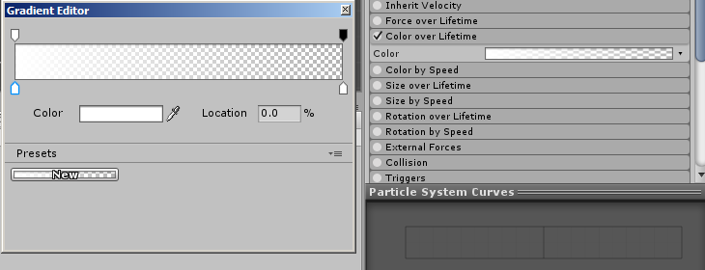

1. Add one coin above a player

8.1 Setting up collider to a coin

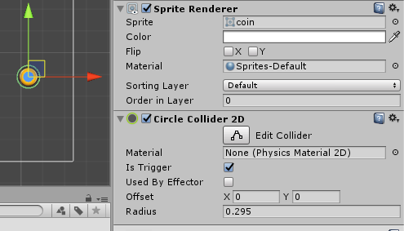

8.2 Add a tag “coin” for reference in the collision process

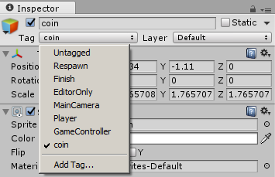

1. Insert a code snippet which checks the collision between a player and coin.

void FixedUpdate () {

bool jetpackActive = Input.GetButton("Fire1");

if (jetpackActive)

{

GetComponent<Rigidbody2D>().AddForce(new Vector2(0, jetpackForce));

Debug.Log ("test"+jetpackForce);

}

}

void OnTriggerEnter2D(Collider2D col)

{

if (col.gameObject.CompareTag("coin"))

{

Destroy(col.gameObject);

}

}

1. Hierarchy structure

