**Lab 7**

**Workshop II (Matching game)**

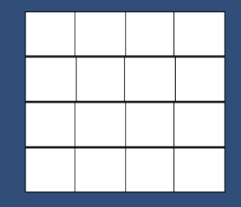 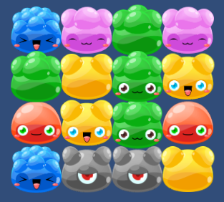

1. Create a new 2D project and save a scene named “Main”.
2. Download “Sprites.zip” from this link: https://goo.gl/W774sU
3. Unzip “Sprites.zip” to Sprites folder. The Sprites folder includes 9 files (png).
4. Try to create your own MatchingGame.
5. The reference:
   1. “MatchingGame.exe” insides “MatchingGame.zip”, downloaded it from this link: https://goo.gl/rBBxcA
   2. The knowledge of making a “OX” game.