**LAB 1: Simple UI**

1. **Building Simple User Interface**
   1. Replace ConstraintLayout with LinearLayout
   2. Add an id to the current TextView
2. **UI event (Click a button, TextView message is changed to “Test”)**

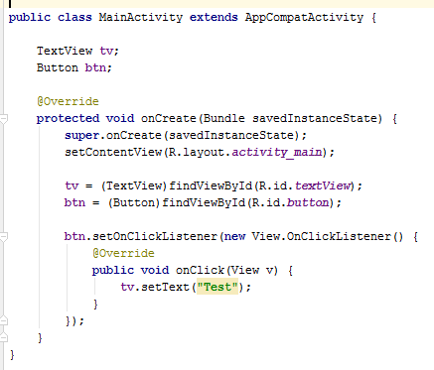

1. Add a new Plain Text (EditText) named it as edt
   1. Change tv.setText(“Test”) to tv.setText(edt.getText().ToString());
2. Exercise
   1. Create an app to convert Thai baht to USA dollar (35 baht = 1 $)
   * Input at EditText
   * Output at TextView
   1. Create an app to sum two number (Two EditTexts, one button)
   2. Create an app with two input
      1. EditText1 = start number (x)
      2. EditText2 = end number (y)
      3. TextView = Show a string “A” whose size = y-x

E.g., x = 1, y=5, result = “AAAA”