**Lab 9**

1. Create a new Android project
2. Create a new java file “Drawable.java” extending View (same place with MainActivity.java)
3. Create two constructors of View
4. Create onDraw function
5. Create a drawable app
   1. Draw a rectangle (width = 400, height = 300)a
   2. Draw a circle (radius = 200)
   3. Draw an oval (width = 200, height = 400)
   4. Draw an arc (width = 400, height = 200, start angle 90, sweep 45
   5. Rotate individual draw
      1. canvas.save()
         1. Rotate operation
      2. canvas.restore()
   6. Draw stroke
      1. paint.setStyle(Paint.Style.STROKE);
      2. paint.setColor(Color.XXXX);
      3. canvas.draw(.....
6. Draw images
   * 1. Watermellon

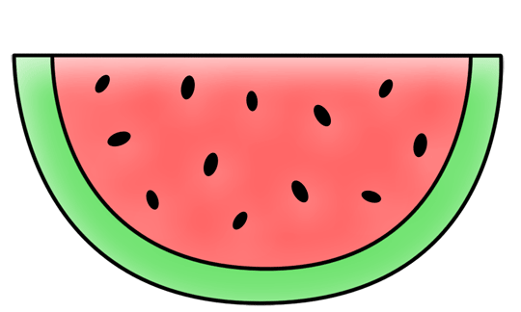

* + 1. Clock

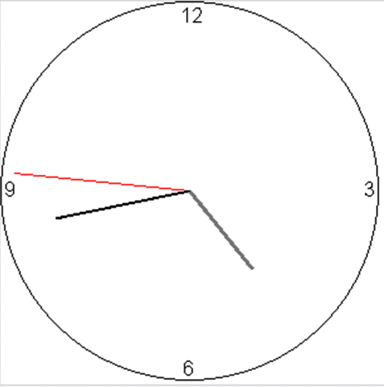

3. Sprite sheet (crop the Grab guy)

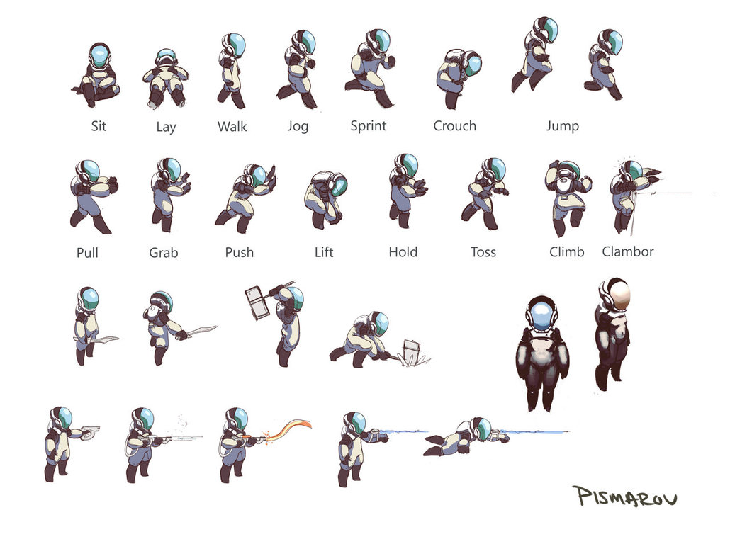

**Extension**

To draw path (curve) example

Paint paint = **new** Paint();

paint.setStyle(Paint.Style.***STROKE***);

paint.setStrokeWidth(5);

Path path = **new** Path();

path.moveTo(100,200);path.cubicTo(100,100,400,100,400,200);

canvas.drawPath(path,paint);