2. Advance:

2.1 Create a 4 color pie chart as shown below

2.2 Rotate the circle chart with speed = 10.

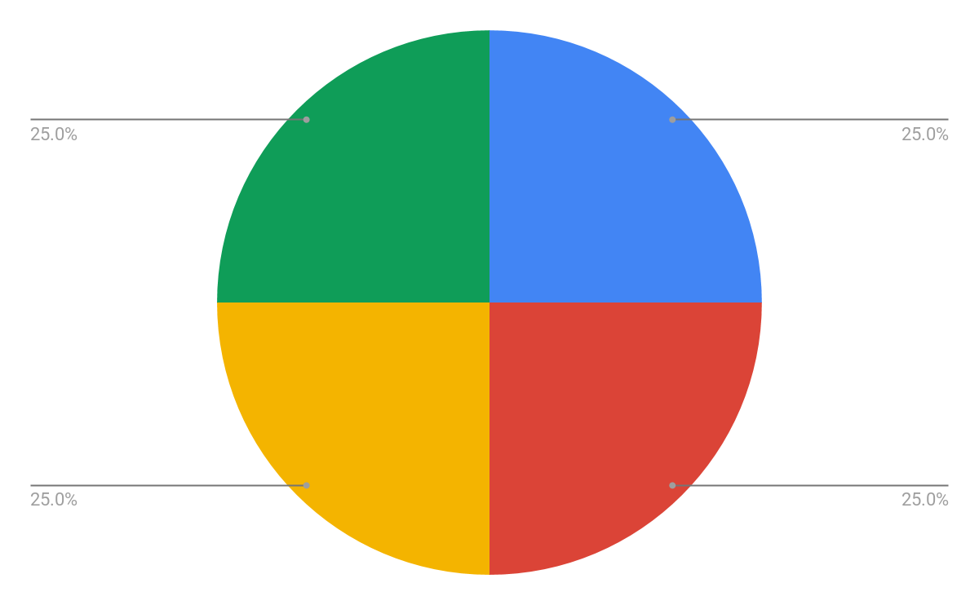

**On Touch**

public boolean onTouchEvent(MotionEvent event)

{

float touchX = event.getX();

float touchY = event.getY();

switch (event.getAction() & MotionEvent.ACTION_MASK) {

case MotionEvent.ACTION_DOWN:

//Do something

//E.g., change X value

break;

}

}

Solution

*<?***xml version="1.0" encoding="utf-8"***?>*

<**AbsoluteLayout xmlns:android="http://schemas.android.com/apk/res/android"**

**xmlns:app="http://schemas.android.com/apk/res-auto"**

**xmlns:tools="http://schemas.android.com/tools"**

**android:layout_width="match_parent"**

**android:layout_height="match_parent"**

**tools:context="com.example.vdo.week8_workshop.MainActivity"**>

<**com.example.vdo.week8_workshop.Week10_Fri**

**android:id="@+id/myView"**

**android:layout_width="wrap_content"**

**android:layout_height="wrap_content"** />

<**SeekBar**

**android:id="@+id/seekBar"**

**android:layout_width="match_parent"**

**android:layout_height="wrap_content"**

**android:layout_x="2dp"**

**android:layout_y="427dp"** />

<**TextView**

**android:id="@+id/textView"**

**android:layout_width="wrap_content"**

**android:layout_height="wrap_content"**

**android:layout_x="164dp"**

**android:layout_y="472dp"**

**android:text="TextView"** />

</**AbsoluteLayout**>

**package** com.example.vdo.week8_workshop;

**import** android.support.v7.app.AppCompatActivity;

**import** android.os.Bundle;

**import** android.widget.SeekBar;

**import** android.widget.TextView;

**import** android.widget.Toast;

**import** org.w3c.dom.Text;

**public class** MainActivity **extends** AppCompatActivity {

SeekBar **sb**;

TextView **tv**;

Week10_Fri **myView**;

@Override

**protected void** onCreate(Bundle savedInstanceState) {

**super**.onCreate(savedInstanceState);

setContentView(R.layout.***activity_main***);

**sb** = (SeekBar)findViewById(R.id.***seekBar***);

**tv** = (TextView)findViewById(R.id.***textView***);

**myView** = (Week10_Fri)findViewById(R.id.***myView***);

**sb**.setOnSeekBarChangeListener(**new** SeekBar.OnSeekBarChangeListener() {

@Override

**public void** onProgressChanged(SeekBar seekBar, **int** progress, **boolean** fromUser) {

**tv**.setText(**"Data: "** + progress);

**float** x = progress * 3.6f;

**myView**.**rot** = (**int**)x;

}

@Override

**public void** onStartTrackingTouch(SeekBar seekBar) {

}

@Override

**public void** onStopTrackingTouch(SeekBar seekBar) {

}

});

}

}

**package** com.example.vdo.week8_workshop;

**import** android.content.Context;

**import** android.graphics.Canvas;

**import** android.graphics.Color;

**import** android.graphics.Paint;

**import** android.os.Handler;

**import** android.support.annotation.Nullable;

**import** android.util.AttributeSet;

**import** android.view.View;

*/\*\**

*\* Created by vdo on 8/18/2017 AD.*

*\*/*

**public class** Week10_Fri **extends** View {

Handler **h**;

**public** Week10_Fri(Context context) {

**super**(context);

}

**public** Week10_Fri(Context context, @Nullable AttributeSet attrs) {

**super**(context, attrs);

**h** = **new** Handler();

}

Runnable **r** = **new** Runnable() {

@Override

**public void** run() {

invalidate();

}

};

**public float x** = 0;

**public float rot** = 0;

@Override

**protected void** onDraw(Canvas canvas) {

**super**.onDraw(canvas);

Paint p = **new** Paint();

p.setColor(Color.***RED***);

*//canvas.drawRect(200+x,200,400+x,400,p);*

*//canvas.save();*

*//canvas.rotate(x,300,300);*

*//canvas.scale(x,1,200,200);*

*//canvas.drawRect(200,200,400,400,p);*

*//canvas.restore();*

canvas.drawArc(300,300,700,700,270,**x**,**true**,p);

p.setColor(Color.***WHITE***);

canvas.drawCircle(500,500,100,p);

*//p.setStrokeWidth(20);*

*//canvas.drawLine(500,500,700,700,p);*

*//x+=0.2;*

**x**=**rot**;

**h**.postDelayed(**r**,50);

}

}