Week 7 https://goo.gl/5CvJi4

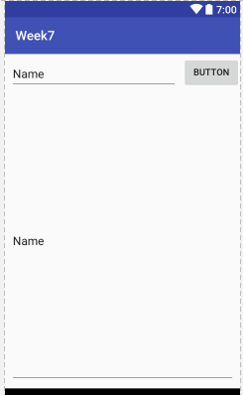

1 EditText, 1 Button, 1 Multiple line edittext

Test with nexus one, pixel, TV xhdpi

1 MainActivity + 3 Layout files

1. Create with Absolutelayout
2. Create with Linearlayout
3. Create with RelativeLayout
4. Create with Constraint Layout
5. Workshop constraint layout
   1. Singapore image: <https://goo.gl/ANV78s>
   2. Set image
      1. Scaletype = centercrop