**LAB3**

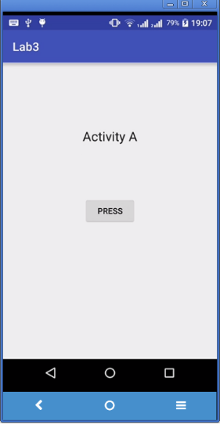**3.1 Create a simple activity “Activity A”**

**package** com.example.pok.week3;  
**import** android.content.Intent;  
**import** android.support.v7.app.AppCompatActivity;  
**import** android.os.Bundle;  
**import** android.util.Log;  
**import** android.view.View;  
**import** android.widget.Button; **public class** ActivityA **extends** AppCompatActivity

{  
  
  String **msg1** = **"Lab3"**;  
 String **msg2** = **"Activity A : "**;  
 Button **button**;  
  
 @Override  
 **protected void** onCreate(Bundle savedInstanceState) {  
 **super**.onCreate(savedInstanceState);  
 setContentView(R.layout.***activity_a***);  
   
 **button** = (Button)findViewById(R.id.***button***);  
 **button**.setOnClickListener(**new** View.OnClickListener() {  
 @Override  
 **public void** onClick(View v) {  
 Intent intent = **new** Intent(getApplicationContext(),ActivityB.**class**);  
 startActivity(intent);  
 }  
 });

Log.*d*(**msg1**, **msg2** + **"onCreate"**);  
 }  
  
 @Override  
 **protected void** onStart() {  
 **super**.onStart();  
 Log.*d*(**msg1**, **msg2**+**"onStart"**);  
 }

*/** Called when the activity has become visible. */* @Override  
 **protected void** onResume() {  
 **super**.onResume();  
 Log.*d*(**msg1**, **msg2**+**"onResume"**);  
 }

*/** Called when another activity is taking focus. */* @Override  
 **protected void** onPause() {  
 **super**.onPause();  
 Log.*d*(**msg1**, **msg2**+**"onPause"**);  
 }

*/** Called when the activity is no longer visible. */* @Override  
 **protected void** onStop() {  
 **super**.onStop();  
 Log.*d*(**msg1**, **msg2**+**"onStop"**);  
 }  
  
 @Override  
 **public void** onDestroy() {  
 **super**.onDestroy();  
 Log.*d*(**msg1**, **msg2**+**"onDestroy"**);  
 }

@Override

**protected void** onRestart() {

**super**.onRestart();

Log.*d*(**msg1**, **msg2**+**"onRestart"**);

}

}

activity_a.xml

*<?***xml version="1.0" encoding="utf-8"***?>*<**RelativeLayout xmlns:android="http://schemas.android.com/apk/res/android"  
 xmlns:tools="http://schemas.android.com/tools"  
 android:id="@+id/activity_main"  
 android:layout_width="match_parent"  
 android:layout_height="match_parent"  
 android:paddingBottom="@dimen/activity_vertical_margin"  
 android:paddingLeft="@dimen/activity_horizontal_margin"  
 android:paddingRight="@dimen/activity_horizontal_margin"  
 android:paddingTop="@dimen/activity_vertical_margin"  
 tools:context="com.example.pok.week3.ActivityA"**>  
 <**TextView  
 android:layout_width="wrap_content"  
 android:layout_height="wrap_content"  
 android:text="Activity A"  
 android:id="@+id/textView"** />  
 <**Button  
 android:text="Button"  
 android:layout_width="wrap_content"  
 android:layout_height="wrap_content"  
 android:layout_below="@+id/textView"  
 android:layout_centerHorizontal="true"  
 android:layout_marginTop="162dp"  
 android:id="@+id/button"** />  
</**RelativeLayout**>

Log data

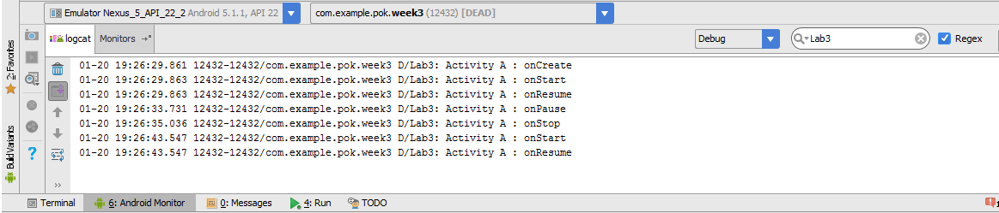

**3.2 Create a simple activity “Activity B” called by “Activity A”**

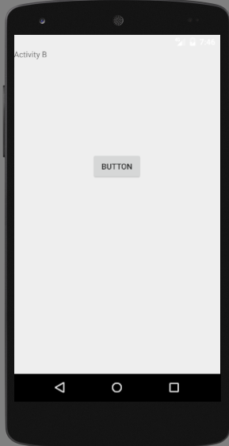**package** com.example.pok.week3;  
**import** android.content.Intent;  
**import** android.os.Bundle;  
**import** android.support.v7.app.AppCompatActivity;  
**import** android.util.Log;  
**import** android.view.View;  
**import** android.widget.Button;  
  
**public class** ActivityB **extends** AppCompatActivity {  
 String **msg1** = **"Lab3"**;  
 String **msg2** = **"Activity B : "**;  
 Button **button**;  
  
 @Override  
 **protected void** onCreate(Bundle savedInstanceState) {  
 **super**.onCreate(savedInstanceState);  
 setContentView(R.layout.***activity_b***);  
 Log.*d*(**msg1**, **msg2** + **"onCreate"**);  
 **button** = (Button)findViewById(R.id.***button***);  
 **button**.setOnClickListener(**new** View.OnClickListener() {  
 @Override  
 **public void** onClick(View v) {  
 Intent intent = **new** Intent(getApplicationContext(),ActivityA.**class**);  
 startActivity(intent);  
 }  
 });  
 }  
  
 @Override  
 **protected void** onStart() {  
 **super**.onStart();  
 Log.*d*(**msg1**, **msg2**+**"onStart"**);  
 }  
 */** Called when the activity has become visible. */* @Override  
 **protected void** onResume() {  
 **super**.onResume();  
 Log.*d*(**msg1**, **msg2**+**"onResume"**);  
 }  
 */** Called when another activity is taking focus. */* @Override  
 **protected void** onPause() {  
 **super**.onPause();  
 Log.*d*(**msg1**, **msg2**+**"onPause"**);  
 }  
 */** Called when the activity is no longer visible. */* @Override  
 **protected void** onStop() {  
 **super**.onStop();  
 Log.*d*(**msg1**, **msg2**+**"onStop"**);  
 }  
  
 @Override  
 **public void** onDestroy() {  
 **super**.onDestroy();  
 Log.*d*(**msg1**, **msg2**+**"onDestroy"**);  
 }  
}

activity_b.xml

*<?***xml version="1.0" encoding="utf-8"***?>*<**RelativeLayout xmlns:android="http://schemas.android.com/apk/res/android"  
 xmlns:tools="http://schemas.android.com/tools"  
 android:id="@+id/activity_main"  
 android:layout_width="match_parent"  
 android:layout_height="match_parent"  
 android:paddingBottom="@dimen/activity_vertical_margin"  
 android:paddingLeft="@dimen/activity_horizontal_margin"  
 android:paddingRight="@dimen/activity_horizontal_margin"  
 android:paddingTop="@dimen/activity_vertical_margin"  
 tools:context="com.example.pok.week3.ActivityA"**>  
  
 <**TextView  
 android:layout_width="wrap_content"  
 android:layout_height="wrap_content"  
 android:text="Activity A"  
 android:id="@+id/textView"** />  
  
 <**Button  
 android:text="Button"  
 android:layout_width="wrap_content"  
 android:layout_height="wrap_content"  
 android:layout_below="@+id/textView"  
 android:layout_centerHorizontal="true"  
 android:layout_marginTop="162dp"  
 android:id="@+id/button"** />  
  
</**RelativeLayout**>

**Exercise**

1. Implement & Experiment Activity C called from Activity B
2. Implement the MapLocation App as shown in Lec3 slide on Page 10.

Insert

<**uses-permission android:name="android.permission.INTERNET"** />

into

AndroidManifest.xml (above <application>)