**Dash Design Document**

**Goals**

* Generate a website for Dash customers to be able to view and update their information at any given time.
* Run on multiple web browsers such as Firefox, Google Chrome, Android, OS, etc.

**Functional Description**

*Data*

* Receive client information (first and last name, email, address, phone number,).
* Receive client payment information (card name, card number/expiration date/CVV).
* Receive client vehicle information (make, model, year, color, axles, license plate, CAV).
* Create a user account based on given information.
* Receive input to update existing fields.

*Pages*

* Display homepage (general info, buttons to access other pages)
  + Simple instructions on how to start.
  + Simple overview of where to use the device.
* Display account information.
  + Display payment information.
  + Display recent history/transactions.
    - Includes location, date, time

**User Interface**

Homepage shows a sign up and login area. Displays simple instructions on how to start commuting with Dash, showcases Dash device and provides a brief description of it.

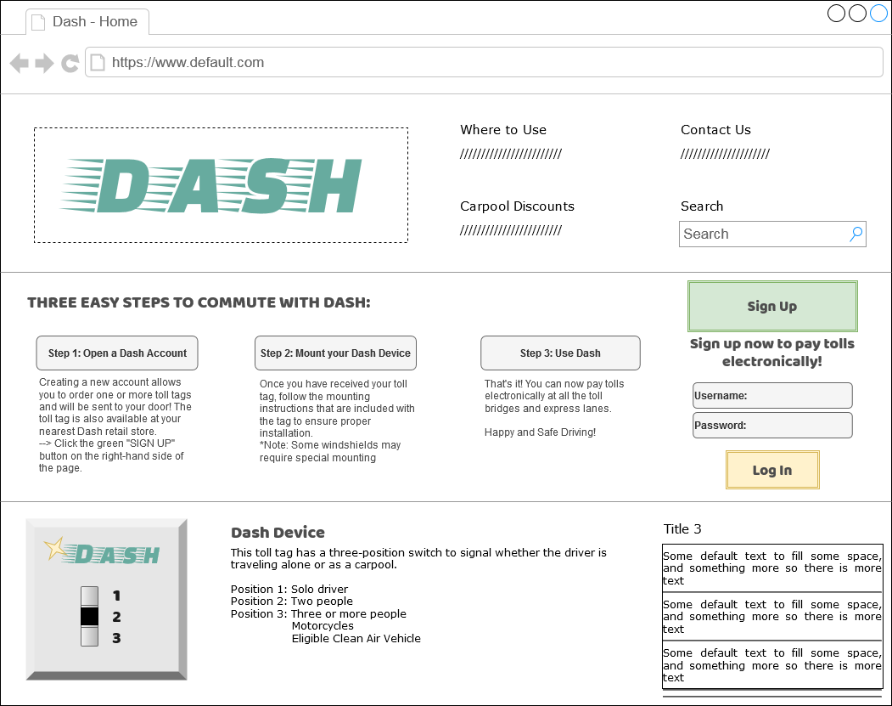

* Buttons
  + Dash Banner: return to homepage
  + Sign Up: create new client account
  + Log In: sign into pre-existing client account
* User Input (keyboard)
  + Username/Password: accept input to log into their account
  + Search: accept input to search through the website.