**Table of Contents**

**1. Introduction**

           1.1 Purpose

1.2 Scope

1.3 Definitions and Acronyms

1.4 References

1.5 Overview

**2. Overall Description**

2.1 Product Perspective

2.2 Product Functions

2.3 User Characteristics

**3. System Features**

3.1 User Requirements

3.2 System Architecture

3.3 System Requirements

**4. Legal, Copyright, and Other Notices**

**5. System Evolution**

**6. Supporting Info**

**1. Introduction**

**1.1 Purpose**

The purpose of this software is to help modernize and expedite travel for the everyday commuter through the use of a new automated toll paying system. Commute is always something people need to take into account when planning a trip and part of that commute usually entails waiting in line to pay the toll at a toll booth. By introducing FasTrak, an electronic toll collector (ETC), we can eliminate long wait times and help push commute faster in the right direction.

**1.2 Scope**

The purpose for this automated tool system is to not only make commuting faster but also to protect toll workers from possible reckless drivers as well.  This system will work with the use of a FasTrak tag inside of a vehicle and the tag will be scanned at toll gates. We will have a database that stores user information associated with their FasTrak tags and when the tag is scanned it will charge the appropriate account accordingly.  Overall, we hope that the use of FasTrak will make the commuting experience faster and more hands free.

**1.3 Definitions and Acronyms**

FasTrak is an ETC, an electronic toll collector. ETC is a new form of toll collection that is helping expedite backed up commute traffic.

**1.4 References**

* <https://www.bayareafastrak.org/en/home/index.shtml>
* Murach’s MySQL 3rd Edition – Joel Murach

**1.5 Overview**

As they say, “Time is Money”. Waiting in long commutes can be draining especially when you have to be somewhere. The use of an ETC like FasTrak helps to alleviate the stress of traffic and move commuters a little faster as they get where they need to go. Overall, an automated process will make toll collecting much faster and can help prevent possible accidents or robberies at toll booths.

**2. Overall Description**

**2.1 Product Perspective**

This product is available for all to use. The FasTrak tag can be purchase on the FasTrak website at: <https://www.bayareafastrak.org/en/home/index.shtml>. Users can create their accounts and register their vehicles to be tracked with the tags.

**2.2 Product Functions**

FasTrak is usable on all eight toll bridges in the bay area as well as any express lane open. Users can:

- Add multiple vehicles to their account

- View toll and express lane transactions

- Edit forms of payment

- Earn discounts on tolls using carpool or energy efficient vehicles

**2.3 User Characteristics**

User should have access to the internet to view transaction statements and needs to have the FasTrak tag activated in their vehicle in order to avoid toll violations.

**3. System Features**

**3.1 User Requirements**

User needs to have set up an account on the FasTrak website and either ordered the FasTrak tag or purchased one at a participating location. Once purchased, device needs to be activated in the user’s vehicle in order to be charged correctly while using FasTrak toll lanes.

**3.2 System Architecture**

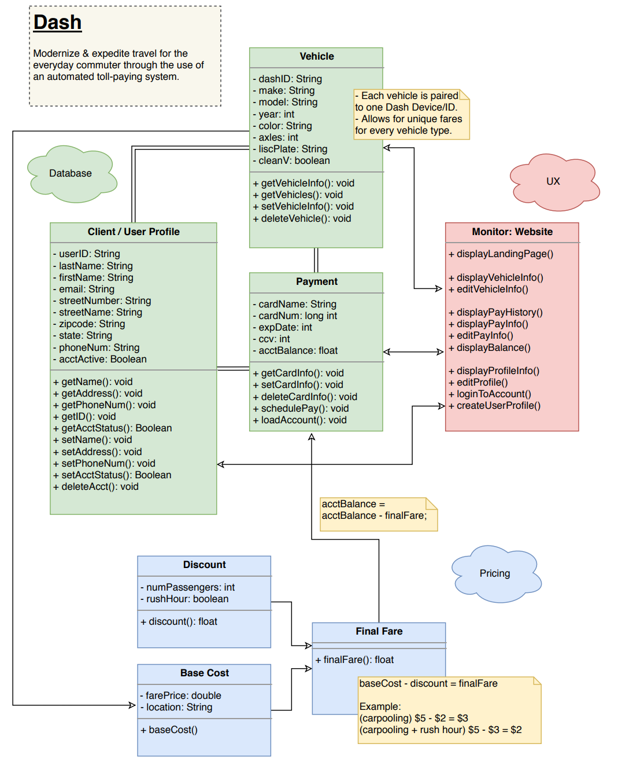

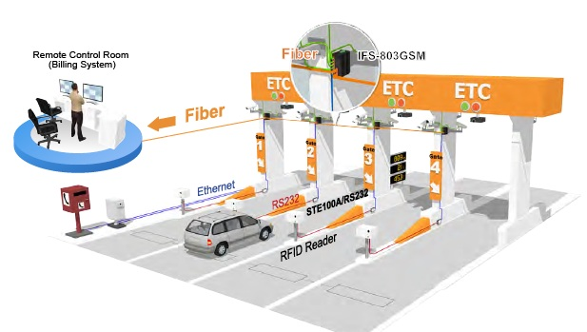

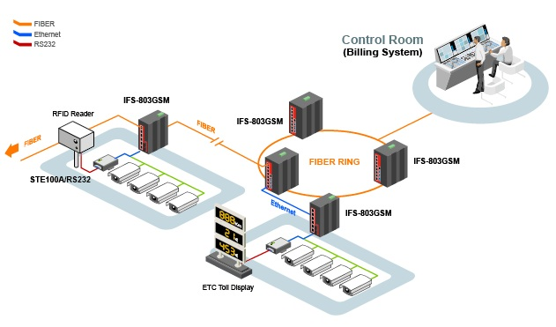

**3.3 System Requirements**

In order for this system to work, we will need to create a relational database in order to hold all of our client information that can be accessed when the FasTrak tag is scanned at corresponding locations. Once scanned, fares will be charged accordingly to each account and transactions can be later viewed on the FasTrak website. FasTrak tags must be activated and placed in the corresponding vehicles in order for RFID readers in the FasTrak toll lanes and highways to scan andensure account charges are being done correctly and not to be seen as toll violators.

**4. Legal, Copyright, and Other Notices**

This project is to simulate FasTrak and all information and technology belongs to FastTrak. We do not own any of their names or ideas but are borrowing them in order to do this project. The only thing that we own is the pseudo database that we will be creating in order to simulate how FasTrak’s database works.

**5. System Evolution**

After the base model is all set, we look to expand on creating more express highway lanes and potentially automating all toll lanes. ETC is the way of the future and will continue to help lessen the burden of heavy commute traffic.

**6. Supporting Info**

N/A