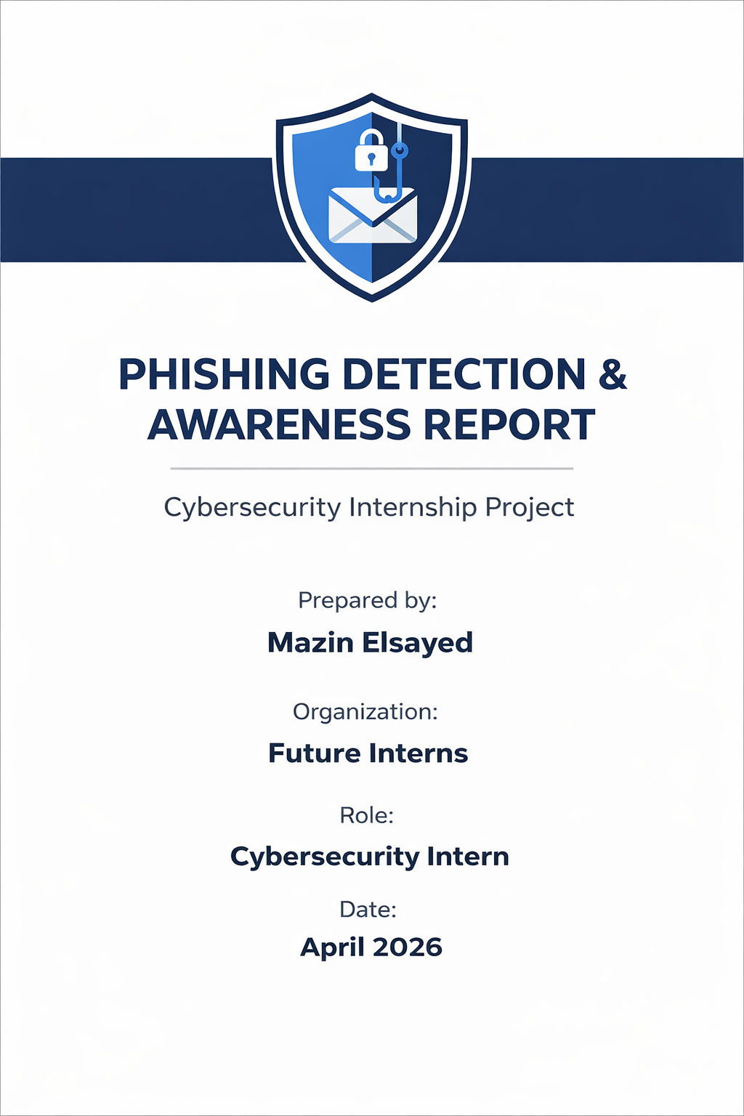
Introduction
Phishing is a type of cyberattack where attackers impersonate trusted organizations or individuals to trick users into revealing sensitive information such as passwords, financial details, or personal data.
It is considered one of the most dangerous threats because it relies on deception rather than technical vulnerabilities, making it highly effective and difficult to detect. Successful phishing attacks can lead to financial loss, identity theft, and unauthorized access to systems.
The human factor plays a critical role in these attacks, as most phishing incidents occur due to user mistakes rather than system failures. This makes security awareness and user education essential in preventing such threats.

Phishing Email Analysis
Email # | Type | Key Indicators | Risk Level | Explanation
Email 1 | Voice Message Scam | Unexpected voicemail, attachment prompt, impersonation of Office 365, generic message | Phishing | Tricks users into downloading a malicious attachment disguised as a voicemail, which may install malware.
Email 2 | Fax / SharePoint Scam | Fake sender, bulk email (undisclosed recipients), attachment link, SharePoint impersonation | Phishing | Pretends to be a fax notification and lures users into clicking a malicious link or downloading a file to compromise their system.
Email 3 | Microsoft Login Alert | Fake domain, Gmail reply-to, SPF/DKIM failure, fear tactic (login from Russia) | Phishing | Uses a fake security alert to scare users into clicking a link or contacting attackers, leading to credential theft.
/Email 4 | Advance-Fee Scam | Unrealistic money offer, requests personal info, fake identity, poor grammar | Phishing | Manipulates victims into believing they will receive money, then asks for personal details or fees to exploit them.
Email 5 | Bank Reward Phishing | Fake banking domain, urgency (points expiring), suspicious link, authentication failure | Phishing | Encourages users to click a fake reward redemption link that leads to a phishing page stealing financial or login information.

Key Observation
After analysing the phishing email samples, several common patterns were identified. These techniques are widely used by attackers to manipulate users and increase the success rate of phishing attacks.

Phishing Patterns
1. Urgency and Fear Tactics
Many emails create a sense of urgency which pressures users to act quickly without thinking, such as:
- “Account will be locked”
- “Points expiring today”
- “Unusual login detected”

2. Impersonation of Trusted Brands
Attackers pretend to be well-known organizations to build trust and makes the email appear legitimate, such as:
- Microsoft
- Banks
- SharePoint services

3. Suspicious or Fake Domains
Phishing emails which are used to trick users into thinking the source is real, attackers often use:
- Lookalike domains
- Random or unrelated URLs
- Free email services (e.g., Gmail)

4. Malicious Links and Attachments
Emails include:
- Fake login links
- Downloadable attachments
These can steal credentials or Install malware.

5. Social Engineering Techniques
This is the core reason phishing attacks succeed. Attackers exploit human emotions such as:
- Fear (account compromise)
- Greed (money reward)
- Curiosity (voicemail/fax)
Phishing attacks are effective not because of advanced technology, but because they exploit human behaviour and trust.

Awareness & Prevention Guidelines
To reduce the risk of phishing attacks, users must follow basic security practices and remain cautious when dealing with emails from unknown or suspicious sources.
Do’s (Best Practices) | Don’ts (Common Mistakes to Avoid)
- Verify the sender’s email address before taking any action.  - Hover over links to check the actual destination before clicking.  - Be cautious of urgent or threatening messages.  - Report suspicious emails to the IT/security team immediately.  - Use Multi-Factor Authentication (MFA) whenever possible. | - Do not click on unknown or suspicious links.  - Do not download unexpected attachments.  - Do not share passwords, OTPs, or sensitive information via email.  - Do not trust emails based only on logos or branding.  - Do not respond to suspicious messages.

Organizational Protection Measures
Organizations should implement the following controls to minimize phishing risks:
- Email filtering and anti-phishing solutions
- Employee security awareness training programs
- Regular phishing simulation exercises
- Strong authentication policies (MFA)
- Incident reporting and response procedures
Conclusion
Phishing attacks remain one of the most common & effective cybersecurity threats, mainly because they exploit human behaviour rather than technical vulnerabilities.
Through the analysis of multiple phishing email samples, it is clear that attackers rely on techniques such as urgency, impersonation, and social engineering to deceive users into taking harmful actions. This highlights the importance of user awareness and proper security practices.
Organizations must combine technical controls with continuous employee training to reduce the risk of successful phishing attacks.
Ultimately, preventing phishing is not only a technical challenge but also a human one, where informed and cautious users serve as the strongest line of defence against cyber-attacks.

