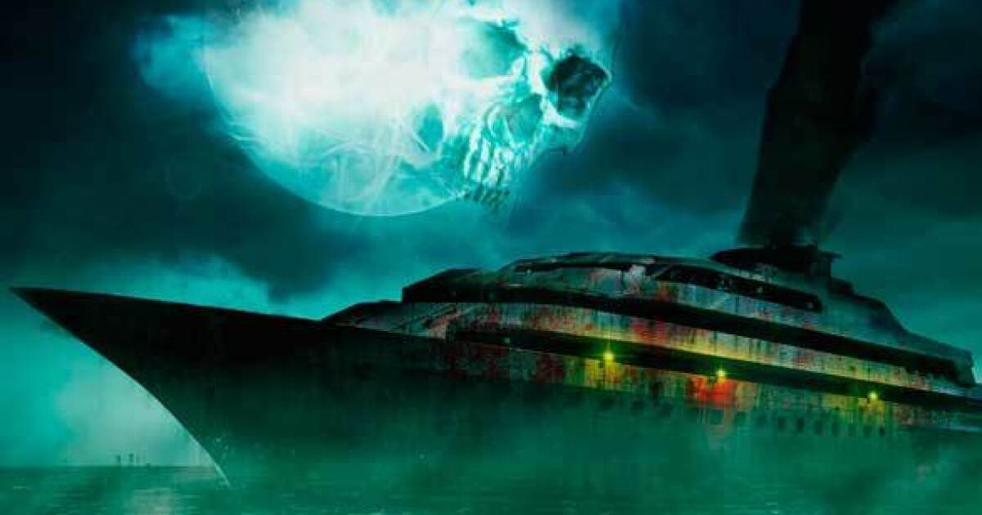

Starfield: Ghost Ocean Liner
  - Version 1.0
Designer: | Marshall Ma
Document Date: | 5/31/2026
Intended Level Delivery Date: | 7/19/2026

Document Revisions Table
Version | Description | Requestor | Date
1.0 | Initial Document | Professor Stephens/Professor Porter | 6/1/2026

Table of Contents
Table of Contents 2
Table of Figures 3
Level Summary 4
Quick Summary 4
Level Feature Overview 4
Development Schedule 4
Level Overview 6
Overview Map 6
Level Details 7
Detail Maps 7
Section 1: Deck Area 7
Section 2: Bridge Area 9
Section 3: Passenger Area 10
Section 4: Crew Area 11
Section 5: Event Area 12
Section 6: Cargo Area 13
Skill Progression Chart 14
Aesthetic References 15
Visual Theme 2: Industrial spaceship interior 16
References 17
Appendices 18
Appendix B: Context Detail 18
General Context 18
Backstory 18
Aftermath 18
Appendix E: Development Risks 19
Appendix F: Key Asset Needs 20

Table of Figures

Figure 1: Overview Map 6
Figure 2: Deck area 7
Figure 3: Bridge Area 9
Figure 4: Passenger Area 10
Figure 5: Crew Area 11
Figure 6: Event Area 12
Figure 7: Cargo Area 13
Figure 8:Luxury ocean liner style 1 15
Figure 9: Luxury ocean liner style 2 15
Figure 10: industrial spaceship style 1 16
Figure 11: Industrial spaceship interior 2 16

Level Summary

Quick Summary
Ghost Ocean Liner is a single player side quest in Starfield. While traveling through space, the player runs out of fuel; in a desperate bid to refuel, they board a passing ocean liner at the very last moment—only to discover that nothing remains inside but wreckage and ruins. As the player ventures deeper into the vessel, they uncover evidence suggesting that some form of creature was responsible for killing everyone on board. However, as their exploration progresses, the player will unearth an even greater secret.

Level Feature Overview
Category | Sub-Category | Feature List
Player | Player Weapons | Distance  - Grendel  - Ember  Melee  - Rescue axe
 | Player Skills/Abilities | - Hacking  - Lockpicking  - Pickpocket
AI | Enemies | - Terrormorph  - Xenogrub
 | Friendlies | - N/A
Challenges | Gameplay Themes | - Environmental storytelling  - Stealth  - Chase and run  - Puzzling
 | Obstacles/Hazards | - Battery and light puzzles  - Ventilation tubes  - Secret doors
 | New/Unique Gameplay | - Secret doors
Context | Where Fits in Game | - A random place in the space
 | Challenge Fit | - Midterm
 | Additional Info | - An ALIEN like story
Aesthetics | Major Visual Themes | - Luxury ocean liner ruins  - Industrial-style Spaceship Interior  - Alien-style Ruins
 | Setting/Mood | - Terrifying  - Heavy

Development Schedule
Milestone | Date
LDD | 6/1/2026
Whitebox | 6/8/20026
Initial Gameplay | 6/22/2026
Gameplay Complete | 7/6/2026
Aesthetics | 7/13/2026
Launch | 7/19/2026

Level Overview

Overview Map
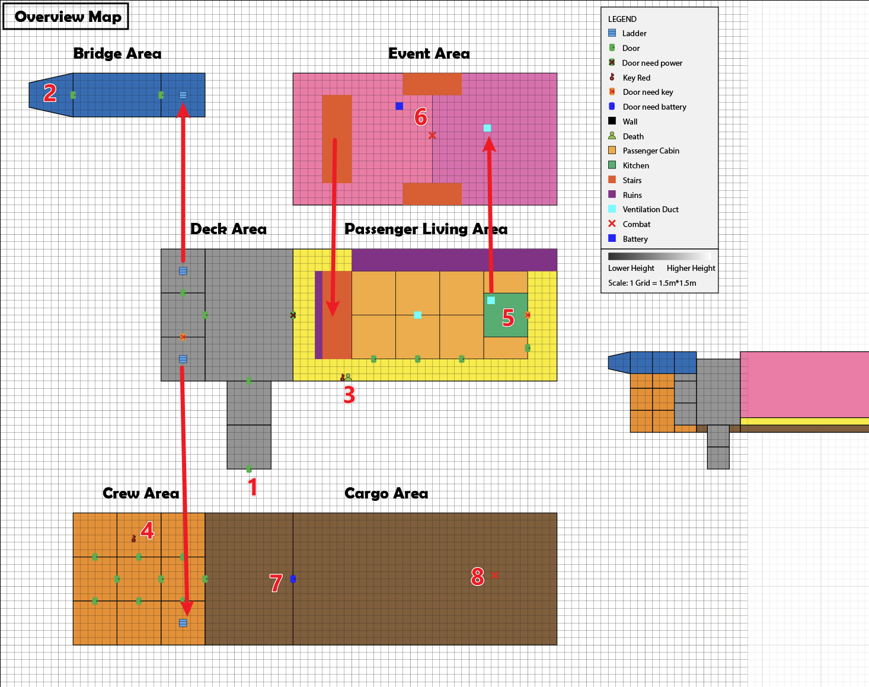
Figure 1: Overview Map
Map Label | Gameplay Summary
1 | Board the cruise ship and enter the main deck area, only to find myself in a state of weightlessness and darkness.
2 | Reach the bridge area, the backup power switch is activated; lighting and gravity are restored to normal. The doors to passenger living area open.
3 | Reach the passenger living area, explore the passenger cabins. Discover a crew member's body and the key to the crew area.
4 | Explore the crew area and find the kitchen key.
5 | Enter the kitchen and proceed to the event area via the ventilation ducts.
6 | Combat has broken out in the event area. Find the battery.
7 | Use the battery to open the cargo area door.
8 | Fight the final battle in the cargo area.

Level Details

Detail Maps

Section 1: Deck Area
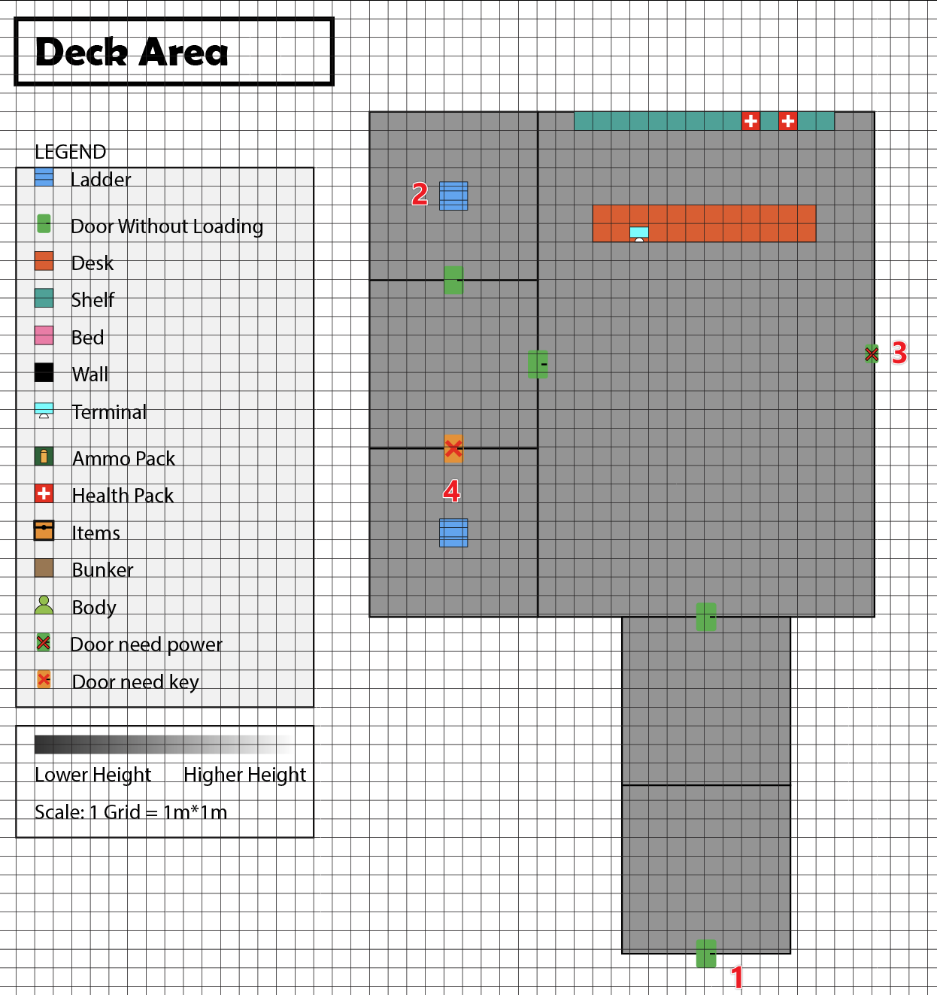
Figure 2: Deck area
Map Label / Stage | Event Summary | Event Details
1 | Aboard the spaceship and arrive at the main hall of the deck area. | The hall was dimly lit and weightless; a flashlight was needed.
2 | Players must first proceed to the Bridge area to activate the backup power supply. | The way to the bridge is unlocked.
3 | Players need to turn on the backup power before they can open this door to the passenger area. | Locked at first.
4 | Players need to find the key to open the door leading to the crew area. | Locked at first.

Section 2: Bridge Area
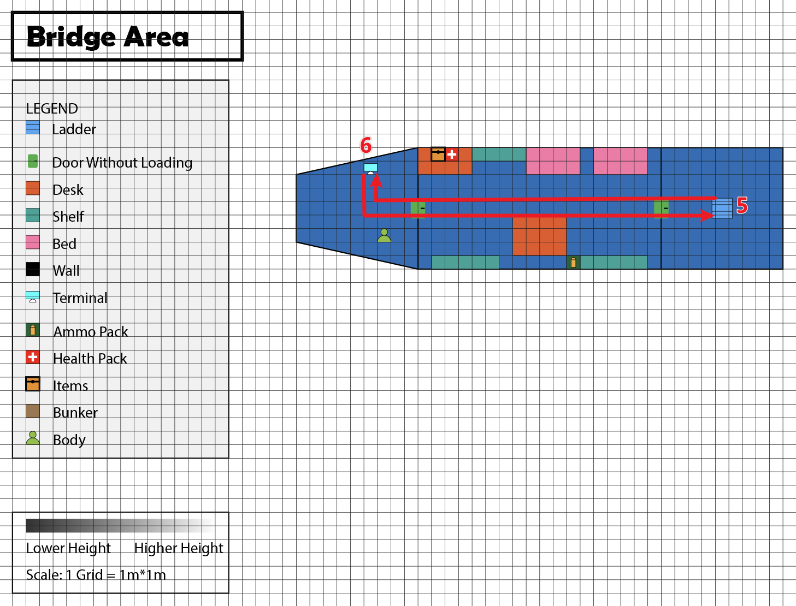
Figure 3: Bridge Area
Map Label / Stage | Event Summary | Event Details
5 | Come from the deck area. | Climb the ladder.
6 | Activate the terminal to power up the ship. | Unlock the door to the passenger area.

Section 3: Passenger Area
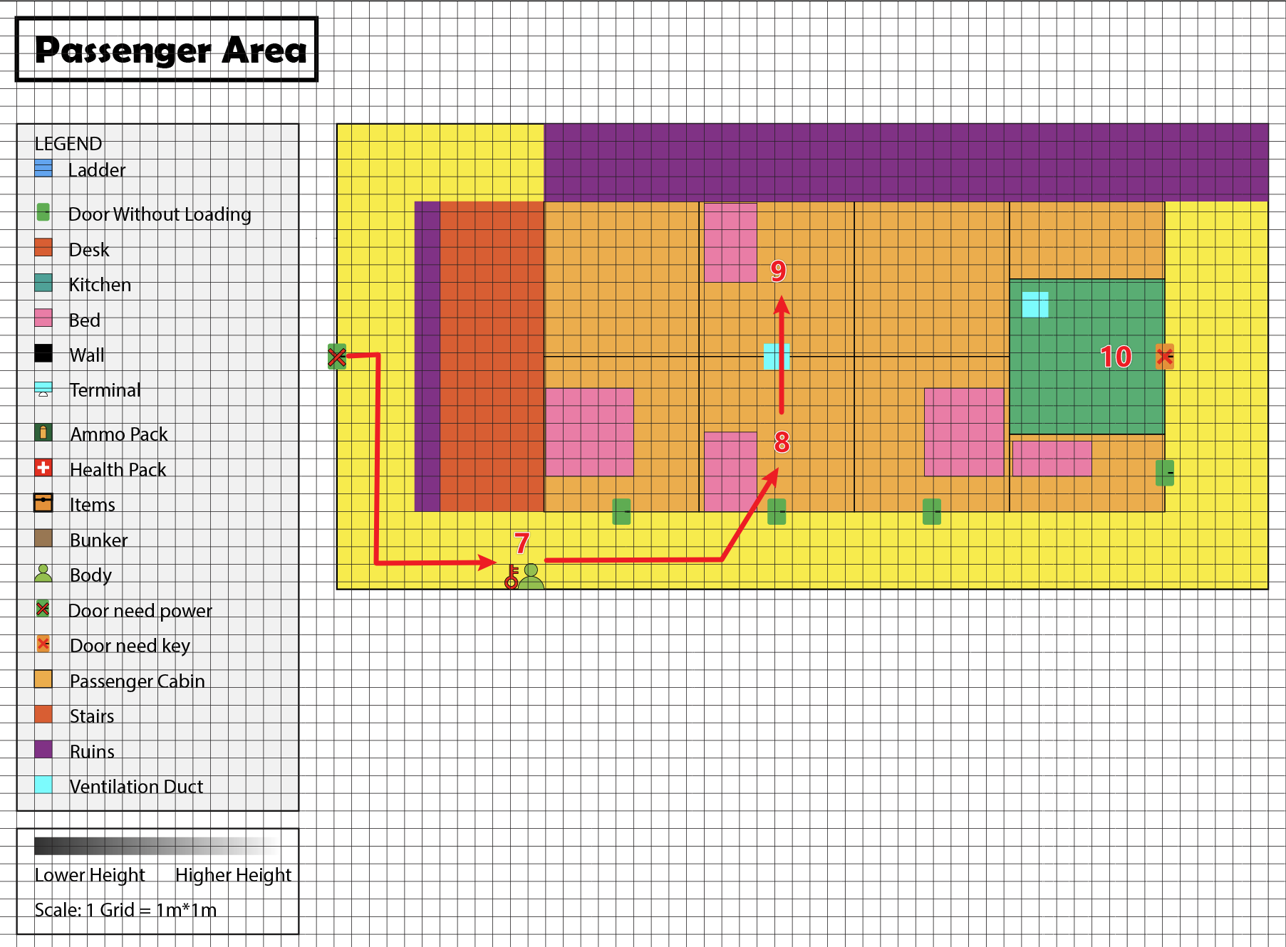
Figure 4: Passenger Area
Map Label / Stage | Event Summary | Event Details
7 | Find a body with key. | The key is to unlock the door to the crew area.
8 | Go inside the passenger cabins. | Interact with some environmental storytelling. Including scenes, documents, bodies.
9 | Go into a secret cabin through ventilation ducts. | Interact with some environmental storytelling. Including scenes, documents, bodies.
10 | The locked kitchen, there is a ventilation through the event area. | The door is locked, need to find a key.

Section 4: Crew Area
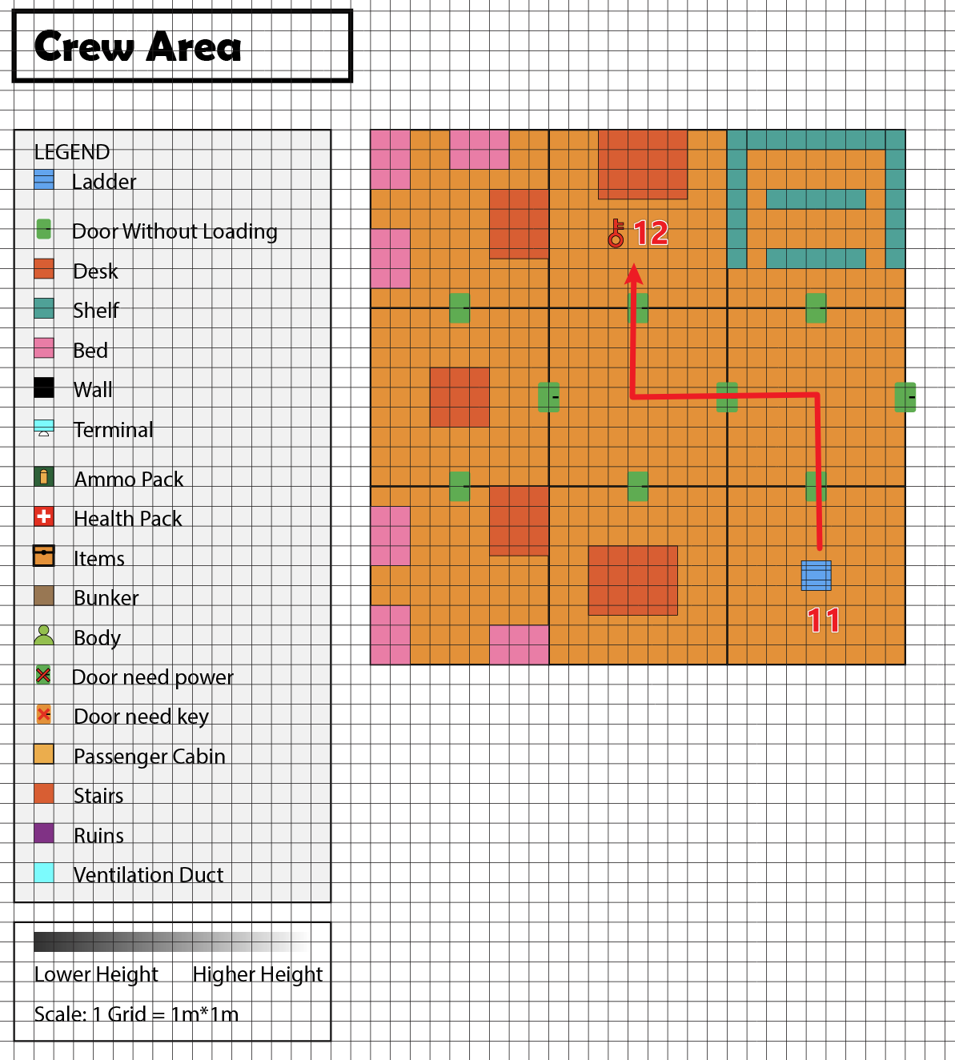
Figure 5: Crew Area
Map Label / Stage | Event Summary | Event Details
11 | Come from the deck area. | Climb down the ladder.
12 | Find the key to the kitchen. | To unlock the kitchen.

Section 5: Event Area
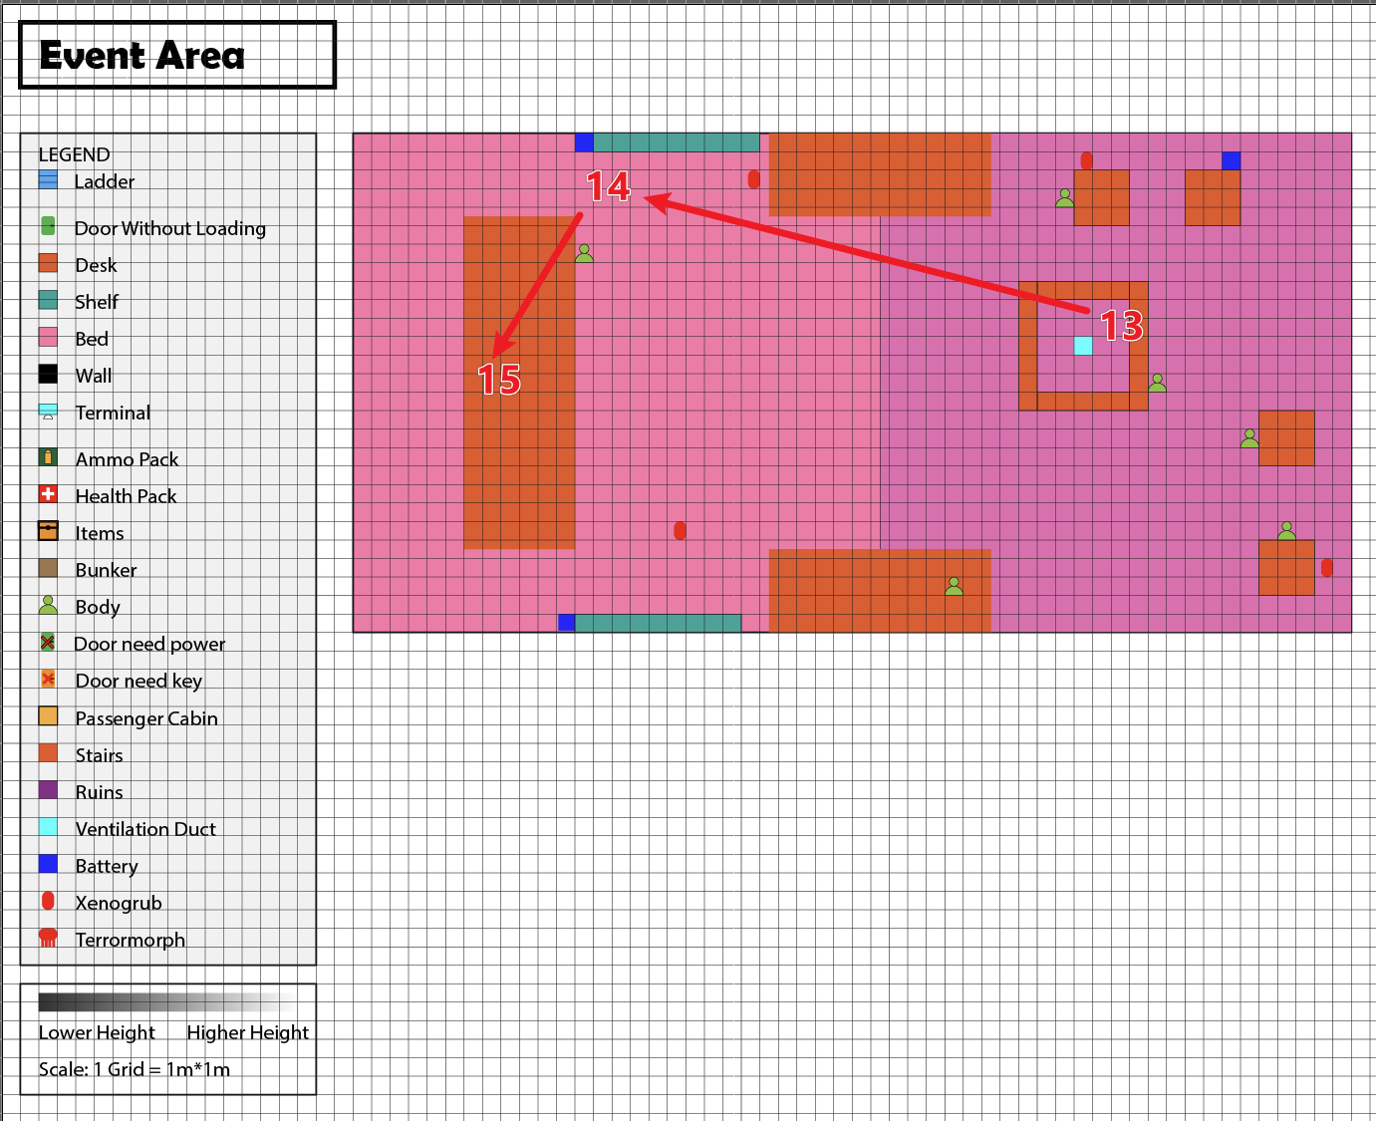
Figure 6: Event Area
Map Label / Stage | Event Summary | Event Details
13 | Climb from the ventilation duct.
14 | Collect 3 batteries. | Four xenogrubs hide in the dark to attack player.
15 | Go through the grand stairs back to the passenger area. | Only can go through in one direction.

Section 6: Cargo Area
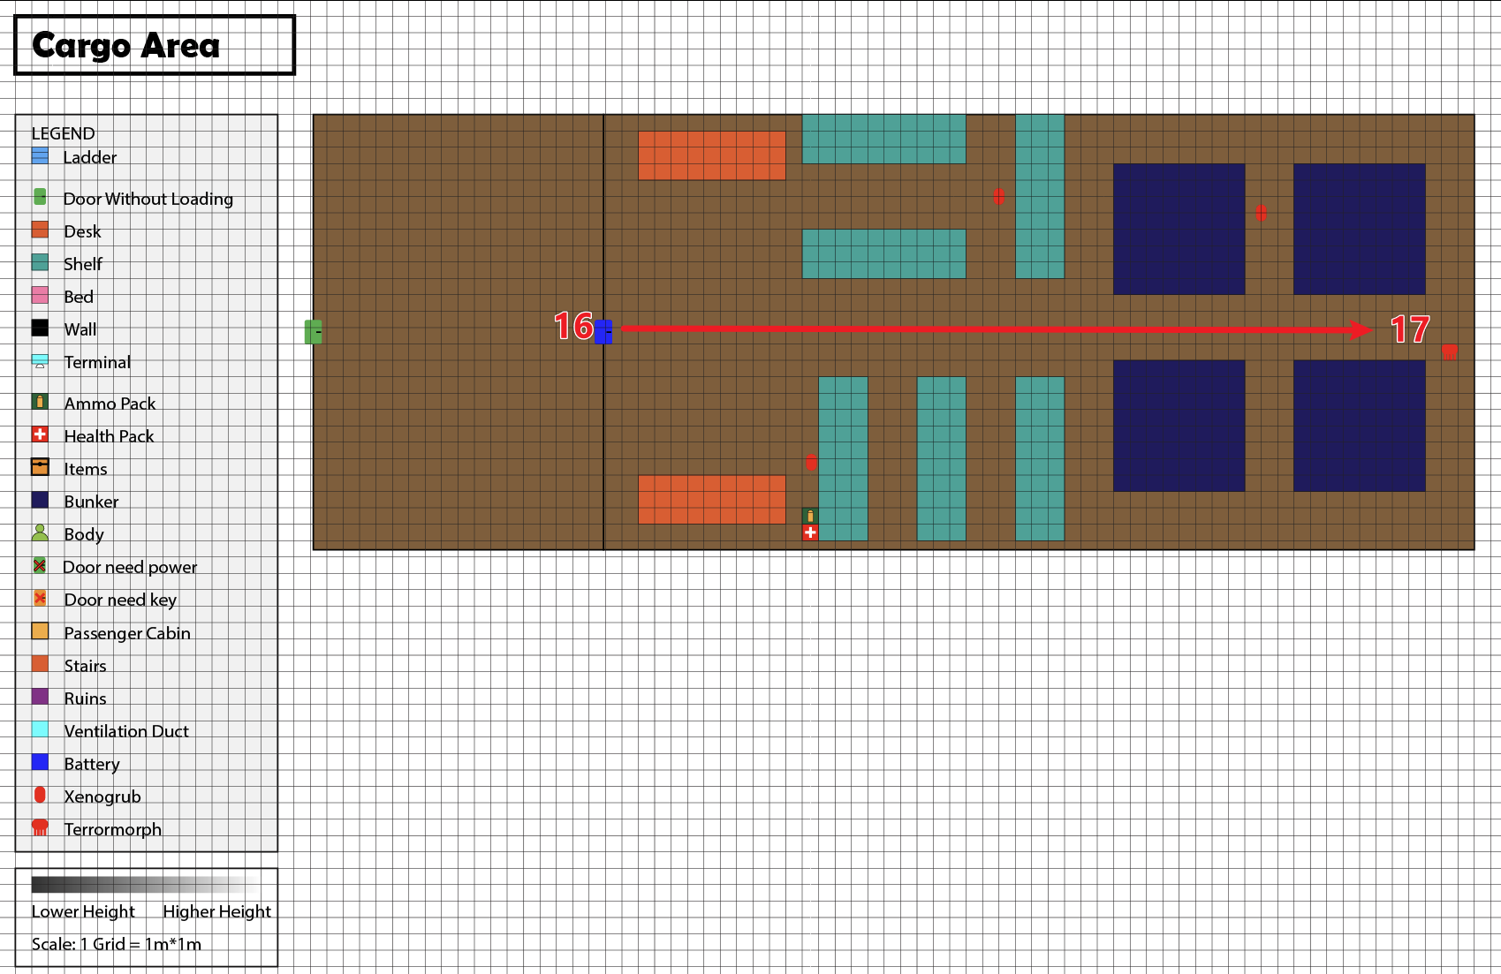
Figure 7: Cargo Area
Map Label / Stage | Event Summary | Event Details
16 | Use 3 batteries collected from event area to unlock the door.
17 | Go inside the cargo area, collect fuel, while fighting with big enemies. | There are 3 xenogrubs and one powerful terrormorph in the room.

Skill Progression Chart
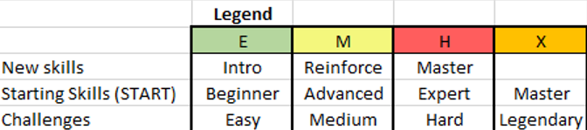

Aesthetic References
An abandoned luxury space liner, strewn with corpses and bearing the scars of battle. The upper decks feature a lavish, cruise-ship aesthetic but in darkness and ruin. The lower decks consist of industrial-style crew quarters.
Visual Theme 1: Luxury Ocean liner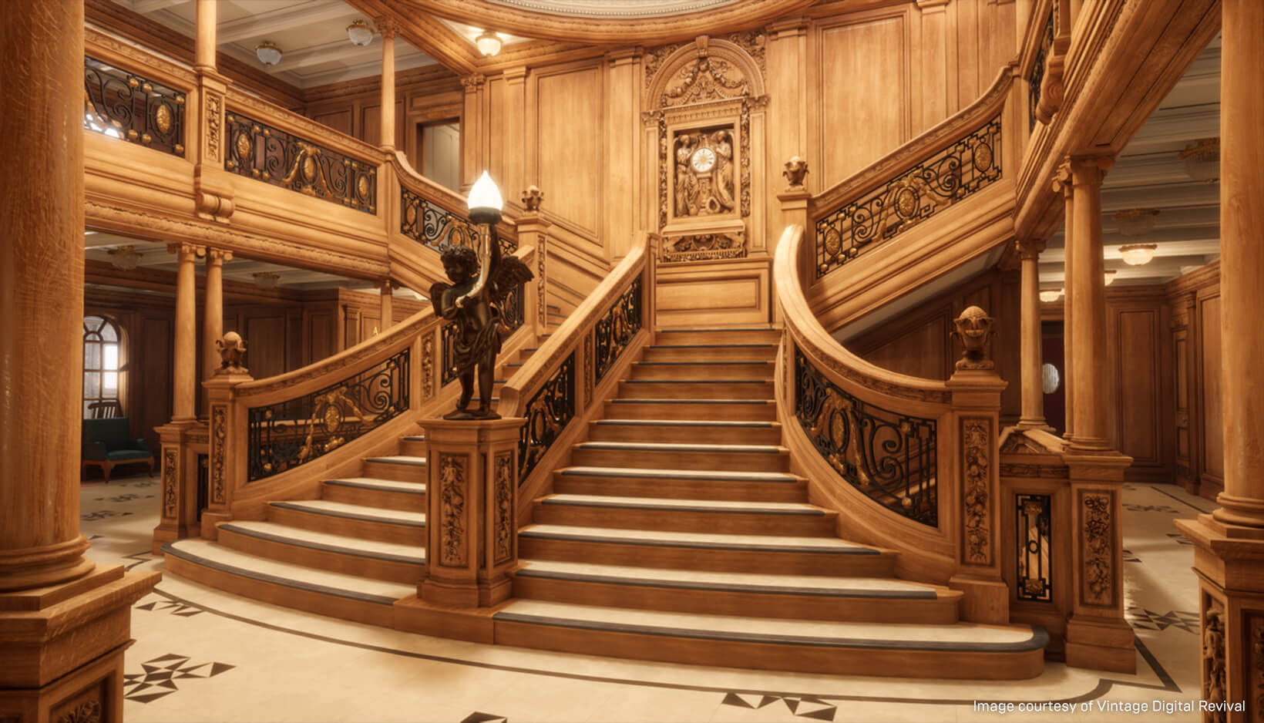
Figure 8:Luxury ocean liner style 1
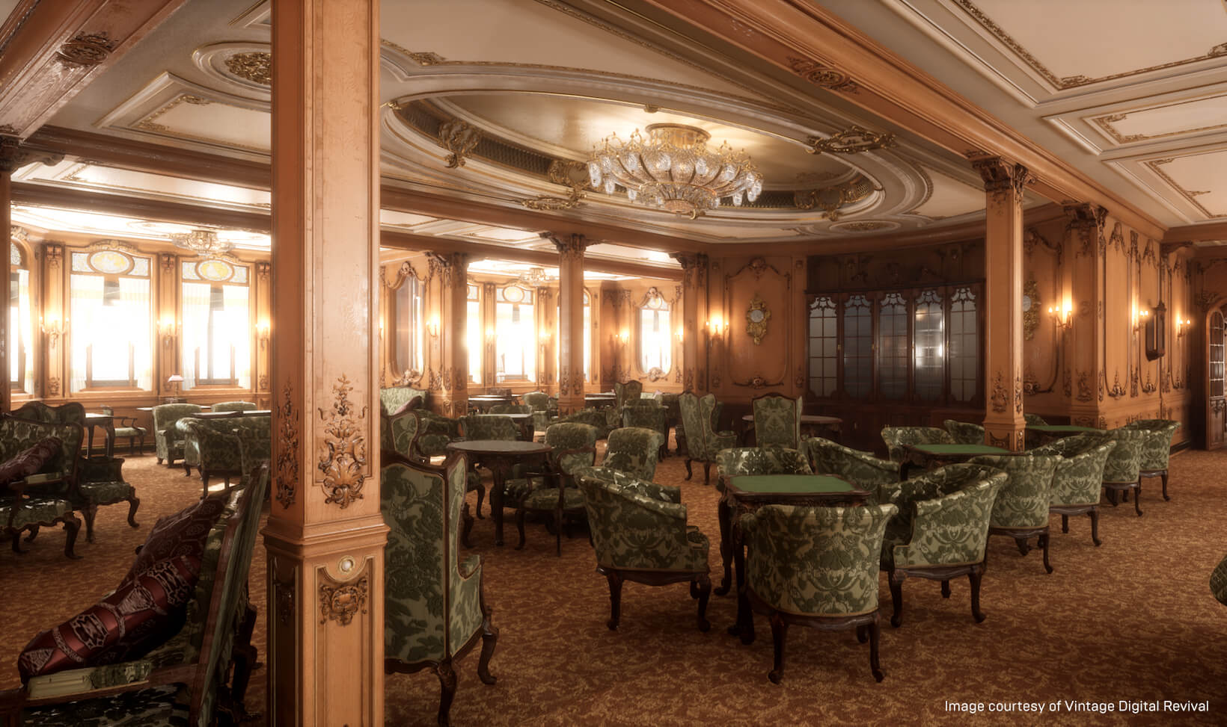
Figure 9: Luxury ocean liner style 2

Visual Theme 2: Industrial spaceship interior
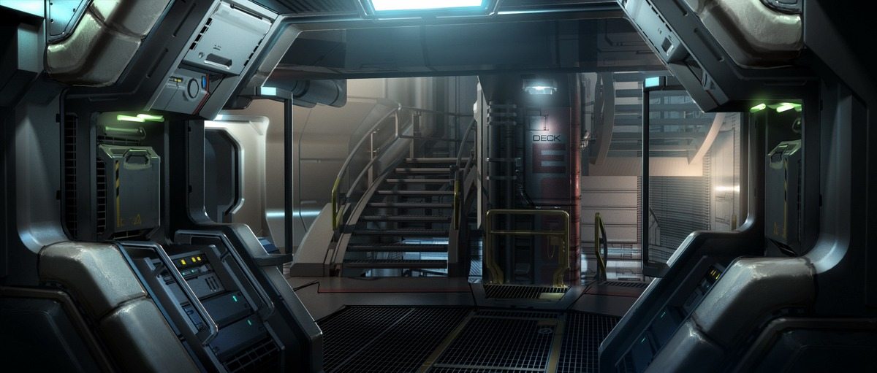
Figure 10: industrial spaceship style 1
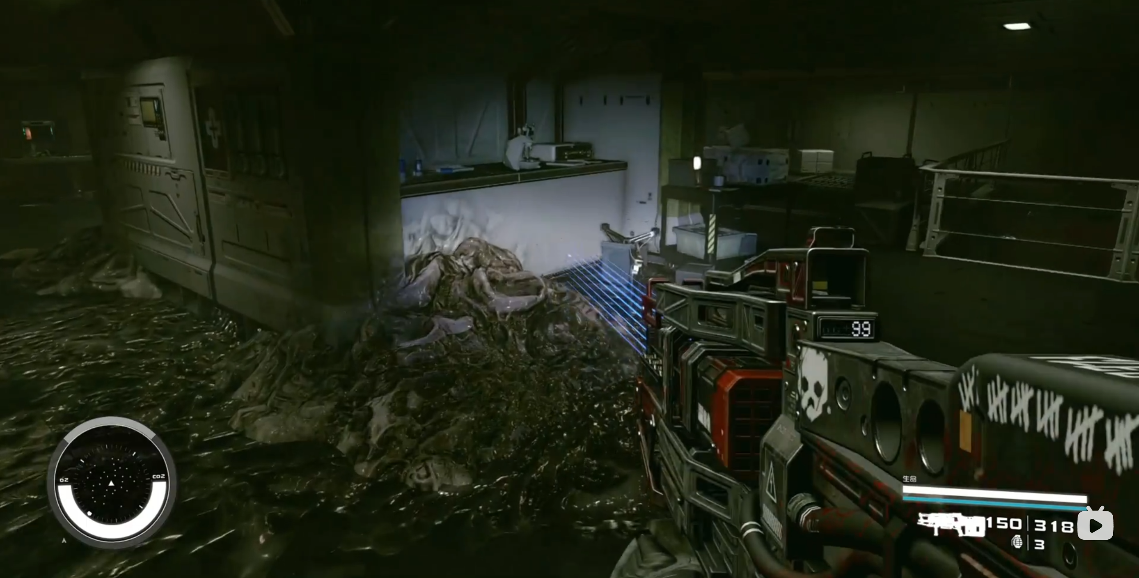
Figure 11: Industrial spaceship interior 2

References
[Cover Image] B. MacDonald, “Terror sets sail on the Ghost Ship for Halloween 2011 [Updated],” Los Angeles Times, Jun. 25, 2011. https://www.latimes.com/travel/deals/la-trb-ghost-ship-halloween-haunted-attraction-06201123-story.html (accessed Jun. 01, 2026).
[1] “Titanic: Project 401,” Titanichg.com, 2015. https://titanichg.com/project-401
[2] J. Spry, “'If ever there’s a movie where I got everything right, it was ‘Alien’: How Oscar winner Roger Christian made ‘Alien: Earth’ feel like a classic (exclusive),” Space, Aug. 27, 2025. https://www.space.com/entertainment/alien-earth-how-oscar-winning-set-designer-roger-christians-original-alien-work-lives-on-exclusive (accessed Jun. 02, 2026).
‌

‌

‌

Appendices

Appendix B: Context Detail

General Context
This level consists of a standalone spacecraft facility situated in deep space, which players can discover and explore during their interstellar travels.

Backstory
While traveling through the stars in their spaceship, the player suddenly realized—to their dismay—that they had forgotten to refuel the vessel after waking up that morning. Consequently, they sent out a distress signal to the nearest ship. However, this massive interstellar cruise liner failed to respond; at this critical moment, the player boarded the liner in search of aid, only to discover that the entire vessel had already been plunged into darkness.

Aftermath
Players can acquire various resources and rewards and uncover the truth behind the events that transpired on this cruise ship.

Appendix E: Development Risks
Map Label | Description/Mitigation | Type | Priority
6 | Large-scale luxury ocean liner environments are difficult to realize within Stanfield’s ship cells. | Mesh | High
8 | Designing a boss fight in a confined space is difficult. The monsters’ AI might be broken. | Script | High

Appendix F: Key Asset Needs
Description | Type | Priority
Deluxe Classical Interior Decoration Art Assets | Mesh | High
Ship Cabin Art Assets | Mesh | Low
Monster Actors | Actor | High

