Starfield: Ghost Ocean Liner
  - RTM Milestone Update
Designer: | Marshall Ma

Table of Contents
Table of Contents 1
Play Instruction 2
Walkthrough 3
Overview Map 3

Play Instruction
- Download “MaZ_GhostOceanLiner.esm” and “MaZ_GhostOceanLiner - Main.ba2”.
- Put “MaZ_GhostOceanLiner.esm” and “MaZ_GhostOceanLiner - Main.ba2”under the folder of “C:\Program Files (x86)\Steam\steamapps\common\Starfield\Data”. (It depends on which folder the player installs on their Starfield).
- Launch the Starfield.
- Click the “Creation” option and wait it loading.
- Press “T”.
- Check the “MaZ_GhostOceanLiner.esm”
- Press “esc” and go back to the main menu.
- Open command window
- Type in “coc newatlantisspaceport03”
- Loading game.
- The Quest Starts. The player can start to play at this level.

Walkthrough

Overview Map
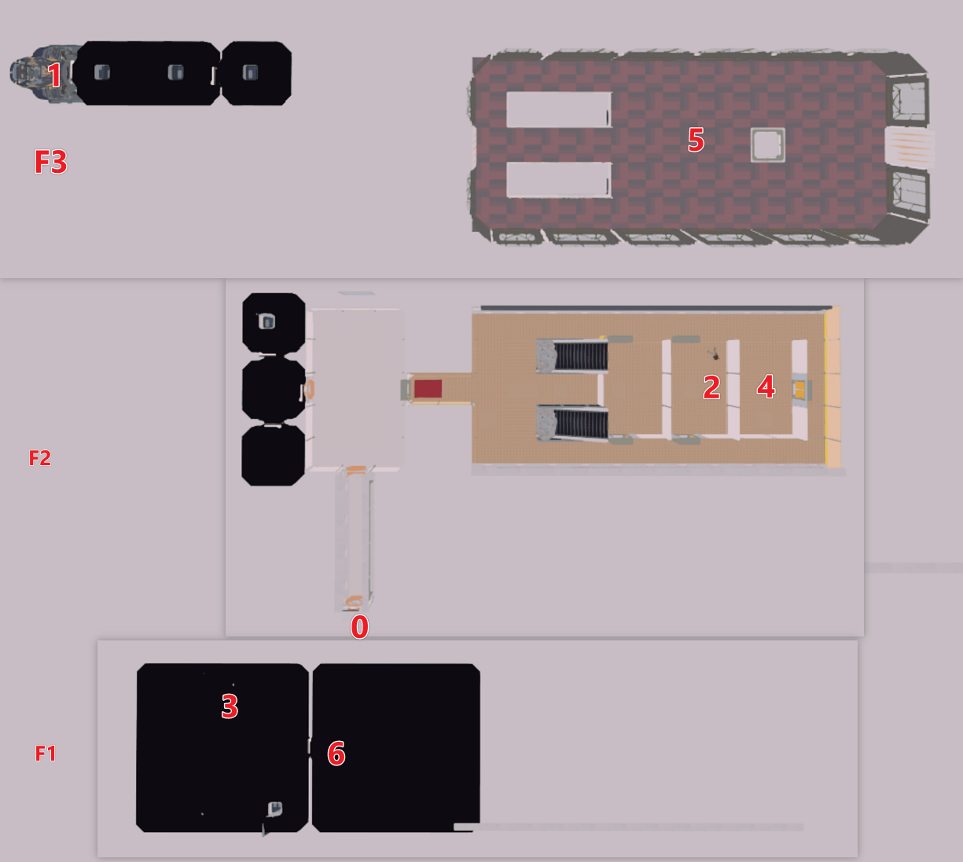
Figure 1: Overview Map
Map Label | Top Level Walkthrough | Change/Update Notes
0 | Board the ocean liner
1 | Go to the bridge area and turn on the power | Adjust the number of monsters to make the level easier.
2 | Go to the kitchen area to find body and key
3 | Go to the crew area to unlock the ventilation system by terminal | Update layout.
4 | Go to the kitchen and find the ventilation duct to the dining area
5 | Go to the dining area and collect the 3rd batteries | Adjust the quest stage triggers’ places
6 | Go to the cargo area and fight with the final boss. | Adjust the save point to avoid death loop in the boss room.

