TUGAS BASIS DATA

Nama : Arnea Wanda Izzi

Nim : 20180801382

SQL CREATE TABLE

//Table Product

CREATE TABLE "PRODUCT_AWI"

( "PRODUCT_ID" NUMBER,

"PRODUCT_NAME" VARCHAR2(50),

"CATEGORY" VARCHAR2(25),

"BUY_PRICE" NUMBER NOT NULL ENABLE,

"SELL_PRICE" NUMBER NOT NULL ENABLE,

"PRODUC_IMAGE" VARCHAR2(50),

"DESCRIPTION" VARCHAR2(50),

CONSTRAINT "PRODUCT_PKAWI" PRIMARY KEY ("PRODUCT_ID") ENABLE

)

//Table Stock

CREATE TABLE "STOCK_AWI"

( "PRODUCT_NAME" NUMBER NOT NULL ENABLE,

"QUANTITY" NUMBER NOT NULL ENABLE,

"DATES" DATE,

"STOCK_BY" NUMBER NOT NULL ENABLE )

/

ALTER TABLE "STOCK_AWI" ADD CONSTRAINT "STOCK_AWI_FKAWI" FOREIGN KEY ("PRODUCT_NAME")

REFERENCES "PRODUCT_AWI" ("PRODUCT_ID") ENABLE

/

//Table Customer

CREATE TABLE "CUSTOMER_AWI"

( "CUS_ID" VARCHAR2(50) NOT NULL ENABLE,

"FIRST_NAME" VARCHAR2(50) NOT NULL ENABLE,

"MIDDLE_NAME" VARCHAR2(50) NOT NULL ENABLE,

"LAST_NAME" VARCHAR2(50) NOT NULL ENABLE,

"SHIPPING_ADDRESS" VARCHAR2(50) NOT NULL ENABLE,

"EMAIL" VARCHAR2(50) NOT NULL ENABLE,

"CONTACT" NUMBER NOT NULL ENABLE,

CONSTRAINT "CUSTOMER_AWI_PKAWI" PRIMARY KEY ("CUS_ID") ENABLE

)

//Table Order

CREATE TABLE "ORDER_AWI"

( "ORDER_NO" VARCHAR2(50) NOT NULL ENABLE,

"CUSTOMER" VARCHAR2(50) NOT NULL ENABLE,

"DATES" DATE NOT NULL ENABLE,

"IS_DELIVER" VARCHAR2(50) NOT NULL ENABLE,

CONSTRAINT "ORDER_AWI_PKAWI" PRIMARY KEY ("ORDER_NO") ENABLE

)

/

ALTER TABLE "ORDER_AWI" ADD CONSTRAINT "ORDER_AWI_FKAWI" FOREIGN KEY ("CUSTOMER")

REFERENCES "CUSTOMER_AWI" ("CUS_ID") ENABLE

/

//Table Order Details

CREATE TABLE "ORDER_DETAILS_AWI"

( "ORDER_NO" VARCHAR2(50) NOT NULL ENABLE,

"PRODUCT_NAME" VARCHAR2(50) NOT NULL ENABLE,

"QUANTITY" NUMBER NOT NULL ENABLE

)

/

ALTER TABLE "ORDER_DETAILS_AWI" ADD CONSTRAINT "ORDER_DETAILS_AWI_FKAWI" FOREIGN KEY ("ORDER_NO")

REFERENCES "ORDER_AWI" ("ORDER_NO") ENABLE

/

ALTER TABLE "ORDER_DETAILS_AWI" ADD CONSTRAINT "ORDER_DETAILS_AWI_FKAWI1" FOREIGN KEY ("PRODUCT_NAME")

REFERENCES "PRODUCT_AWI" ("PRODUCT_ID") ENABLE

/

//Table Employee

CREATE TABLE "EMPLOYEE_AWI"

( "EMP_ID" VARCHAR2(50) NOT NULL ENABLE,

"FIRST_NAME" VARCHAR2(50) NOT NULL ENABLE,

"MIDDLE_NAME" VARCHAR2(50) NOT NULL ENABLE,

"LAST_NAME" VARCHAR2(50) NOT NULL ENABLE,

"FATHER_NAME" VARCHAR2(50) NOT NULL ENABLE,

"MOTHER_NAME" VARCHAR2(50) NOT NULL ENABLE,

"EMAIL" VARCHAR2(50) NOT NULL ENABLE,

"GENDER" VARCHAR2(50) NOT NULL ENABLE,

"DATE_OF_BIRTH" VARCHAR2(50) NOT NULL ENABLE,

"MARITAL_STATUS" VARCHAR2(50) NOT NULL ENABLE,

"ADDRESS" VARCHAR2(50) NOT NULL ENABLE,

CONSTRAINT "EMPLOYEE_AWI_PKAWI" PRIMARY KEY ("EMP_ID") ENABLE

)

SQL INSERT TABLE

//Insert Product

insert into PRODUCT_AWI

values ('001','PENSIL','ALAT TULIS','2000','5000','-','-')

insert into PRODUCT_ AWI

values ('002','PULPEN','ALAT TULIS','2000','5000','-','-')

insert into PRODUCT_ AWI

values ('003','PENGHAPUS','ALAT TULIS','2000','5000','-','-')

//Insert Stock

insert into STOCK_AWI

values ('001','100','01/11/2019','AWIZZI')

insert into STOCK_AWI

values ('002','150','01/11/2019','AWIZZI')

insert into STOCK_AWI

values ('003','200','02/11/2019','AWIZZI')

//Insert Customer

insert into CUSTOMER_AWI

values ('001','ARNEA','-','-','CISOKA','a@gmail.com','08123456789')

insert into CUSTOMER_AWI

values ('002','WANDA','-','-','CISOKA','w@gmail.com','08123456788')

insert into CUSTOMER_AWI

values ('003','IZZI','-','-','CISOKA','i@gmail.com','08123456787')

//Insert Order

insert into ORDER_AWI

values ('001','001','17/11/2019','D')

insert into ORDER_AWI

values ('002','002','17/11/2019','D')

insert into ORDER_AWI

values ('003','003','16/11/2019','D')

//Insert Order Details

insert into ORDER_DETAILS_AWI

values ('001','001','50')

insert into ORDER_DETAILS_AWI

values ('002','001','40')

insert into ORDER_DETAILS_AWI

values ('003','002','50')

SQL SELECT TABLE

//jawaban no 6

select a.order_no, a.dates, c.first_name, b.product_name, b.quantity, d.sell_price, b.quantity*d.sell_price as total

from order_awi a, order_details_awi b, customer_awi c, product_awi d

where a.order_no = b.order_no and c.cus_id = a.customer and d.product_name = b.product_name

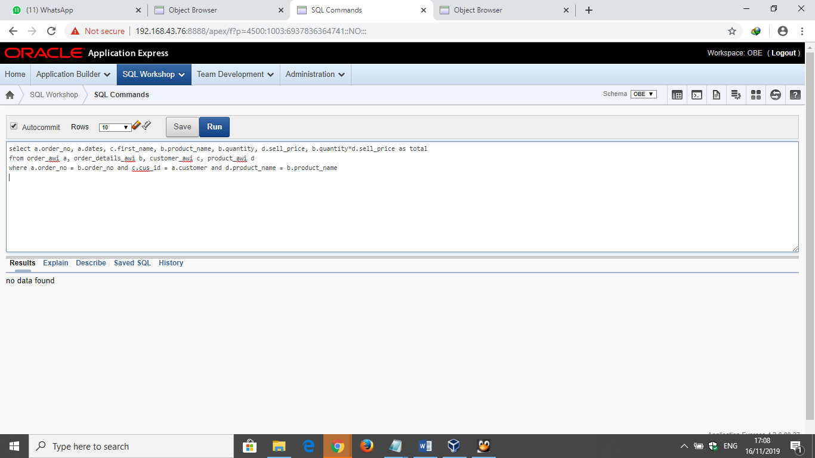

//jawaban no 7

select product_name, sum(quantity)

from order_details_awi

group by product_name, quantity

order by quantity desc

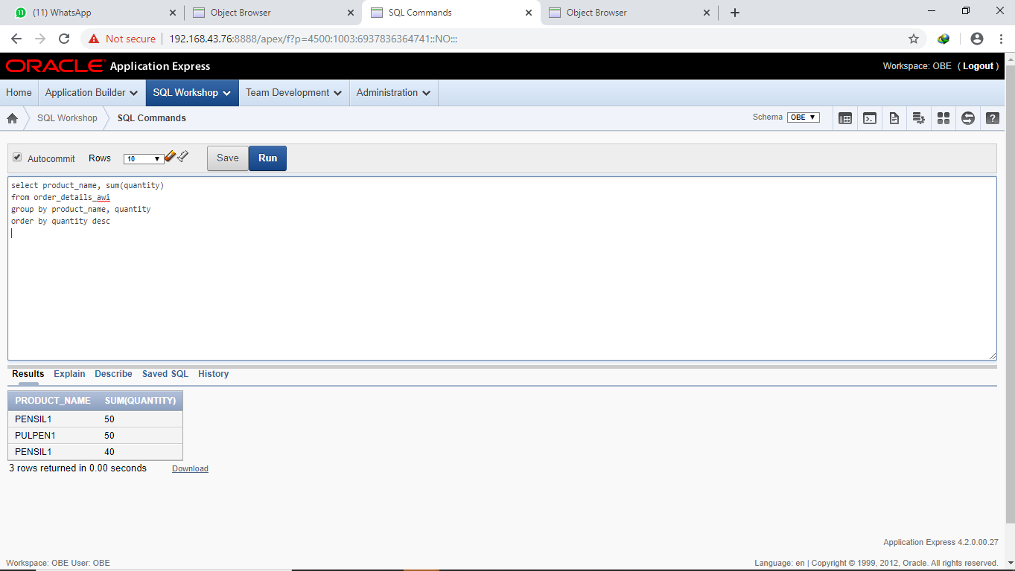

//jawaban no 8

select a.date, b.product_name, sum(b.quantity),

persentase = (sum(b.quantity)/

select sum(d.quantity)

from order_awi c, order_details_awi d

where d.order_no = c.order_no and c.date = ('02/11/2019')*100

from order_awi a, order_details_awi b

where b.order_no = a.order_no and a.dates = ‘02/11/2019’

group by a.date,b.product_name,b.quantity

