UTS BASIS DATA

SOAL :

1. Perhatikan Diagram dibawah ini :

|  |
| --- |
| Product |
| Product ID |
| Product Name |
| Category |
| Buy Price |
| Sell Price |
| Product Image |
| Description |

|  |
| --- |
| Order |
| Order No |
| Customer |
| Date |
| Is Deliver |

|  |
| --- |
| Employee |
| Emp ID |
| First Name |
| Middle Name |
| Last Name |
| Father Name |
| Mother Name |
| Email |
| Gender |
| Date of Birth |
| Marital Status |
| Address |

|  |
| --- |
| Login |
| User ID |
| Password |
| Access Level |

|  |
| --- |
| Payment |
| Payment No |
| Payment Type |
| Date |
| Amount |

|  |
| --- |
| Customer |
| Cus ID |
| First Name |
| Middle Name |
| Last Name |
| Shipping Address |
| Email |
| Contact |

|  |
| --- |
| Stock |
| Product Name |
| Quantity |
| Date |
| Stock By |

|  |
| --- |
| Order Details |
| Order No |
| Product Name |
| Quantity |

|  |
| --- |
| Shipment |
| Shipment Address |
| Shipment Date |
| Note |
| Shipment Contact |

Dari Diagram online shop diatas, buatlah :

1. Entity Diagram
2. Tentukan hubungan antar entity
3. Tentukan Primary Key dan Foreign Key yang dibutuhkan
4. Create Table
5. Insert Data (bebas) untuk semua table
6. Tampilkan data transaksi
7. Tampilkan produk terbanyak dijual
8. Tampilkan presentasi penjualan tiap hari untuk masing-masing produk

**Entity Diagram**

**Login**

**Customer**

**Has**

**Order**

**Product**

**Order Details**

**Payment**

**Shipment**

**Manage**

**Stock**

**Employee**

**Manage**

**Hubungan antar entity, Primary key, dan Foreign key**

|  |
| --- |
| Product |
| Product ID (PK) |
| Product Name |
| Category |
| Buy Price |
| Sell Price |
| Product Image |
| Description |

|  |
| --- |
| Order |
| Order No (PK) |
| Customer (FK) |
| Date |
| Is Deliver |

|  |
| --- |
| Employee |
| Emp ID (PK) |
| First Name |
| Middle Name |
| Last Name |
| Father Name |
| Mother Name |
| Email |
| Gender |
| Date of Birth |
| Marital Status |
| Address |

|  |
| --- |
| Login |
| User ID (PK) |
| Password |
| Access Level |

|  |
| --- |
| Payment |
| Payment No (PK) |
| Payment Type |
| Date |
| Amount |

|  |
| --- |
| Customer |
| Cus ID (PK) |
| First Name |
| Middle Name |
| Last Name |
| Shipping Address |
| Email |
| Contact |

|  |
| --- |
| Stock |
| Product Name (FK) |
| Quantity |
| Date |
| Stock By (FK) |

|  |
| --- |
| Order Details |
| Order No (FK) |
| Product Name |
| Quantity |

|  |
| --- |
| Shipment |
| Shipment Address |
| Shipment Date |
| Note |
| Shipment Contact |

**QUERY**

//Tampilkan data transaksi

SELECT A.ORDER_NO, A.CUSTOMER, C.FIRST_NAME, OD.PRODUCT_NAME, OD.QUANTITY, A.O_DATE, A.IS_DELIVER

FROM T_ORDER A

JOIN ORDERDETAILS OD ON A.ORDER_NO=OD.ORDER_NO

JOIN CUSTOMER C ON A.CUSTOMER=C.CUS_ID

ORDER BY A.ORDER_NO ASC



Result.01

//Tampilkan produk terbanyak dijual

SELECT A.ORDER_NO, A.CUSTOMER, C.FIRST_NAME, OD.PRODUCT_NAME, OD.QUANTITY, A.O_DATE, A.IS_DELIVER

FROM T_ORDER A

JOIN ORDERDETAILS OD ON A.ORDER_NO=OD.ORDER_NO

JOIN CUSTOMER C ON A.CUSTOMER=C.CUS_ID

ORDER BY OD.QUANTITY DESC



Result.02

//Tampilkan presentasi penjualan tiap hari untuk masing-masing produk

SELECT A.ORDER_NO, A.CUSTOMER, C.FIRST_NAME, OD.PRODUCT_NAME, OD.QUANTITY AS QTY_SELL, A.O_DATE, A.IS_DELIVER, to_char(OD.QUANTITY/SO.QUANTITY*100)||' %' AS PERCENTAGE

FROM T_ORDER A

JOIN ORDERDETAILS OD ON A.ORDER_NO=OD.ORDER_NO

JOIN CUSTOMER C ON A.CUSTOMER=C.CUS_ID

JOIN STOCK SO ON OD.PRODUCT_NAME=SO.PRODUCT_NAME

WHERE A.CUSTOMER=C.CUS_ID

ORDER BY A.ORDER_NO ASC



Result.03

**QUERY DARI PAK. MASMUR**

**No. 6**

SELECT a.ORDER_NO, a.O_DATE, c.FIRST_NAME, b.PRODUCT_NAME, b.QUANTITY, d.SELL_PRICE, (b.QUANTITY*d.SELL_PRICE) as TOTAL

FROM T_ORDER a,ORDERDETAILS b,CUSTOMER c,PRODUCT d

WHERE b.ORDER_NO= a.ORDER_NO and c.CUS_ID= a.CUSTOMER and d.PRODUCT_NAME= b.PRODUCT_NAME 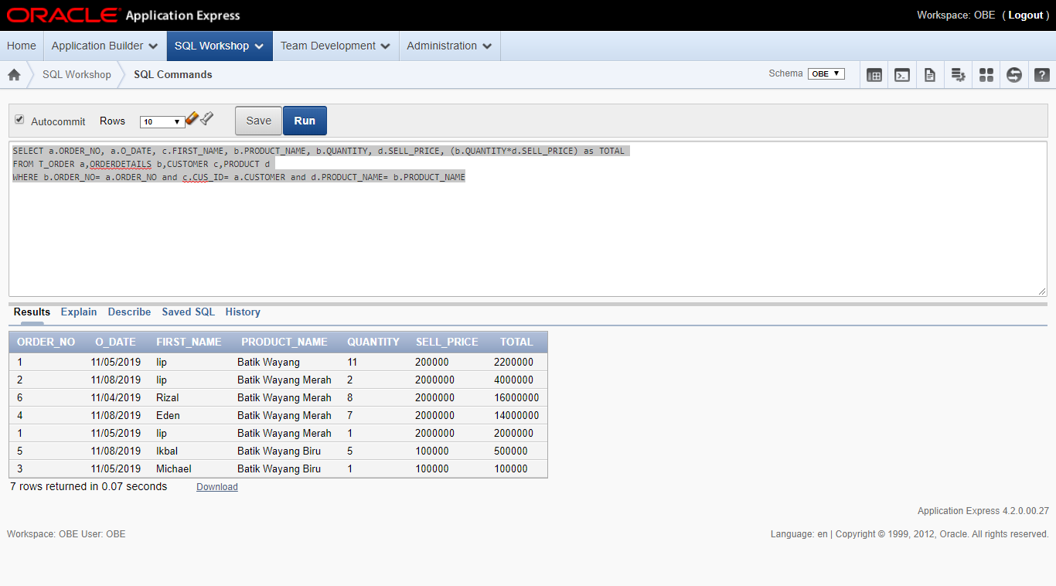

**No. 7**

SELECT PRODUCT_NAME, SUM(QUANTITY)

FROM ORDERDETAILS

GROUP BY PRODUCT_NAME, QUANTITY

ORDER BY QUANTITY DESC 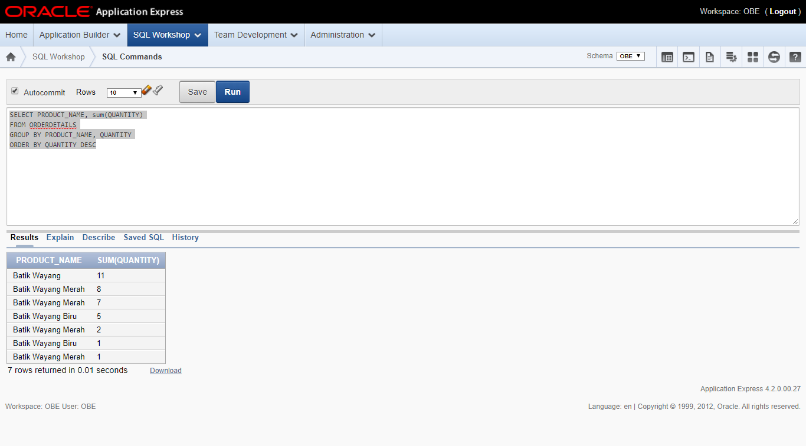

**//QUERY EDIT BY IIP MUHAMAD IKBAL**

**No. 8**

SELECT SUM(c.QUANTITY) FROM ORDERDETAILS c, T_ORDER d WHERE d.ORDER_NO = c.ORDER_NO and d.O_DATE= '11/05/2019'

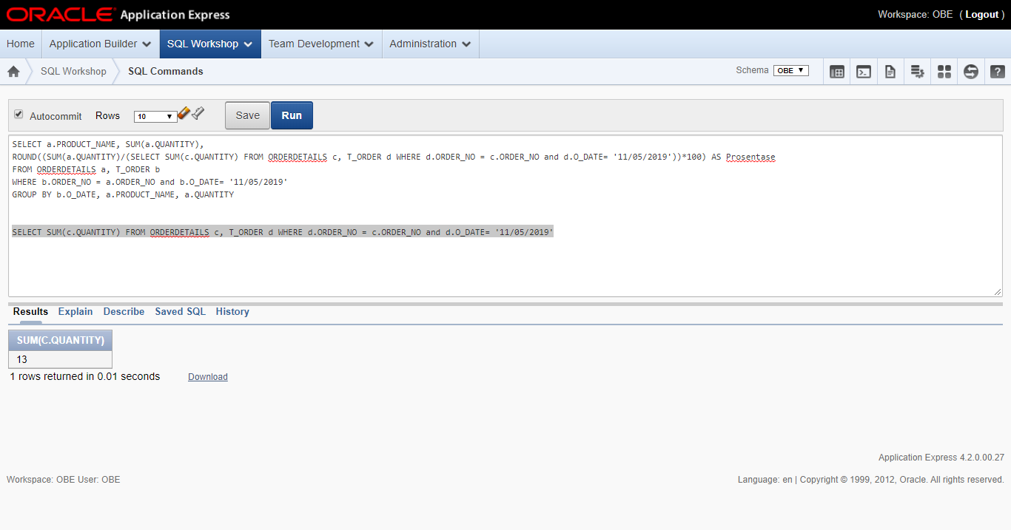

SELECT a.PRODUCT_NAME, SUM(a.QUANTITY),

ROUND((SUM(a.QUANTITY)/(SELECT SUM(c.QUANTITY) FROM ORDERDETAILS c, T_ORDER d WHERE d.ORDER_NO = c.ORDER_NO and d.O_DATE= '11/05/2019'))*100) AS Prosentase

FROM ORDERDETAILS a, T_ORDER b

WHERE b.ORDER_NO = a.ORDER_NO and b.O_DATE= '11/05/2019'

GROUP BY b.O_DATE, a.PRODUCT_NAME, a.QUANTITY

