Nama : Rizki Dwi Rahmawan

Nim : 20180801326

Jurusan : teknik informatika

Mata kuliah : BASIS DATA

**REVIEW UTS DATABASE ORACLE**

Hubungan antar entity, Primary key, dan Foreign key dari ke 5 tabel dan Menggunakan syntax query dari Pak Mazmur Tarigan

|  |
| --- |
| Product |
| Product ID (PK) |
| Product Name |
| Category |
| Buy Price |
| Sell Price |
| Product Image |
| Description |

|  |
| --- |
| Order |
| Order No (PK) |
| Customer (FK) |
| Date |
| Is Deliver |

|  |
| --- |
| Stock |
| Product Name (FK) |
| Quantity |
| Date |
| Stock By |

|  |
| --- |
| Order Details |
| Order No (PK) |
| Product Name (FK) |
| Quantity |

|  |
| --- |
| Customer |
| Cust ID (PK) |
| First Name |
| Middle Name |
| Last Name |
| Shipping Address |
| Email |
| Contact |

DESC PRODUCT_NOV

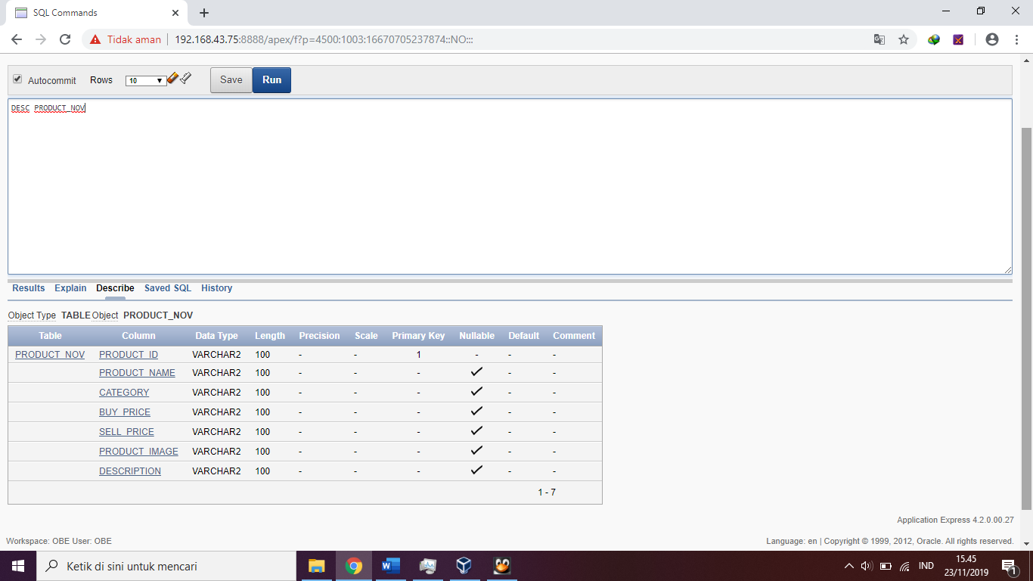

DESC ORDER_NOV

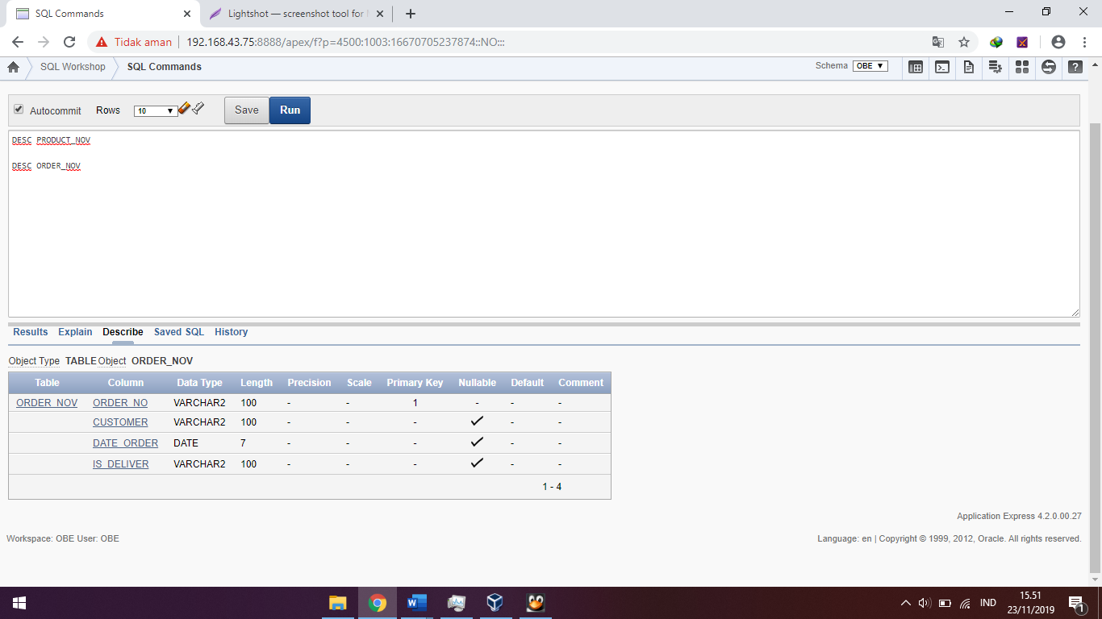

DESC CUSTOMER_NOV

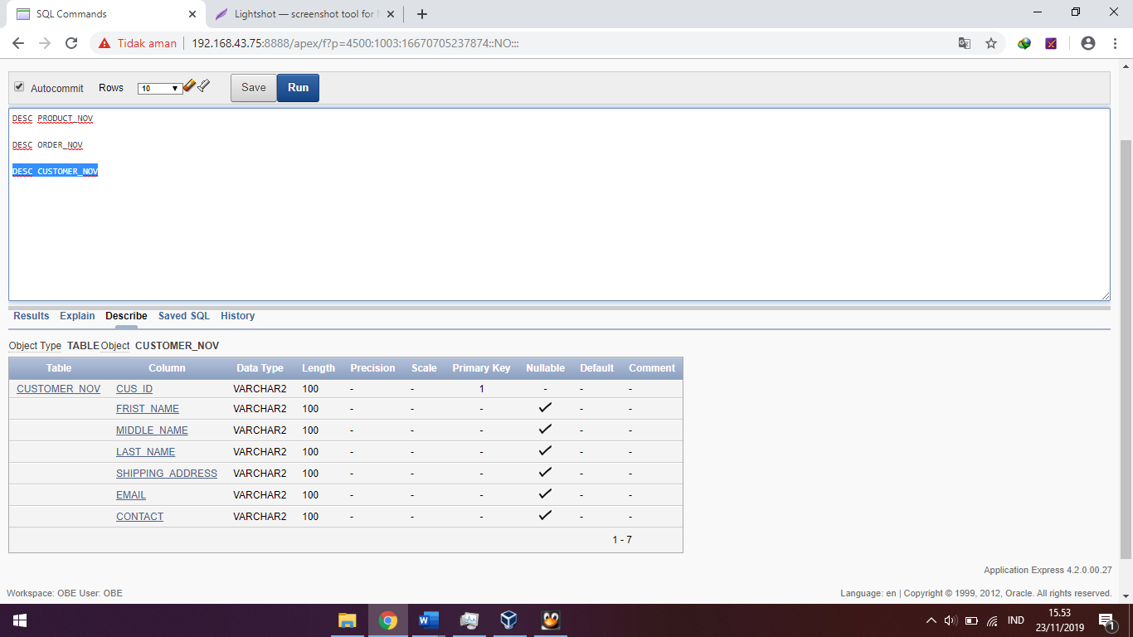

DESC ORDER_DETAILS_NOV

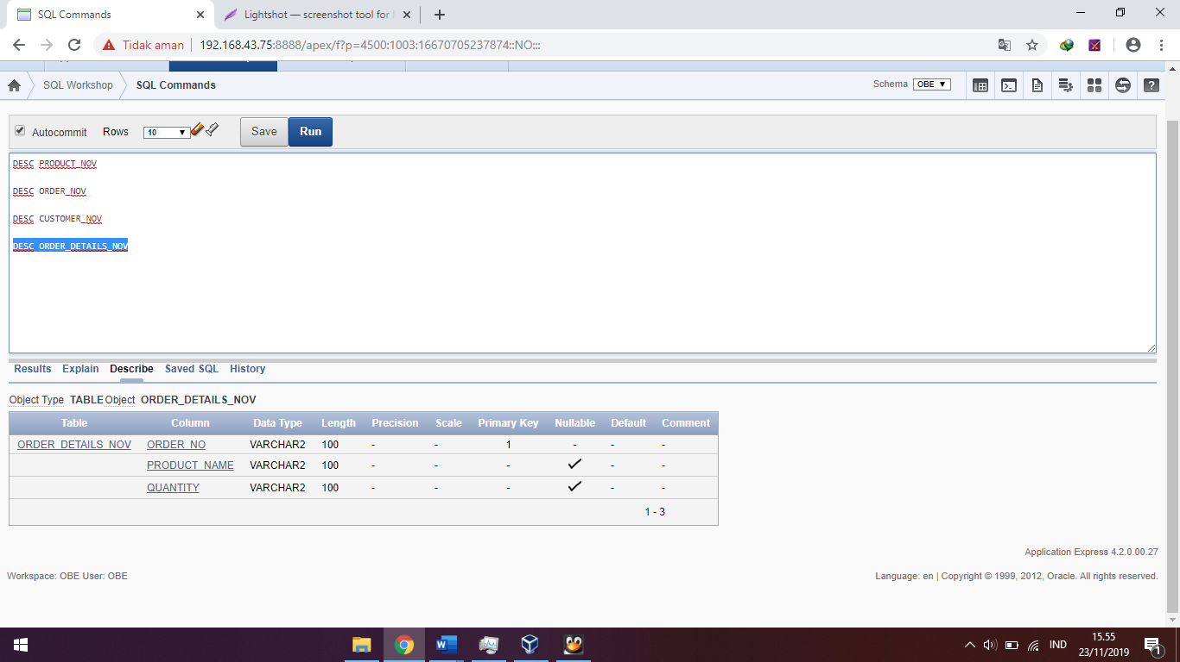

DESC STOCK

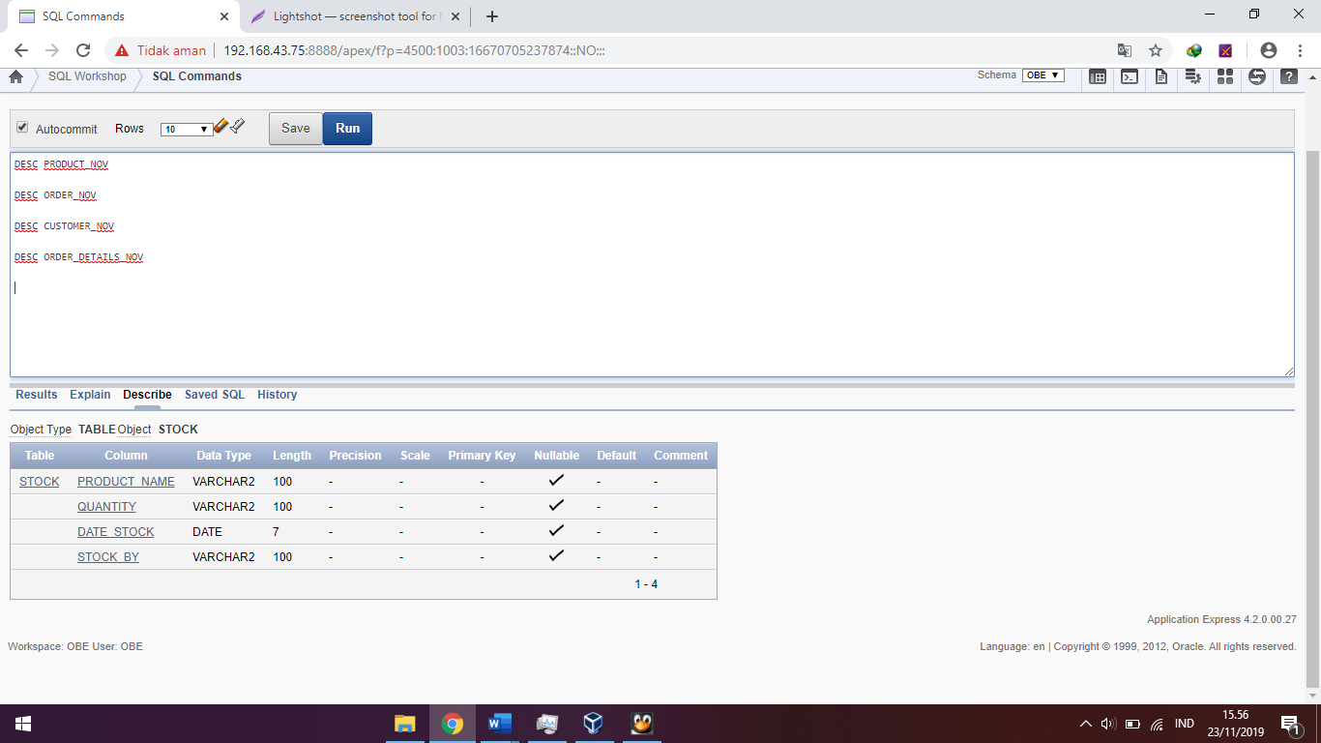

SELECT * FROM PRODUCT_NOV

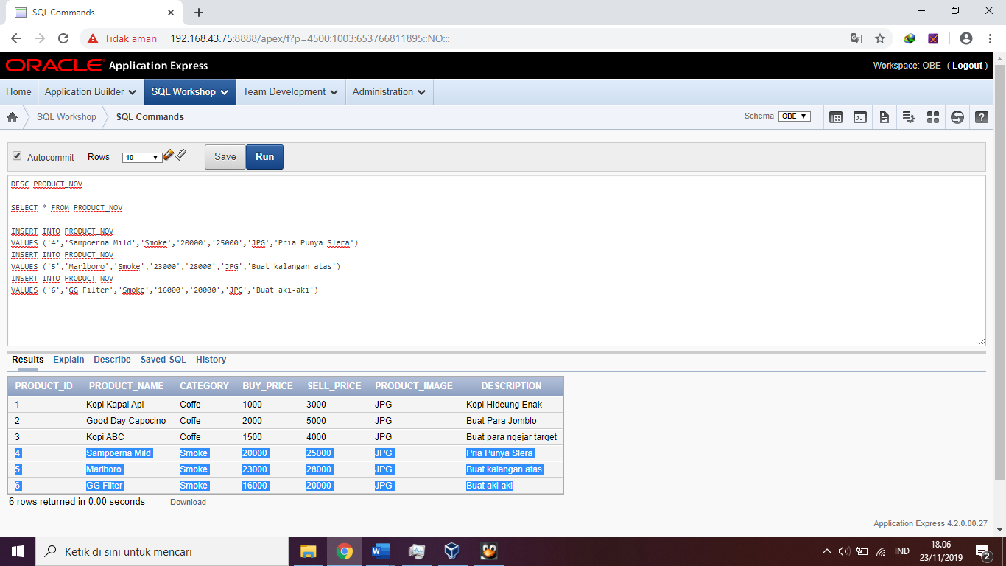

SELECT * FROM STOCK

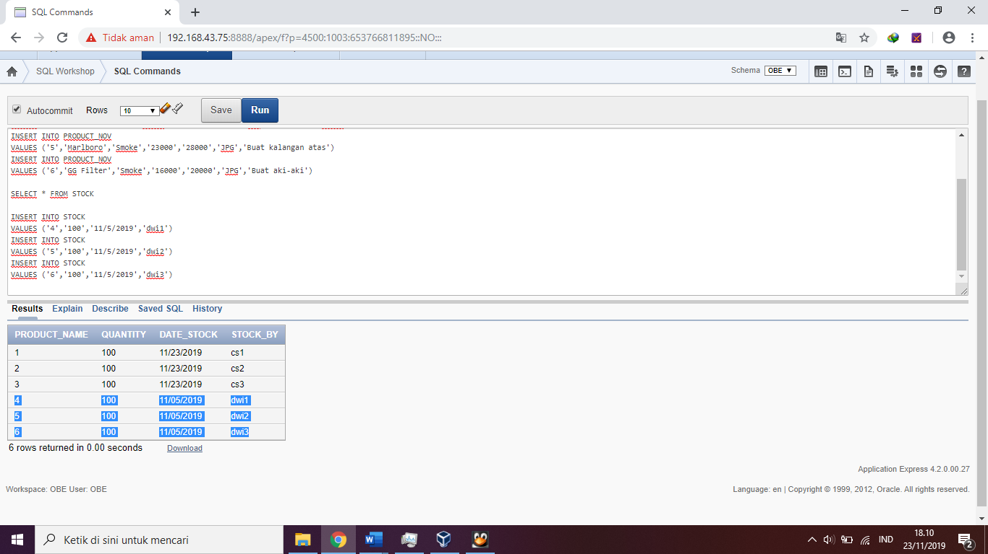

SELECT * FROM ORDER_NOV

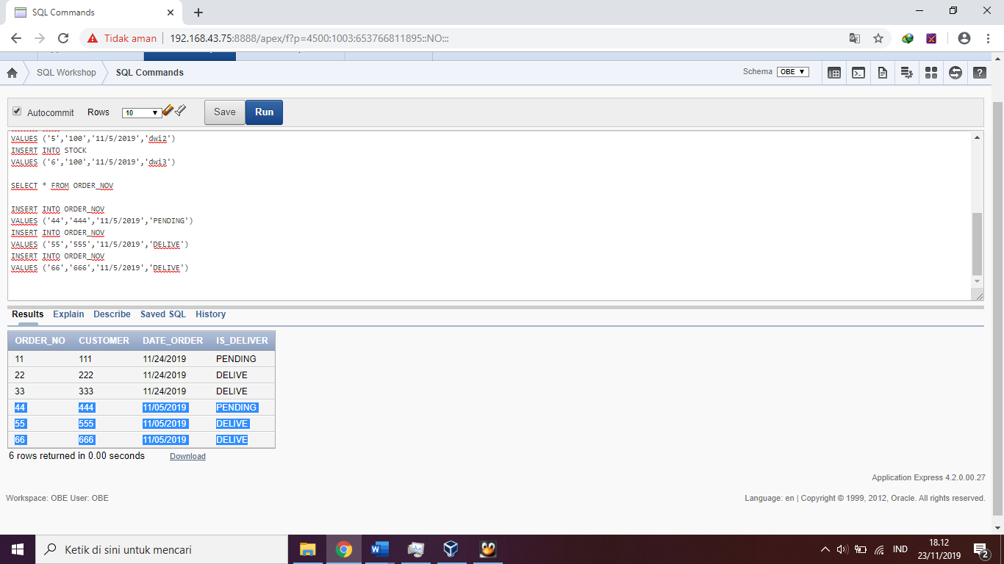

SELECT * FROM CUSTOMER_NOV

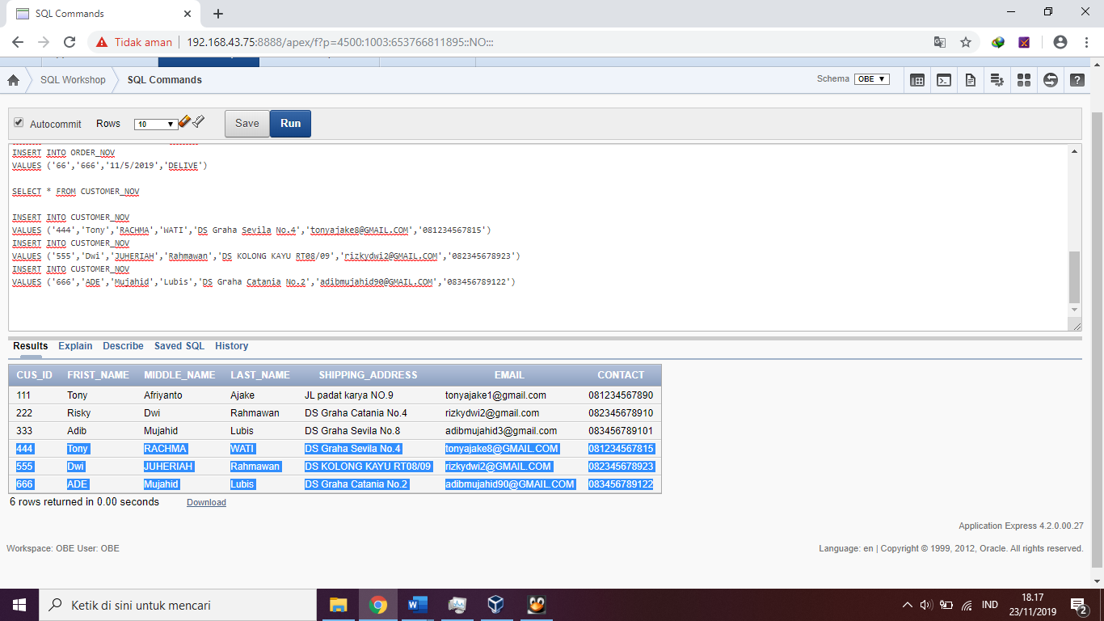

SELECT * FROM ORDER_DETAILS_NOV

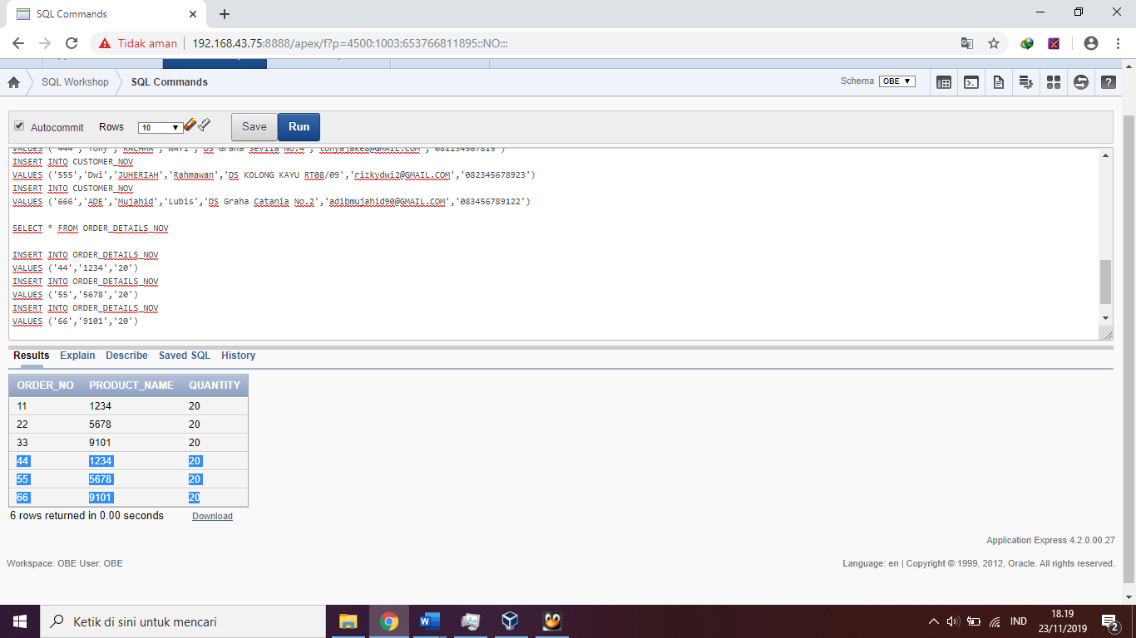

6. SELECT A.ORDERNO, A.DATEORDER, C.FIRSTNAME, B.PRODUCTNAME, B.QUANTITY, D.SELLPRICE, B.QUANTITY*D.SELLPRICE AS TOTAL

FROM ORDER_NOV A, ORDERDETAIL_NOV B, CUSTOMER C, PRODUCT D

WHERE B.ORDERNO = A.ORDERNO AND C.CUS_ID = A.CUSTOMER AND D.PRODUCT_NAME = B.PRODUCTNAME

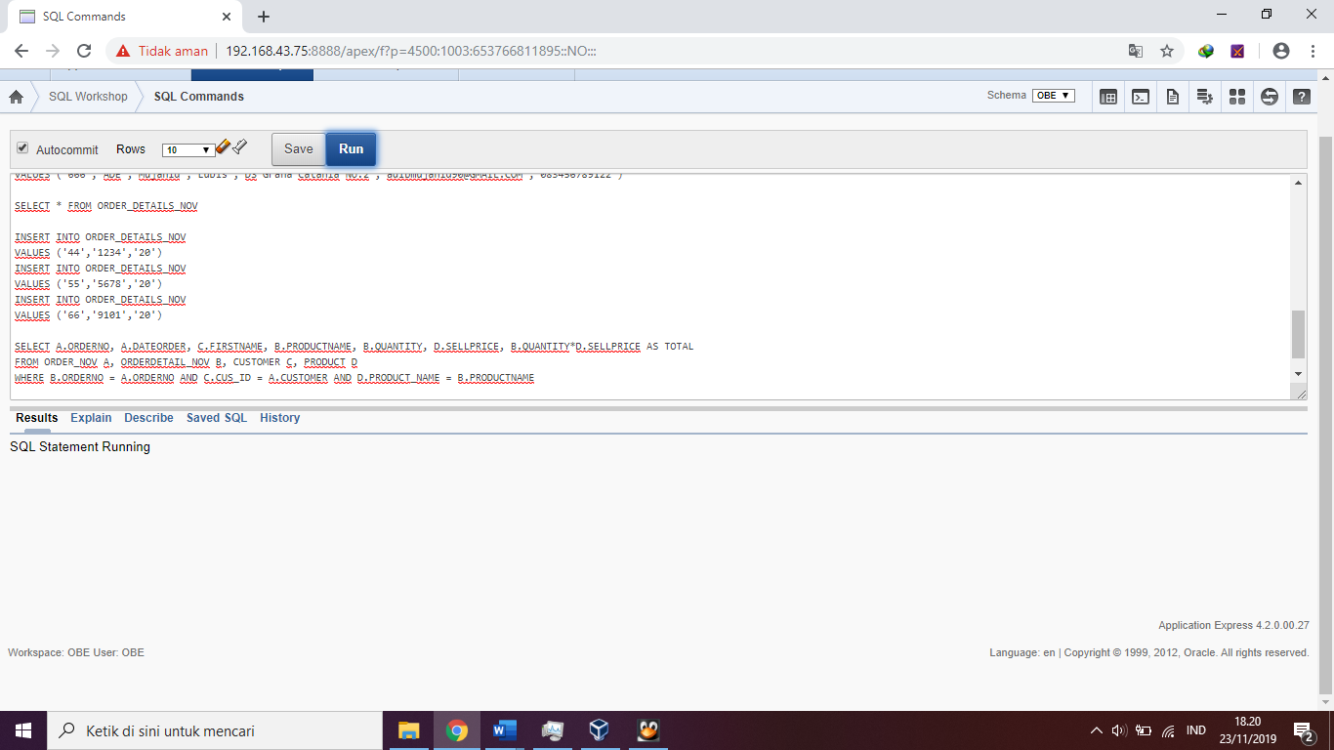

7. SELECT PRODUCT_NAME, SUM(QUANTITY)

FROM ORDER_DETAILS_NOV

GROUP BY PRODUCT_NAME, QUANTITY

ORDER BY QUANTITY DESC

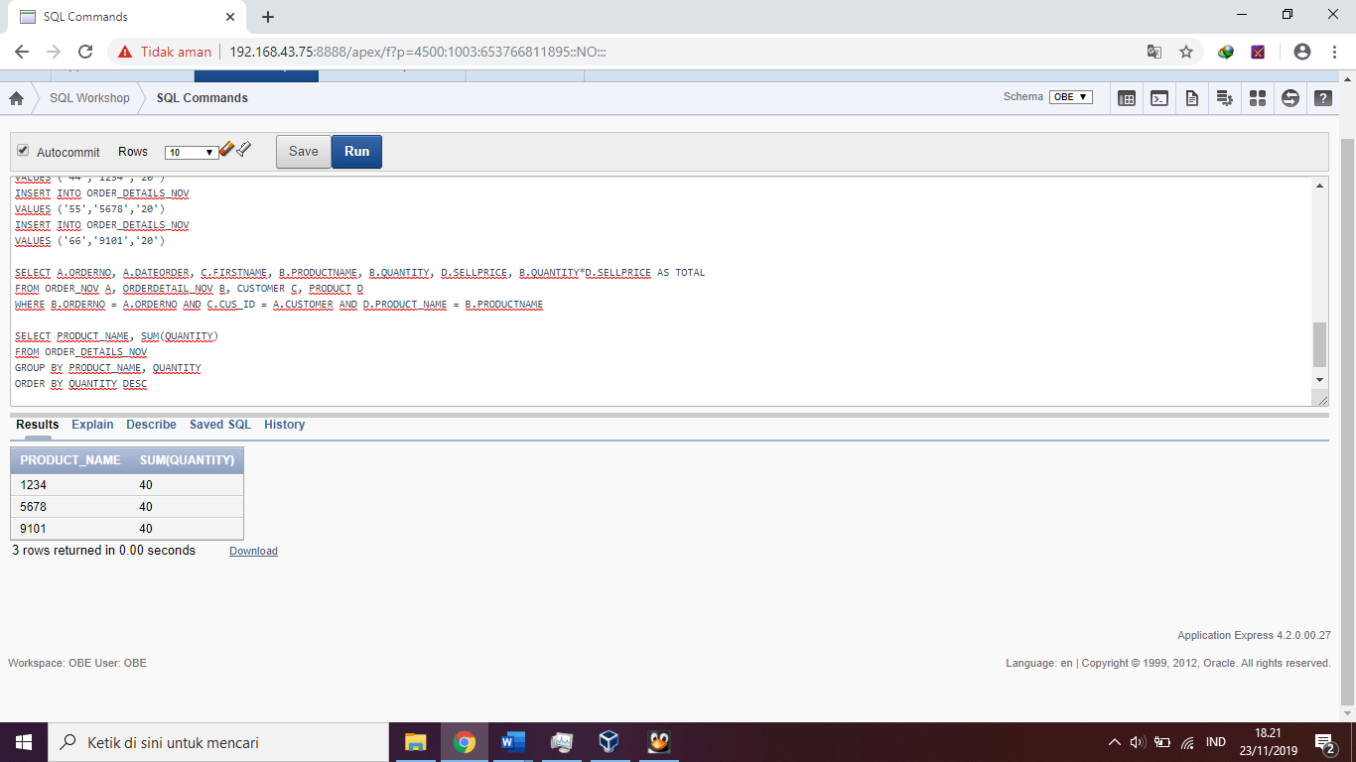

8. SELECT A.DATTE, B.PRDCT_NAME, SUM(B.QUANTITY)

PERSENTASE = (SUM(B.QUANTITY)/

SELECT SUM(D.QUANTITY)

FROM GORDER_NOV C, GORDER_DETAILS D

WHERE D.ORDERNO = C.ORDERNO AND C.DATTE = '2019-11-16')*100

FROM GORDER_NOV A, GORDER_DETAILS B

WHERE B.ORDERNO = A.ORDERNO AND A.DATTE = '2019-11-16'

GROUP BY A.DATTE, B.PRDCT_NAME, B.QUANTITY