**Nama : HERIISKANDAR** **NIM : 20180801315  
 Basis Data**

desc Product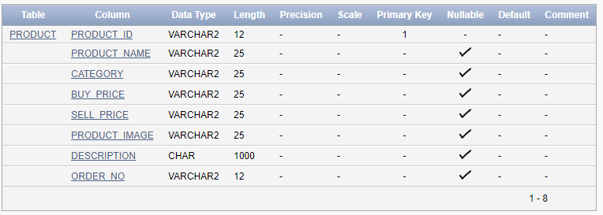

desc Employee

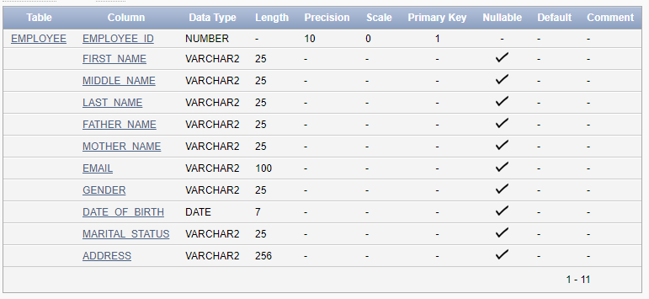

desc Customer

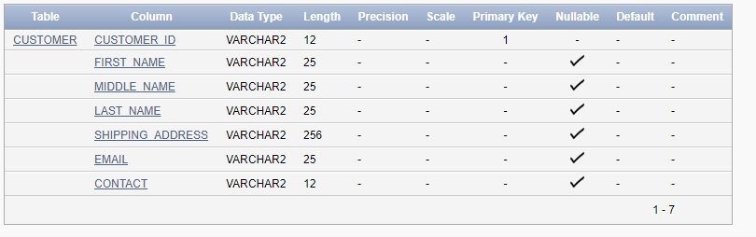

desc Transaction_Order

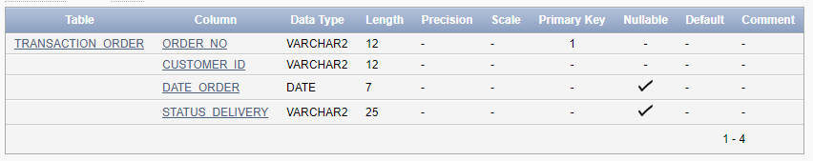

desc Payment

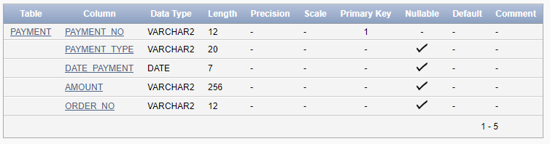

desc Login

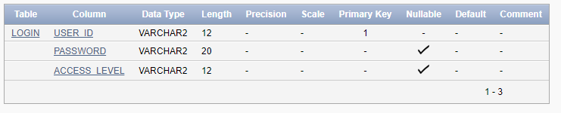

desc Shipment

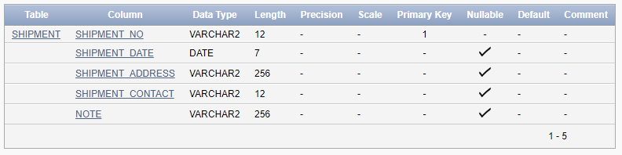

desc Stock

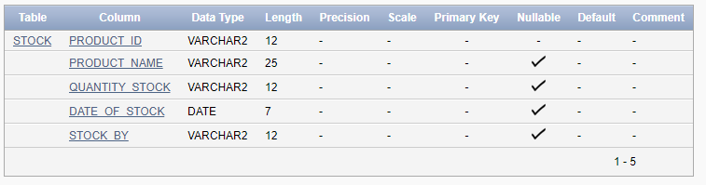

desc Transaction_Order_Details

