CODE

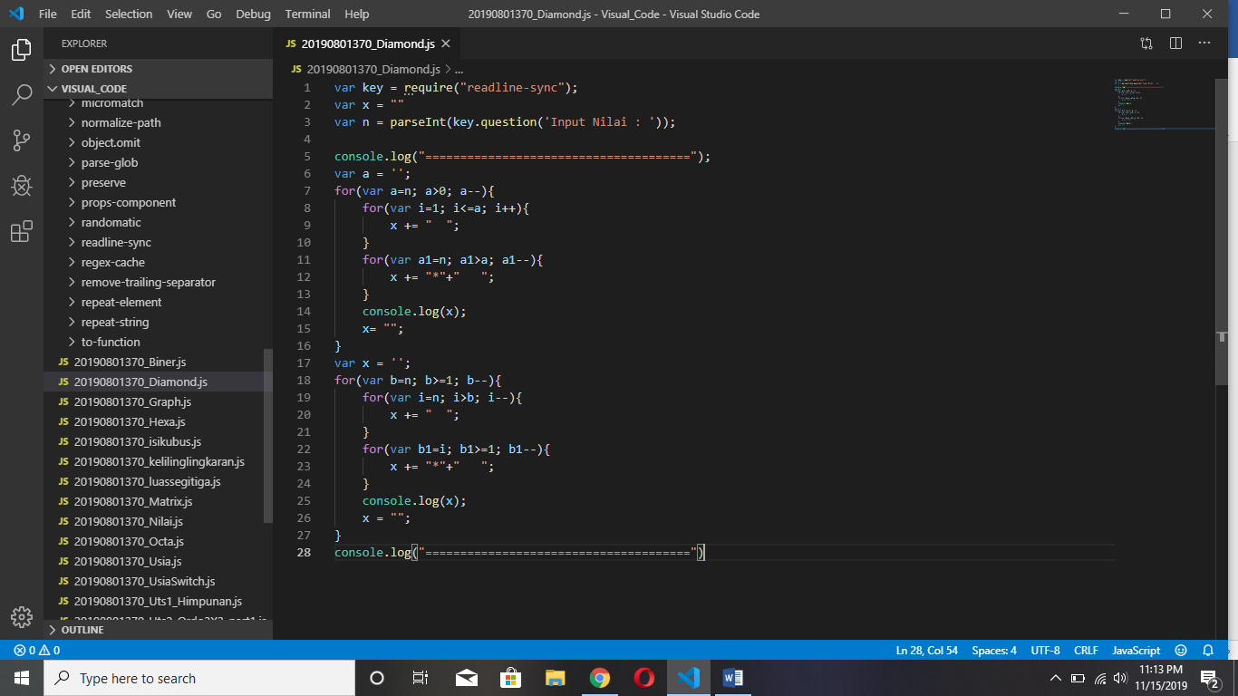

HASIL

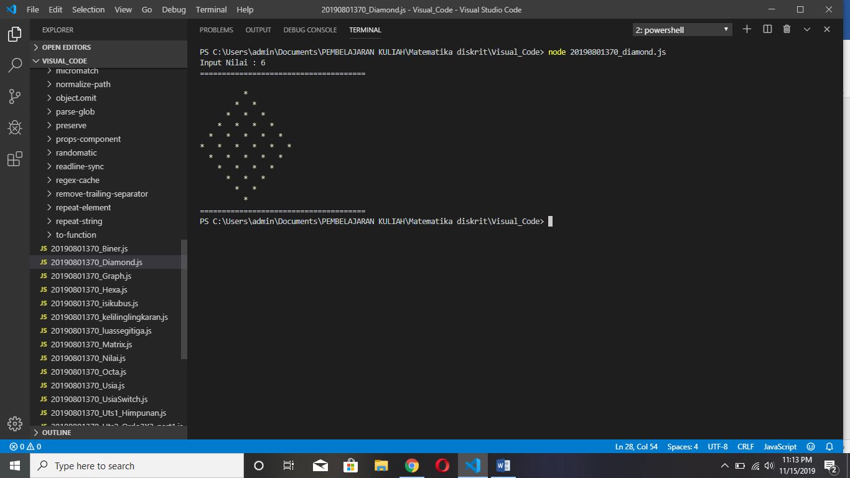

CODE BINTANG MERUNCING KE ATAS

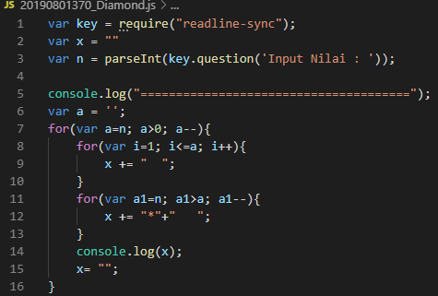

|  |  |  |
| --- | --- | --- |
| INPUT | PROSES | OUTPUT |
| **6** | A > 0 (TRUE) A – 1  I < A (TRUE) print “spasi” sampai **False**  A1 > A ((TRUE), A = 1, 2>1) print “*” | **\*** |
|  | A > 0 (TRUE) A – 1  A1 > A ((TRUE, A = , 3>1)) output “*”  A1 > A ((TRUE, A = , 2>1)) output “*” | **\* \*** |
|  | A > 0 (TRUE) A – 1  A1 > A ((TRUE, A = , 4>1)) output “*”  A1 > A ((TRUE, A = , 3>1)) output “*”  A1 > A ((TRUE, A = , 2>1)) output “*” | **\* * \*** |
|  | A > 0 (TRUE) A – 1  A1 > A ((TRUE, A = , 5>1)) output “*”  A1 > A ((TRUE, A = , 4>1)) output “*”  A1 > A ((TRUE, A = , 3>1)) output “*”  A1 > A ((TRUE, A = , 2>1)) output “*” | **\* * * \*** |
|  | A > 0 (TRUE) A – 1  A1 > A ((TRUE, A = , 6>1)) output “*”  A1 > A ((TRUE, A = , 5>1)) output “*”  A1 > A ((TRUE, A = , 4>1)) output “*”  A1 > A ((TRUE, A = ,3>1)) output “*”  A1 > A ((TRUE, A = , 2>1)) output “*” | **\* * * * \*** |

CODE BINTANG MERUNCING KE BAWAH

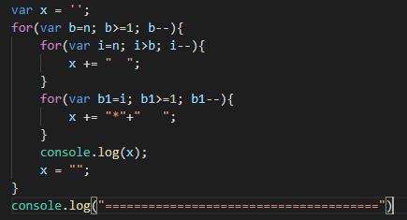

|  |  |  |
| --- | --- | --- |
| INPUT | PROSES | OUTPUT |
| **6** | A > 0 (TRUE) A – 1  A > 0 (TRUE) A – 1  A1 > A ((TRUE, A = , 6>1)) output “*”  A1 > A ((TRUE, A = ,5>1)) output “*”  A1 > A ((TRUE, A = , 4>1)) output “*”  A1 > A ((TRUE, A = , 3>1)) output “*”  A1 > A ((TRUE, A = , 2>1)) output “*”  A1 > A ((TRUE, A = , 1>1)) output “*” | **\* * * * * \*** |
|  | A > 0 (TRUE) A – 1  A1 > A ((TRUE, A = ,5 >1)) output “*”  A1 > A ((TRUE, A = , 4>1)) output “*”  A1 > A ((TRUE, A = , 3>1)) output “*”  A1 > A ((TRUE, A = , 2>1)) output “*”  A1 > A ((TRUE, A = , 1>1)) output “*” | **\* * * * \*** |
|  | A > 0 (TRUE) A – 1  A1 > A ((TRUE, A = , 4>1)) output “*”  A1 > A ((TRUE, A = , 3>1)) output “*”  A1 > A ((TRUE, A = , 2>1)) output “*”  A1 > A ((TRUE, A = , 1>1)) output “*” | **\* * * \*** |
|  | A > 0 (TRUE) A – 1  A1 > A ((TRUE, A = , 3>1)) output “*”  A1 > A ((TRUE, A = , 2>1)) output “*”  A1 > A ((TRUE, A = , 1>1)) output “*” | **\* * \*** |
|  | A > 0 (TRUE) A – 1  A1 > A ((TRUE, A = , 2>1)) output “*”  A1 > A ((TRUE, A = , 1>1)) output “*” | **\* \*** |
|  | A > 0 (TRUE) A – 1  I < A (TRUE) print “spasi” sampai **False**  A1 > A ((TRUE), A = 1, 1>1) print “*” | **\*** |

var key = require("readline-sync");

var s = " "

var n = 6;

var a = '';

for(var a=n; a>0; a--){

    for(var i=1; i<=a; i++){

        s += "  ";

    }

    for(var a1=n; a1>a; a1--){

        s += "*"+"   ";

    }

    console.log(s);

    s= "";

}

var s = '';

for(var b=n; b>=1; b--){

    for(var i=n; i>b; i--){

        s += "  ";

    }

    for(var b1=i; b1>=1; b1--){

        s += "*"+"   ";

    }

    console.log(s);

    s = "";

}

|  |  |  |
| --- | --- | --- |
| Input | A1 | Output |
| 6 | 1 | * |
|  | 2 | * * |
|  | 3 | * * * |
|  | 4 | * * * * |
|  | 5 | * * * * * |

|  |  |  |
| --- | --- | --- |
| Input | r | Output |
| 6 | 6 | * * * * * * |
|  | 5 | * * * * * |
|  | 4 | * * * * |
|  | 3 | * * * |
|  | 2 | * * |
|  | 1 | * |