

**NAVAL**

**POSTGRADUATE**

**SCHOOL**

**MONTEREY, CALIFORNIA**

**GROUND COMBAT VEHICLE SURVIVABILITY ROBUSTNESS ANALYSIS THROUGH MODEL BASED SYSTEMS ENGINEERING (MBSE)**

by

SE311-114G Vehicle Survivability

June 2013

Capstone Project Advisors: Dr. Douglas W. Nelson

Dr. Eugene P. Paulo

**CAPSTONE PROJECT REPORT**

**Distribution authorized to U.S. Government Agencies and their Contractors (Administrative or**

**Operational Use) (1 June 2012). Other requests for this document must be referred to President,**

**Code 261, Naval Postgraduate School, Monterey, CA 93943-5000 or RDECOM, Aberdeen Proving**

**Ground, Aberdeen, Maryland via the Defense Technical Information Center, 8725 John J. Kingman**

**Rd., STE 0944, Ft. Belvoir, VA 22060-6218.**

THIS PAGE INTENTIONALLY LEFT BLANK

|  |  |  |  |  |  |  |
| --- | --- | --- | --- | --- | --- | --- |
| **REPORT DOCUMENTATION PAGE** | | | | | *Form Approved OMB No. 0704-0188* | |
| Public reporting burden for this collection of information is estimated to average 1 hour per response, including the time for reviewing instruction, searching existing data sources, gathering and maintaining the data needed, and completing and reviewing the collection of information. Send comments regarding this burden estimate or any other aspect of this collection of information, including suggestions for reducing this burden, to Washington headquarters Services, Directorate for Information Operations and Reports, 1215 Jefferson Davis Highway, Suite 1204, Arlington, VA 22202-4302, and to the Office of Management and Budget, Paperwork Reduction Project (0704-0188) Washington DC 20503. | | | | | | |
| **1. AGENCY USE ONLY *(Leave blank)*** | | **2. REPORT DATE**  June 2013 | | **3. REPORT TYPE AND DATES COVERED**  Capstone Project Report | | |
| **4. TITLE AND SUBTITLE** **Ground Combat Vehicle Survivability Robustness Analysis through Model Based Systems Engineering (MBSE)** | | | | | **5. FUNDING NUMBERS** | |
| **6. AUTHOR(S)** David L. Basala, Louis W. Berklich, Christine K. Brennan, Steven P. Mazza, Joseph J. Rambousek, Donna A. Ray, Daniel Torres | | | | |
| **7. PERFORMING ORGANIZATION NAME(S) AND ADDRESS(ES)**  Naval Postgraduate School  Monterey, CA 93943-5000 | | | | | **8. PERFORMING ORGANIZATION REPORT NUMBER** NPS-SE-13-XX | |
| **9. SPONSORING /MONITORING AGENCY NAME(S) AND ADDRESS(ES)**  Department of the Army  U.S. Army Research, Development, and Engineering Command  3071 Aberdeen Blvd.  Aberdeen Proving Ground, MD 21005 | | | | | **10. SPONSORING/MONITORING**  **AGENCY REPORT NUMBER** | |
| **11. SUPPLEMENTARY NOTES** The views expressed in this thesis are those of the author and do not reflect the official policy or position of the Department of Defense or the U.S. Government. IRB Protocol number ______N/A______. | | | | | | |
| **12a. DISTRIBUTION / AVAILABILITY STATEMENT**  Distribution authorized to U.S. Government Agencies and their Contractors  (Administrative or Operational Use) (1 June 2012). Other requests for this document  must be referred to President, Code 261, Naval Postgraduate School, Monterey, CA  93943-5000 or RDECOM, Aberdeen Proving Ground, Aberdeen, Maryland via the  Defense Technical Information Center, 8725 John J. Kingman Rd., STE 0944, Ft.  Belvoir, VA 22060-6218 | | | | | **12b. DISTRIBUTION CODE**  C | |
| **13. ABSTRACT (maximum 200 words)**  Insert abstract here. | | | | | | |
| **14. SUBJECT TERMS** Model Based Systems Engineering, MBSE, Survivability, Ground Vehicle, Combat Vehicle, | | | | | | **15. NUMBER OF PAGES**  XXX |
| **16. PRICE CODE** |
| **17. SECURITY CLASSIFICATION OF REPORT**  Unclassified | **18. SECURITY CLASSIFICATION OF THIS PAGE**  Unclassified | | **19. SECURITY CLASSIFICATION OF ABSTRACT**  Unclassified | | | **20. LIMITATION OF ABSTRACT**  UU |

NSN 7540-01-280-5500 Standard Form 298 (Rev. 2-89)

Prescribed by ANSI Std. 239-18

THIS PAGE INTENTIONALLY LEFT BLANK

**Distribution authorized to U.S. Government Agencies and their Contractors (Administrative or Operational Use) (1 June 2012). Other requests for this document must be referred to President, Code 261, Naval Postgraduate School, Monterey, CA 93943-5000 or RDECOM, Aberdeen Proving Ground, Aberdeen, Maryland via the Defense Technical Information Center, 8725 John J. Kingman Rd., STE 0944, Ft. Belvoir, VA 22060-6218**

**GROUND COMBAT VEHICLE SURVIVABILITY ROBUSTNESS ANALYSIS THROUGH MODEL BASED SYSTEMS ENGINEERING (MBSE)**

SE311-114G Vehicle Survivability

David L. Basala; Louis W. Berklich Christine K. Brennan

Steven P. Mazza Joseph J. Rambousek Donna A. Ray

Daniel Torres

Submitted in partial fulfillment of the

requirements for the degree of

**MASTER OF SCIENCE IN SYSTEMS ENGINEERING**

from the

**NAVAL POSTGRADUATE SCHOOL**

**JUNE 2013**

Lead Editor: Louis W. Berklich

Reviewed By:

____________________ ____________________

Dr. Douglas H. Nelson Dr. Eugene P. Paulo

Capstone Project Advisor Project Advisor

Accepted By:

____________________

Cliff Whitcomb

Systems Engineering Department

THIS PAGE INTENTIONALLY LEFT BLANK

ABSTRACT

**GROUND COMBAT VEHICLE SURVIVABILITY ROBUSTNESS ANALYSIS THROUGH MODEL BASED SYSTEMS ENGINEERING (MBSE)**

**SE311-114G Vehicle Survivability–June 2013**

**Masters of Science in Systems Engineering**

**Advisor: Dr. Douglas H. Nelson Systems Engineering Department, Naval Postgraduate School**

**Advisor: Dr. Eugene P. Paulo Systems Engineering Department, Naval Postgraduate School**

THIS PAGE INTENTIONALLY LEFT BLANK

TABLE OF CONTENTS

I. INTRODUCTION 1

A. BACKGROUND 3

B. PROBLEM STATEMENT 4

C. RESEARCH QUESTIONS 4

D. Problem Space Boundaries 5

E. MBSE Methodology 6

F. Related Research 7

II. Process Development 8

III. Operational Analysis 10

A. Identification of Stakeholders 12

1. Stakeholder Identification 12

2. Stakeholder Analysis 13

B. Capability needs statement 14

C. Top level system functions and Requirements 14

C. Operational Concept and Scenario 15

1. Baseline Mission Scenario 16

2. Initial Order of Battle 17

3. Initial Force Disposition 17

4. Terrain and Red Force Composition and Disposition 18

D. Measures of Effectiveness and Measures of suitability 20

IV. Systems Architecture 22

A. Functional decomposition 25

B. physical decomposition 25

V. Systems Analysis 27

VI. Model Development 28

VII. Model Execution 29

A. Analysis Tools 29

A. Modeling and Simulation 31

1. Design of Experiments Planning 31

a. Model Data References and Definitions 31

b. Factor Levels and Probability Distributions 31

c. Probability Model 31

d. Factorial Design 31

e. OMOE for Cost As Independent Variable 31

B. Simulations 31

1. Approach and Process 32

a. Back of the Envelope Informal Approaches 32

b. Formal Model Approaches 32

c. Process 32

d. Resources 32

2. Variables and Factors. 32

a. Variables of Interest 32

b. Inputs and Outputs 32

c. Noise Factors 32

3. Factors not considered 32

VIII. Results 33

1. Regression Analysis and CAIV Results 33

2. Baseline Analysis 33

3. Alternative Configuration Analysis 33

XI. Summary and Recommendations 34

A. Challenges 34

B. Follow-on Work 34

C. Recommendations 34

Appendix A: Reference Models for Simulations 35

Appendix B: Simulation Output Data 36

LIST OF REFERENCES 37

INITIAL DISTRIBUTION LIST 40

**LIST OF FIGURES**

Figure 1: Initial Order of Battle 9

Figure 2: OV-1 Initial force disposition (after Treml) 9

Figure 3 RED defensive operation plan (from Treml) 11

**LIST OF TABLES**

THIS PAGE INTENTIONALLY LEFT BLANK

LIST OF FIGURES

**No table of figures entries found.**

THIS PAGE INTENTIONALLY LEFT BLANK

LIST OF TABLES

Table 1. Caption typed here 2

THIS PAGE INTENTIONALLY LEFT BLANK

LIST OF ACRONYMS AND ABBREVIATIONS

**Acronym Definition**

AMC Army Materiel Command

AUTL Army Universal Task List

Bn Battalion

BoE Back of the envelope

CAB Combined Arms Battalion

CAP Corrective Action Plan

CDD Capability Development Document

CMP Configuration Management Plan

CONOPS Concept of Operations

DAG Defense Acquisition Guidebook

DM Data Management

DoD Department of Defense

DoE Design of experiment

DODAF Depart of Defense Architecture Framework

DREN Defense Research and Engineering Network

EFP Explosively Formed Penetrators

FFBD Functional Flow Block Diagram

FER Force (or Fractional) Exchange Ratio

FOUO For Official Use Only

FRG Federal Republic of Germany

GCV Ground Combat Vehicle

GVSO Ground Vehicle Survivability Optimization

HOQ House of Quality

HQ Headquarters

IDEF Integration Definition for Function Modeling

IED Improvised Explosive Devices

IMS Integrated Master Schedule

IPT Integrated Product Team

JCIDS Joint Capabilities Integration Development System

MANA Map Aware Non-uniform Automata

MANPADS Man-portable air-defense systems

MBSE Model-based Systems Engineering

MBT Main battle tank

MCoE Maneuver Center of Excellence

METT-TC Mission, enemy, terrain troops and time and civil

MOE Measures of Effectiveness

MRAP Mine Resistant Armor Protected vehicle

M&S Modeling and Simulation

MSSE Masters Science Systems Engineering

NOLH Nearly orthogonal latin hypercube

NPS Naval Postgraduate School

OEM Original Equipment Manufacturer

OR Operations Research

OSP Operational Standard Procedure

PA Process Assurance

PL Programmatic Lead

PM Program Manager

PTL Project Team Lead

QFD Quality Functional Deployment

PEO CS & CCS Program Executive Office Combat Support and Combat Service Support

PEO GCS Program Executive Office Ground Combat Systems

RDECOM Research, Development and Engineering Command

RIA Rock Island Arsenal

ROI Return on investment

RPG Rocket Propelled Grenade

SAM Surface-to-Air Missile

S&T Science and Technology

SCAD Simulation Concept Architecture Design

SE Systems Engineering

SEED Simulation and Efficient Experimental Design

SE-WIPT Systems Engineering Working-level Integrated Product Team

SME Subject Matter Expert

SoS System of Systems

SOW Scope of Work

TARDEC Tank and Automotive Research, Development and Engineering Center

TPM Technical performance measures

TRAC TRADOC Analysis Center

TRADOC Training and Doctrine Command

WBS Work Breakdown Structure

WSTAT Whole Systems Trades Analysis Toolset

THIS PAGE INTENTIONALLY LEFT BLANK

EXECUTIVE SUMMARY

Required for OR, SE and EE. First paragraph is aligned with the left margin (not indented).

THIS PAGE INTENTIONALLY LEFT BLANK

ACKNOWLEDGMENTS

The Ground Systems Survivability Team of Cohort SE311-114G would like to extend its appreciation and thanks to the following:

• First and foremost we would like to thank our respective families for their patience and tolerance of long nights, odd hours, and strange, seemingly one-sided discussions through headphones and microphones. This would not have been possible without your love and support.

•RDECOM for sponsoring the SE311-114G Cohort throughout the Masters of Science in Systems Engineering program

•ARDEC, TARDEC (and Donna’s org), our respective organizational employers for accommodating our continuing education during normal duty hours.

• The U.S. Army Maneuver Center of Excellence (MCoE) in supporting the Ground Systems Survivability Capstone Project

• RDECOM Liaison Mr. Ryan McCullough for providing feedback throughout the Capstone process

• MCoE Liaison Mr. Ted Macuiba for providing guidance as a critical stakeholder in the Team’s Capstone efforts

• NPS Capstone Advisors Professors Dr. Douglas Nelson and Dr. Gene Paulo NPS Department of Systems Engineering, for being an integral part of the reviewing process, providing encouragement and guidance and holding us to scope and timing.

• Professor NPS Department of Systems Engineering for providing direction, being a part of the reviewing process and providing real world expertise on ground combat vehicle use.

• Professor Brigitte Kwinn

• Major Tobias Treml FRG Army for providing extensive background and support for MANA® modeling, scenarios and baseline information

• NPS Faculty attending IPR-1 and IPR-2 and their invaluable feedback

• And of course our Professors throughout the past two years who spent countless hours going above and beyond to make this a most enlightening and challenging experience and provided the foundational knowledge of MSSE curriculum which prepared the team for the Capstone effort

•Finally our thanks goes out to all of those at the Naval Postgraduate School that have provided supporting services from the Dudley Knox Library staff, Tech Support, Thesis Processing Office, ….

THIS PAGE INTENTIONALLY LEFT BLANK

# I. INTRODUCTION

*“To hold the cavalry in reserve for the end of the battle, is to have no idea of the power of combined cavalry and infantry charges either for the attack or for defense.”*

Napoleon Bonaparte (Cairnes, 2004)[NEED Pg#]

Military tactics and strategy within the United States have long been predicated on the Cold War. During the opening phases of the Iraqi conflict, these tactics and strategies were proven out as our combined arms units rapidly moved forward, gaining continual victories. In the following years, however, our enemies adopted new tactics utilizing improvised explosive devices (IED) and explosively formed penetrators (EFP) as part of their insurgency. (Kempinski & Murphy, 2012) These weapons have a devastating effect on both armored and unarmored mobile targets and resulted in the deployment of Mine-Resistant Ambush Protected (MRAP) vehicles as a means to counter these weapons.

Increasing survivability traditionally has occurred at the vehicle level. The increase has meant adding armor as with the MRAPs or other technologies such as soft and hard-kill active protection or signature management, all of which add weight and in turn, decrease mobility. This “iron triangle” of survivability, lethality, and mobility in combat vehicles has historically been balanced to meet force effectiveness and mission success. Unfortunately, the increased lethality of our opponents has driven vehicle designs further into the survivability corner of the triangle resulting in heavy vehicles with limited mobility.

A different methodology for achieving survivability and mission completion is that of integrated survivability. The integrated survivability concept has been with us from the days of the interlocked shields of a Roman phalanx to combined arms maneuvers in modern day warfare. (Pederson, 1998) Current combat commanders in the field utilize integrated survivability as a matter of course when calling in air cover, artillery support, or flanking units.

Within design, however, vehicles are still thought of as individual units unlike the interlocked shields of the Romans. Looking beyond single vehicle enhancements to understand the integrated survivability of a system of systems (SoS), and the implication in the context of unit or brigade mission completion, requires an analytical process and methodology.

Model Based Systems Engineering (MBSE) could potentially provide the framework necessary for discovering these relationships. Understanding system-level interconnections through MBSE provides greater design fidelity, and SoS analysis assesses overall system level survivability through integration of both threat and system viewpoints and accounts for multiple combat-arms structures

The idea that improving lethality or mobility would also increase survivability has long been supported by professional military judgment within the combat vehicle community. This position is supported by the U.S. Air Force in aerial combat and their quest for faster, more maneuverable fighters. (Haulman, 2002) With regard to ground combat vehicles, however, this is not as obvious. Analytical metrics have yet to be developed that define the trade of armor protection for increased mobility or increased lethality. This analytical relationship with respect to protection must be understood and quantified from a systems perspective, specifically in understanding the associated trade-offs. The materiel components and non-materiel functions and features that can be incorporated into vehicle designs and organizational activities comprise this trade space. The impacts of various combinations of these parameters on operational performance of the missions provide the knowledge base for cost effective definition of both needed and desired combat vehicle capabilities.

The application of statistical analysis to combat simulations of a company or platoon-sized ground combat maneuver unit provides a solid foundation for beginning to acquire the necessary knowledge base. The company/platoon-sized unit gives the opportunity to study high-level trends and provides a quantitative definition of the trade space in terms of unit survivability and mission completion. The unit size provides manageable dimensions of simulation while allowing the alteration of both unit composition and individual vehicle capabilities.

## A. BACKGROUND

There has been much written in regards to the interplay of mobility, lethality and survivability. And within the ground combat vehicle engineering community, there resides a tacit knowledge that improving vehicle survivability equates to additional armor, which yields a heavier vehicle, and consequently a loss of mobility.

With the advent and use of improvised explosive devices (IED), rocket-propelled grenades (RPG), explosively-formed penetrators (EFP) and advanced optical and thermal imaging systems, understanding the survivability/mobility trade has never posed a greater challenge. Overcoming widely varying threats, providing consistent combat effective mobility across the operational climate and terrain spectrums, and packaging precise engagement capability on a single platform has proven problematic. (Mait & Kugler, 2004)

The major improvements in lethality posed by our opponents have led to vehicle-specific solutions such as the MRAP. This issue has driven an intense, narrow focus on single vehicle capabilities with respect to survivability. Few if any to this point, seem to account for the interrelationship of multiple capabilities.

The U.S. Army is of course very aware of the existance of interactions of supporting units. They note that success is achieved “…not by a single vehicle or section of vehicles but by the ability of the combined arms support to deliver overmatch effects as needed.” (FM 3-21.31 The Stryker Brigade Combat Team, 2003)[NEED Pg#] It is also reflected by Molitoris & Hicks when they noted that “system level survivability is dependent on the mission profile and protection of the baseline system.” (Molitoris & Hicks, 2009)[NEED Pg#] This sentiment was echoed, though less strongly, in the U.S. Army Equipment Modernization Strategy published in 2013. The authors point out that “the future environment will require versatile and tailorable formations that are regionally aligned and mission focused to meet combatant commander’s needs.” (Army Equipment Modernization Strategy, 2013)[NEED Pg#]

The US Army Maneuver Center of Excellence (MCoE) has interest in analytically understanding the interplays and interactions with respect to the integrated survivability of a combat unit. More specifically they need to understand how the addition or subtraction of specific capabilities impact the overall unit survivability and mission success.

## B. PROBLEM STATEMENT

Design and analyze company-level ground combat mounted maneuver unit in a combined arms scenario, with the intent of providing clear, quantitative understanding of the design trade space of the vehicle and its infantry squad as related to other mission capabilities, such as mobility, lethality, and possibly networked communications, as well as others as they apply to survivability outcomes. Design solutions include breadth of DOTMLPF considerations.

## C. RESEARCH QUESTIONS

The idea that increasing lethality or mobility would also increase survivability has been supported with professional military judgment, but no analytic metrics have been developed that can trade the weight of armor protection for increased mobility or increased lethality. Improvements in protection must be understood and quantified from a systems perspective, specifically in understanding the associated trade-offs. Materiel components and non-materiel functions and features that can be incorporated into vehicle designs and organizational activities comprise the trade space that will be studied. Combining the impacts of these trade-space parameters on the statistical operational performance of the organization’s missions are crucial for the decision maker with respect to cost development.

## D. Problem Space Boundaries

The problem space is bounded by several things including timing, access to information and software, capability in using various software packages, and of course the scope of work (SOW). The SOW for Determining Combat Vehicle Survivability through the Linkage of other Operational Requirements was developed with Ted Maciuba, Director, Mounted Requirements, MCoE in conjunction with NPS faculty advisors Dr. Gene Paulo, Dr. Doug Nelson and Paul Beery (Aug 20, 2012).

The scope of this effort is focused solely on defining a process to assess combat vehicle survivability within the context of the combined arms unit. It does not address in any way force protection and assumes in the context of the model that if a vehicle does not survive its crew does not survive.

Addressed within the simulations are standard mechanized infantry, heavy armor, artillery, and medium air support. Because of schedule constraints weather was not considered as a factor, nor was any counterstrike capability included. Inclusion of these variables could of course lead to different conclusions to specific applications. However such inclusion would not negate the process by which the data was achieved.

Simulation models were set up in accordance with Treml’s doctoral work and run as a series of experiments which varied a range of parameters. Selected parameter variations encompassed standard U.S. Army ground combat vehicles and unit compositions. The purpose was one of determining if the variations resulted in an increased unit survivability and mission success rate. The models, processes, and resultant model data are the primary work products of the effort supporting this paper.

The models allow the variation of both the vehicle and unit constituents thereby enabling the measurement of the effects of changes to armor, armament, mobility, detection and unit composition. The limit placed on the trade space is technology that is projected to be fieldable by 2018. While this precludes the consideration of some exciting potential opportunities for improvement of mission success, it does provide a tight focus of effort on near-term options with potential for immediate gain.

Specific recommendations for follow-on work are provided later in this paper and include items such as a user dashboard for direct interaction and manipulation of the model. While this work will facilitate a dashboard effort, it is not included as part of the deliverables.

The emphasis of the research is on the effects of varying the configuration of a system of systems. There is also an operational component that dovetails with the effort. The operational analysis, however, is limited commensurate with the scope of the project in order to best address the requests of our primary stakeholders, the Maneuver Center of Excellence (MCoE).

The model and model analysis delivered is unclassified and contains no Classified or For Official Use Only (FOUO) data. Consequently, while the model and the analysis process are academically sound, the resulting information may be skewed based on the use of synthetic data in the model (e.g., vehicle top speed, primary armament maximum effective range, etc.). The model and processes used to obtain realistic results is predicated on the acquisition and use of classified data.

## E. MBSE Methodology

Model-based Systems Engineering (MBSE) as defined by INCOSE as “the formalized application of modeling to support system requirements, design, analysis, verification and validation activities beginning in the conceptual design phase and continuing throughout development and later life cycle phases.” [NEED CITATION]

A model-based approach provides many advantages including the ability to develop a process that is traceable and repeatable because it is captured via interrelated models as opposed to paper. [NEED CITATION] In addition, this provides the ability to trace requirements back to the source documentation, as well as store that information to ensure that traceability and rationale for requirements is maintained.

Utilizing an MBSE approach supports systems engineering (SE) decisions through the insight provided by research questions. These questions are the basis for developing the instantiations of the architecture and functions in an operational context. The instantiations then give the ability to quantifiably evaluate the system’s objective performance.

General use cases and architectures were developed based on the application of a combined arms unit to a specific problem. The resultant information was captured in and integrated diagram set that provided a cohesive view of the overarching architecture. These architectural models allowed the identification of interface points that need additional definition.

A key aspect of the process was to ensure proper identification of the system design decisions that the MBSE process was designed to inform. However an important caveat to the process is implementing the current toolset. Toolsets within the SE community have yet to be fully integrated. This is true of the toolset utilized for this paper creating a deficiency with respect configuration control of the models and data sets. The deficiency was overcome by using a configuration control process to ensure concurrency in the data being used by the various tools such as: Vitech CORE, MANA and Microsoft Excel.

The methodology developed for implementing an analytical measure to the overall mission success/unit survivability was based upon several key measures of success including, vehicle survival rate and the Force Exchange Ratio (FER). The purpose for the methodology is so that each time a new unit, mission or system is introduced it would not require a start from scratch approach, but rather the implementation of the key data necessary to achieve the desired analysis. The process developed is a scoped down version of the process needed to carry out a fully integrated evaluation of survivability in terms of system of systems. Scope reduction was driven because of the constraints of resources and schedule. However, necessary follow-on work has been identified to achieve a fuller process.

## F. Related Research

Provide an introduction and brief overview to related research.

## WSTAT

(PM-GCV)

## Systm of systems analysis toolset (SoSAT)

SoSAT suite is a collection of advanced modeling and simulation tools aimed at, “understanding characteristics of large-scale interdisciplinary problems that involve multiple distributed systems that are embedded in networks at multiple levels and domains.” (Thompson) The toolset places a specific emphasis on repair and supply chain management and materiel availability in addition to other aspects of complex system of systems modeling that are common to the other toolsets. It is also capable of taking into account and providing detailed cost analysis and reporting.

As an example, SoSAT would be well suited to support the assessment and analysis of the impacts of architectural changes to a large scale, network enabled, distributed system providing insight into performance based logistics analysis and operational availability arising from these changes. As with other analysis toolsets, SoSAT facilitates interactive interrogation, allowing engineers to perform and measure trade-offs by constructing and running models. The specific insight that this toolset can provide might include the cost of sustainment activities.

In addition to modeling and simulation, SoSAT offers sophisticated data visualization capabilities allowing its users access to detailed, real-time information at various levels during execution. This type of detailed analysis facilitates the trade space analysis necessary without the need to go outside of the toolset.

## Capability Portfolio Analysis Tool (CPAT)

CPAT, developed under the direction of Program Executive (PEO) Ground Combat Systems (GCS) is specifically designed to facilitate the acquisition process by enabling trade-off and evaluation on the basis of cost, schedule, and performance. It was originally designed for and consequently focuses on supporting, “the formal Analysis of Alternatives (AoA) process.” (Ewing, 2013) The model captures forty-nine attributes of forty-seven different vehicles. The vehicles are divided into twenty roles including Infantry Fighting Vehicle, Command and Control, Main Battle Tank, Medic, and others. There are ten roles within the Heavy Brigade Combat Team and ten roles derived from the Stryker Brigade Combat Team.

## Naval Ship Design Dashboard

# II. Process Development

One of the key deliverables of this project is the process. The objective is the development of a repeatable process that is useful across multiple scenarios and models, utilizing different systems and data that can be used to develop reports, simulation data, and recommendations.

The foundation for the MBSE process lies in the SoS SE Elements found in the “Systems Engineering Guide for System of Systems” developed by the Department of Defense. (Systems Engineering Guide for Systems of Systems, 2008) The DoD process as seen in Figure X revolves around requirements, relationships, and architectures.

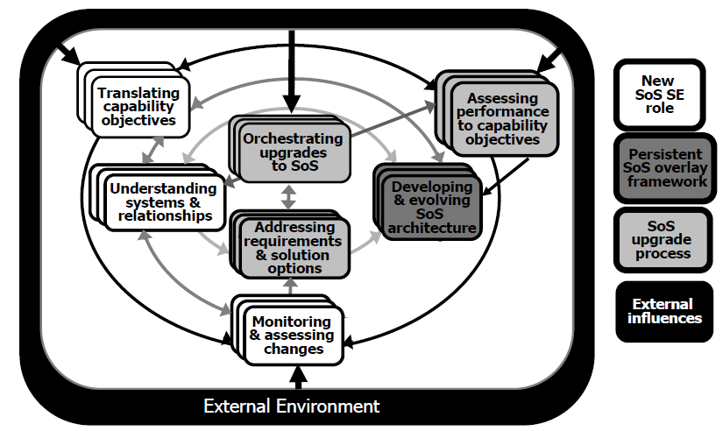

SoS SE elements and relationships (from (Systems Engineering Guide for Systems of Systems, 2008, p. 30)

The process developed for this effort, while based on the DoD model provides for a richer environment specific to the problem at hand.

[Need to delineate why our model deviates for the DOD model and specifically why it is better for this particular application]

The MBSE process shown in Figure X is a global view of the overall process that was used in developing the models and data. The five elements of the process are:

- Performing an operational analysis to define the concept of operations and the required capabilities

- Developing the system functional architecture including interdependencies and relationships

- A systems analysis to determine critical functions to the required capabilities

- Developing a model and modeling toolset to analyze the system capabilities

- Execution of the model defining the baseline and the most appropriate changes to stress the baseline.

Each of these steps is further defined in the following sections.

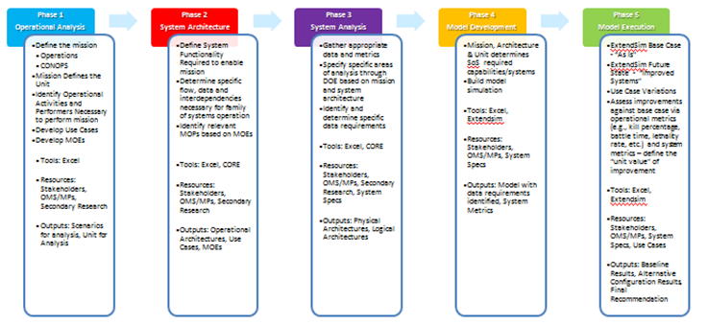

MBSE process for ground systems survivability robustness (after [NEED CITATION])

# III. Operational Analysis

Phase 1 of this process is the Operational Analysis which is founded in the operational viewpoint of mission scenarios. The requirements analysis phase was focused on the identification of a specific mission to be evaluated from the operational perspective of overall survivability of a unit. Intrinsic to this phase was the selection of the mission scenario which acted as the basis to achieve the capstone requirements.

A key element in the operational analysis was the discovery of previous work at the Naval Postgraduate School (NPS) by Major Tobias Treml, FRG Army. Major Treml is an operations research student at NPS working toward his doctorate. Treml’s work on developing an analytical underpinning for selecting specifications of future combat vehicles provided the basis for the analytical models on which this paper is based.

Treml developed an operational scenario within a tool called Map Aware Non-Uniform Automata (MANA). MANA is "an agent-based model developed by the Operations Analysis group at Defence Technology Agency in New Zealand.” [NEED CITATION] This tool is agent – based and therefore “allows scenarios to be run relatively fast, over many excursions in order to discover unique situations or tactics where friendly forces can achieve dominance over an enemy.” [NEED CITATION] “Another key feature of agent-based models is that, although the one-to-one interaction between various agents and their environment may be quite simple, the combined effect of many agents interacting can lead to complicated group dynamics and emergent behaviour.” [NEED CITATION]

One of the fundamental elements of Phase 1 of the process is identification of the following information as laid out in the U.S. Army METT-TC (ADRP 3-0 Unified Land Operations, 2012):

Mission Variables (METT-TC)

* Mission shall define the tasks and purpose required of the identified unit
* Enemy shall define the capabilities, doctrine, and threat from opposing forces
* Terrain shall define the climate, environment, routes, obstacles, and fields of fire
* Troops shall define size, unit, capabilities, support, and status of friendly forces
* Time available
* Civil considerations

Completing a METT-TC provides the basic information necessary to complete specific use cases and architectures. Following this process, different missions can be developed, use cases created, architectures built, models executed, analysis completed, and the scenarios evaluated in an entirely repeatable fashion.

In conjunction with the defined mission variables, the entities (unit, vehicles, etc.) relevant to the operational scenario were identified utilizing invaluable input from the stakeholders. Within the context of this effort, combat vehicles were defined as the primary unit and assigned supporting vehicles and infantry. These supporting vehicles consisted of helicopters and unmanned air vehicles, which will be discussed further and evaluated as part of unit definition.

Next, an analysis of individual unit capabilities was developed to provide direction with respect to mobility, lethality, survivability and situational awareness. This was done by identifying initial system characteristics and capabilities of each platform. Additionally, the tactics and techniques for the unit was identified to create a decision based simulation that would emulate a real scenario. These baseline system characteristics were derived from the platform original equipment manufacturer (OEM) data sheets. The tactical decision process was developed using subject matter experts (SME) from former military personnel, initially developed by Treml. [NEED CITATION]. This methodology defined the overall baseline, resulting in traceability to the requirements analysis.

Finally, utilizing the input from stakeholders and the prioritized capability requirements from the developed scenario and unit, appropriate Measures of Effectiveness (MOE) were determined. The four MOEs for assessment were blue force vehicle kills, blue force kills, Force Exchange Ratio and mission success. These MOEs drove the technical performance measures (TPM) that were used to identify the critical system functions and configuration changes.

THESE PARAGRAPHS ARE CURRENLY UNFINISHED

Finally, Phase 1 will also include the development of the Operational Architecture. It is in this phase that the team will begin to detail out the operational activities and necessary performers for those activities. Since the unit and mission will have been identified, the team will focus on decomposing the scenarios to develop a detailed operational hierarchy and diagram the architectures to identify interrelationships and dependencies. This diagramming will include the development of the specific use case models and which requirements they are directly linked to. Through the decomposition of Operational Activities and the Requirements Analysis phase, the team will determine the high level MOEs at which we will be assessing the modeled information.

## A. Identification of Stakeholders

### 1. Stakeholder Identification

This thesis has laid out a process that is multifaceted and spans many areas of the system development process. Therefore, there are multiple stakeholders interested in the different capabilities offered by the tools and process. The user, Science and Technology (S&T) and Acquisition communities all have an interest in the capabilities this process can provide. Table X depicts the major stakeholders that were identified and leveraged for guidance and requirements development.

|  |  |  |
| --- | --- | --- |
| **Project Role** | **Name** | **Expectation** |
| SPONSOR | | |
| RDECOM Sponsor | Mr. Dale Ormond, Director RDECOM | Applicable product, demonstration of systems engineering and model based systems engineering techniques to address difficult problems |
| RDECOM Representative | Ryan McCullough, HQ RDECOM | Applicable product |
| USERS | | |
| MCoE Representative | Ted Macuiba, | Applicable product to provide analytical underpinnings to capability decisions for survivability trade-space alternatives |
| PEO CS&CSS Representative | Bobbe Desmond, APEO SEI | Applicable product to provide insight to current systems and potential implications of capability improvements |
| PEO GCS Representative | Tony Desmond, APEO SEI | Applicable product to provide insight to current systems and potential implications of capability improvements |

Table X Stakeholders and users

In order to fully understand the needs of these stakeholders and the desired requirements, both primary and secondary research was performed. Initially stakeholder documentation was gathered, reviewed and parsed for applicable information regarding survivability definitions and current shortfalls. That information was used as the basis for the stakeholder discussions to gather additional relevant information and clarify questions that arose during the primary research effort. These discussions were held individually with the MCoE, the PEOs and the RDECOM community. And the discussions afforded each stakeholder the opportunity to voice their needs and requirements.

### 2. Stakeholder Analysis

The user community, specifically the Maneuver Center of Excellence (MCoE) is the main stakeholder for this project and is interested in an analytical process and methodology that tangibly measures the overall survivability of a system of systems, looking beyond the single vehicle enhancements to understand the implications to the overall unit. The outlined framework provides some analytical underpinnings to the assessments done to evaluate capability improvements for future systems. For example, the user is interested in what the improvements to survivability of the entire unit are if a specific aspect of a single system capability is modified. This process identifies the overall improvement to survivability in terms of FER, blue force kills, mission success and vehicle kills, taking into account not only the improvement to the given system, but the ramifications to other elements of the SoS. This will give the stakeholder a more justifiable explanation for capability decisions which account for design trade-space implications.

The S&T community wants to know the direction that the future systems are looking at moving. It is in the interest of the S&T community to be able to invest in areas of research to help the user community to achieve the capability improvements they are trying to implement. The first portion of this process will help the user define what capabilities will drive the greatest improvement in unit survivability. Next, identifying what materiel changes are required to make those capabilities a reality will fall onto the technology community. This will provide investment insight to what systems are going to provide the greatest return on investment (ROI) and what the secondary implications may be in terms of the trade space and design. Therefore, the RDECOM community is a stakeholder in the outputs of this process and toolset.

The third stakeholder of interest is the Acquisition community, specifically the system of systems interactions and the impacts of the desired capabilities on those existing systems. This stakeholder is key because it is necessary to have the acquisition community buy-in in order to employ system upgrades.

## B. Capability needs statement

The Maneuver Center of Excellence has a need to better understand the trade space available across key system and system-of-systems attributes that will provide an operationally effective, survivable and affordable capability to execute a wide variety of missions successfully.

## C. Top level system functions and Requirements

The system of interest is a system of systems, specifically a combined arms maneuver company with air support. The system operational requirements and functions are the focus of the research, as opposed to the system maintenance and support requirements and functions.

“A *function* refers to a specific or discrete action (or series of actions) that is necessary to achieve a given objective: that is, an operation the system must perform…” (Blanchard & Fabrycky, 2011)[NEED Pg#]

At this point it is beneficial to examine U.S. Army doctrine to note the operations that are used in land based campaigns as described in Army Doctrine Reference Publication, No. 3-0, Unified Land Operations.

To execute combined arms operations, commanders conceptualize capabilities in terms of combat power. Combat power has eight elements: leadership, information, mission command, movement and maneuver, intelligence, fires, sustainment, and protection. The Army collectively describes the last six elements as the warfighting functions. Commanders apply combat power through the warfighting functions using leadership and information.

(ADRP 3-0 Unified Land Operations, 2012)[NEED Pg#]

The approach involves adjusting design levels, or factors for four of the six warfighting functions (as achieved in system element performance adjustments), movement and maneuver, intelligence, fires and protection. The end state desired for the mission is acquiring and holding a defended objective as to be described in the next section. Some of the movement and maneuver tasks associated with achieving the goal are; move, maneuver, employ direct fires, occupy an area, and conduct mobility and counter-mobility operations. The intelligence warfighting function tasks involved include; Support situational understanding, Provide intelligence support to targeting and information capabilities, and collect information. All of the fires warfighting functional tasks are called upon in the scenario to be studied; deliver fires, integrate all forms of Army fires, and conduct targeting. Two tasks from the protection warfighting function studied by the team were conduct survivability operations and coordinate air defense.

The combined arms maneuver system, with the warfighting functions and their associated tasks providing the context, has the following system level functions and requirements: 1) defeat red ground forces, 2) seize and occupy Objective 1 within 14 hours, 3) minimize blue platform loss during conduct of mission (less is better, (O) = 0). These achieve the desired end state of the scenario to be described, with a focus on survivability for the student team in support of the goals of the project stakeholders.

## C. Operational Concept and Scenario

Development of an operational concept and scenario was a critical component in developing the model. The basic concept of operations is contained in the TRADOC Analysis Center’s (TRAC) Multilevel Scenario 2 (MLS2) [NEED CITATION]. This scenario provides the strategic and tactical platforms, general command structures, and operational objectives with which to work. Additionally, the scenario outlines the forces available. Exploration of the activity surrounding this scenario led to Major Tobias Treml’s (FRG Army) unpublished operations research thesis *"Alternative approach for the development of future Ground Combat System specification"* and the supporting simulation model as a basis for the model development in this paper. (Treml) There were several key reasons for the utilization of Major Treml’s completed model. The simulation offered a far richer environment than could be create within the given time and skill set and provided very solid technical support as modifications were made to model.

Additionally, the Treml model already incorporated several key model elements including both the terrain type and the force disposition (reinforced mechanized company with air support).

### 1. Baseline Mission Scenario

The baseline scenario for the area MANA simulation has been provided by MAJ. Tobias Treml, FRG Army. The scenario is generally a mechanized infantry aggressor against light infantry defenders supported by heavy mortar and heavy armor. The defenders are dug in and have emplaced IEDs and Minefields to slow the aggressors and allow engagement.

Blue Force, the aggressor, is a balanced company team (1 mechanized platoon, 1 tank platoon) of a Combined Arms Battalion (CAB) which attacks along a major highway 30 km south to take Objective 1 as prerequisite for the future attack by the Battalion against Objective HAWK which is outside the model space.

The company’s attack is the Battalion’s major effort and has priority over indirect fire support and is the main focus of the Battalion UAV reconnaissance effort.   Two medium attack helicopters will provide close air support and additional reconnaissance capabilities.

The Battalion Commander's intent for the company team is to maintain as much offensive momentum as possible to keep the enemy off balance but also to destroy detected enemy in the area of operations. After reaching Objective 1 the company team will secure the objective until follow-on forces attack over their own positions to Objective HAWK.

(Treml)[NEED Pg#]

### 2. Initial Order of Battle

The initial order of battle in the simulation is shown in Figure X. Blue Force is a task organized force consisting of four armored infantry fighting vehicles (IFV) with seven mounted infantry, four main battle tanks (MBT), one Battalion tasked 155mm howitzer, one Battalion tasked light unmanned aerial vehicle (UAV), and supported by two medium attack helicopters (MAH).

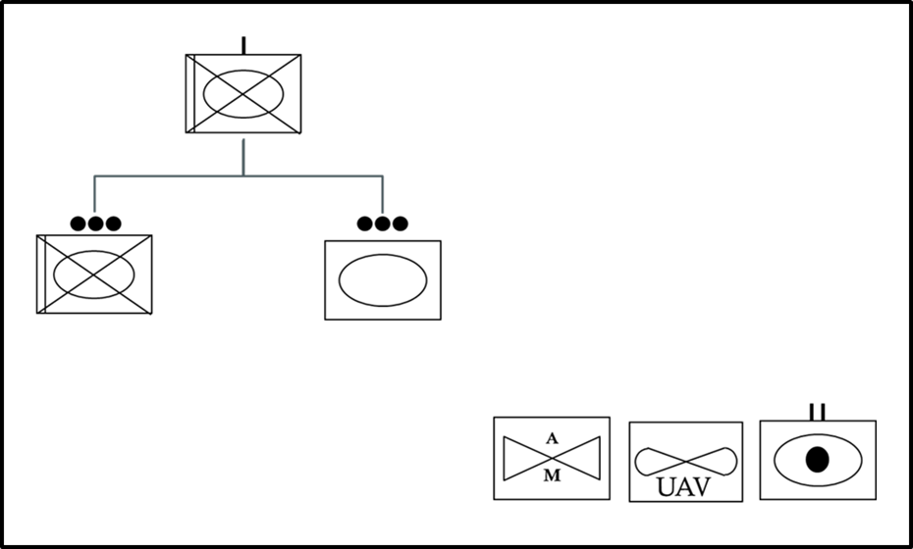

Initial order of battle

### 3. Initial Force Disposition

The OV-1 (Figure X) shows the relative initial disposition of Blue force. The Blue force line of attack is shown as the blue arrow running from North to South; 2-way voice and data communication linkages from Blue force elements to HQ (yellow bolts) and Blue - Red tactical engagements (red lines). Objective 1 for Blue force is at the southern extreme of the battle area.

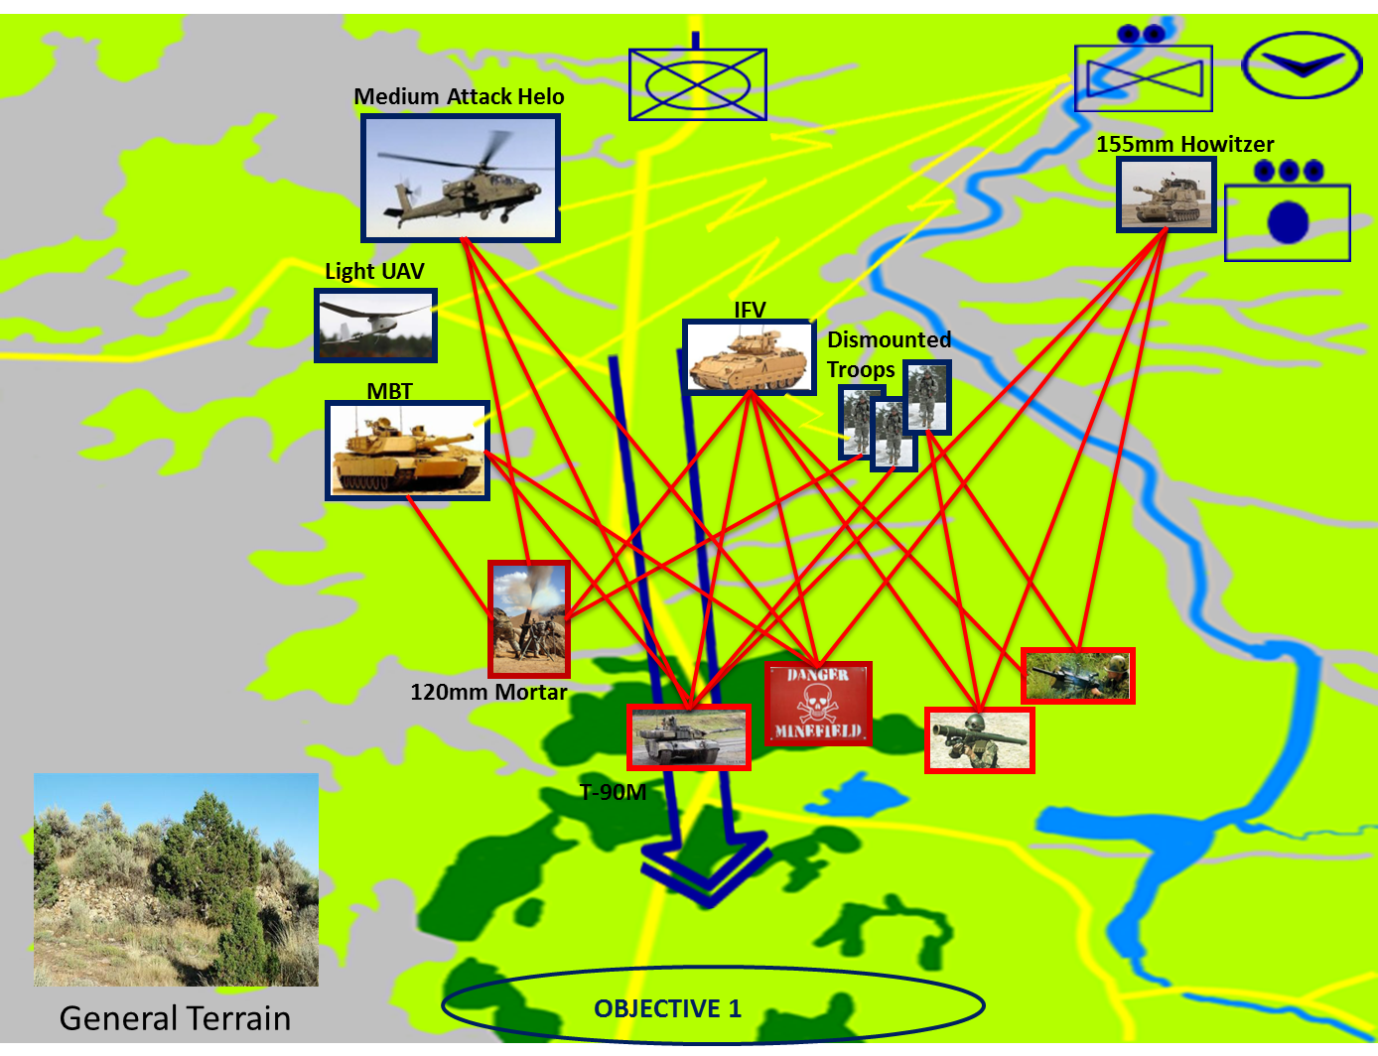

OV-1 Initial force disposition (after Treml)

### 4. Terrain and Red Force Composition and Disposition

The topography as defined by the TRAC MLS2 Scenario is a hilly/rugged area in a temperate climate with a mix of field and forest. [NEED CITATION] This terrain, while playing to the mechanized infantry in many respects, also supports light infantry defenders with advanced weapons such as MANPADS, heavy mortars, and heavy armor support.

The terrain, as modeled within MANA, is a 30 kilometers width and 40 kilometers depth. It is challenging with cover for infantry as well as wide-open areas conducive to employment of long range weapons. The blend of various terrains provides for high speed movement for combat vehicles and cover and possibilities for fighting positions. It provides mechanized forces the ability to move at high speed from north to south from generally open fields and rolling terrain to forests in the south. The southern extent of the operation area is modeled as dense vegetation with high a concealment factor and a medium cover factor. This terrain restricts sensor detection rates for agents and because of narrow canyons, vehicles have only limited access. This terrain provides excellent cover and concealment for defenders. The southern reaches are utilized by the Red forces to increase their effective combat strength.

The Red force defensive positions are shown in Figure X. Red forces using surprise, attack the Blue forces from fortified concealed positions at close range. Their objective is to inflict as many casualties as possible on the Blue force and stop or slow the Blue force attack speed. (Treml)

A detachment of Red infantry (infantry group 1) has the advantage of emplaced IEDs to fortify northern position during the initial phase of the defense. When the Blue force reaches the southernmost minefield, Red infantry (infantry group 2) will attack with 60-mm mortars, Milan anti-tank missiles, and indirect fire support from the 120-mm mortar section. While the infantry and mortar have the Blue force pinned, the T90-M tank platoon will move forward and counterattack to destroy Blue forces. A SA-18 Surface-to-Air Missile (SAM) team will provide single layer air defense.

Infantry group 3 will be dug in at the southernmost point along the corridor of the Blue advance. They will intercept and engage any surviving Blue force elements that break through the ambush position with light arms. Red company headquarters (HQ) will coordinate fire requests and provide battlefield information.

All forces will fight out of prepared defensive positions and will use the advantage of surprise. The intention is to inflict as many casualties as possible and defend successfully against Blue forces. (Treml)

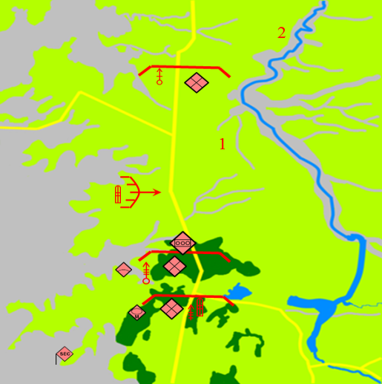

Red force defensive positions (from (Treml))

Red force equipment, capabilities and disposition generally follow the U.S. Army OPFOR Guide (FM 7– 100.4 OPFOR Opposing Force Organization Guide, 2007)

## D. Measures of Effectiveness and Measures of suitability

A Measure of Effectiveness is, “A measure used to quantify the performance of a system, product or process in terms that describe a measure to what degree the real objective is achieved.” (International Council on Systems Engineering, 2011) [NEED Pg#] Noting that the model and simulations are representations of the system of interest combined arms maneuver company with air support, the following have been established as Measures of Effectiveness; 1) Mission Completion/Success which is defined as at least one main battle tank reaching objective 1 in (O) 100% of the simulation trial runs, 2) Number of Vehicles dead lined (rendered non-mission capable) as a Less is Better measure with (O) = 0 in 100% of the simulation trial runs, 3) Elapsed time to complete successful mission with (T) = 14 hours or less, and 4) Force Exchange Ratio (FER) defined as (Blue losses/Total Blue)/(Red losses/Total Red) which is a Less is Better measure [NEED CITATION]. Vehicle survivability is a point of emphasis but the FER must be kept in mind as the baseline scenario for the combined arms company has only four blue infantry sections. Furthermore, the basic assumption is made that a platform’s crew does not survive when their vehicle is dead-lined during a simulation run.

The system Measures of Suitability/Performance (MOS/MOP) decompose (or support) the overall System Measures of Effectiveness. The model and simulation program chosen provide a variety of outputs that permit deeper examination of system design parameter choice effects and comparing performance between tested (simulated) system configurations. The first and second MOPs are related to MOEs # 1 & # 2, they are 1) average number of main battle tanks operational at the end of the simulation, and 2) average number of infantry fighting vehicles operational at the end of the simulation. MOP # 3 is the average number of model steps at run completion. The final MOP is related to the last MOE and is the ratio of dismount blue forces lost to the crew blue forces lost. This can give insight to the balance of the effects between ground combat system design parameters and indirect fire factors such as air and artillery support.

# IV. Systems Architecture

Phase 2 of the process required the development of a system of systems (SoS) architecture. A system of systems is viewed within the Office of the Secretary of Defense (OSD) as a “set or arrangement of systems that results when independent and useful systems are integrated into a larger system that delivers unique capabilities.” (Systems Engineering Guide for Systems of Systems, 2008) [NEED Pg#] With the vast number of definitions of system of systems and the scope to identify all the integration elements, the choices made to limit the scope to the interdependencies and relationships that are directly impacted by the identified parameters. Therefore, secondary and tertiary effects of the interdependencies such as fuel economy, reliability or sustainment were not investigated. Process as defined however includes many of those elements are identified. This broader scope of functions is included in the process to facilitate follow on work which could incorporate those factors.

During Phase 2, the System Architecture Phase, appropriate system functionality was identified and mapped to the operational activities and performers. When system functions were then delete linked directly back to the operational scenario and unit being studied. The architecture is based upon a functional architecture developed by the Tank Automotive Research Development and Engineering Center (TARDEC) Systems Engineering Group (SEG) and being leveraged by current ground system program managers [NEED CITATION]. The original function set spanned 178 system functions. Many of the elements however were deemed to be outside the scope of this project. In order to scope down the functions list the systems critical to the four main capabilities of interest, mobility, lethality, situational awareness and protection were identified. The level of fidelity for analysis was then determined and functions that were at too low of a level were eliminated. One of the functions, for example, that was deemed to be relevant was “manage signatures.” However, specific signatures such as thermal, infrared and visual were removed as being too low to be relevant in this study. This effort narrowed the list to 67 functions deemed to be relevant to the question at hand.

The final specific areas of interest that have the greatest impact and differentiation on the combat system were identified by leveraging a report developed by the Program Manager (PM) Ground Combat Vehicle (GCV). PM-GCV developed the Whole Systems Trades Analysis Toolset (WSTAT). WSTAT is a “decision support tool that integrates otherwise separate subsystem models into a holistic system view mapping critical design choices to consequences relevant to stakeholders.” (Davis, 2012) [NEED Pg#] This report provided a summary of system functions and specifically those that provided the most differentiation in performance between solution options. Figure X depicts the final set of 19 functions that the team focused on. INPUT PROCESS FROM WSTAT REPORT ONCE OPSEC’d

PLACEHOLDER, MUST OPSEC FIRST

The final 19 functions were used to develop the functional hierarchy, identify the function to function relationships, the function to physical relationships and the physical hierarchy. “[I]n an SoS, it is important to identify the critical set of systems that affect the SoS capability objectives and understand their interrelationships.” (Systems Engineering Guide for Systems of Systems, 2008) [NEED Pg#] The function to function relationships provided insight to identify the dependencies between given system function that need to be managed and considered when working to achieve an overall capability. The dependencies were created with the help of SMEs from the given system area, as well as those with operational experience. Figure X depicts those relationships.

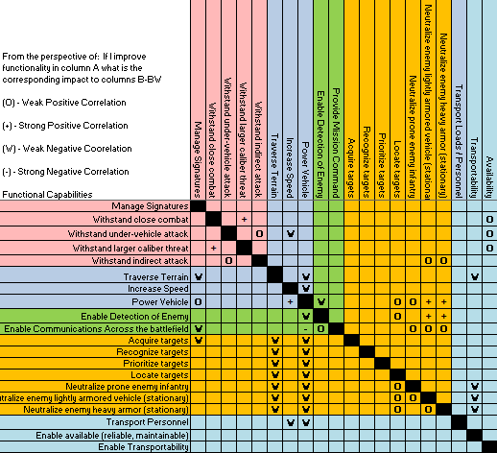

Function to function relationship matrix [from NEED CITATION]

Given the prospect of the functionality on the left being improved, the relationship to the corresponding functionality was identified as either weak or strong and positive or negative. This set the basis to identify the dependencies for the secondary and teriatry effects that an improvement or alteration would have on the overall SoS. Although these initial dependencies have been identified, it is necessary that the specific equations for each of these correlations be deteremined. That is recommended follow-on work.

Once the logical architecture had been laid out, the team was able to identify the key physical components of the SoS. The physical hierarchy was developed from a SoS perspective, the team leveraged the required capabilities, system functions and mission scenario to derive the top level components. Once the hierarchy was in place a relationship matrix was created. As shown in Figure X, the matrix identified which components were utilized to satisfy the given function. This allowed the team to analyze which components had the greatest breadth of impact on the functions. Additionally, it allowed the team to prioritize the components for potential materiel changes, based upon functional impacts.

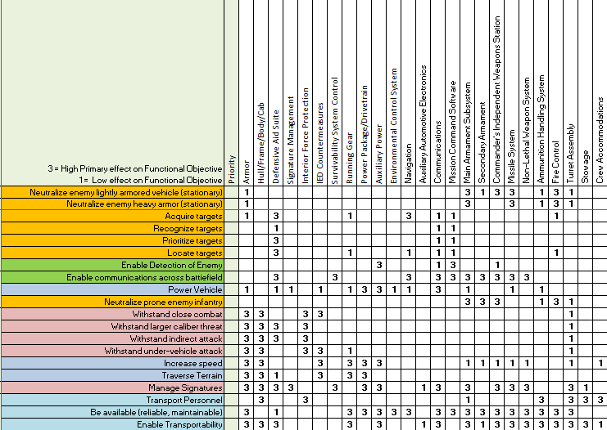

Function to physical relationship matrix [from NEED CITATION]

By implementing this process the team was able to look at a specific design aspect within a given system or system of systems and implement a change to see how the outcome rolls up to impact the overall Survivability MOEs of the unit.

THESE PARAGRAPHS ARE CURRENLY UNFINISHED

## A. Functional decomposition

## B. physical decomposition

# V. Systems Analysis

The third phase, or the System Analysis Phase, will provide the meat of the system analysis work to be done. During this phase the team will gather the necessary data based on the specified systems and MOPs from the previous stages, to layout a design of experiments like approach to identify the top few (likely between two and five) characteristics are that play a role in the variation of operational survivability within the context of the example missions chosen for modeling and the operational tasks associated with those missions. This will narrow down the evaluation from a large number of factors by weeding out those elements, based on the system and mission, which have very little impact on the overall MOEs. This analysis contributes to the notion of designating Key Technical Performance Measures (KTPMs) that permit high level designers to span large portions of the trade space by adjusting relatively few of the ground systems integrated elements or their performance parameters. For the purposes of this report, some of the factors will be omitted from consideration due to the restriction of only considering unclassified data as possible architectural and simulation model inputs. Where phases one and two define the decisions to be made in the development of the methodology and example architectures, phase three results will provide insight into the variability in and range of operational effectiveness that can be expected. Different specific instantiated solutions that satisfy the functional and performance requirements to varying degrees and with different trade off considerations are substituted into and out of the models to stress the scenario’s baseline architecture. Once those areas have been identified the team will work to gather data and identify additional alternate configurations, both materiel and non materiel, which would further exercise those elements.

# VI. Model Development

During this phase of the process a culmination of the information and data determined from the initial phases will be used to structure and build the models. The models will utilize the capabilities, systems, relationships, and variables of both enemy and friendly forces. The model(s) to be executed will analyze a single company against enemy forces in the terrain (environment, climate, obstacles, routes, climate, etc.) that is defined by the operational scenario. Both a Combined Arms Maneuver (CAM) scenario and a Wide Area Security (WAS) scenario will be evaluated. A CAM’s objective is to compel the enemy to respond to friendly action while a WAS’s objective is to retain the initiative by improving civil conditions and applying combat power to prevent the situation from deteriorating. These underlying objectives will help to shape the models, ultimately providing pertinent survivability data from opposite ends of the spectrum and fostering effective decision making. Other items that will be employed to define the models are TRADOC standard operational scenarios and stakeholder(s) input. TRADOC operational scenarios will immensely help in defining variables such as; mission(s), the enemy, terrain, and the troops/unit. As stated earlier, stakeholder(s) input will help to shape the entities relevant to the operational scenario, from which the model will be derived. A key element of this modeling process will be to identify the interactions and relative relationships between and within systems, because the data itself will not be completely accurate due to security reasons. However, the ability to take a model and identify which relationships need to be measured and evaluated and the type of system data that is required to make an accurate model, will allow follow on efforts, For Official Use Only (FOUO) or Classified, to alter the model to meet those standards, without the need to reinvent the wheel.

# VII. Model Execution

Finally, phase five of this initial effort will be Model Execution. This phase includes the actual running of the model, identification of the a baseline and baseline results, and integrating system improvements and use case variations to evaluate the effects on the overall survivability of the unit. This will allow the team to analyze what are the key areas of design and which system qualities attribute most greatly to the overall survivability of the unit, thereby providing the most likely trade space to work within.

A model will be developed with a simulation program to analyze the mission survivability based upon the provided data. This will allow for a baseline to be set for each of the scenarios, utilizing a common unit, and then alternative configurations will be introduced to identify the overall impact to survivability, force protection, operational success and cost. This beta model will be utilized to deliver indications and trends, but not specific solutions or recommendations.

Finally, an analysis of alternatives will be completed to identify the current capabilities and tools that exist to implement this process for a more user friendly interface as well as to recommend the path forward for follow-on efforts

## A. Analysis Tools

Several tools were used in both the analysis of the data produced by the models and in the design of experiments. The nearly orthogonal Latin hypercube (NOLH) methodology was applied to reduce the number of comparisons required in order to obtain results while still maintaining statistical integrity. (Hernandez, 2008)[NEED Pg#]

Statistical methodologies were applied to the data in order to discern patterns. Specifically, SAS Corporation’s JMP software package was utilized for the statistical analysis. According to the SAS corporate website JMP is, “…desktop statistical discovery software from SAS built with scientists and engineers in mind.” (SAS Institute Inc, 2013)[NEED Pg#] The JMP software was used extensively to assist in the interpretation of the large amounts of data obtained as a result of our model runs. The software's capabilities for exploratory data analysis combined with similar capabilities for statistical modeling and predictive analytics was leveraged to achieve a better understanding of the data. Several statistical methodologies were used including principal component analysis, a multivariate method, to help identify the factors of greatest influence in our desired outcome. Also used heavily were categorical analysis, multivariate analysis of variance (Fit MANOVA), and the fit model platform.

Principal component analysis provided the focus on the most important factors, those most affecting the outcomes. The tool simultaneously considers, “a small number of independent linear combinations (principal components) of a set of variables that capture as much of the variability in the original variables as possible.” (SAS Institute Inc., 2013)

Back of the envelope (BoE) calculations utilized Microsoft’s Excel for tabulating experimental model results, recording and distributing design of experiment (DoE) data, and for managing correlation matrices proved extremely useful. Easily integrated with the primary statistical analysis tool, JMP, Excel provided a distribution and collection point for both DoE data and model results, allowing quick and easy tabulations of basic success and failure summaries. It also had the benefit of being readily accessible and provided no additional burden to the learning curve.

Map Aware Non-uniform Automata (MANA) is an agent-based simulation tool capable of carrying out complex experiments in compressed time. The Operations Analysis group at Defence Technology Agency in New Zealand developed it as a flexible platform for quickly and easily modeling complex behavior among autonomous agents. (McIntosh, Galligan, Anderson, & Lauren, 2007) This type of modeling is particularly well suited to capturing the behavior, interaction, and performance of military vehicles and warfighters in simulated combat. [NEED CITATION] Parameters for each agent, in this case individual vehicle platforms and infantry, can be adjusted and the outcome measured for changes in effectiveness. For example, the maximum effective range for a primary weapon on a main battle tank (MBT) can be adjusted and the results recorded. This allowed us to make many such adjustments over multiple runs to determine the most critical parameters to squad success.

Agent-based modeling is a distinctly different approach to traditional centralized modeling. (McIntosh, Galligan, Anderson, & Lauren, 2007) Traditional modeling methodologies rely on a central engine which continually calculates and determines the behaviors, actions, and effects for all of the constituent model pieces, simultaneously. [NEED CITATION] In agent-based modeling, the disposition and capabilities of individual model actors (automata) is determined in advance and the actions influenced by the disposition and enabled through the capabilities is calculated and carried out by each actor. [NEED CITATION] In this way, MANA very accurately represents the type of system of systems that we are modeling.

MANA allows multiple runs to be set up and data to be captured, providing the basis for our statistical analysis in JMP. The resultant comma separated value (CSV) files were imported into Microsoft Excel, cleaned up, and some additional calculations were performed (e.g., force effectiveness value, or FEV). The cleaned up data was then imported into JMP for further analysis.

## A. Modeling and Simulation

### 1. Design of Experiments Planning

#### a. Model Data References and Definitions

#### b. Factor Levels and Probability Distributions

#### c. Probability Model

#### d. Factorial Design

#### e. OMOE for Cost As Independent Variable

## B. Simulations

### 1. Approach and Process

#### a. Back of the Envelope Informal Approaches

#### b. Formal Model Approaches

#### c. Process

#### d. Resources

### 2. Variables and Factors.

#### a. Variables of Interest

#### b. Inputs and Outputs

#### c. Noise Factors

### 3. Factors not considered

Due to the limitations of the tool, some important elements of an operational engagement were not considered such as:

Operational Variables (PMESII-TC)

* Political
* Military
* Economic
* Social
* Information
* Infrastructure
* Physical Environment

The modeling tool used, MANA, is not the only tool available. Other tools have the capability to allow for implementation of the various operational variables noted previously. However, due to both time and the lack of availability MANA and its basic capabilities were implemented to provide the basis for the analysis.

# VIII. Results

### 1. Regression Analysis and CAIV Results

### 2. Baseline Analysis

### 3. Alternative Configuration Analysis

# XI. Summary and Recommendations

## A. Challenges

The lack of higher power tools and assistance reiterates the necessity of the process as the foundation for this type of work. The process as stated can be followed using different tools to achieve a higher fidelity model. Process outlined in this thesis identifies the type of data and steps required to achieve an outcome, and it does not dictate tools to use.

## B. Follow-on Work

## C. Recommendations

# Appendix A: Reference Models for Simulations

# Appendix B: Simulation Output Data

THIS PAGE INTENTIONALLY LEFT BLANK

# LIST OF REFERENCES

*FM 3-21.31 The Stryker Brigade Combat Team.* (2003). Washington DC, USA: US Army Infantry School, Department of the Army.

(2008). *Systems Engineering Guide for Systems of Systems.* Office of the Under Secretary of Defense, Office of the Under Secretary of Defense (Acquisition and Technology). Washington DC: Director, Systems and Software Engineering, Office of the Secretary of Defense.

(2010). *TRADOC Pam 525-3-1 THE ARMY OPERATING CONCEPT.* United States Army Training adn Doctrine Command. Fort Monroe VA: U. S. Army Training and Doctrine Command, Department of the Army.

(2012). *ADRP 3-0 Unified Land Operations.* Washington DC: Headquarters, Department of the Army. Retrieved January 11, 2013

(2013). *Army Equipment Modernization Strategy.* Future Force Division (FDF). Washington DC: Department of the Army Office of the Deputy Chief of Staff, G-8 Future Force Division (FDF).

Blanchard, B., & Fabrycky, W. (2011). *Systems Engineering and Analysis* (5th ed.). Upper Saddle River, New Jersey, USA: Prentice-Hall. Retrieved 2012

Cairnes, W. E. (Ed.). (2004). *Napoleon's Military Maxims* (Vol. 1). (G. C. D'Aguulier, Trans.) Mineola, NY, USA: Dover Publishing.

Haulman, D. D. (2002). *NO CONTEST: AERIAL COMBAT IN THE 1990s.* Maxwell AFB, AL: U. S. Air Force Historical Research Agency.

Hernandez, A. S. (2008). *Breaking barriers to design dimensions in nearly orthogonal Latin hypercubes.* Monterey California: Naval Postgraduate School. Retrieved April 1, 2013, from http://www.dtic.mil/cgi-bin/GetTRDoc?AD=ADA494168

Kelly, T. K., Landree, E., Peters, J. E., Steeb, R., Moore, L. R., & Martin, A. (2011). *The U.S. Combat and Tactical Wheeled Vehicle Fleets.* National Defense Research Institute,. Arlington VA: RAND Corporation.

Kempinski, B., & Murphy, C. (2012, November). Technical Challenges of the U.S. Army’s Ground Combat Vehicle Program. *Working Paper Series Congressional Budget Office*, 64.

Mait, J. N., & Kugler, R. L. (2004, July). Alternative Approaches to Army Transformation. *Defense Horizons*, p. 9.

McIntosh, G. C., Galligan, D. P., Anderson, M. A., & Lauren, M. K. (2007). Recent Developments in the MANA Agent-based Model. *Scythe - Workshop 13* (pp. 38-39). Singapore: International Data Farming Community. Retrieved April 1, 2003, from http://harvest.nps.edu/scythe/Issue1/scythe_1_1.pdf

Molitoris, H., & Hicks, D. (2009, August). System Engineering approach to assessing Integrated Survivability. Warren, MI, USA: US Army RDECOM-TARDEC.

Pederson, R. B. (1998). *A Study of Combined Arms Warfare by Alexander the Great.* Fort Leavenworth, KS: U.S. Army Command and General Staff College. Retrieved February 3, 2013, from http://www.dtic.mil/dtic/tr/fulltext/u2/a350056.pdf

SAS Institute Inc. (2013, April 1). *JMP*. Retrieved April 1, 2013, from JMP statistical discovery from SAS: http://www.jmp.com/

SAS Institute Inc. (2013, April 1). *capabilities index-principal components*. Retrieved April 1, 2013, from JMP: http://www.jmp.com/capabilities/Principal_Components.shtml

Treml, T. (n.d.). New Approach for the Development of Specifications for a Future Ground Combat Vehicle. Monterey, CA, USA: Naval Postgraduate School.

THIS PAGE INTENTIONALLY LEFT BLANK

# INITIAL DISTRIBUTION LIST

1. Defense Technical Information Center

Ft. Belvoir, Virginia

1. Dudley Knox Library

Naval Postgraduate School

Monterey, California

1. Name of Addressee

Organization of Addressee

City, State

1. Name of Addressee

Organization of Addressee

City, State

1. Name of Addressee

Organization of Addressee

City, State

1. Name of Addressee

Organization of Addressee

City, State

1. Name of Addressee

Organization of Addressee

City, State

**Marine Distribution List can be found on our website.