IRP 2

Did the design team follow its own process?

Based on an inspection and mapping of the ADNS Master Schedule contained in the ADNS Increment III Critical Design Review dated 7 MAR 2007 to the ADNS Systems Engineering Plan (version 3.0) dated SEP 2008 and corroborated by the CDRL Status Report, we conclude that design team followed its own process.

The basic development process follows the classic “V” model.

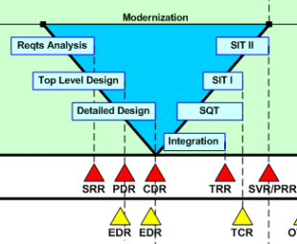

The specified process begins with requirements analysis and a system requirements review (SRR) followed by top-level design and preliminary design review (PDR), detained design and critical design review (CDR), integration and test readiness review (TRR), software qualification test (SQT), and system integration tests (SIT I & II).

The evolutionary acquisition process is supported by an incremental development and release schedule.

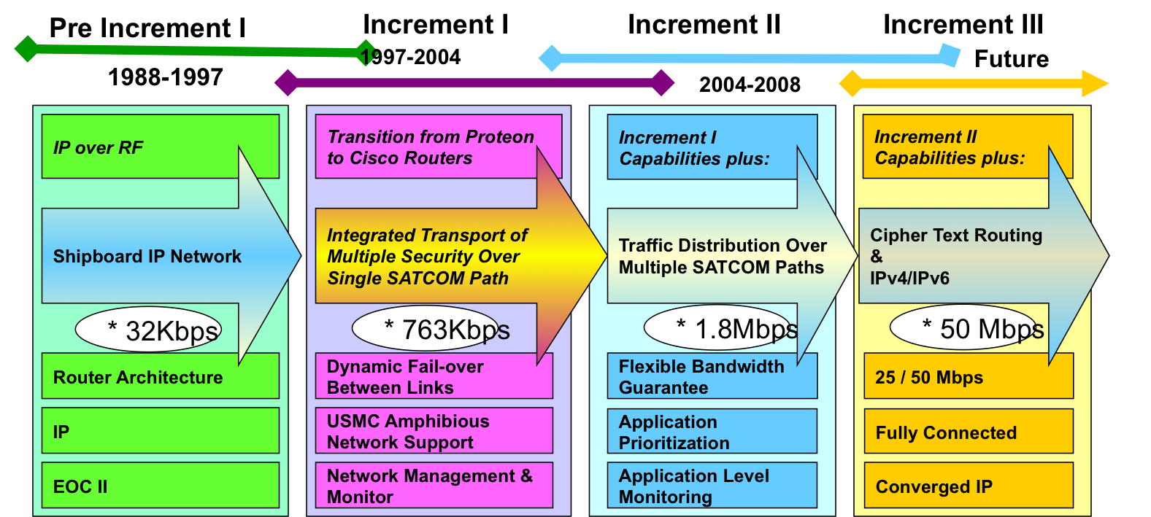

Mapping this release schedule to the ADNS Master Schedule contained in the ADNS Increment III Critical Design Review reveals a high degree of adherence and correlation between the specified and executed processes.

Looking through the ADNS Master Schedule under Engineering we find the following activities:

1. Requirements analysis (e.g., lines 32, 43, & 54)
2. Various system design line items (e.g., lines 55 & 56 mechanical and electrical design)
3. Integration (e.g., line 74)
4. Software test report (e.g., line 75)
5. System integration and testing (e.g., line 110)

The CDRL Status report also corroborates the process with the following items:

1. Preliminary design review (0007-ADNS-A004-CM-PDR-001)
2. Critical design review (0007-ADNS-A005-CA-CDR-001)
3. Software test report (0007-ADNS-A007-STR-001)

The high degree of adherence between the specified and executed processes demonstrates sufficiently that the design team followed its own process.