Module 4 Assignment

Steve Mazza

# Worst Interface Ever?

The Motorola RAZR (not to name names) was a member of the last generation of “dumb” flip-phones. It was outfitted with a number of physical buttons to control the phone’s activities. Among those were a rocker and a selector (momentary push button) located along the left side edge. Remarkably, the selector cycled through volume levels while the rocker (much better suited to that task) was used to affect two different settings depending on which pay it was pressed. Abysmal! They eventually fixed this with a firmware update. Characteristic of phones of that era, and motivated by consumer pressure to pack additional functionality into the devices, the performance of many activities required traversing several levels of nested menus which, for us lesser mortals, mandated trips back to the well-worn User Manual. Unacceptable! Lastly, it was impossible to store more than one phone number with any given contact, leaving you with duplicate entries that looked like “Mom home” and “Mom cell” and “Mom work.” WTF?!? <- Worthless Tele Phone ☺

# Great User Interfaces

The hallmarks of great user interfaces are evident in some consumer goods but not as pervasive as one might suspect. Let’s investigate what makes a great interface. It should:

* Present as obvious the intended purpose of the item (or software)
* Make most accessible the functionality that is most likely to be performed
* Hide complexity behind natural actions
* Require no specialized skills or knowledge to operate effectively
* Fit comfortably into the user’s environment and physiognomy

I find very few items that check all of these boxes. But one standout is the Apogee Duet, an external sound card and digital-to-analog converter for my MacBook Pro. 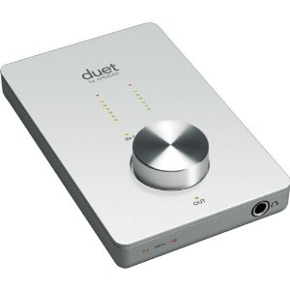While the Apogee Duet is capable of handling a fair amount of complexity (multiple line-in and microphone inputs as well as multiple analog and MIDI outputs), it hides all of this complexity behind a sophisticated layer that automatically detects and switches inputs and outputs based on where it detects a signal. Very smart, since I don’t need to even think about it. The only interface item that it presents is a large round knob on the surface of the device that controls volume. Well… it’s a sound card, after all.