1. True or False (7 points): Circle or Underline T or F

T F If a System passes all the Development Tests and meets all the Technical Specifications, then it cannot fail the Operational Test

T F Initial concept and requirement documents can provide the initial basis for planning a T&E program.

T F Tactics are usually developed as part of the later phases of Development Test and Evaluation

T F The MOE's used in the Analysis of Alternative(AOA) should NOT be used as Test Program MOE's

T F We can determine if two systems are significantly different by using the t-statistic and a hypothesis test.

T F The Consumers Risk (B) is a defined as a Type II error and occurs when we accept the Null Hypothesis (Ho), when in fact it is false. i.e. we accept bad articles.

T F Pre-Trial runs should never be conducted because of player learning effects

2. With regards to the t-statistic parameters (1-sided Specification Guarantee, Mean of Data, Sample Variance, and Sample Size). Circle or Underline T or F: ( 1 point each, total 4 pts)

T F As (n) approaches 30, the t-distribution approaches the f-distribution

T F Holding other parameters constant, an increase in sample variance (data scatter) will increase the confidence level.

T F Holding other parameters constant, an increase in difference between the sample mean and Specification Guarantee will increase the confidence level.

T F Holding other parameters constant, an increase in sample size will increase the confidence level.

Multiple Choice: (2 points each) Circle or Underline BEST Answer e.g. a. JCIDS Process

3. Which one of the following is not a criteria for determining Critical Operational Issues for OTE:
a. Relevance
b. Cost
c. Importance
d. Risk

- Which one of the following statements is FALSE about the Scope of System Requirements:

a. Defines what the system is to do
b. Defines desired system requirements and constraints
c. Defines specific designs and solutions
d. Defines system products and processes

5. To determine whether to test to a high confidence level, which of the following would not be a significant consideration:

a. Safety of Test
b. Criticality of the Issue
c. Cost of tests
d. Contractual Incentive
e. All are important considerations for confidence level determination

6. Which of the following statements about Technical Performance Measurement is False:
a. It measures differences between Achieved and Allocated Values
b. It only tracks Critical Parameters
c. It should not forecast values to be achieved at completion
d. It is a product design assessment tool

7. Which of the following statements is NOT a current DOD Testing policy?

a. T&E should be commenced as early as possible
b. Decisions to commit resources for programs should be based on successful completion of T&E
c. Combined DT/OT should be avoided whenever possible.
d. Combining Operational Testing and Training is encouraged.

8. The Power of the Test (1-B) refers to:
- Probability of rejecting a good product
- Probability of accepting a good product
- Probability of rejecting a bad product
- Probability of accepting a bad product

9. Which of the following is not a Safety Hazard Category:
a. Marginal
b. Severe
c. Critical
d. Catastrophic

10. When supply support is limited or non-representitive, OT&E will measure:
a. Operational Availability (Ao)
b. Inherent Availability (Ai)
c. Achieved Availability (Aa)
d. Administrative Logisitics Downtime

11. (11 Pts) Indicate whether each phrase is a COI, MOE, MOP, DE (Data Element), OBJ (Objective), or C (Criteria) after each statement. e.g. ……..COI

- To Determine the Survivability of the Infantry Fighting Vehicle………..
- Outside Air Temperature…………………………………………………
- Transportability and Reliability…………………………………………..
- Is the Mobility of the SPAW satisfactory for the Attack Mission?...........
- 2000 lbs or less……………………………………………………………
- P(kill) (Probability of Kill)……………………………………………….
- Percent of Operators judging controls to be satisfactory…………………
- Mean Time Between Critical Operational Failure (MTBCOF)………….
- Fording Capability………………………………………………………..
- To Assess small boat handling qualities………………………………….
- Is the ship survivability satisfactory for the self-defense mission? ……..

12. (6 pts) What are the three major elements of Combat Effectiveness?
1. Personnel

2. Equipment

3. Training

13. (6 pts) What is the difference between Operational Effectiveness and Operational Suitability?

Operational effectiveness is the overall degree of mission accomplishment of a system when used by typical users in a realistic environment.

Operational suitability is the degree to which a system can be placed satisfactorily in field use with consideration given to availability, compatibility, transportability, interoperability, reliability, maintainability, safety, supportability, training, etc.

14. (6 pts) What is the difference between Interoperability and Compatibility?

Interoperability refers to how a system under test behaves when interacting with other systems.

Compatibility refers to how a system under test behaves within a particular environment.

15. (4 pts) List four MANPRINT Domains.

1. Manpower
2. Training
3. System Safety
4. Soldier Survivability

16. (4 Pts) Circle or Underline either OTE or DTE as appropriate.

OTE DTE Tests are conducted in an uncontrolled environment and are generally not repeatable

OTE DTE Employs technical criteria for evaluation such as signal strength and rate of climb

OTE DTE Tests are structured to hold many parameters constant while measuring one or two others.

OTE DTE Testing is accomplished by typically the same type of personnel expected to use and maintain the system in the field or fleet

17. (4 pts) Suppose we wish to estimate the Reduction in Lethality (RIL) of an aircraft jamming pod. Test runs are conducted on an instrumented range against a ground based SAM simulator. The jammer is scored in terms of its capability to successfully cause missiles fired at the aircraft to miss beyond their lethal range. The trial results for the jammer are shown in the matrix below. What is the Reduction in Lethality?

Data | Dry (Jamming off) | Wet (Jamming on)
Hits | 12 | 6
Misses | 24 | 19

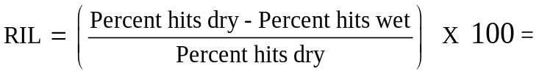

((12 / (12 + 24)) – 6 / (6 + 19)) / (12 / (12 + 24)) x 100 = 28

18. (6 pts) Estimating sample size using Military Significant Difference. Suppose we are buying a new system that is designed to have an infrared detection range of 14.2 km or more. If the actual infrared detection range is less than 11.2 km, the effectiveness of the system would not support mission requirements. During testing we are willing to accept a probability of a Type 1 error (α) of 0.10, but we want to have a 0.975 probability of detecting a “bad” system. Prior test results indicate that the standard deviation of the detection ranges is normally distributed and should be about 2.8 km.

How many trials (n) do you estimate will be required to meet this criteria?

Zα =

Z_{β} =

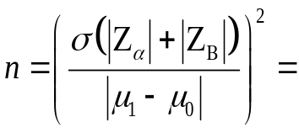

19. (10 Points) An operational requirement stated that a Marine Howitzer must be able to be positioned and set up ready for fire by the crew in 8 minutes or less. Four tests were run resulting in the following data: 8.5 min, 6.9 min, 7.2 min, and 7.8 min.

a. Assuming an unknown population variance, What was the resulting confidence that the requirement had been met? (t-table last page)

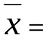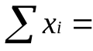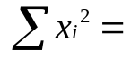

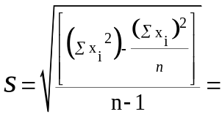

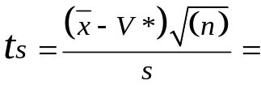

α = Percent Confidence =

20. (10 Points) The Defender Mobile Air Defense System was required to launch 4 missiles within 35 secs. The results of the preliminary trials are shown below. Given the same Mean and Standard Deviation, how many trials would be required to achieve a 95% confidence?
= 32.5 s = 4.2 α = n =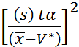

ν = tα = n =

ν = tα = n =

ν = tα = n =

ν = tα = n =

21. (6 pts) The following pairwise comparison was conducted between competing artillery systems using Radial Miss Distance as an MOP. Test the hypotheses that there is no statistical significant difference between the artillery systems at a 90% confidence level. Each Weapon System fired four rounds. Assuming pooled sample variances for degrees of freedom, would you accept or reject the hypothesis based on the following test results (radial miss distances and standard deviations):
Weapon System 1: 18, 19, 20, 15, with sx₁ = 2.16
Weapon System 2: 14, 16, 13, 15, with sx₂ = 1.29
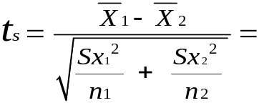
tα/2 =

Would you accept or reject the hypothesis?

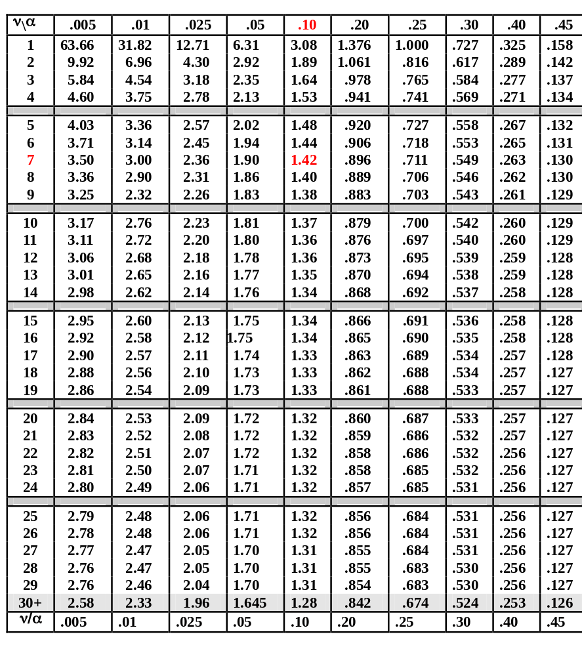
t-tables

