SE4150 Exam 1

This exam will assess your understanding of the material in Modules 1-4. It is composed of essay type questions (points indicated) and multiple choice (4 points each); for a total of 100 points.

1. What is the role of the system architect?
- Defines boundaries, goals, and functions; allocates functionality; creates concepts; defines interfaces and abstractions; delivers value.
- Manages risk; maps views; treats people-ware independently; engineers solutions.
- Assigns boundaries; allocates responsibilities; increases complexity.
- Manages project resources; allocates functionality; designs solutions.

2. What are the deliverables of the system architect?
- A set of system goals; a functional description of the system; a management plan for the implementation of the system.
- A concise and reasonable set of goals; a functional description of the system; a concept design; a description of operational implementation; a process for controlling interfaces for product form.
- A functional description of the system; a set of concept designs; a set of test and validation criteria.
- A set of requirements; a functional description of the system; a management plan for the system development; a risk management plan related to uncertainty in system development.

3. Which of the following does not characterize the relationship between system architecting and systems engineering?
- Architecting complements SE in dealing with immeasurables and structuring an unstructured problem.
- A good systems engineer will need to apply architecting skills throughout a development project.
- Architecting is a separate and distinct discipline with no direct relationship to engineering.
- Architects and engineers use similar models in design and analysis.

4. We talk about architecting in terms of progressive refinement because
- The problem itself becomes less ill-defined as we build models.
- Evaluation criteria and their relative importance can change over time.
- There is an increase in specificity and design detail as we proceed.
- All of the above.

5. Good functional modeling languages exhibit all of the following except which one?
- They support the concepts of abstraction or layers of drill-down.
- They can only be used to represent a hierarchical view of the system.
- They support context-level models for boundary and interface management.
- They are based on a set of intuitive graphical and textual representations.

6. Model-based systems engineering differs from “traditional” systems engineering in that it
- Uses models as the only tool in the specification, design, integration, validation and operation of a system.
- Uses models in a central role in the specification, design, integration, validation and operation of a system.
- Uses models as the only products of systems engineers and architects.
- Uses models primarily in comparing alternative architectures.

7. (20 points) Before the end of the next decade, NASA astronauts will again explore the surface of the moon. The current concept of operations is similar to the Apollo system; the key difference being that there are two launch vehicles: one for crew (up to 7 astronauts) and one for the lunar lander and equipment. A heavy-lift rocket blasts off, carrying a lunar lander and a "departure stage" needed to leave Earth's orbit. The crew launches separately, then docks their capsule with the lander and departure stage and heads for the moon. Three days later, the now-connected vehicles go into lunar orbit. The astronauts enter the lander, leaving their capsule waiting for them in orbit. After landing and exploring the surface, the crew blasts off in a portion of the lander, docks with the capsule and travels back to Earth (just like Apollo). Let us now consider the architecture of the lunar lander only (that smaller vehicle that drops out of lunar orbit, lands on the moon and returns to lunar orbit; not the other vehicles). Having talked with all of the relevant stakeholders and conducted a great deal of research, you start to refine the scope of the problem by identifying inputs and outputs. Complete the list of inputs and outputs

Inputs | Outputs
Passengers (lunar explorers) | Passengers returned from surface
Radio messages from earth | Radio messages to earth
Fuel | Emissions
Control (piloting/user) | Energy (thrust, heat, light)
Scientific samples & data | Scientific samples & data
8. (20 points) To further refine the boundaries and interfaces, please redraw the lunar lander system in problem #7 above as a system context diagram. This is the system’s one big function in its environment interacting with peer systems via input and output flow items; all labeled.

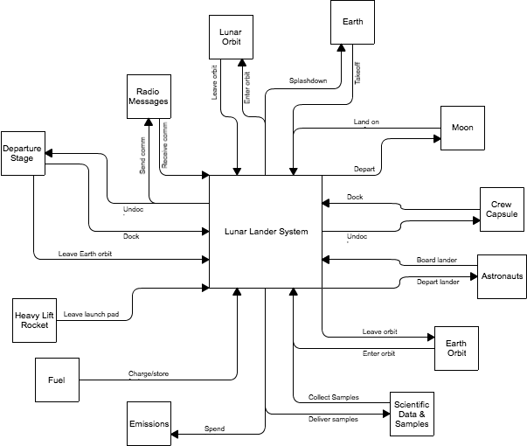
9. (30 points) In order to gain a better understanding of the requirements of a lunar lander system, you start creating a functional architecture. Sitting down with the Apollo veterans, astronauts, and astronomers from NASA, you solicit their input regarding the many different missions and functions that such a craft (that forms the primary materiel portion of the system) must be able to perform. They listed the following ideas (but they aren’t very well organized):
Navigate  Communicate  Pick up astronauts  Launch & recover moon-rover  Survive  Drop off cargo  Return lunar specimens  Move equipment  Drop astronauts off on moon  Secure cargo  Transport animals and plants for lunar experiments  Dispose of waste  Transport astronauts | Image lunar surface  Process satellite signals  Receive radio messages  Send radio messages  Provide life-support  Transport astronauts  Secure passengers  Survive damage  Launch from service module  Return to service module  Maintain interior atmosphere  Provide heat & cooling  Maneuver  Transport equipment

- Use at least four of the functions listed to illustrate how you can organize them in a functional flow diagram.

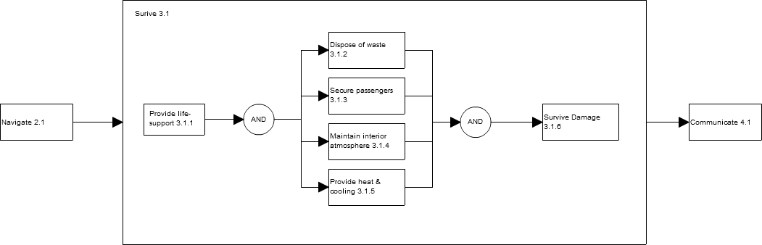

(b) Use at least four of the functions listed to illustrate how you can organize them in a functional hierarchy showing decomposition.

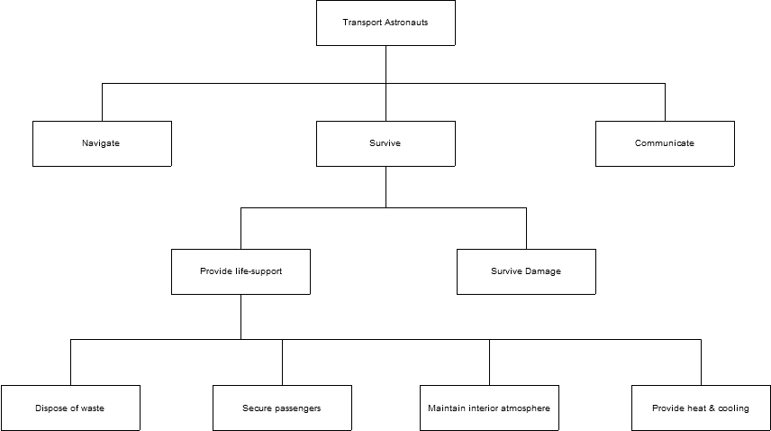
10. (6 points) What is your favorite part about the course so far? What is your least favorite? What are we doing well and what could we do better?

I believe that the lectures do a fantastic job of reinforcing and highlighting the reading. They are well organized and engaging, as well. The reading is taxing but worthwhile. While there is more reading in this class than in previous classes, you’ll get no complaint from me; this is grad school, after all.

There are relatively few small grades punctuated by some larger assessments, which means that there is little opportunity to compensate for less than stellar performance. A more even distribution of points would provide a relative safety net.

