Engineering Notebook
Steve Mazza

Concerns
1/28/2013
In addressing the system process improvement, the thrust of the developer's effort has been toward what appears to be architecture improvement. They are recommending the use of a graph database and citing performance issues as the basis. My concern is that if database performance is not the long pole in the tent then any amount of performance improvement will not yield the desired results for the customer. Granted, it is possible that the graph database may hold improvements for system and information integration. I don't know this to be the case, however, and don't recall hearing it specifically from the developers.
In general, the easy wins for improving the decision making process are likely to be a) the integration of information and systems, b) the processing and transfer of that information, and c) the effective representation of that information to the end user -- representation that facilitates the specific decision making process.
I don't feel like I actually know enough about the existing process (the process they are trying to improve) to make an assessment regarding how effectively (if at all) the above issues are being addressed. Caveat: it is possible that I have a sufficiently poor understanding of their effort and focus as to have completely missed the mark with any of my assumptions.
But, if I am not completely incorrect – or as a proposal for determining if I am incorrect – I propose the following clarifying question:
- What specific process improvements does the proposed graph database address? What are the metrics against which its success will be judged?
- What are the customer's overall process improvement goals? How are these proposed to be supported through the recommended architecture? By what metrics?
- What are the barriers or constrains to system process improvement that are beyond our control? These might look like infrastructure inadequacies or stop gaps to system integration (policy or otherwise).
- Has the end user been interviewed regarding their opinion (feedback) on the efficacy of the existing system? Often end users have insight that does not make its way back up to the program leads. Often in these cases the end user has found ways to work around system inadequacies.

Graph Database Performance Improvement
2/2/2013
In a study done at the University of Mississippi experimental results demonstrate that query times for unstructured non-numeric data are substantially faster in a NoSQL Graph database vs. similar queries in a traditional Relational Database Management System (RDBMS). The amount of increase in speed was heavily tied to the connectedness of the nodes in the graph database. Consequently, for shallow queries where interrelationships could be maintained isomorphic to a K-graph, the increases were an order of magnitude. For less connected queries, the increases were closer to a factor of 4.
For semi-structured queries on textual data where results are expected to extract from full-text search, the graph database demonstrated a shortened query time that scaled with size far better than the RDBMS. “At small scale, MySQL performed slightly better than Neo4j, but scaling upward dramatically shifted the search times in favor of Neo4j.”
In aggregate, in a large repository of random non-numeric semi-structured data and given a range of full-text queries to locate related information, the graph database should easily be expected to show at least a 20% improvement in query times.

Thoughts On EEAs
2/4/2013

Goal 1
How do we measure an improvement in effectiveness and success for the PACCOM decision makers’ process? Is success an all-or-nothing proposition or is it measured as a function of time or effort or correctness? What about effectiveness? Is a decision making process effective if it facilitates the right decision but does so in a time that renders the decision moot? What are the bounds on effectiveness with respect to time, manpower, effort, and other costs?

Question 1.1
I am assuming that the percent reduction in time refers to the decision makers’ process. Note: the inherent underlying technology that will result in a reduction in time is whatever is facilitated by the graph DB that would be otherwise impractical or impossible with a RDBMS (see previous entries). Any other improvements (reductions) in time are owed to the implementation of the technology and do not constitute an inherent quality, rather one owed to the general application of the system independent of the specifics (i.e., Ruby on Rails / Neo4j).

Metric 1.1.1
We will have to get very creative to show that a 20% reduction in the overall Acquire -> Assess -> Report process is due specifically to the selection of Ruby on Rails / Neo4j and not to its implementation (e.g., process improvements).

Question 1.2
Are we asking, “What is the benefit due to reduction in time to the COP/shared SA for all of the Pacific AOR?” Are we looking for an aggregate improvement?

Metric 1.2.1
Is this a function of the individual improvement at a single installation/ship? What does it look like? Is it likely to be linear or (more likely) logarithmic?

Question 1.3
Is this the same as asking, “What cannot be effective integrated?” If so, implicit in this is a buried question about Cognitive Load on the watch officers resulting from having to manually aggregate data from disparate sources.

Metric 1.3.1
Maybe we can cite the paper I found and summarized (above). Key: graph DB performance increases are optimized for unstructured non-numeric data which characterizes most of the sources that the customer needs to bring together.

Metric 1.3.2
This will follow directly from 1.3.1 if we can show that the data integration was a manual effort – or at least that it resulted in a manual effort.

Moving Forward With Modeling
2/6/2013
We could do a whole lot worse that to provide a very high level model of the process. Components might include disparate unstructured data sources, the Neo4j engine (lots of performance gains here), the end user (watch officer), some representation of additional sources not presented (aggregated) within the system, and an abstract reference to the Pacific AOR.
The Neo4j engine could be modeled alongside the previous RDBMS implementation using data from Vicknair.
The inherently good handling of unstructured data could be represented as a coefficient to the entire processing time if we could determine a rough measure of the cost (units???) due to Cognitive Load on the watch officer of manually referencing and aggregating external data.
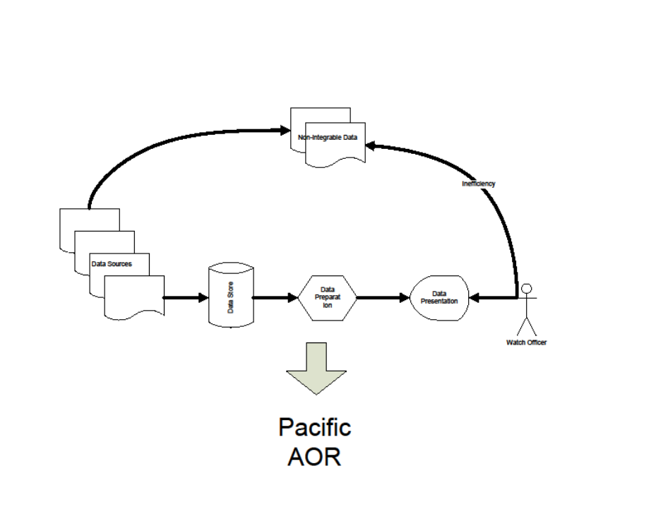

Forming a Model
2/7/2013

The domain over which the system can operate
There is some collection of data from which information is drawn and presented to the end user (watch officer). Some portion, I_{graphdb} can be integrated and indexed within the graph database. We are presuming that I_{graphdb} represents a larger subset of the total collection of data than I_{rdbms}. In either case, there is the balance of non-integrable data, I_{nonintegrable} that causes friction in the system by requiring the end user to reference it manually (outside of the integrated and indexed data feed).

The rate at which the system can operate over the domain
The inherent efficiency, E, in the processing of the integrable data would differ between the graph db (E_{graphdb}) and the RDBMS (E_{rdbms}) and would represent the processing time for some known set of records.

Cognitive Load
Based on the size of the collection of I_{nonintegrable} we can arrive at a coefficient of friction, K. I'm not sure if K represents a linear approximation or not (but I suspect so). At any rate, this coefficient represents the cognitive load on the end user which will have a large impact on the (perceived and real) overall performance of the system. Lower values of K are better.

Aggregation (extrapolation)
Benefit to the entire Pacific AOR is not going to be simply a sum of all the individual installation improvements. There is some loss inherent in rolling this up, so we'll have to play with this a bit but we might be able to represent this as some function f(N), where N is the number of installations in the Pacific AOR.

BoE Calculations
2/12/2013
We have begun our BoE calculations – at least the initial creation of the working relationships among some of the moving parts. A spreadsheet has been circulated that claims to fairly well nail down the Acquire portion of the data collection and processing task. I think that the calculations are more or less verifiable (i.e., correct) but possibly not valid. They address kbps throughput and data size and a number of other issues related to moving data around all of which has to be done regardless of the implementation of the data store (graph database vs rdbms). So my fear is that while the calculations look well thought out, they may be irrelevant as they don’t differentiate any of the advantages of the proposed architectural changes.
Another possible way to go would be to focus on what the graph database facilitates that the rdbms did not. See my quick-and-dirty diagram above. The portion of documents that the graph can effectively handle among all documents necessary to supply critical decision making information would ideally be larger than the similar portion of documents that the rdbms can handle. And this will have the effect of consolidating and indexing relevant documents for later retrieval and reference, thus reducing the manual processing by the watch officer during his decision making process.

“Key Man” Risk
2/16/2013
There is a nontrivial project risk due to Christy’s impending maternity leave. This is certainly not the first time this has crossed my mind – it’s just the first time I’ve written it down. She’ll be going on maternity leave soon and that will leave us one person short on our team. But even more, Christy is such an assertive and organized member of the team that we may all underestimate the extent to which we have become dependent on her for her leadership and guidance.
Furthermore, it makes me nervous to hear her talk as if she’ll just be out for a couple of weeks over the break. Not to disparage her in any way, but this is her first child and I’d bet that she’s grossly underestimating the physical, emotional, and temporal toll of having a newborn. By the way, the irony is not lost on me that I’m the one saying this.
Anyway, we don’t seem to have any better plan than to divide up her work and carry on. Maybe there’s nothing much else we can do, anyway. Possibly we can adjust scope a bit. At any rate, I believe that we should be thinking beyond the two-week window that Christy has established for herself. In the likely event that she’s not back to 100% in that timeframe, I want to have a contingency plan (<- read with just a hint of sarcasm).

Processing Vicknair
2/19/2013
I struggled a bit with how to analyze the Vicknair data. What I’ve done is to convert the findings of the search time for text data to a difference between the RDBMS and Neo4j (we’re likely not interested in the integer data results). Then I changed the column labels by removing the “d=” which was common to all the columns and reduced the column labels to numerical values. Lastly, I changed the row headers to a numerical coefficient based on the product of the number of nodes and the payload. This should be reasonable defensible since it’s what is represented in the data (N nodes each of size d). I further reduced the values by a factor of 1000 as an across the board reduction shouldn’t affect the results. Then I ran both ANOVA and linear regression on the resulting data. Additionally, I used Excel’s conditional formatting to create a heat map of the values to aid in visual inspection.

“A Comparison of a Graph Database and a Relational Database,” Vicknair, et al, University of Mississippi, no date given. [VICKNAIR]
Neo4j was used in the study.
MySQL was used in the study.
[VICKNAIR]

