1. True and False (7 Points) Circle (if .pdf) or Underline T or F

T F Current DOD policies encourage combining Testing and Training whenever possible.

T F Non-Developmental Items (NDI) and Commercial Off-the Shelf (COTS) items need not be tested since commercial testing is usually more than sufficient to meet military requirements

T F Contractors are normally not allowed to participate in the OPEVAL

T F Susceptibility is defined as P(Kill | Hit)*P(Hit)

T F Background Factors should not be measured because of the added instrumentation costs.

T F Live Fire Testing evaluates system survivability and weapon lethality

T F A Dendritic can be used as a tool for identifying systems functions and capabilities

2. With respect to Factorial Designs mark T or F (1 point each, total 6 points)

T F Significant interactions between factors could invalidate initial test conclusions.

T F If the variance within a factor (data scatter) is increased, the test becomes more sensitive and therefore it may be easier to determine the difference between factors.

T F A purpose of blocking is to decrease the experimental error within the primary factors.

T F In a Fractional Factorial test design, each trial run will contain at least one ALIAS

T F A Pareto chart may be used to rank the relative magnitude of factors when there are insufficient degrees of freedom to determine factor significance

T F The order of the trial runs should be randomized when possible

Multiple Choice (2 Points each) Circle (if .pdf) or Underline BEST ANSWER

3. The Fisher LSD family error rate for multiple comparisons is:
a. The probability of correctly identifying a difference in pairs of factor means
b. The probability of correctly finding no difference in pairs of factor means
c. The probability of not finding a difference in factor means when there is one
d. The probability of incorrectly identifying a difference between pairs of factor means when there is none

4. In a 2⁴ Half Fractional Factorial with factors A, B, C, D, what is the Alias of the BD Interaction?
a. CD
b. ABC
c. AC
d. DB
e. None of the Above

5. The three sections of an Effectiveness Test or Suitability Test are:
a. Objective, Criteria, Analysis
b. Objective, Procedure, Analysis
c. Objective, Equations, Analysis
d. Objective, Procedure, Resources

6. A test design variable matrix includes:
a. Variables, Control Method, Instrumentation
b. Variables, Factor/Levels, Instrumentation
c. Control Method, Factor/Levels, Instrumentation
d. Variables, Control Method, Factor/Levels

Matching (5 pts):
7. In the example Two Factor Test Design for the Radial Miss Distance of several Aircraft, match the following: (Only one Each) Place letter in appropriate blank

_C_ Aircrew A. Primary Factor
_E_ Radial Miss Distance B. Unmeasured Background Variable
_A_ Aircraft C. Blocking Factor
_D_ Weather factors D. Measured Background
_B_ Random Variations E. Dependent Variable

8. (4 pts) List Four DT&E Problems/Lessons Learned that were identified in the Army Testing Study reading:

1. _PM should start test-planning earlier________________

2. _Historical data should be used to better estimate cost, schedule, and resources___

3. _PM should plan for contingencies and not assume perfect success in the test process__

4. _Decision makers should fully understand the risk reduction role of T&E in the SE process_

9. (16 pts) Three different IR Sensors were tested to determine differences in maximum detection range against a common target.

a. (12 pts) Using Anova, test the null hypothesis that there was no significant difference between IR Sensor detection ranges at α = 0.05 level of significance. (SHOW ALL WORK)

IR SENSORS (a _{j}) (1000 yds)
Sensor A (a₁) | Sensor B (a₂) | Sensor C (a₃)
12 | 9 | 7
9 | 12 | 9
11 | 8 | 6
 | 8 | 6
32 | 37 | 28

One Way ANOVA formulas:
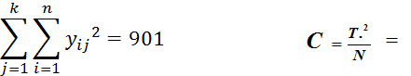
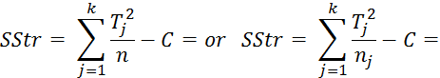

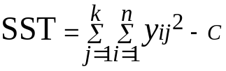 = 45.63636

SSE = SST - SStr = 127.1136

Source | D.F. | Sums of Squares | Mean Squares | Fs | Fα = 0.05 | Significant /  Not Significant
IR Sensor | 2 | 24.2197 | 12.10985 | 4.523523 | 0.048502 | Significant
Exp. Error | 8 | 21.41667 | 2.677083
Total | 10 | 116.9167

b. (4 pts) Estimate the parameters: overall mean (u), and factors a₁ , a₂ , a₃
_{u =} 8.8181 a₁ = 0.8484

a₂ = 0.4318 a₃ =-1.8181
10. (9 pts) Three Radar modifications were tested for detection range improvement using five trials each. The following single factor ANOVA Table presents the results:

Source | D.F. | Sums of Squares | Mean Squares | Fs | P
Radar Modification | 2 | 139.6 | 69.8 | 5.72 | 0.018
Exp. Error | 12 | 146.4 | 12.2
Total | 14 | 286.0

The Mod sample means are: Mod A = 31.4, Mod B = 28.6, Mod C = 24.0

Using the Fisher LSD test, determine if any of the modifications were significantly different from each other at a level of significance of α = .05, and find the upper and lower confidence limits for the difference of means.
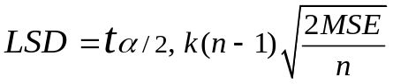 =

Results:
_{Comparison} | _{Difference} | _{LSD} | _{Lower Conf. Limit.} | _{Upper}  _{Conf. Limit} | _{Significant or Not Significant}
A – B | _{31.4 – 28.6 = 2.8}
_{B – C} | _{28.6 – 24.0 = 4.6}
_{A – C} | _{31.4 – 24.0 = 7.4}

11. (4 pts) The following Minitab table presents Fisher LSD 95% confidence intervals for the difference of pairs of three aircraft factor means.

Aircraft = F16 subtracted from:

Aircraft Lower Center Upper ---------+---------+---------+---------+
F18 -0.819 2.100 5.019 (------*-------)
F5 2.048 4.800 7.552 (------*------)
---------+---------+---------+---------+
-4.0 0.0 4.0 8.0
Aircraft = F18 subtracted from:

Aircraft Lower Center Upper ---------+---------+---------+---------+
F5 -0.219 2.700 5.619 (-------*------)
---------+---------+---------+---------+
-4.0 0.0 4.0 8.0

a. Circle or underline the pairs of factor means that are significantly different from each other at a level of significance of α = .05: F18-F16, F5-F16, F5-F18
12. (7 pts) To compare five different formulations of fuel, seven different armored vehicles drove the identical route once with each fuel type. For each vehicle/fuel-type combination a fuel cost-of-operation value was determined. These numbers were analyzed with a standard Two-Factor ANOVA model yielding the table which is partially filled in below.

Source | D.F. | Sums of Squares | Mean Squares | Fs | F α = .05
Armored Vehicle
Fuel Types |  |  | 12
Exp. Error |  |  | 4
Total |  | 174

A) Fill in the missing entries.

B) Making the normal assumptions, would you accept the hypothesis that there is no significant difference between the fuel cost of operations for each vehicle type, with α = .05? Why?

13. (10) A reduced regression model for predicting Sonar Detection Range included Water Depth (w), Sensor Modification (s), and Water Depth/SensorMod (ws) Interactions in the form:
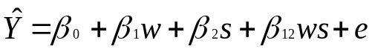

The 2^{k} factor settings, calculated factor effects and the grand mean of the data are below:
Factor | Settings
Water Depth (w) | 200 ft (-)
Water Depth (w) | 900 ft (+)
Sensor Modifications (s) | Mod I (-)
Sensor Modifications (s) | Mod II (+)
Factor Effects:
Grand Mean of Data 41.0
Water Depth (w): 3.8
Sensor Modification (s): - 5.2
Water/Sensor Interaction (ws) - 2.4

- (3) Determine the coefficients for the reduced Regression Equation:

- (5) Predict the result for Run (5) (200 ft and Mod II):

3. (2) The result for Run (5) was 35.5, what was the residual for Run (5)?
14. (15 pts) The following is a 2⁴ Half Fractional Test Design. Determine Contrasts, SS, MSE, Fs, Fα, factor effects, and Acceptance or Rejection of the Null Hypothesis for Main factors A & B and Interaction CD. Test the Hypothesis Ho: A = B = CD = 0 at a level of significance of .05 i.e. no significant difference in factor levels or interaction. The Residual/Sum of Squares Error (SSE) is given below. (Show All Work) 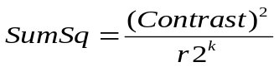
_{24 Half Fractional Test Design}
 |  | A (-) |  | A (+) |  | Row Sum
 |  | B (-) | B (+) | B (-) | B (+) | Row Sum
C (+) | D (+) | 24 |  |  | 25 | 49
C (+) | D (-) |  | 23 | 16 |  | 39
C (-) | D (+) |  | 20 | 21 |  | 41
C (-) | D (-) | 17 |  |  | 21 | 38
Column Sum |  | 41 | 43 | 37 | 46 | 167

Contrasts:
A:

B:

CD:

Fill in Blanks with Answers Here:
Source | Deg. Of  Freedom | Contrast | Sum Squares | Mean  Squares | Fs | F_{.05} | Factor Effect | Accept/Reject Ho:

Main Factors
A
B

Interactions

C-D
Residual (SSE) | 3 |  | 6.0

15. (5 pts) Calculate and plot the AD Interaction. (Show Y-axis scaling). Would you expect this interaction to be significant? Why or why not?
AD Interaction:
- D +

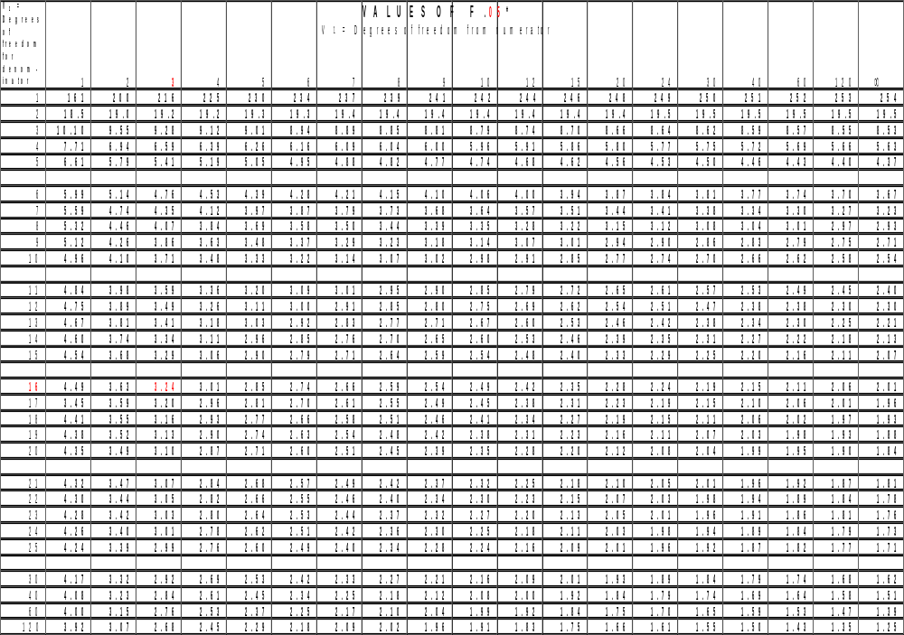
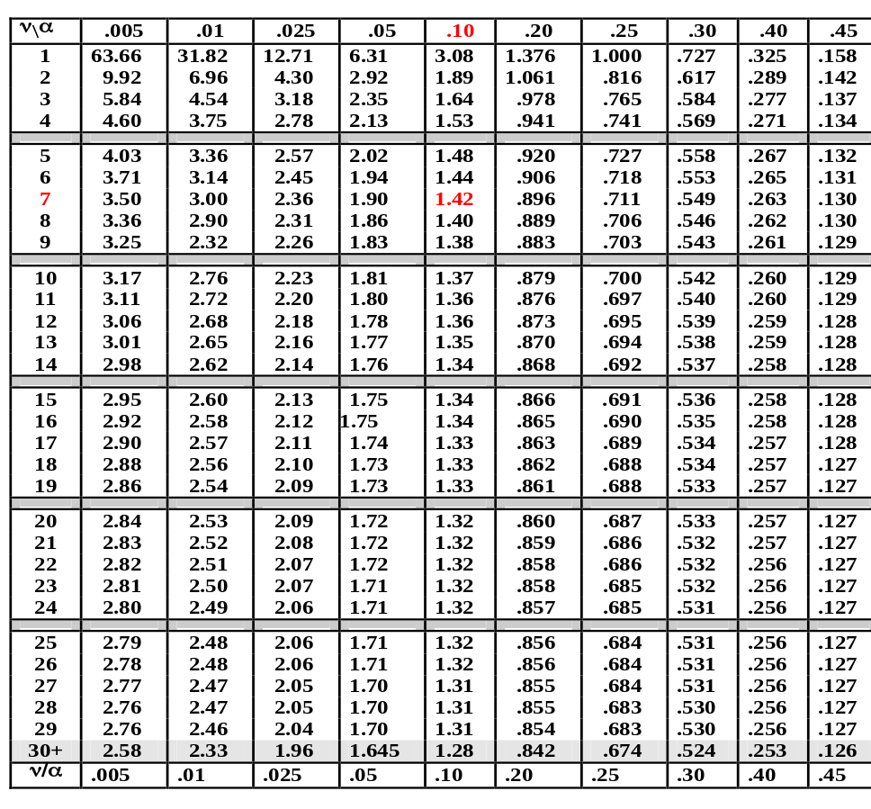
t-tables

