Your Ultimate Journey to Studying in Germany 🇩🇪
A Step-by-Step Guide with UniAdvisorAI

Welcome to Your Future! 🚀
Studying in Germany is an incredible opportunity, but the process can often feel overwhelming. That's where UniAdvisorAI comes in! We have designed a platform that acts as your personal, AI-powered counselor to make your journey incredibly easy, highly motivated, and absolutely clear. Follow this simple step-by-step guide to secure your dream admission!

Step 1: Sign up & Login
Your journey begins with a simple login. Create your free account to access all our premium AI tools, track your applications, and save your progress securely in the cloud.
[ PLACEHOLDER: Insert Login Screen Image Here ]
----------------------------------------------------------------------

Step 2: Build Your Profile
Tell us about yourself! Enter your academic background, current GPA, language proficiencies (English & German), and work experience. This is crucial because our AI engine uses these details to find programs where you have the absolute highest chances of acceptance.
[ PLACEHOLDER: Insert Profile Information Section Image Here ]
----------------------------------------------------------------------

Step 3: Get AI-Powered Recommendations
Meet Chat Nova—your personal AI assistant! By analyzing your profile against thousands of German university programs, Nova will recommend the exact degrees tailored for you. You will see a match score indicating your admission chances, meaning you only apply to programs where you are highly likely to be accepted!
[ PLACEHOLDER: Insert AI Recommendations / Chat Nova Image Here ]
----------------------------------------------------------------------

Step 4: Create Winning Documents (SOP & CV)
A strong Statement of Purpose (SOP) and a German-style academic CV are your secret weapons to winning an admission. With UniAdvisorAI, you can generate and create your tailored SOP and German-style CV directly on our platform! Our AI SOP Generator and CV Evaluator will guide you step-by-step to craft flawless documents that stand out to university admission committees.
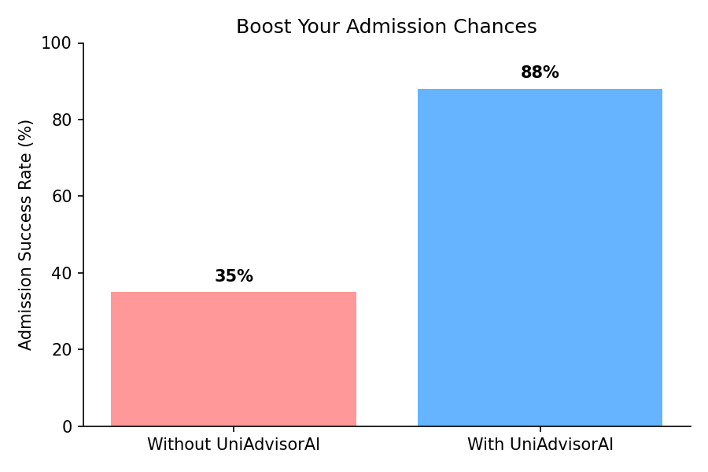

Step 5: Application Tracking & Process
Once you have selected your ideal programs, use our 7-Phase Application Tracker to manage every detail. We guide you through:
- 1. Eligibility Details
- 2. Language Test Requirements
- 3. Document Preparation
- 4. University Application Submission
- 5. Admission & Offer Letters
- 6. Financial Setup (Blocked Account)
- 7. Visa Process & Embassy Appointment
No more missed deadlines, missing documents, or confusion. Everything is beautifully organized in one place!
[ PLACEHOLDER: Insert Application Tracking Process Image Here ]
----------------------------------------------------------------------

You Are Ready! 🎉
With UniAdvisorAI, you are perfectly equipped to navigate the German university application system. Log in today, let our AI guide your path, and take the first step toward an amazing future in Germany!

