Molecule Comparisons (Filtered)
(This one had 2 SMILES in the ground truth but only 1 molecule in the image)

US20050009817A1_p0016_x1358_y2226_c00056
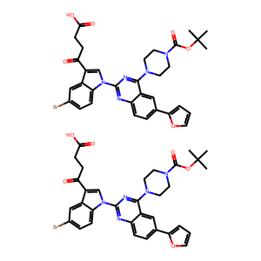

US20060122222A1_p0006_x1536_y2845_c00004
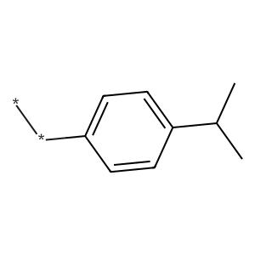

US20030130506A1_p0043_x0899_y1697_c00142
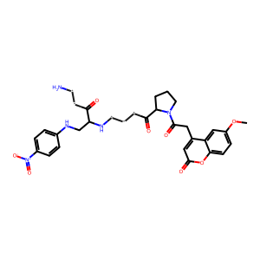

US20050009817A1_p0020_x0594_y2309_c00068
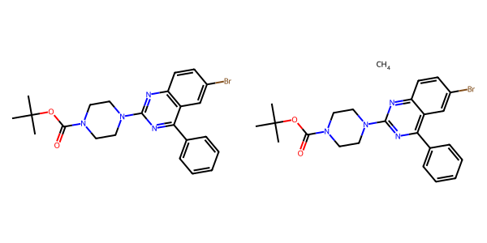

US20070249620A1_p0018_x1209_y0937_c00010
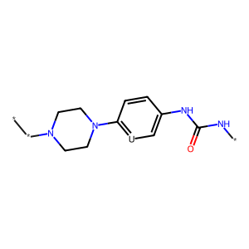

US20040229890A1_p0013_x1457_y0666_c00057
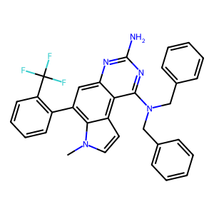

US20050288357A1_p0063_x0518_y0647_c00115
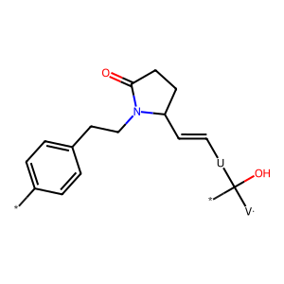

US20030130506A1_p0010_x0383_y2595_c00033
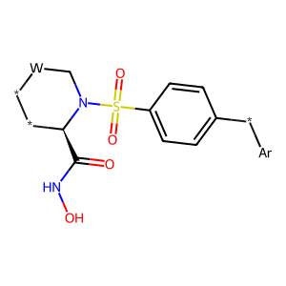

US20050288357A1_p0047_x1475_y0848_c00085
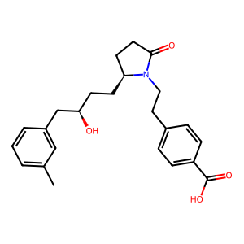

US20050182067A1_p0026_x1586_y1042_c00010
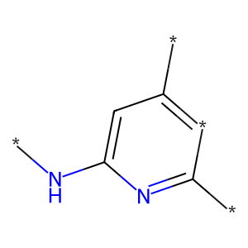

US20050182067A1_p0048_x0707_y0570_c00164
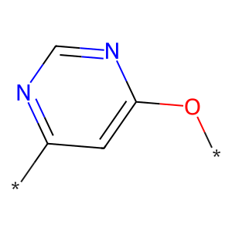

US20050288357A1_p0047_x0502_y0844_c00083
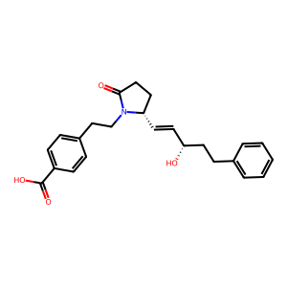

US20070179177A1_p0022_x0609_y1278_c00136
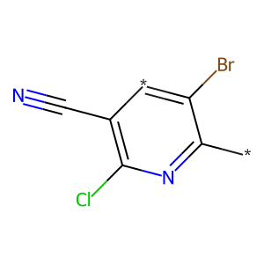

US20070049758A1_p0012_x0479_y1869_c00005
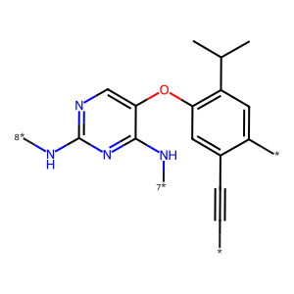

US20070249620A1_p0001_x1376_y0697_c00000
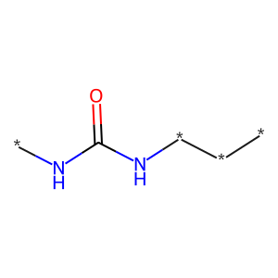

US20050113580A1_p0080_x0338_y0900_c00155
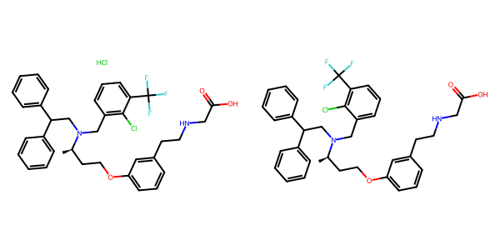

US20040266789A1_p0006_x1401_y0536_c00004
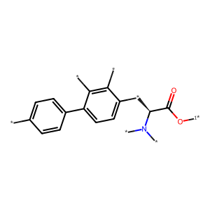

US20050009817A1_p0009_x0579_y1706_c00011
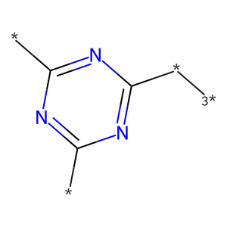

US20050002859A1_p0015_x1453_y2068_c00092
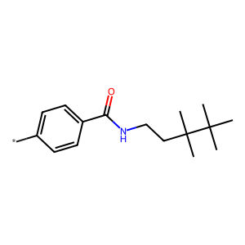

US20060122222A1_p0040_x1313_y0721_c00105
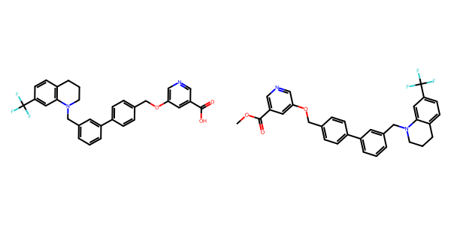

US20070049758A1_p0016_x1427_y0646_c00012
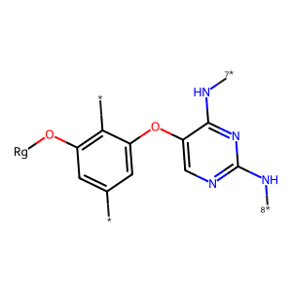

US20050043351A1_p0001_x1536_y1025_c00000
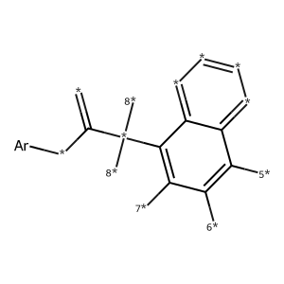

US20040229890A1_p0003_x0662_y1706_c00007
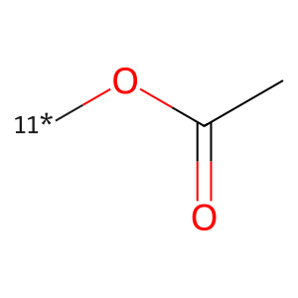

US20070270434A1_p0018_x0404_y2396_c00040
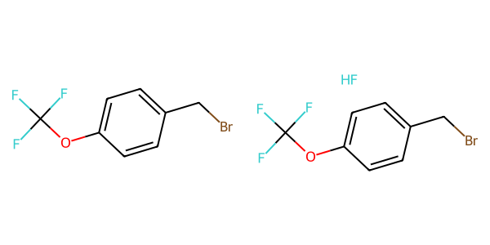

US20030130506A1_p0004_x0551_y1960_c00008
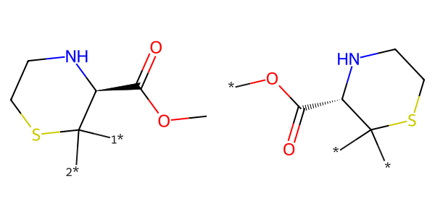

US20070179177A1_p0021_x1531_y2195_c00134
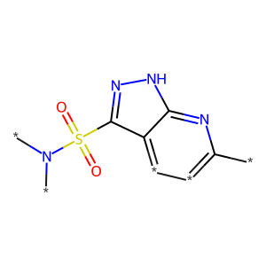

US20070105909A1_p0022_x0610_y2522_c00049
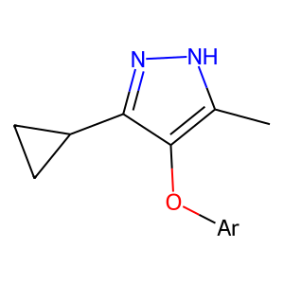

US20040254236A1_p0037_x0488_y1434_c00146
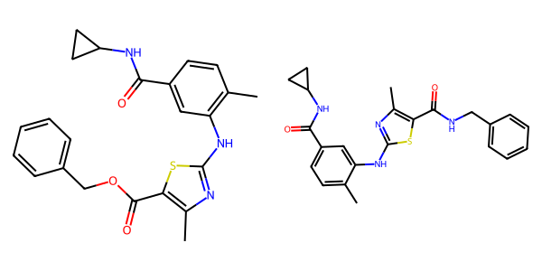

US20050002859A1_p0038_x0344_y0823_c00135
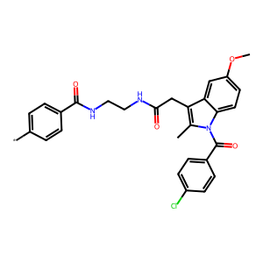

US20080113922A1_p0008_x1320_y1305_c00020
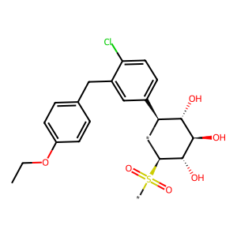

US20070049758A1_p0014_x1446_y1735_c00009
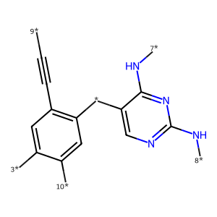

US20050004369A1_p0017_x1375_y2642_c00024
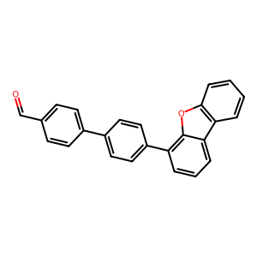

US20070015754A1_p0015_x0353_y0596_c00066
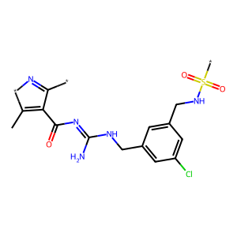

US20050182067A1_p0039_x1442_y2307_c00151
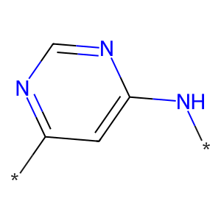

US20030130506A1_p0003_x0392_y2374_c00002
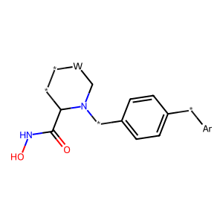

US20050009817A1_p0022_x0681_y0702_c00073
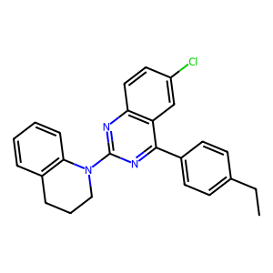

US20050288357A1_p0066_x1539_y0947_c00118
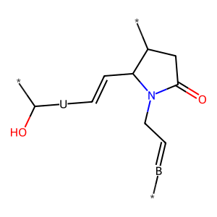

US20050002859A1_p0024_x1442_y1277_c00122
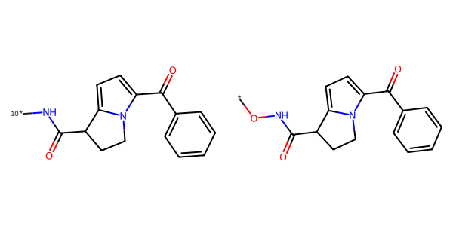

US20070179154A1_p0042_x1376_y1828_c00057
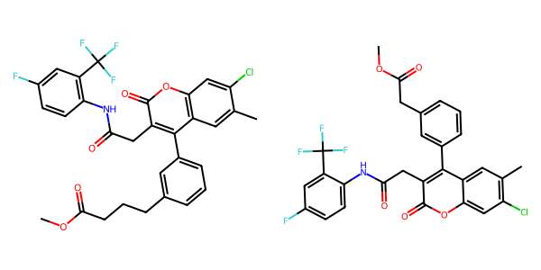

US20070179177A1_p0021_x1536_y2786_c00135
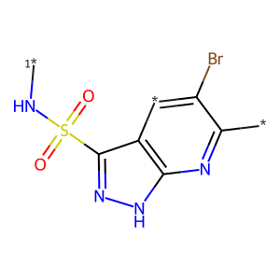

US20070105909A1_p0034_x0460_y1063_c00106
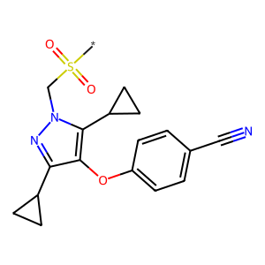

US20060154945A1_p0003_x0404_y1991_c00004
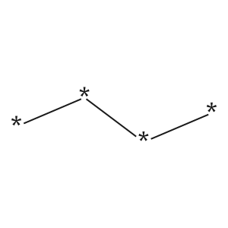

US20050182067A1_p0048_x0765_y1900_c00165
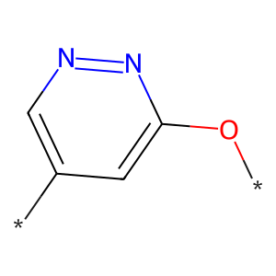

US20050002859A1_p0024_x0451_y1702_c00119
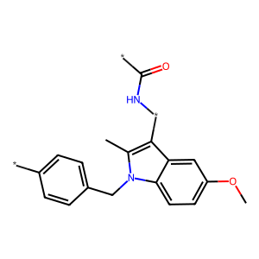

US20070015754A1_p0014_x1326_y2235_c00065
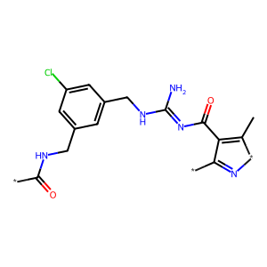

US20040229890A1_p0015_x1435_y2559_c00068
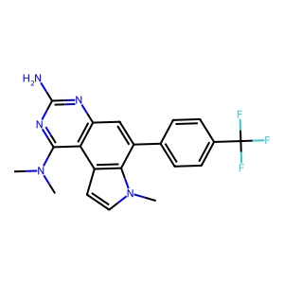

US20050002859A1_p0015_x1487_y0738_c00091
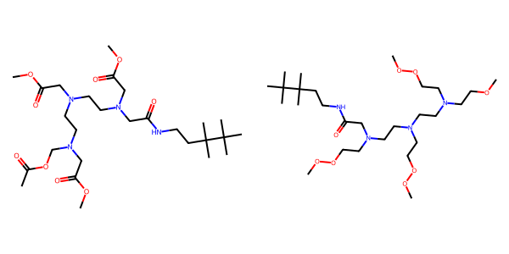

US20040266789A1_p0007_x1367_y1327_c00007
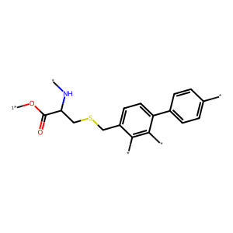

US20070270434A1_p0015_x1376_y2386_c00029
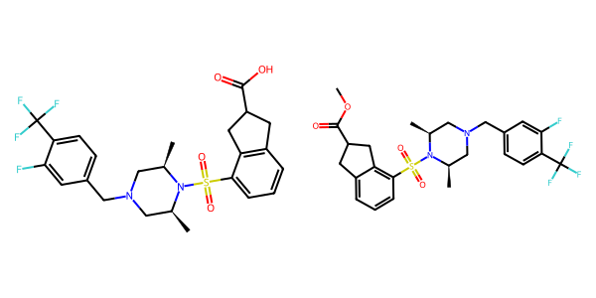

US20050288357A1_p0006_x1491_y1404_c00002

US20070105909A1_p0001_x1423_y0823_c00000
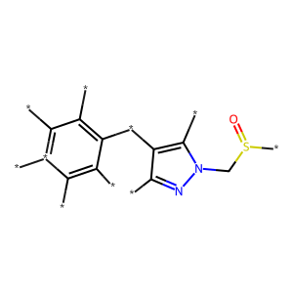

US20050009817A1_p0018_x0506_y2240_c00062
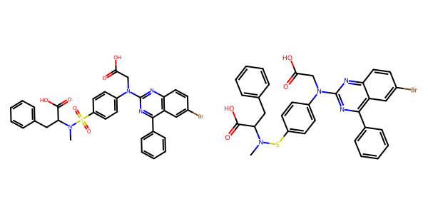

US20040229890A1_p0022_x1621_y2943_c00101
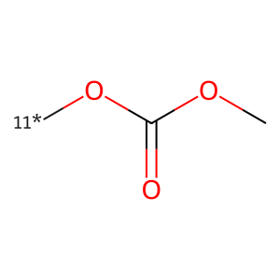

US20060154945A1_p0016_x0402_y1570_c00053
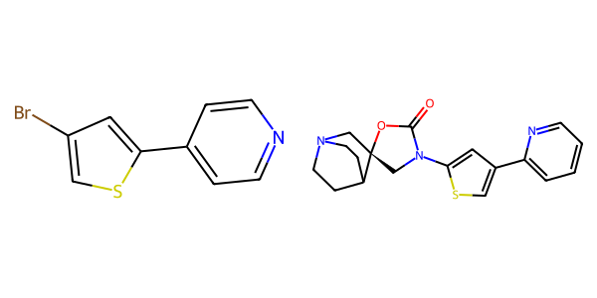

US20050075347A1_p0001_x1448_y1085_c00000
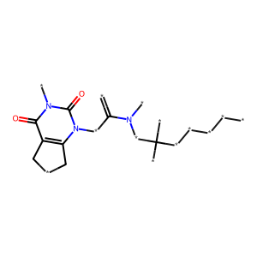

US20050043351A1_p0017_x1425_y1952_c00047
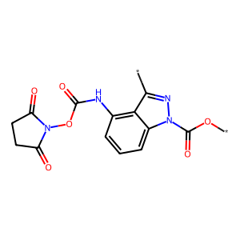

US20050182067A1_p0045_x0765_y2765_c00160
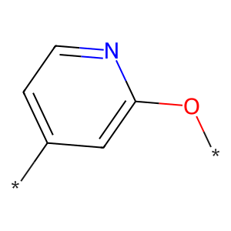

US20050182067A1_p0026_x1619_y0585_c00009
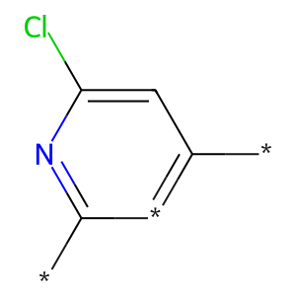

US20070105909A1_p0016_x1592_y2663_c00019
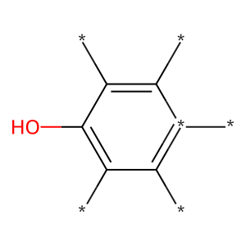

US20070105909A1_p0028_x1552_y1603_c00073
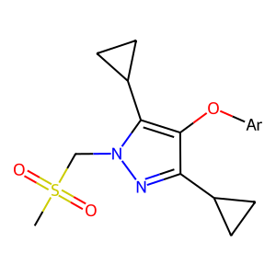

US20070105909A1_p0017_x1427_y1960_c00026

US20070049758A1_p0010_x1457_y2612_c00003
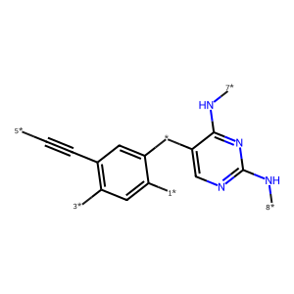

US20050009817A1_p0006_x1632_y0537_c00005
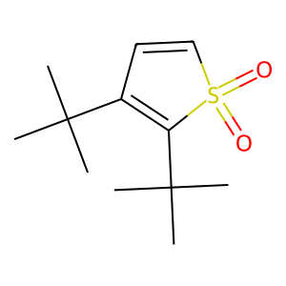

US20080113922A1_p0008_x1320_y1877_c00021
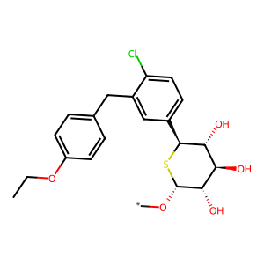

US20050182067A1_p0035_x0548_y0818_c00127
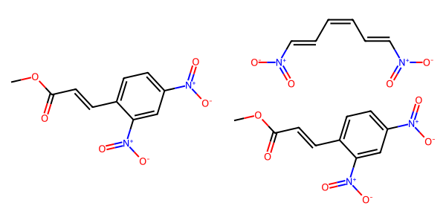

US20050009817A1_p0016_x0367_y1043_c00054
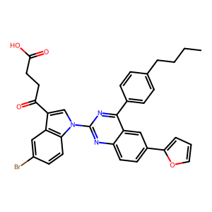

US20070265270A1_p0012_x0801_y0569_c00058
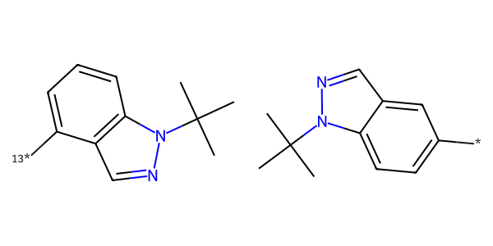

US20070179154A1_p0011_x0688_y1468_c00003
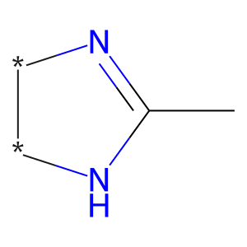

US20050002859A1_p0038_x1398_y1884_c00138
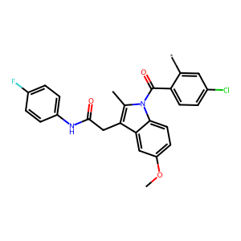

US20050002859A1_p0024_x0336_y0622_c00118
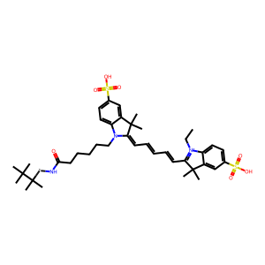

US20060122222A1_p0025_x0363_y1056_c00070
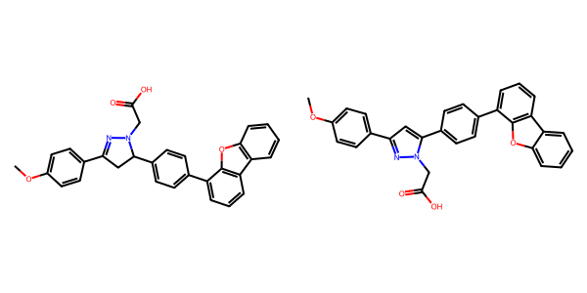

US20050004369A1_p0026_x1307_y2432_c00046
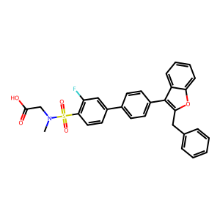

US20050009817A1_p0008_x0632_y1980_c00009
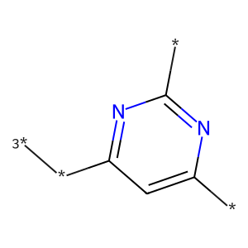

US20040266789A1_p0049_x1496_y1933_c00082
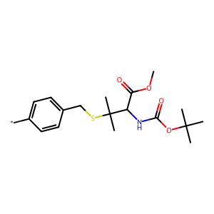

US20070155803A1_p0029_x1358_y1732_c00073
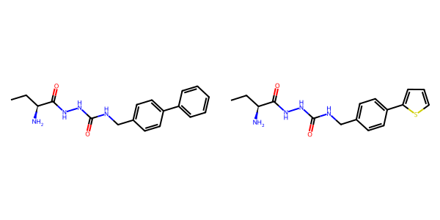

US20070015754A1_p0015_x0411_y2439_c00068
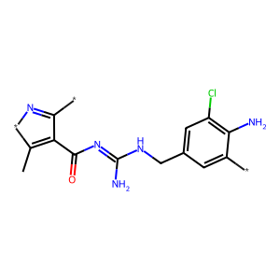

US20070265270A1_p0034_x1406_y2511_c00138
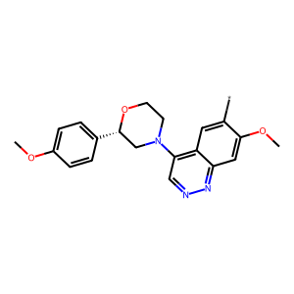

US20070049758A1_p0011_x1452_y0646_c00004
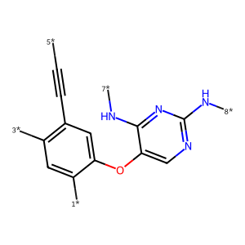

US20070105909A1_p0031_x1536_y1448_c00094
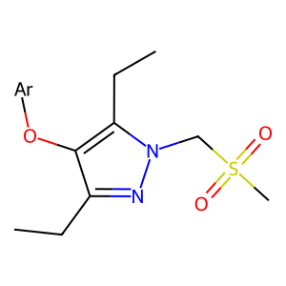

US20070249620A1_p0039_x0488_y1530_c00035
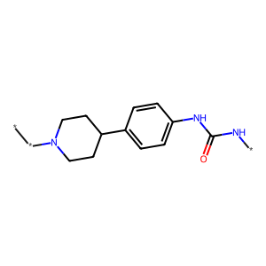

US20050004369A1_p0030_x0443_y1000_c00056
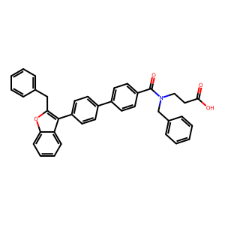

US20050288357A1_p0062_x0568_y2346_c00113
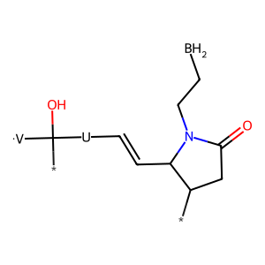

US20070155803A1_p0020_x1323_y2114_c00037
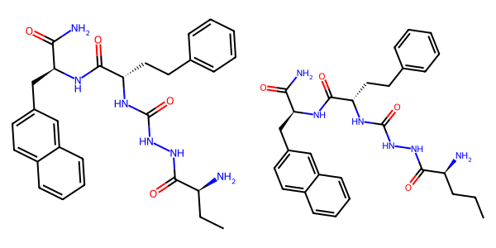

US20080113922A1_p0008_x0347_y2067_c00017
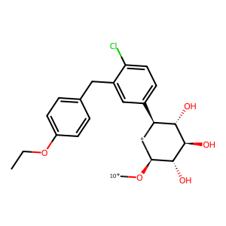

US20080113922A1_p0008_x1320_y0682_c00019
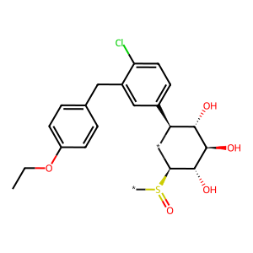

US20050182067A1_p0035_x1514_y0785_c00130
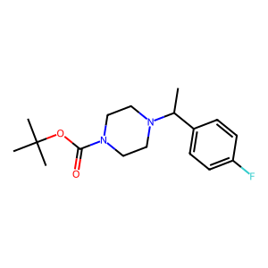

US20070249620A1_p0037_x0515_y0602_c00032
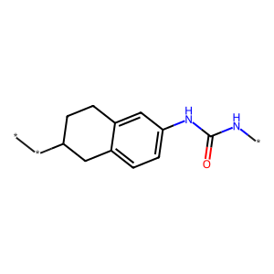

US20050002859A1_p0016_x0336_y0672_c00094

US20070015754A1_p0045_x0532_y0578_c00269
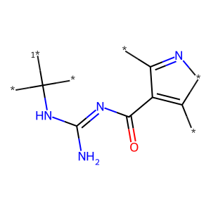

US20070249620A1_p0041_x0517_y1970_c00038
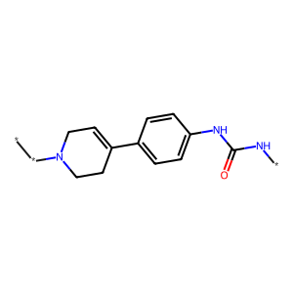

US20050002859A1_p0015_x0608_y2562_c00090
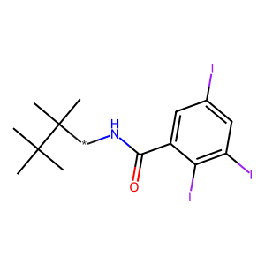

US20050002859A1_p0016_x0451_y1771_c00095

US20070105909A1_p0020_x1570_y1542_c00033
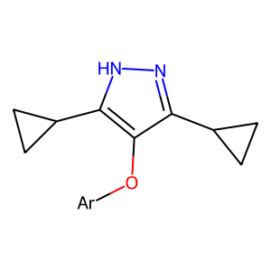

US20050182067A1_p0043_x0765_y2660_c00157
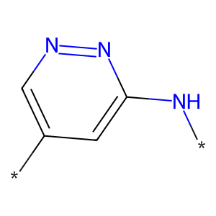

US20050288357A1_p0049_x0502_y1379_c00090
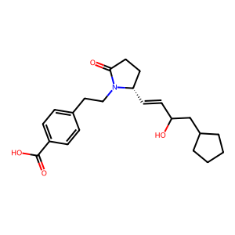

US20050182067A1_p0040_x0765_y0572_c00152

US20060122222A1_p0027_x0379_y1064_c00078
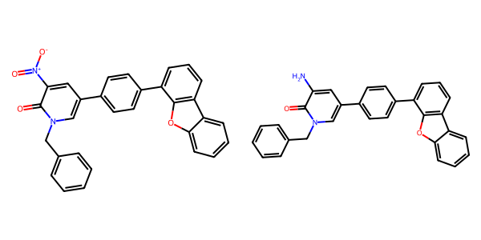

US20050054819A1_p0014_x1375_y1229_c00046
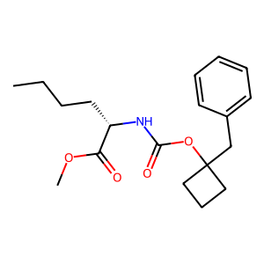

US20070049758A1_p0014_x1456_y2580_c00010
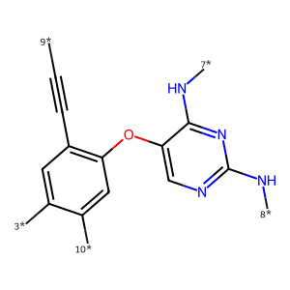

US20050004369A1_p0029_x0443_y0744_c00053
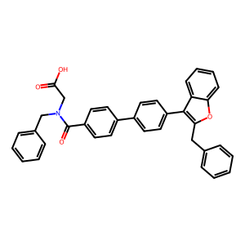

US20050288357A1_p0005_x1541_y2587_c00000

US20070015754A1_p0015_x0337_y1555_c00067
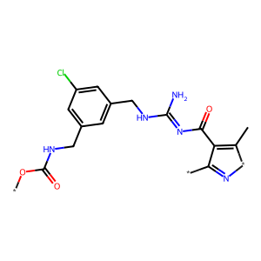

US20060122222A1_p0015_x0638_y2624_c00044
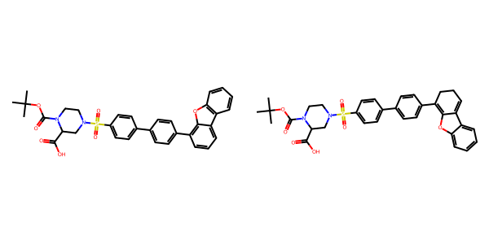

US20060281700A1_p0062_x0402_y1072_c00039
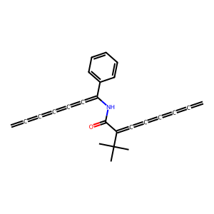

US20070049758A1_p0016_x1409_y2383_c00013
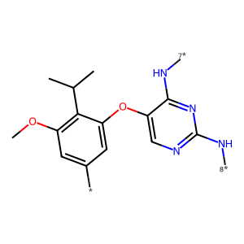

US20050002859A1_p0038_x0461_y2211_c00136
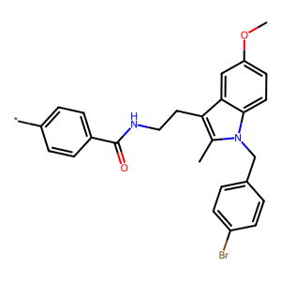

US20070015754A1_p0001_x1502_y1304_c00000
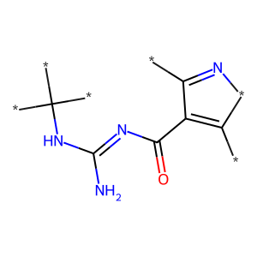

US20060122222A1_p0015_x0638_y2146_c00043
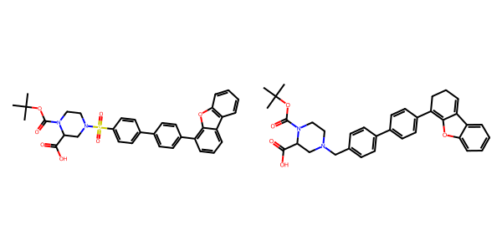

US20070179177A1_p0003_x0558_y2478_c00000

US20050113580A1_p0041_x1328_y1816_c00063
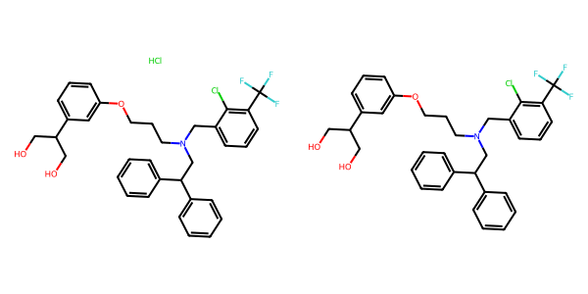

US20060122222A1_p0007_x0571_y1069_c00005
