t-Test

Assumptions:

1. Population belongs to Normal Distribution
2. Random Observations
3. Independent Observations

Known: UK’s truancy = 8% i.e. Population mean = 8%

Q: Does the sample represent UK’s truancy?

Q: Is sample mean = 8%?

H0: sample mean = 8%

H1: sample mean ≠ 8%

H0: sample mean - 8% = 0

H1: sample mean – 8% ≠ 0

|  |  |  |  |  |
| --- | --- | --- | --- | --- |
| **One-Sample Statistics** | | | | |
|  | N | Mean | Std. Deviation | Std. Error Mean |
| Percent truant days pre intervention | 299 | 14.2038 | 13.07160 | .75595 |

s.e.^2 = s.d.^2/n = 13.07^2/299

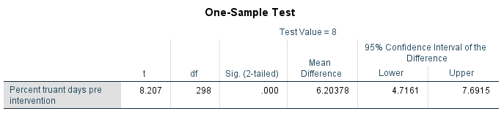

*p*-value = 0.000

If *p* < α, reject H0

If *p* > α, do not reject H0

Pre-set α = 5% = 0.05

Since p-value = 0.000 < 0.05, we reject H0 in favour of H1 that sample mean is not 8%.

Since observed significance is 0.000 < 0.05, we reject H0 in favour of H1 that sample mean is not 8%.

Sample mean is not 8% (*p* = 0.000).

Df = degrees of freedom, generally n – 1

Sample mean is not 8%. On the other words, sample does not represent the population.

Paired sample t-test

Q: Does the program decrease the truancy?

H0: the program decreases the truancy

H1: the program does not decrease the truancy

p-value = P(Getting this sample, given that H0 is true)

~~H0: PreTruancy > PostTruancy~~

~~H0: PreTruancy – PostTruancy > 0~~

~~H0: PreTruancy – PostTruancy = 1 , 2 , 3, 4, …~~

H0: PreTruancy – PostTruancy = 0

~~H1: PreTruancy – PostTruancy > 0~~

~~H2: PreTruancy – PostTruancy < 0~~

H1: PreTruancy – PostTruancy ≠ 0

H0: PreTruancy – PostTruancy = 0

H1: PreTruancy – PostTruancy ≠ 0

It is a two-tailed test.

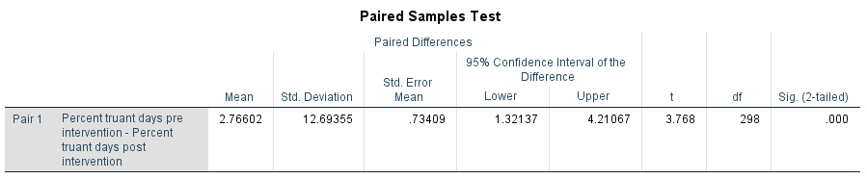

Pre-set significance level, alpha = 5%

p-value = 0.000

Since the observed significance is 0.000 (< 0.05), we reject H0 in favour of H1 that the program changes the truancy.

The program changes truancy (*p* = 0.000).

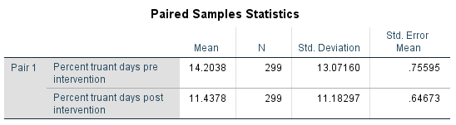

Furthermore, the pre-program truancy is 14.20% while the post-program truancy is 11.43%. Therefore, we believe that the program decreases truancy by 2.77% with 95% confidence interval (1.32%, 4.21%).

Assumptions:

Random sample

Independent observations

Normality

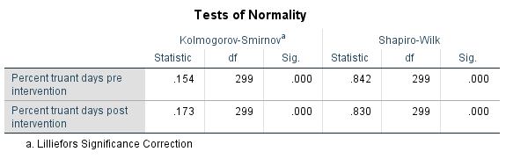

p-values of both tests for pre- and post-program truancy is 0.000 so that the normality cannot be assumed.

H0: population is normality

H1: population is not normality

Large number theory (Central Limit Theory)

If sample size is large enough, sample mean follows normal distribution.

n is 299

Does male

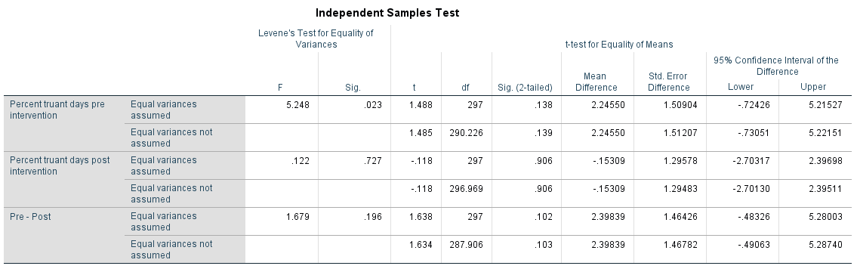

Levene’s test

H0: Equal variances

H1: Unequal variances

Pre-truancy

P = 0.023 (< 0.05) 🡺 variances not equal

Does male and female pre-program truancy differ?

H0: malePreTruancy = FemalePreTruancy

H1: malePreTruancy <> FemalePreTruancy

P = 0.139 (>0.05) so that malePreTruancy = FemalePreTruancy

Does male and female post-program truancy differ?

H0: malePostTruancy = FemalePostTruancy

H1: malePostTruancy <> FemalePostTruancy

P = 0.906 (>0.05)

Does program truancy differ on gender?

H0: maleProgramEffect = FemaleProgramEffect

H1: maleProgramEffect <> FemaleProgramEffect

P= 0.196 🡺 same variances

P = 0.102 (> 0.05) 🡺 program has same effect on both genders.