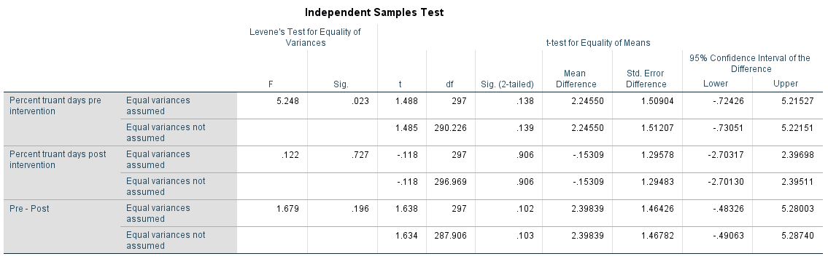

Incoming QC

TQC Total Quality Control

Q1.

H0: μ (mean) = 25

H1: μ (mean) <> 25

Alpha = 0.10 = 10%

100% - 10% = 90%

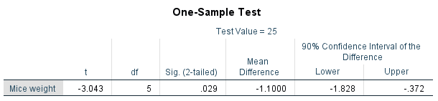

P= 0.029

Since the observed significance is 0.029 (<0.10), we reject H0 in favour of H1 that the mice weight is not 25g.

The mean mice weight is not 25g (*p* = 0.029).

Q2

H0: μ = $25,000

H1: μ <> $25,000

α = 0.02 P(Reject H0 if H0 is true) = Tolerant Risk

100 – 2 = 98

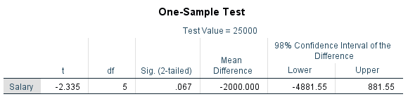

P = 0.067

Since the observed significance is 0.067 (>0.02), we do not reject H0 that the mean salary is $25,000.

The mean salary is $25,000 (*p* = 0.067).

98% C.I. = (20118, 25881). $25000 falls between 98% C.I. so that mean salary is $25000.

Q3

H0: The typing program does not change typing speed.

H1: The typing program changes typing speed.

H0: Pre_speed = Post_speed

H1: Pre_speed <> Post_speed

Alpha = 0.025 P(Reject H0 if H0 is true) = Risk

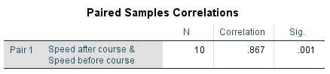

Correlation = 0.867 (>0.5) 🡺 we can use paired samples t-test.

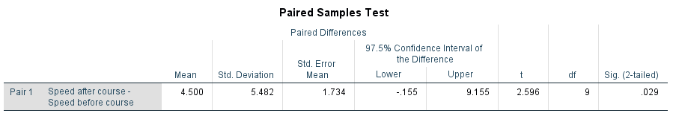

P = 0.029

Since the observed significance is 0.029 (>0.025), we do not reject H0 that the course does not change the typing speed.

IF alpha = 0.05

P = 0.029

Since the observed significance is 0.029 (<0.05), we reject H0 in favour of H1 that the course changes the typing speed.

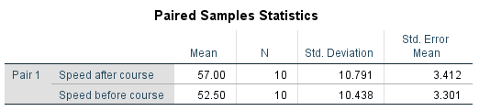

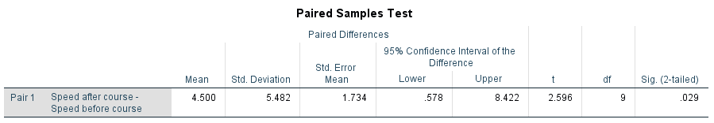The speeds before and after course are 52.50 and 57.00. We believe that the course increases the typing speed by 4.50 with 95% Confidence Interval (0.578, 8.422).

Common alpha = 5%, 1%, 0.1%

Alpha = 20%

Q5

H0: μ8 = μ10

H1: μ8 <> μ10

Alpha = 0.10

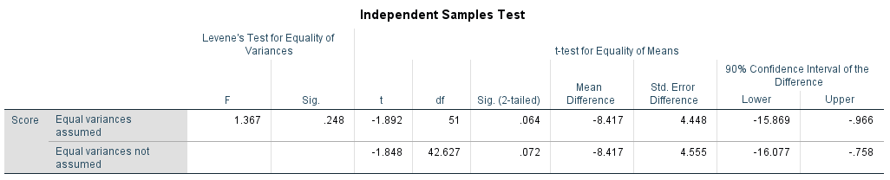

P = 0.248 🡺 same variances

P = 0.064 🡺 unequal mean

Since the observed significance is 0.064 (<0.10), we reject H0 in favour of H1 that the scores are different at different exam time.

The scores at 8 am and 10 am are different (*p* = 0.064).

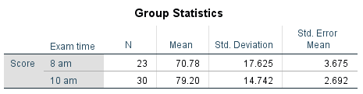

The scores at 8 am and 10 am are 70.78 and 79.20, respectively. We believe that score at 10 am is higher than 8 am by 8.42 with 90% Confidence Interval (0.966, 15.869).

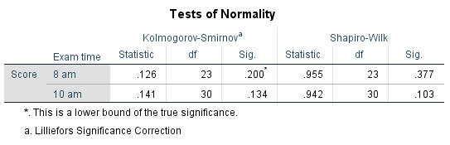

Validate Assumptions



All p-values are greater than 0.05 so that normality can be assumed.

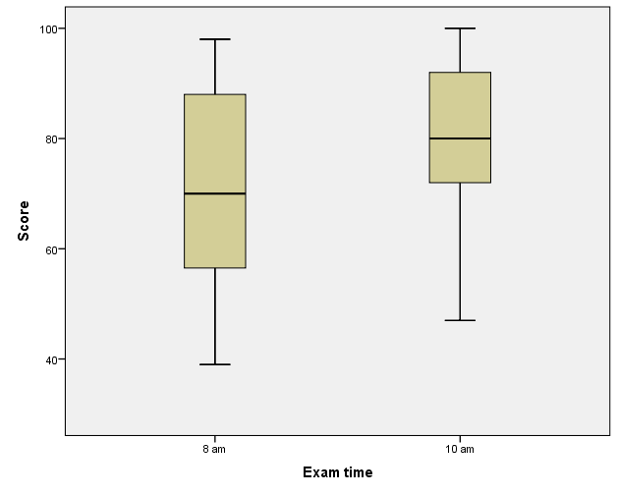

There are not outliers.

ANOVA

ANalysis Of VAriances

F-Test

Assumptions

1. Random observations
2. Independent observations
3. Normality
4. Same variances

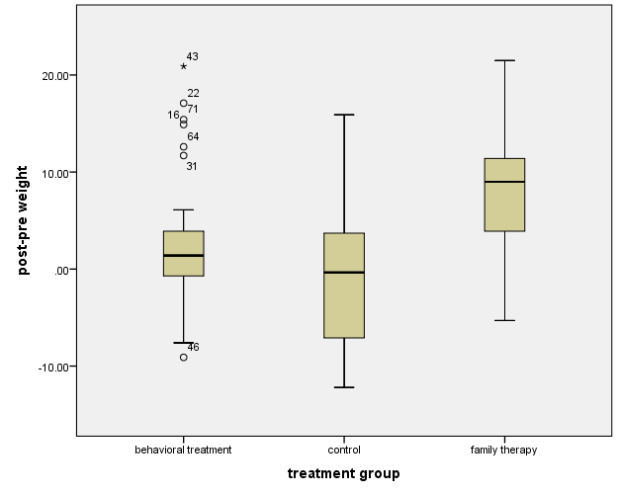

There are outliers and extreme case in behaviour treatment group. We have to check the data quality of these cases.

Assumptions

1. Random observations 🡸 Must be done in the experiment design
2. Independent observations 🡸 Must be done in the experiment design
3. Normality

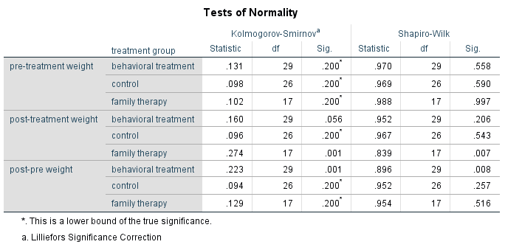

Pre-treatment weights are normal distribution.

Post-treatment weights and treatment effect (post-pre weight) are not normality.

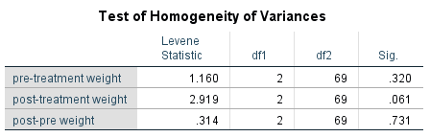

All p-values are greater than 0.05 so that same variances can be assumed.

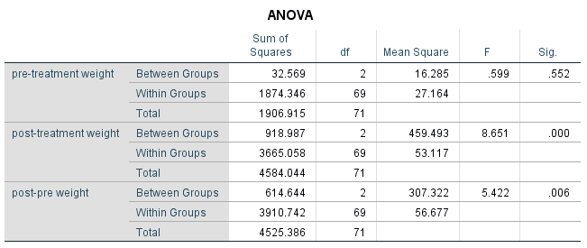

P = 0.552

Pre-treatment weights among three groups are same (*p* = 0.552).

P= 0.006

Treatment effect are not same for all groups (*p* = 0.006).

H0: All treatments have same effect on weight.

H1: NOT all treatments have same effect on weight.

Since the observed significance is 0.006 (<0.05), we reject H0 in favour of H1 that NOT all treatments have same effect on weight.

Which pairs are different?

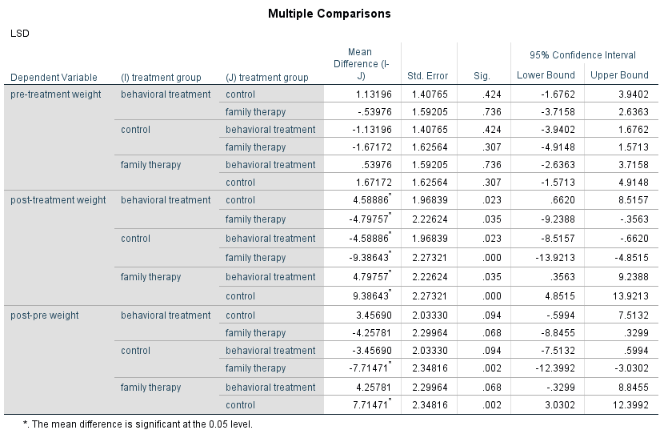

Post-Weight

(B, C), (B, F), (C, F),

Treatment effect

(C, F),

Family therapy and Control groups have different treatment (p= 0.002). On the other words, family therapy can recover anorexia.