Validate data

Boxplot

Outliers, Extreme cases

Check Assumptions

1. Random observations
2. Independent observations
3. Normality (Violate)
4. Same Variances

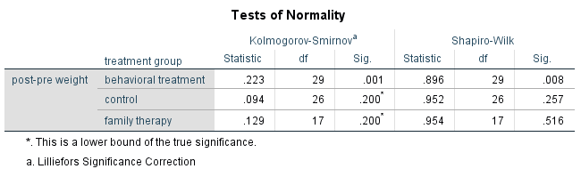

1. Same variances

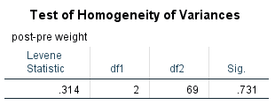

P = 0.731 🡺 Same variances

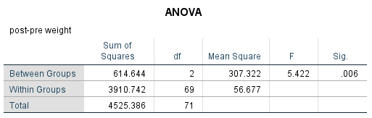

P = 0.006

Not all pairs of groups are equal (*p* = 0.006)

H0: All treatments have same effect on anorexia

H1: Not all treatments have same effect on anorexia

H0: Effect_control = Effect_Family = Effect_Behaviour

~~H1: Effect_control <> Effect_Family <> Effect_Behaviour~~

H1: Not (Effect_control = Effect_Family = Effect_Behaviour)

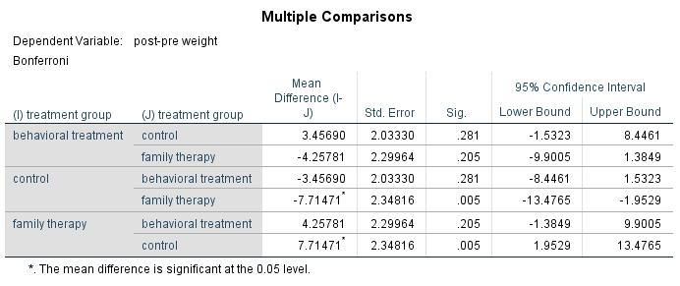

From the post-hoc analysis, we get the (Family, Control) having different effect on the anorexia (p = 0.005).

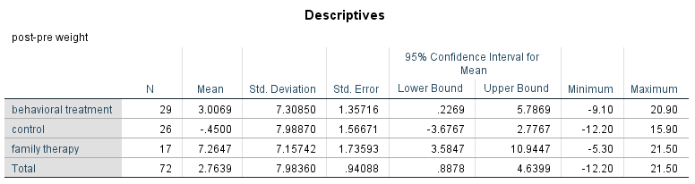

Family therapy and control group change weight by +7.26 and -0.45. Therefore, we believe the family therapy increase weight by 7.26 with 95% C.I. (3.58, 10.94).

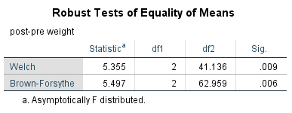

P = 0.009, 0.006 (<0.05) 🡺 not all groups are equal.

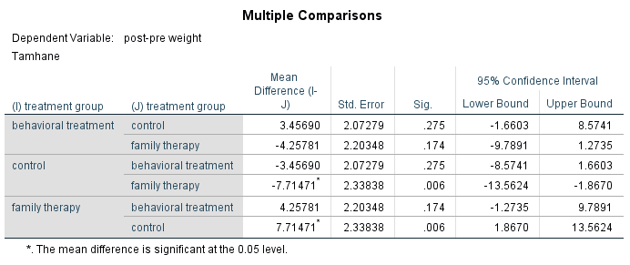

If violate the normality and same variances, we can use Welch and Brown-Forsythe

If do not violate the normality and same variances, we can use ANOVA

* > 0.05
* < 0.05

Q1.

Q: Which battery type is suitable for manufacturing?

H0: Battery_1 = Battery_2 = Battery_3 = Battery_4

H1: Not (Battery_1 = Battery_2 = Battery_3 = Battery_4)

Alpha = 0.05 (Pre-set) P(Type I Error) = P(Reject H0 if H0 is true) = Risk

1. Validate data

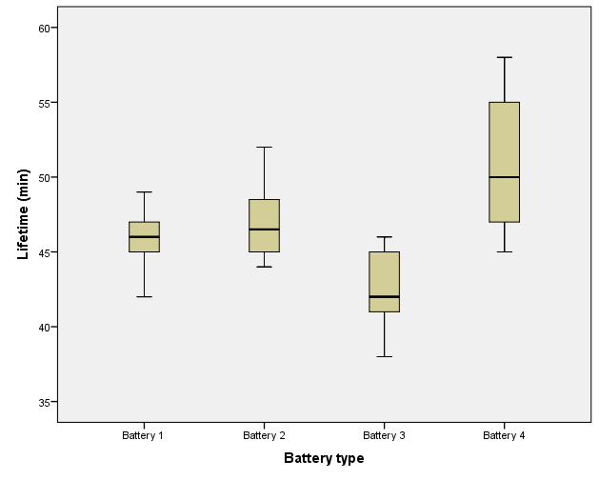

There is no outlier.

1. Check Assumptions
2. Random observations

Assume the sample is randomly drawn.

1. Independent observations

Assume the batteries are tested independently.

1. Normality

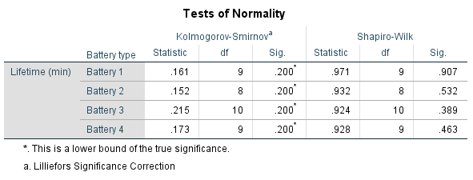

From the table, the least p-value is 0.200 (>0.05) 🡺 normality can be assumed.

1. Same variances

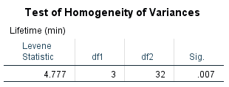

P = 0.007 (<0.05) 🡺 Same variances cannot be assumed.

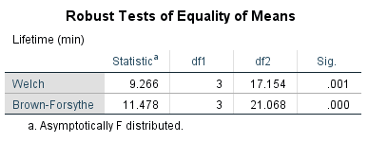

P = 0.001 (<0.05) 🡺 Not all batteries have the same lifetime.

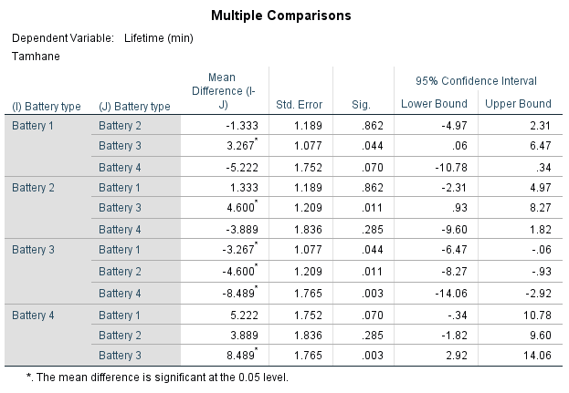

(1, 3) (2,3) (3,4)

(3,1), (3,2), (3,4) are pairs having different lifetime. In short, Battery 3 is different from other batteries.

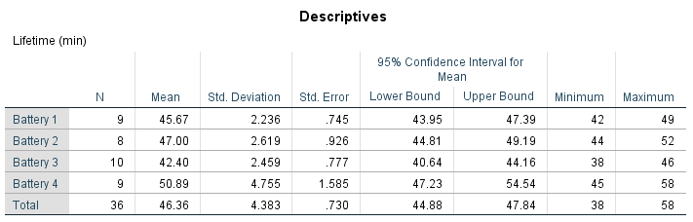

50.89, 47.00, 45.67 and 42.40 are lifetime of Battery 4, 2, 1 and 3. We believe that Battery 3 has the least lifetime.

Q2.

Q: Which method produce the greatest yield?

H0: All methods have the same yield

H1: Not all methods have the same yield

1. Validate data

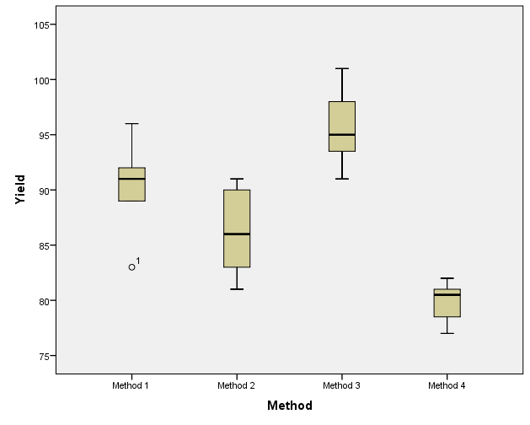

There is one outlier, i.e. case 1 of Method 1. We have to check the Case 1 record.

1. Validate Assumptions
2. Random observations
3. Independent observations
4. Normality

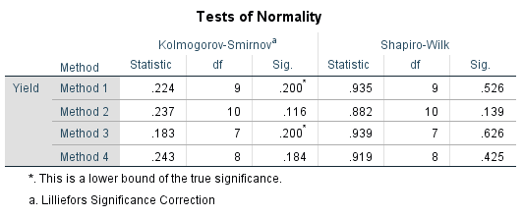

The least p-value is 0.116 (>0.05) 🡺 Normality can be assumed.

1. Same variances

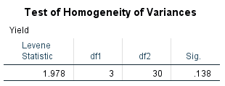

P= 0.138 (>0.05) 🡺 Same variances

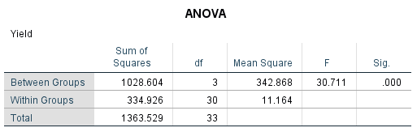

P = 0.000 (<0.05) 🡺 Not all methods have the same yields.

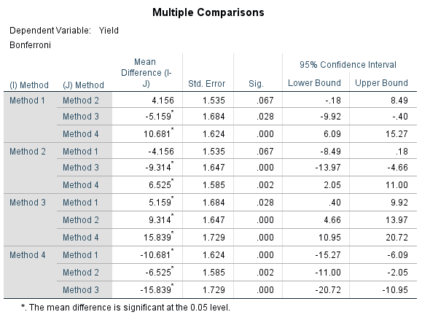

(1, 3), (1, 4), (2, 3), (2, 4), (3, 4)

(3,1), (3,2), (3, 4)

(4,1), (4, 2), (4, 3)

Methods 3 and 4 are different from other methods.

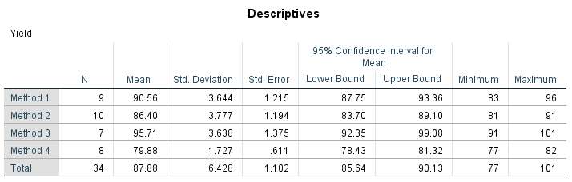

95.71, 90.56, 86.40 and 79.88 are yields of Methods 3, 1, 2 and 4. Method 3 have the highest yield of 95.71 with 95% C.I. (92.35, 99.08).