H0: Triplicity and Life exciting are independent

H1: Triplicity and Life exciting are not independent

Pre-set alpha = 0.05

Triplicity and Life exciting belong to Nominal variable

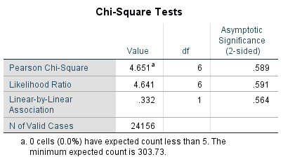

Pearson Chi-Square p-value = 0.589

Since the observed significance is 0.589 (>0.05), H0 is not rejected, i.e., Triplicity and Life exciting are independent.

Triplicity and Life exciting are independent (p = 0.589).

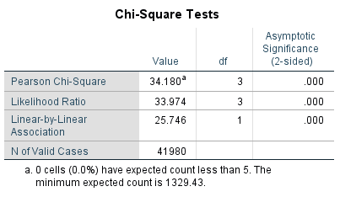

P = 0.000 🡺 Happiness and Decade of survey are not independent 🡺 Happiness changes across time.

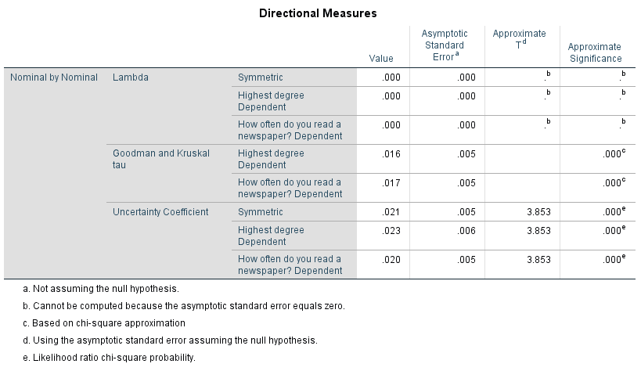

Crosstab

Nominal \* Nominal 🡺 Nominal

Nominal \* Ordinal 🡺 Nominal

Nominal \* Numeric 🡺 Nominal by Interval

Ordinal \* Ordinal 🡺 Ordinal

Ordinal \* Numeric 🡺 Nominal by Interval

Numeric \*Numeric 🡺 R-square