Chi-square Test is used for

1. Test independence of two variables (nominal and ordinal variables) (Parametric test)
2. Test fitness of model (Non-parametric test)

Q1.

H0: Route and shift are independent for incident

H1: Route and shift are not independent for incident

Alpha = 0.05

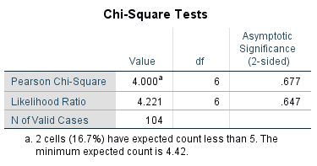

P=0.677

Shift and route are independence for incidences (*p*=0.677).

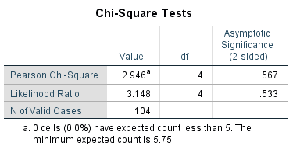

P=0.567

Shift and route are independence for incidences (*p* = 0.567).

Q: 1/3 male are smokers?

Q: traffic accident at a junction is Poison Distribution?

H0: Triciplicity has equal chance

H1: Triciplicity has unequal chance

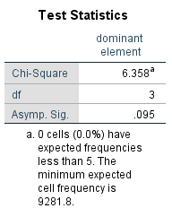

P = 0.095

Triciplicity has equal chance (p = 0.095).

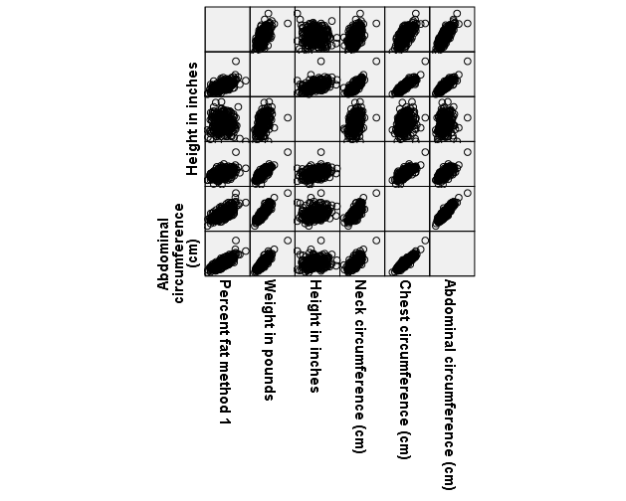

|  |  |  |  |  |
| --- | --- | --- | --- | --- |
|  | Non | Weight | Height | Weight & Height |
| Chest | 0.916** | 0.592*** | 0.913*** | 0.400*** |
| Hip | 0.874** | 0.248*** | 0.882*** | 0.094 |
| Knee | 0.737** | -0.085 | 0.745*** | 0.035 |
| Neck | 0.754** | 0.064 | 0.756*** | 0.429 |