Q:

BodyFat = a + b*AbdomCirc

Unknown = a , b

Plot Scatter diagram

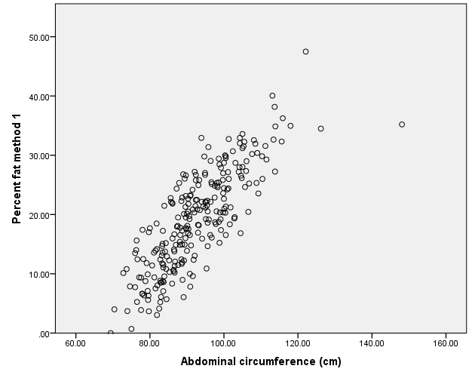

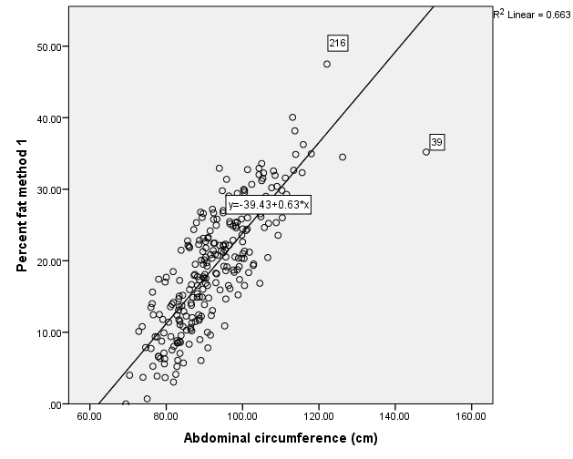

Outliers are cases 39 and 216.

Y_Predicted = -39.43 + 0.63*AbdomCirc

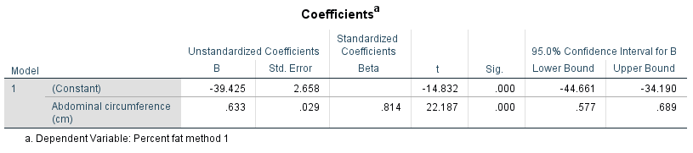

Y = -39.43 + 0.633*AbdomCirc

H0: Beta = 0

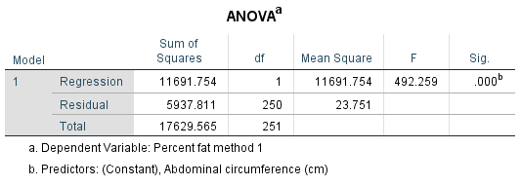

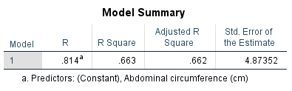

How fit is our model?

R Square = 0.663 🡺 Model is good.

Y = -39.43 + 0.633*AbdomCirc

To Predict

AbdomCirc =90 cm

BodyFat_Predicted = -39.43 + 0.633*AbdomCirc

= -39.43 + 0.633*90 = 17.5%

Assumptions

1. Randomness 🡸 X x Residual
2. Independent observations 🡸 CaseNo x Residual
3. Normality
4. Same variances
5. Y_Means fall onto predicted line

Q1

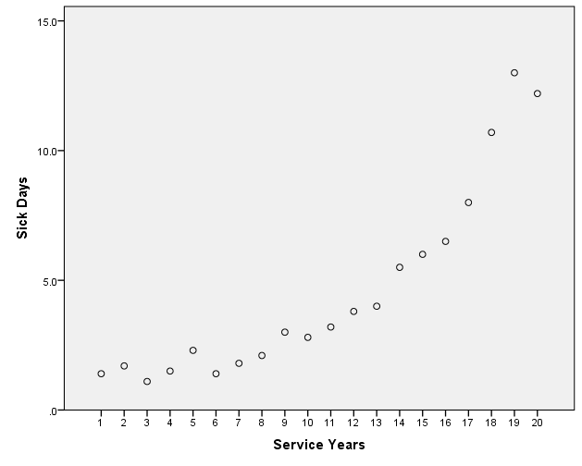

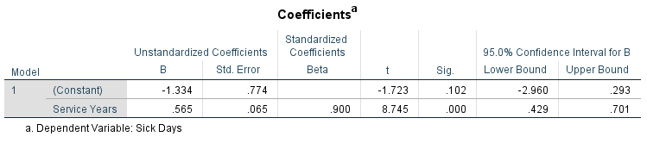

Y = -1.334 + 0.565X

SickDays = -1.334 + 0.565ServYrs

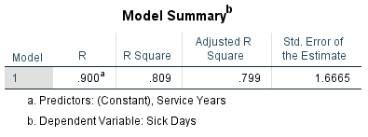

R-Square = 0.809

Adjusted_R-Square = 0.799

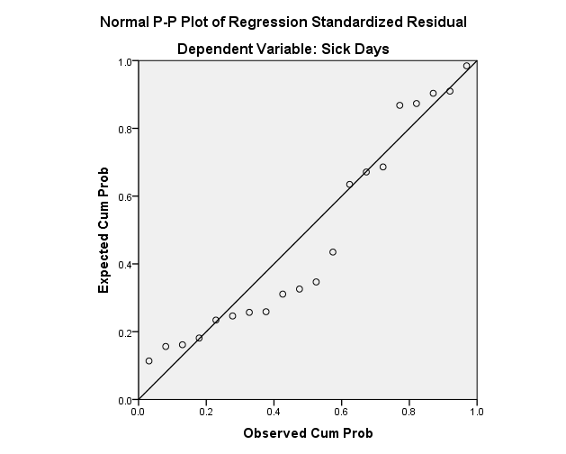

Cannot assume normality.

For 16.5 service years,

SickDays = -1.334 + 0.565ServYrs = -1.334 + 0.565*16.5 = 7.9885 sick days = 8.0 sick days

Ranking

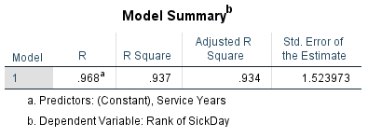

R-square = 0.937

Adj. R-square = 0.934

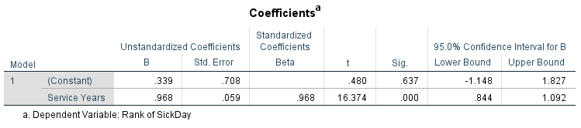

RSickDays = +0.339 + 0.968*ServYrs

For 16.5 service years,

RSickDays = +0.339 + 0.968*ServYrs

RSickDays = +0.339 + 0.968*16.5 = 16.311

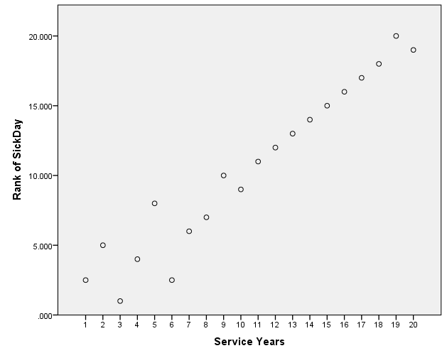

For 16.5 service years,

RSickDays = +0.339 + 0.968*ServYrs

RSickDays = +0.339 + 0.968*16.5 = 16.311 Rank

Rank 16 = 6.5

Rank 17 = 8.0

Rank 16.311 = SickDays?

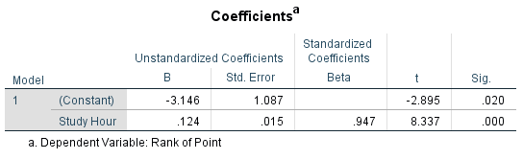

RY = -3.146 + 0.124*X

Adj. R-square = 0.884

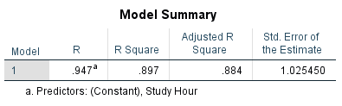

When X = 95,

RY = -3.146 + 0.124*95 = 8.634

RY = 8, Y =80

RY = 9.5, Y =90

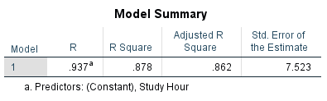

Adj. R-square = 0.862

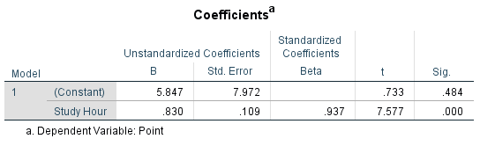

Y = 5.847 + 0.830*X