Q1.

Q: Is mice weight equal to 25g?

H0: mean = 25

H1: mean <> 25

Alpha = 0.10

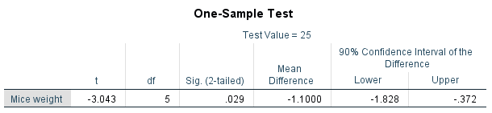

P = 0.029

Since the observed significance is 0.029 (<0.10), we reject H0 in favour of H1 that mice weight is not 25g.

Q2.

Paired samples t-test

H0: Course does not change typing speed.

H1: Course changes typing speed.

Two-tailed paired samples t-test

Alpha = 0.025

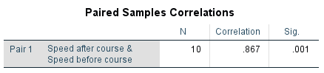

R = 0.867 (>0.50) so that we can use paired-samples t-test.

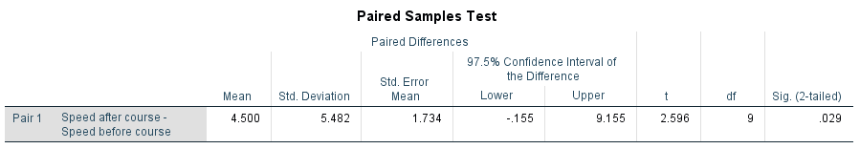

P = 0.029

Since the observed significance is 0.029 (>0.025), we do not reject H0 that the course does not change typing speed.

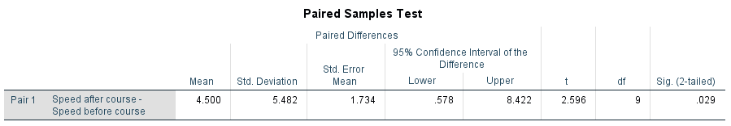

95% confidence interval of typing speed change is (0.578, 8.422).

Q3.

H0: μ8 = μ10

H1: μ8 ≠ μ10

α = 0.10 = P(Type I Error) = P(Reject H0 if H0 is true) = Tolerant Risk

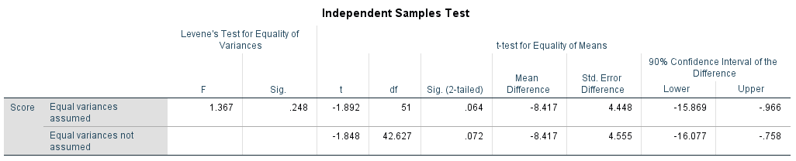

H0: variances are equal

H1: variances are unequal

P = 0.248 🡺 variances are same

H0: μ8 = μ10

H1: μ8 ≠ μ10

P = 0.064

Since the observed significance is 0.064 (<0.10), we reject H0 in favour of H1 that exam time affects exam score.

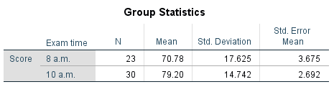

The exam scores at 8 a.m. and 10 a.m. are 70.78 and 79.20, respectively. We believe that 10 a.m. score is 8.42 with 90% confidence interval (0.966, 15.869).

Q4.

H0: μ1 = μ2 = μ3 = μ4

H1: μ1 <> μ2 <> μ3 <> μ4 (Incorrect)

H1: Not(μ1 = μ2 = μ3 = μ4)

Alpha = 0.05

Assumptions:

1. Random observations
2. Independent observations
3. Normality
4. Same variances

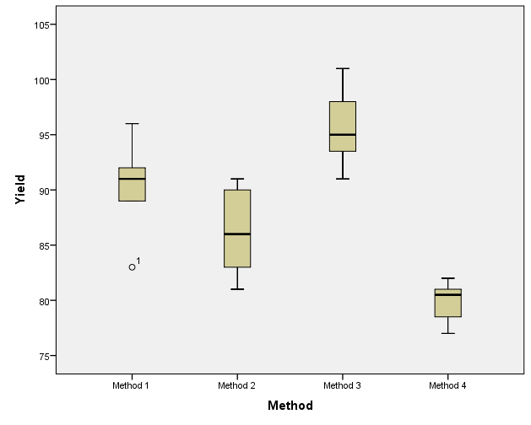

One outlier is found in Method 1. The case number is 1. We have to verify the case data.

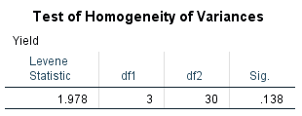

H0: Same variances

H1: Unequal variances

P = 0.138 (>0.05) so that same variances can be assumed.

Q5.

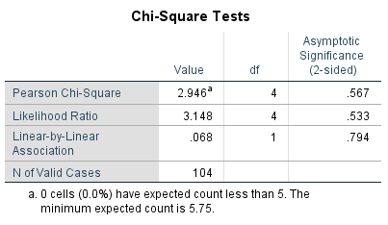

H0: Route and shift are independent for incidence.

H1: Route and shift are not independent for incidence.

P = 0.567

Since the observed significance is 0.567 (>0.05), we do not reject H0 that route and shift are independent for incidence.

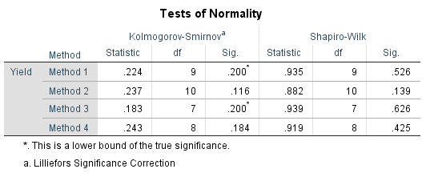

The least observed significance is 0.116 (>0.05) so that we believe the sample is normality.

Descriptive Statistics -> Explore 🡺 1. Outliers? 2. Normality?

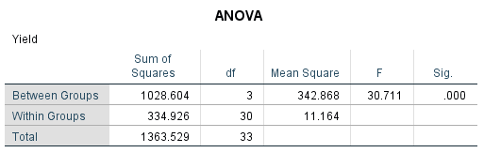

P = 0.000

Since the observed significance is 0.000 (<0.05), we reject H0 in favour of H1 that not all methods have same yield.

(1, 3), (1, 4), (2, 3), (2, 4), (3, 4) have different yields.

(1, 3), (2, 3), (3, 4) implies that yield of Method 3 is different from other methods.

95.71, 90.56, 86.40 and 79.88 are yields of Method 3, 1, 2 and 4, respectively. We believe that Method 3 has the highest yield with mean 95.71 and 95% confidence interval (92.35, 99.08).

Outlier

Normality

Post-hoc 🡺 find different group

Means plot 🡺 assist to find different group

Q7

Y = a + bX

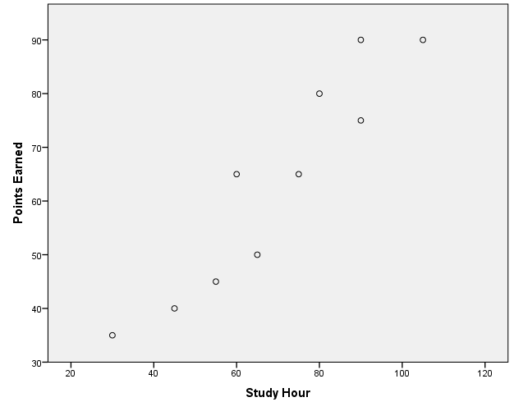

Scatter diagram

Outlier: No outlier

The points are believed linear.

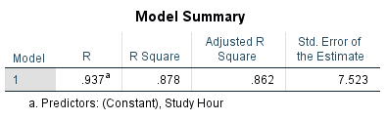

Model Fit?

R-Square = 0.878

Adj. R-Square = 0.862

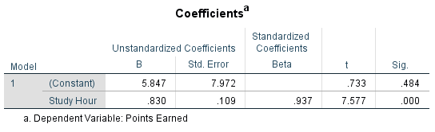

Y = a + bX

Points_Earned = 5.487 + 0.830 * Study_Hr

Given: Study_Hr = 75

Predicted Points_Earned = ?

Predicted Points_Earned = 68.06 //

95%C.I. = (62.40, 73.72)//

H0: B = 0

H1: B <> 0

P= 0.000

The observed significance is 0.000 (< 0.05) so that B is believed not equal to zero.

Given: Study_Hr = 75

Predicted Points_Earned = ?

95%C.I. = ?