Generative AI (CSCI-5240)

Final Project Report

COPD Multi-Model Analysis System using Agentic AI
EMAI-COPD: An Ethical Multimodal Agentic AI System for Preventive, Diagnostic, and Therapeutic Decision Support in COPD

Instructor
Prof. Farnoush Banaei-Kashani

Teaching Assistant
Vicente Ramos

Student
Muhammad Babar
muhammad.babar@ucdenver.edu
Student ID: 111866322

Department of Computer Science and Engineering
College of Engineering, Design and Computing
University of Colorado Denver

1. Introduction
Artificial Intelligence (AI) is becoming an important part of many industries, and healthcare is one of the areas where it is making a big impact. AI helps doctors and researchers analyze large amounts of patient data quickly and accurately. Instead of relying only on manual analysis, AI systems can find patterns, predict risks, and support better decision-making. One important use of AI in healthcare is predicting diseases and identifying patients who may be at high risk, so that early action can be taken. In this project, we developed an Agentic AI System focused on analyzing patient data related to Chronic Obstructive Pulmonary Disease (COPD). COPD is a serious lung condition that is often linked to factors like age and smoking. Early detection of risk can help improve patient outcomes, which is why building intelligent systems for analysis is important. Our system takes simple inputs such as age and smoking level and uses multiple models to evaluate the patient’s risk level.
The main idea behind this project is to simulate how a real-world AI system works. Instead of using only one model, our system uses multiple models to analyze the same data. Each model gives its own prediction and confidence score. These results are then compared, and the system selects the best-performing model based on its confidence. This approach is useful because different models may perform differently depending on the data and comparing them helps improve accuracy and reliability.
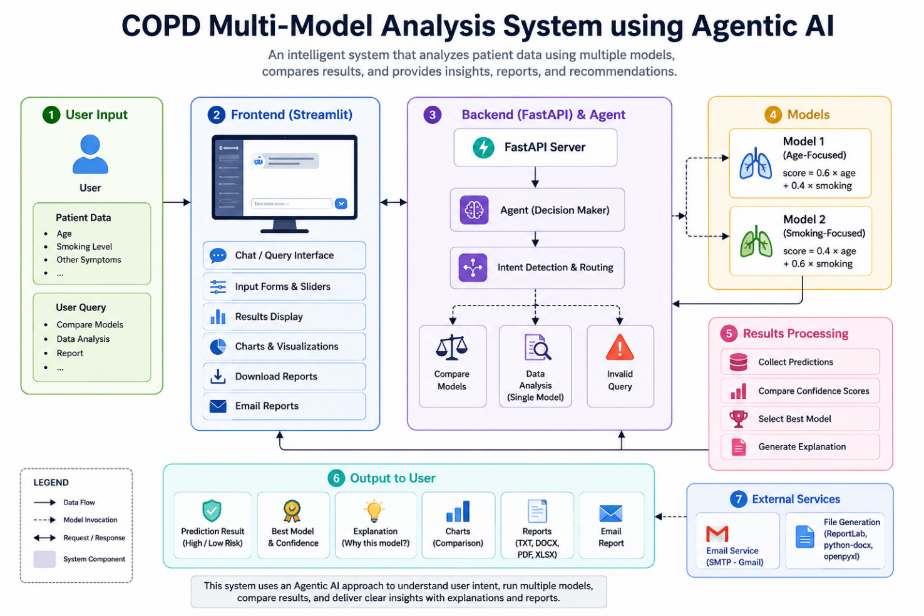
Figure 1:COPD AI System Architecture Diagram
Another important goal of this project is to provide a user-friendly interface where users can easily input data and understand the results. The system displays predictions, comparisons, charts, and explanations in a clear and simple way. It also allows users to download reports and share results via email, making the system practical and easy to use.
This project also demonstrates the concept of an agent-based architecture. In this design, an agent acts like a controller that decides what action to take based on the user’s input. For example, if the user wants to compare models, the agent runs all models and compares them. If the user wants a simple analysis, the agent runs a single model. The agent manages different tasks such as data processing, model selection, comparison, and response generation.
Overall, this project shows how AI, combined with a structured system design, can be used to build intelligent applications for healthcare. It highlights the importance of using multiple models, providing explanations, and designing systems that are both powerful and easy to use.
2. Problem Statement
In the healthcare field, professionals often need reliable tools that can help them make quick and informed decisions about a patient’s condition. One of the key requirements is the ability to analyze patient risk efficiently, especially when dealing with diseases like COPD where early detection can make a significant difference. Doctors and healthcare providers also benefit from tools that allow them to compare different predictive models, since no single model works best in every situation. In addition, it is very important for these systems to provide clear explanations, so that users can understand why a certain prediction was made, rather than just seeing a final result.
However, many existing systems have several limitations. Most tools rely on only one predictive model, which reduces flexibility and may not always give the most accurate result. Another major issue is that many systems do not explain their predictions clearly, making it difficult for users to trust or understand the outcome. This lack of transparency is a big problem, especially in healthcare, where decisions can directly affect patient lives. Furthermore, many systems are not designed with the end user in mind. They often have complex or unfriendly interfaces, making them difficult to use for healthcare professionals who may not have a strong technical background.
This project aims to solve these problems by designing and developing a system that is both intelligent and user-friendly. Instead of relying on a single model, the system uses multiple models to analyze the same patient data, providing a more comprehensive view. It then compares the results of these models and selects the best one based on confidence. To improve transparency, the system also provides clear explanations that describe how the prediction was made and why a particular model was chosen. In addition to analysis and comparison, the system focuses on usability. It includes a simple and interactive interface where users can easily input data and view results. The system also allows users to download reports in multiple formats and share them via email, making it practical for real-world use.
Overall, the problem addressed in this project is the lack of intelligent, transparent, and user-friendly tools for patient risk analysis. By combining multiple models, clear explanations, and an easy-to-use interface, this system provides a more effective solution for healthcare data analysis.
3. Objectives
The main objective of this project is to develop an intelligent and user-friendly system that can analyze patient data and support decision-making using Artificial Intelligence. The project focuses on combining multiple capabilities such as model analysis, comparison, explanation, and reporting into one complete system. By using an agent-based approach, the system is designed to understand user input and perform the appropriate task automatically. This makes the system flexible, efficient, and closer to real-world AI applications. In addition, the project emphasizes simplicity and usability so that users can easily interact with the system, understand the results, and use them for further analysis or sharing.
The main objectives of this project are:
- To build an Agentic AI system that can manage different tasks based on user input
- To simulate multi-model analysis using more than one predictive model
- To create a user-friendly dashboard for easy interaction and visualization
- To provide model comparison and explanation for better understanding of results
- To generate downloadable reports in multiple formats
- To support email sharing of results for practical use and communication
4. System Overview
The proposed system is designed as a complete pipeline that connects user interaction with intelligent data processing and result presentation. It is divided into three main components: the backend, the agent layer, and the frontend. Each component has a specific role, and together they work in coordination to provide a smooth and efficient user experience. The system starts with user input from the interface, processes the data through the backend and agent logic, and then returns meaningful results such as predictions, comparisons, and reports. This modular design makes the system organized, easy to maintain, and scalable for future improvements.
The system consists of three main components:
- Backend (FastAPI)
The backend is responsible for handling all the core processing tasks of the system. It acts as the central engine where data is received, processed, and sent back to the user. The backend performs the following functions:
- Handles data processing based on user inputs
- Executes different models to generate predictions
- Manages API requests and responses between the frontend and agent
2. Agent Layer
The agent layer acts as the “brain” of the system. It interprets the user’s query and decides what action needs to be performed. Instead of running everything blindly, the agent intelligently routes the request to the appropriate function. Its responsibilities include:
- Deciding what to do based on the user query
- Routing requests such as model comparison or single analysis
- Managing the flow of data between models and the backend
3. Frontend (Streamlit UI)
The frontend is the user-facing part of the system. It provides an interactive and easy-to-use interface where users can input data and view results. It focuses on usability and visualization. The frontend provides:
- A simple input interface for user queries and data
- Visualizations such as tables and charts
- Downloadable reports in multiple formats
- A chat-style history panel to track previous queries
5. System Architecture
The system architecture is based on an Agentic AI design, where an intelligent agent controls the flow of operations instead of following a fixed sequence of steps. This design allows the system to behave more dynamically and respond differently depending on the user’s query. The architecture ensures that each component of the system has a clear role, and all parts work together smoothly to process data and generate results. When a user enters a query, the system does not directly execute a model. Instead, the agent first interprets the request, decides what action is required, and then routes the task accordingly. This makes the system more flexible, scalable, and closer to real-world AI systems.
The overall working of the system follows a structured process. First, the user provides input through the interface. The agent then interprets the query to understand whether the user wants model comparison or a single analysis. After that, the system sends the data to the models, where predictions are generated. Once all results are available, the system compares the outputs and selects the best model based on confidence. Finally, the results are displayed to the user and stored in the system for future reference.
The flow of data in the system can be described as follows:
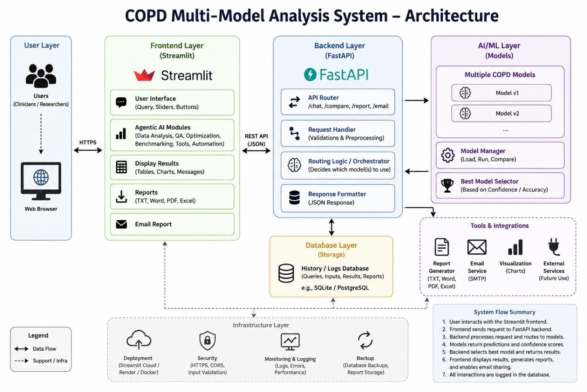
Figure 2: Data Flow in Agentic AI System
This architecture ensures a clear separation of responsibilities between components. The agent plays a central role in controlling the system, which makes it easier to extend the system in the future, such as adding more models or advanced AI features.
6. Technologies Used
This project is developed using a combination of modern and efficient technologies that support both backend processing and frontend interaction. The system is built using Python, which provides strong support for AI and data processing. FastAPI is used for the backend to handle API requests, execute models, and manage data flow. Streamlit is used to create an interactive and user-friendly frontend interface where users can input data and view results. Pandas is used for data handling and organizing results into structured formats. For report generation, ReportLab and python-docx are used to create PDF and Word files. Additionally, SMTP with Gmail is used to send reports via email, making the system more practical and useful.
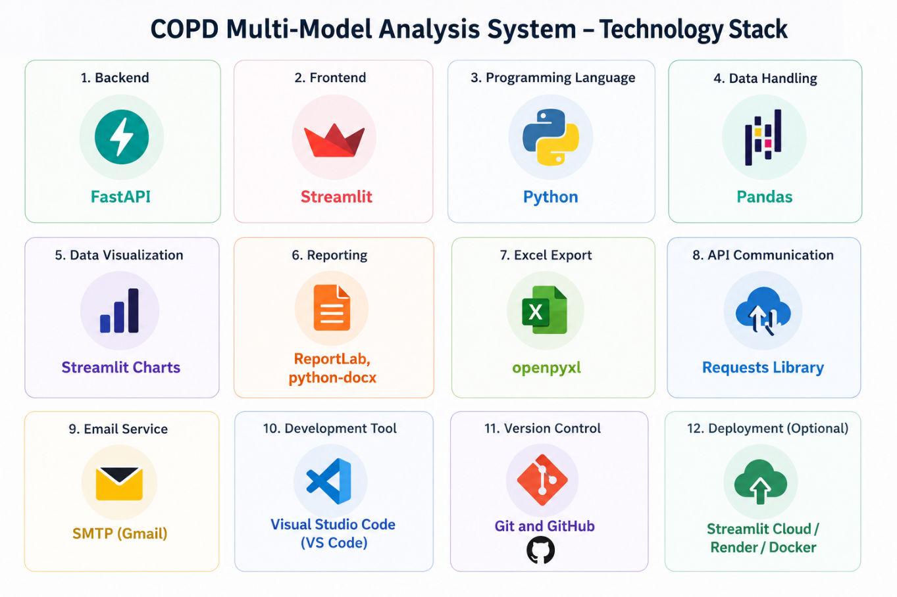
Figure 3: Technology Stack
7. Data Input
The system uses simple and easy-to-understand patient inputs to perform risk analysis. The goal is to keep the input process straightforward so that users can quickly enter data without needing medical or technical expertise. In this project, two main features are considered: age and smoking level. These inputs are important factors in assessing the risk of diseases like COPD, as both age and smoking habits have a strong impact on lung health. The system takes these values, processes them through the models, and calculates a risk score that is used to determine whether the patient falls into a high-risk or low-risk category.
The system takes the following patient inputs:
- Age
- Smoking level
These features are used together to calculate a risk score, which forms the basis for prediction and model comparison.
8. Model Design
In this project, two simple predictive models are implemented to simulate how different models can analyze the same patient data in different ways. The purpose of using two models is to demonstrate multi-model analysis, where each model gives a slightly different importance to input features. Instead of building complex machine learning models, these models use weighted formulas to calculate a risk score based on age and smoking level. This approach helps in understanding how different factors influence predictions and makes the system easy to explain and interpret.
The first model is designed to give more importance to age, assuming that age plays a stronger role in determining risk. The second model focuses more on smoking, considering it as a major contributing factor. By comparing these two models, the system can evaluate which perspective provides a better prediction for a given input.
The models used in this system are:
Model 1 (Age-focused)
- Gives more importance to age
- Uses a weighted formula where age has a higher contribution
score=0.6⋅age+0.4⋅smokingscore = 0.6 \cdot age + 0.4 \cdot smokingscore=0.6⋅age+0.4⋅smoking
Model 2 (Smoking-focused)
- Gives more importance to smoking
- Uses a weighted formula where smoking has a higher contribution
score=0.4⋅age+0.6⋅smokingscore = 0.4 \cdot age + 0.6 \cdot smokingscore=0.4⋅age+0.6⋅smoking
Both models calculate a score that represents the overall risk level. These scores are later used to classify the patient as high risk or low risk and to compare which model performs better with the given data.
9. Prediction Logic
After the models calculate a score using the input features (age and smoking level), the system applies a simple rule to convert this score into a meaningful prediction. The purpose of this step is to classify the patient into a risk category that is easy to understand. Instead of showing only numerical values, the system translates the score into labels such as High Risk or Low Risk, which makes the output more useful for users.
Each model generates a score between 0 and 1, where a higher value indicates a higher level of risk. This score is then compared against a predefined threshold to determine the final prediction. The threshold used in this system is 0.5, which acts as a decision boundary between low and high risk. This approach is simple, consistent, and easy to interpret.
The prediction logic used in this system is:
- Each model calculates a score between 0 and 1
- The system then classifies the result based on the score
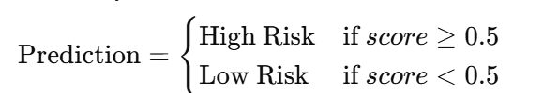
10. Agent Logic
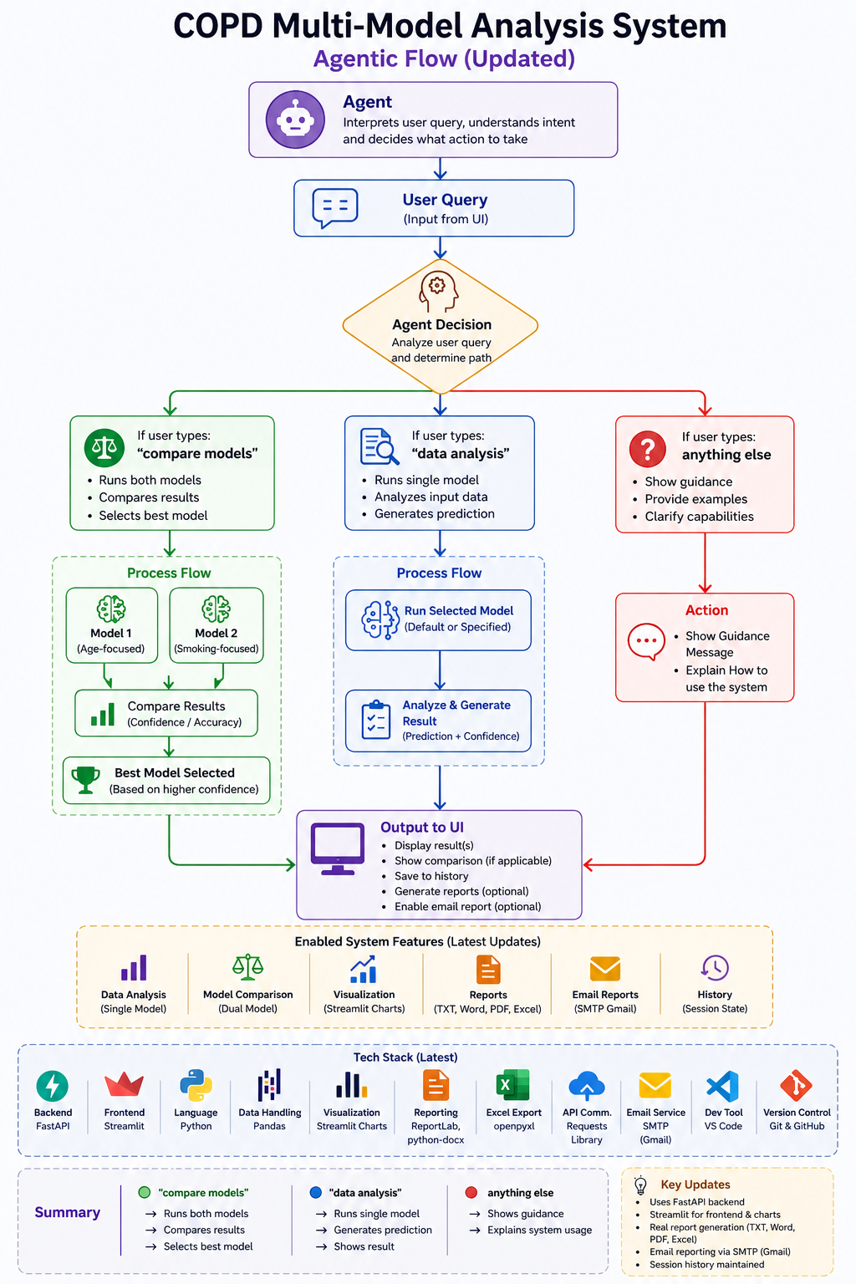
Figure 4: Agentic Logic

11. Model Comparison
The system compares different models using their confidence scores. The model with the highest confidence is selected as the best model. This is done using the following method:
max(results, key=lambda x: x["confidence"])
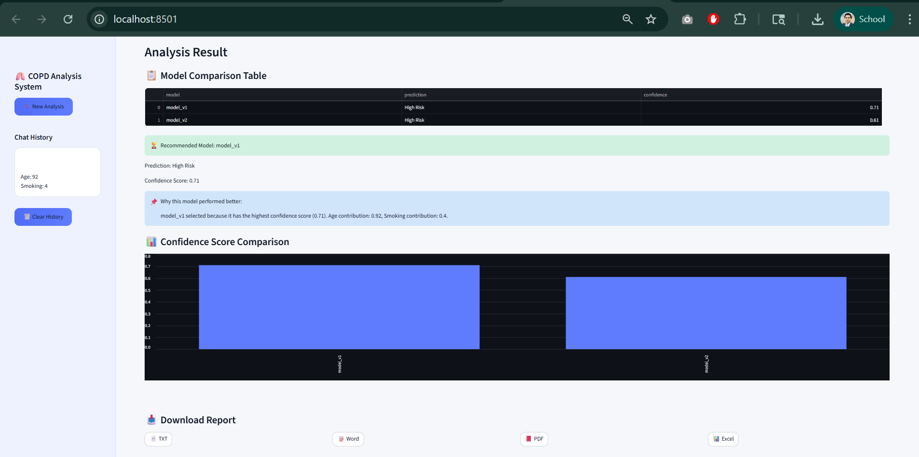
Figure 5: Multi-Model Comparison Result
This approach ensures that the most reliable prediction is chosen for the final output.
12. Explanation System
The system also provides clear explanations for its decisions. It explains why a model was selected and shows the contribution of input features such as age and smoking.
For example:
Model_v2 is selected because it has the highest confidence among all models.
13. User Interface
The user interface of the system is developed using Streamlit, which allows the creation of interactive and easy-to-use web applications using Python. The UI is designed to be simple, clean, and similar to modern AI tools, making it comfortable for users to interact with the system. It focuses on providing a smooth experience where users can easily enter inputs, view results, and access additional features like history and reports.

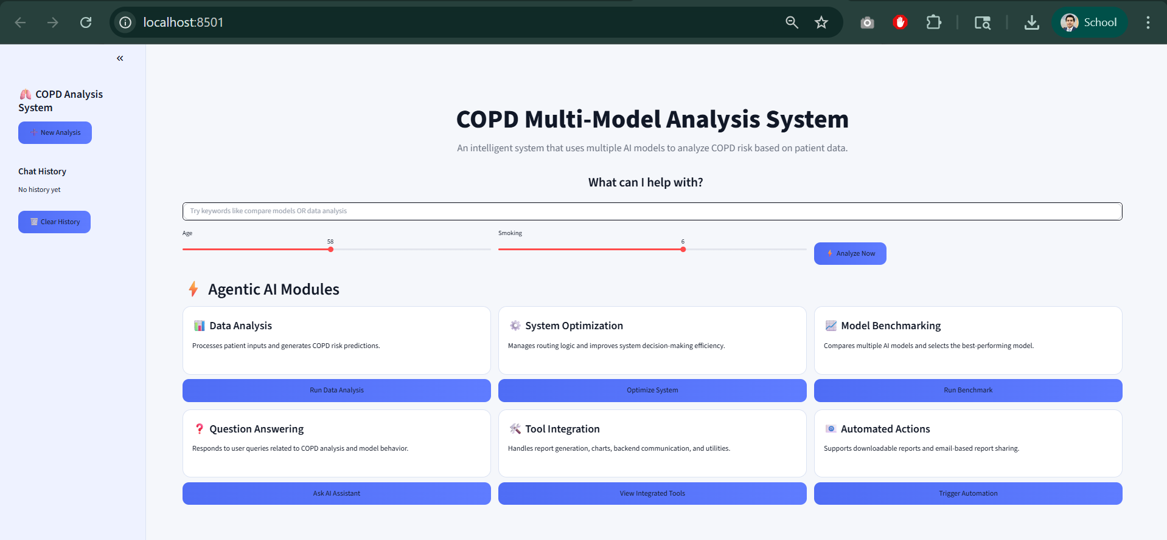
Figure 6: System Homepage Interface
The interface includes the following key features:
- ChatGPT-style layout for a modern and familiar user experience
- Left sidebar (history) to display previous queries and results
- Input panel for entering queries and patient data
- Output visualization to clearly show predictions and comparisons
- Report downloads in multiple formats for saving results
Overall, the UI ensures that the system is not only functional but also user-friendly and visually organized.
14. Chat History
The system includes a chat-style history feature that keeps track of user interactions and results. This allows users to review their previous inputs and outputs without needing to repeat the analysis. It improves usability by providing continuity and making it easier to compare past results.
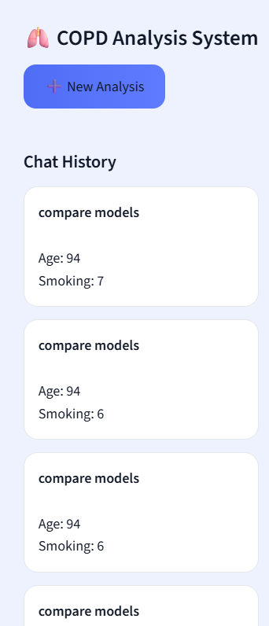
Figure 7: Chat History
The system stores the following information:
- Previous queries entered by the user
- Results generated by the system
- Best model selected during comparison
This feature helps users track past analysis, revisit decisions, and better understand how results may change based on different inputs.
15. Visualization
The system presents results in a clear and visual format so users can easily understand and compare model outputs. Instead of only showing text, it uses structured tables and charts to make the information more intuitive. This helps users quickly identify which model performs better and how confident each prediction is.
The system provides two main types of visual outputs:
Table
Displays key details for each model, including:
  - Model name
  - Prediction (High Risk / Low Risk)
  - Confidence score
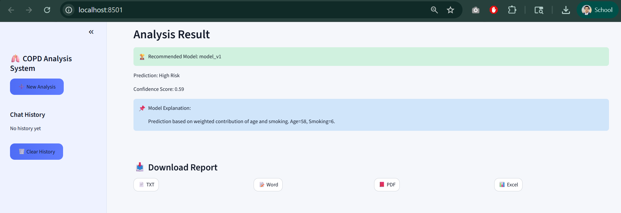
Figure 8: Model Comparison Table
Chart
A bar chart that visually compares the confidence scores of different models, making it easier to identify the best-performing model at a glance
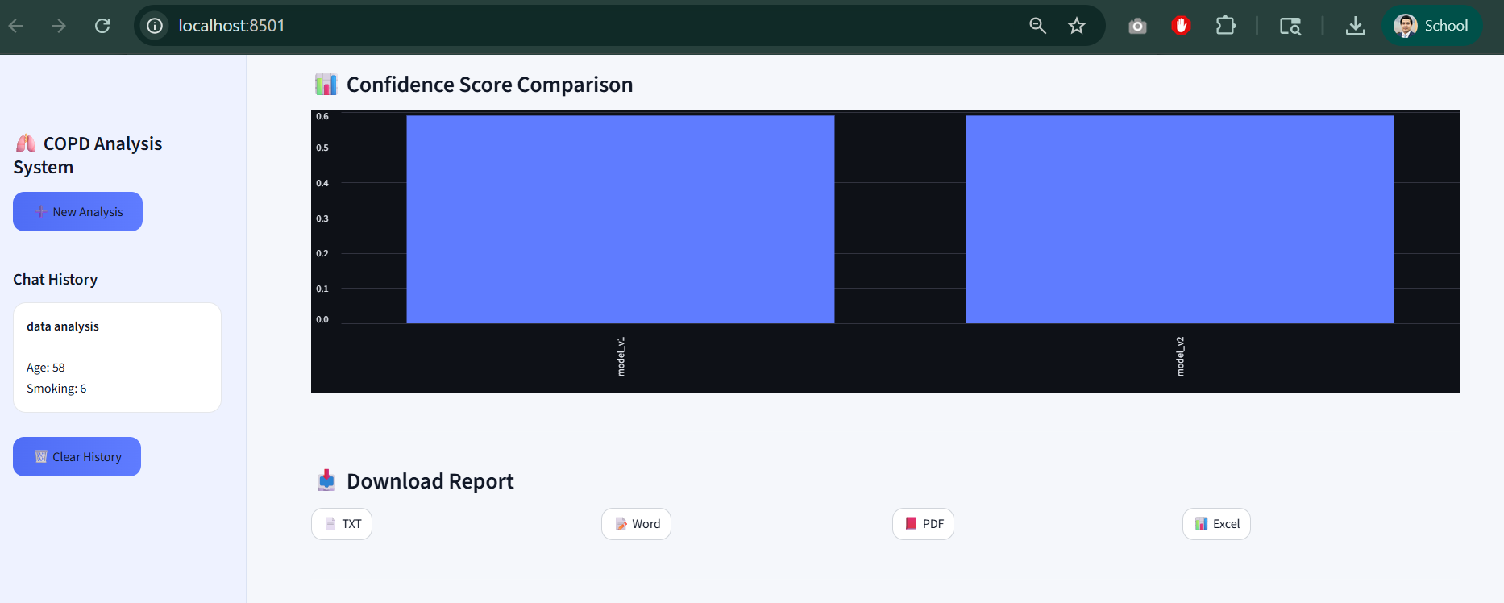
Figure 9: Confidence Score Comparison Chart
These visualizations improve clarity and make the system more user-friendly.
16. Report Generation
The system provides a report generation feature that allows users to save and share the analysis results in different formats. This makes the system more practical for real-world use, as users can keep records of their analysis or share them with others. The reports are automatically generated based on the results produced by the models.
The system supports the following report formats:
- TXT (Text file)
- Word document (.docx)
- PDF file
- Excel file (.xlsx)
Each report includes:
- Model results showing predictions and confidence scores
- Best model selected based on highest confidence
- Explanation describing why the model was chosen and how the result was derived
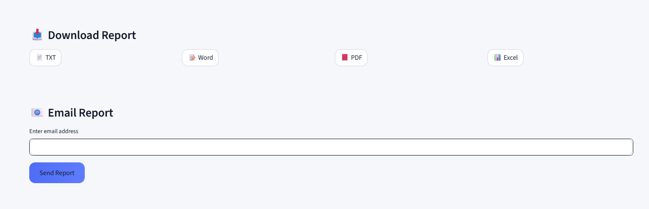
Figure 10: Report Download Options
This feature ensures that users can easily download, store, and share their analysis in a professional and convenient way.
17. Email Integration
The system includes an email integration feature that allows users to share analysis results directly from the application. This makes it convenient to send reports to others without needing to download and attach files manually. The feature is simple and easy to use, requiring only an email address to send the report.
Users can:
- Enter an email address
- Send the generated report directly
This functionality is implemented using:
- SMTP (Simple Mail Transfer Protocol) for sending emails
- Gmail App Password for secure authentication
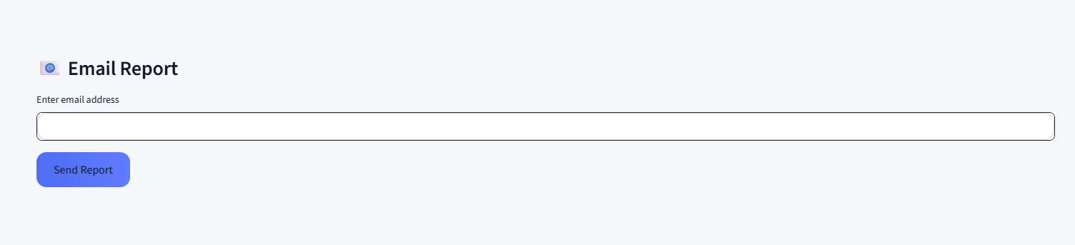
Overall, this feature improves the usability of the system by enabling quick and direct sharing of results.
19. Error Handling
The system includes proper error handling to ensure smooth and stable operation, even when users provide unexpected or incorrect inputs. This helps prevent crashes and improves the overall user experience. Instead of failing silently or showing technical errors, the system provides clear and user-friendly messages to guide the user.
The system handles the following situations:
- Invalid input by checking whether the query matches expected commands
- Empty queries by prompting the user to enter a valid request
- Backend errors by displaying appropriate error messages instead of breaking the application
For example, if a user types “hello” or any unsupported query, the system does not crash. Instead, it shows a helpful message guiding the user to enter valid commands such as “compare models” or “data analysis”.
This approach ensures that the system remains reliable, user-friendly, and easy to interact with.
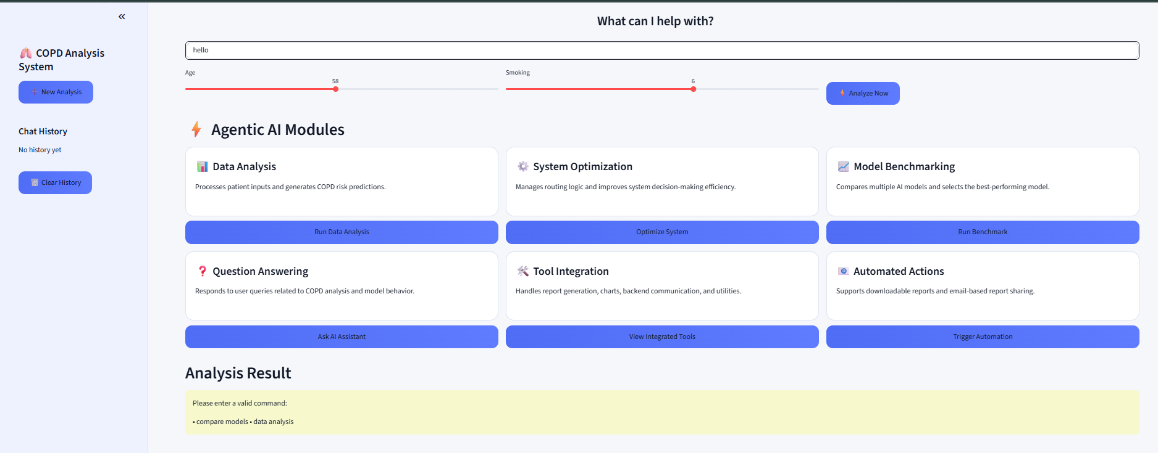
Figure 11: Ask for correct input

20. Testing
Testing is an important part of this project to ensure that the system works correctly under different scenarios. The system was tested using different types of user inputs to verify that it produces the expected output and handles errors properly. The testing process focused on validating the agent logic, model execution, and user interface behavior.
The following test cases were used:
Input | Expected Output
compare models | Model comparison result
data analysis | Single model result
hello | Guidance message
These test cases confirm that the system behaves correctly for valid commands and also handles invalid inputs gracefully.
21. Results
The results of this project show that the system works effectively in performing patient data analysis and presenting meaningful outputs. The system successfully processes user inputs and applies the designed models to generate predictions. It also demonstrates the ability to compare multiple models and identify the best one based on confidence scores. The outputs are displayed in a clear and structured format, making it easy for users to understand the results.
The system successfully:
- Analyzes patient data using input features such as age and smoking level
- Compares multiple models to evaluate different predictions
- Selects the best model based on the highest confidence score
- Generates reports in multiple formats for download
- Displays results clearly using tables, charts, and explanations
Overall, the system meets its objectives and provides a complete solution for multi-model analysis with a user-friendly interface.
22. Limitations
Although the system works effectively and meets its main objectives, it has some limitations that can be improved in future work. These limitations are mainly due to the simplified design and the use of simulated models instead of real-world data and machine learning techniques. Understanding these limitations helps in identifying areas for enhancement and further development.
The current limitations of the system are:
Models are simple (proxy models)
The models used in this project are basic and based on fixed formulas rather than trained machine learning algorithms.
No real medical dataset
The system uses simulated input data instead of real patient datasets, which limits real-world accuracy.
No real ML training yet
The models are not trained using machine learning techniques, so the system does not learn from data or improve over time.
These limitations highlight that the project is a prototype and can be further enhanced by integrating real data, advanced models, and more interactive features.
23. Future Work
While the current system provides a strong foundation, there are several realistic improvements that can make it more powerful, accurate, and closer to real-world applications. Future development will focus on enhancing the intelligence of the models, improving user interaction, and making the system scalable and deployable.
Future improvements include:
Integration of real machine learning models (scikit-learn)
Replace the current proxy models with trained models such as logistic regression or decision trees using real datasets to improve prediction accuracy.
Use of advanced models where appropriate
Explore more complex approaches only if supported by sufficient data and evaluation, ensuring improvements are meaningful and not just added complexity.
Improved natural language understanding
Allow users to enter flexible queries (e.g., “Which model is better?”) instead of fixed commands, making the system easier to use.
Voice input support
Enable users to provide input using speech-to-text, improving accessibility and user experience.
File upload feature
Allow users to upload datasets (e.g., CSV files) for batch analysis instead of entering values manually.
Cloud deployment
Deploy the system on platforms like AWS, Azure, or Streamlit Cloud to make it accessible from anywhere and support multiple users.
Enhanced reporting and sharing
Improve report formatting and allow sending structured reports (e.g., PDF attachments) directly via email.
Scalability and performance improvements
Optimize backend processing to handle larger datasets and multiple simultaneous users efficiently. These improvements will help transform the current prototype into a more practical, scalable, and intelligent system suitable for real-world use.
24. Conclusion
This project demonstrates how an Agentic AI system can effectively manage different components of an intelligent application and provide meaningful insights from user data. The system is designed to handle multiple models, compare their outputs, and present structured results in a clear and user-friendly way. By using an agent-based approach, the system can dynamically decide what action to take based on user input, making it flexible and efficient.
The project successfully shows how different aspects of technology can be integrated into one complete solution. It combines AI logic for decision-making, system design for managing workflows and components, and a user-friendly interface for easy interaction and visualization. The inclusion of features such as model comparison, explanations, report generation, and email sharing further enhances the usefulness of the system.

References
- Srinivasu, P. N., et al. “Exploring Agentic AI in Healthcare: A Study on Its Working and Applications.” Frontiers in Medicine, 2025.
Frontiers in Medicine Paper
- Zhao, L., et al. “AI Agent in Healthcare: Applications, Evaluations, and Future Directions.” Nature Digital Medicine, 2026.
Nature Digital Medicine Paper
- Karunanayake, N., et al. “Next-Generation Agentic AI for Transforming Healthcare.” Computational and Structural Biotechnology Journal, 2025.
Healthcare AI Research Paper
- Demrozi, F., et al. “Multimodal AI (MMAI) for Next-Generation Healthcare.” Smart Health Journal, 2025.
Multimodal AI Healthcare Paper
- Zhang, R., et al. “Multimodal Artificial Intelligence in Medicine: A Task-Oriented Review.” Frontiers in Medicine, 2025.
Multimodal AI in Medicine Review
- FastAPI Documentation
- Streamlit Documentation
- Python Official Documentation
- Pandas Documentation
- ReportLab Documentation
- python-docx Documentation
- OpenPyXL Documentation
- Uvicorn Documentation
- Requests Library Documentation
- Git Documentation
- GitHub Documentation
- Visual Studio Code Documentation
- SMTP Protocol Overview (Google Developers)
- Scikit-learn Documentation
- OpenAI Platform Documentation
- Agentic AI Concepts – IBM Technology
- Machine Learning Basics – Google Developers

